TITLE:

Design the back-propagation algorithm.

AIM: To write a program for Implementation of back-propagation.

OBJECTIVES:
- Understand basic concepts of back-propagation neural network.
- Implement basic method for weight modification.

THEORY:
Backpropagation Algorithm:

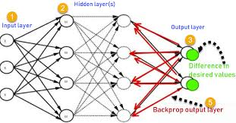

Backpropagation algorithm is a widely used algorithm in training feedforward neural networks for supervised learning. Generalizations of backpropagation exist for other artificial neural networks (ANNs), and for functions generally – a class of algorithms is referred to generically as "backpropagation". In deep learning, backpropagation computes the gradient of the loss function with respect to the weights of the network for a single input–output example, and does so efficiently, unlike a naive direct computation of the gradient with respect to each weight individually. This efficiency makes it feasible to use gradient methods for training multilayer networks, updating weights to minimize loss; gradient descent, or variants such as stochastic gradient descent, are commonly used. The backpropagation algorithm works by computing the gradient of the loss function with respect to each weight by the chain rule, computing the gradient one layer at a time, iterating backward from the last layer to avoid redundant calculations of intermediate terms in the chain rule; this is an example of dynamic programming
Questions for Review:

- Explain neuro fuzzy hybrid, neuro genetic hybrid and fuzzy genetic hybrid system?
- Define Bias and Threshold.
- Write Short Note on Important terminology on ANN's

