TITLE:

Implement basic logic gates using Mc-Culoch-Pitts or Hebbnet neural networks

AIM: To write a program for Implementation of Basic fuzzy gates.

OBJECTIVES:
- Understand basic concepts of Mc-Culoch-Pitts or Hebbnet neural networks
- Practical implementation of Basic logic gates.

THEORY:

McCulloch-Pitts Neuron
The artificial neuron receives one or more inputs (representing excitatory postsynaptic potentials and inhibitory postsynaptic potentials at neural dendrites) and sums them to produce an output (or activation, representing a neuron's action potential which is transmitted along its axon). Usually each input is separately weighted, and the sum is passed through a non-linear function known as an activation function or transfer function

The first computational model of a neuron was proposed by Warren MuCulloch (neuroscientist) and Walter Pitts (logician) in 1943.
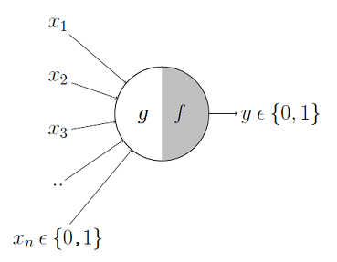

It may be divided into 2 parts. The First part G takes an input performs an aggregation and based on aggregated value the second part,F makes a decision.

Hebb Learning Model
Training Algorithm For Hebbian Learning Rule
The training steps of the algorithm are as follows:
- Initially, the weights are set to zero, i.e. w =0 for all inputs i =1 to n and n is the total number of input neurons.
- Let s be the output. The activation function for inputs is generally set as an identity function.
- The activation function for output is also set to y= t.
- The weight adjustments and bias are adjusted to:
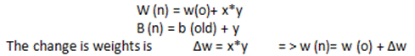
- The steps 2 to 4 are repeated for each input vector and output.

questions for Review:
- Explain Hebb Learning using an example?
- Explain McCulloch–Pitts Neuron in brief by cosidering AND gate example?
- Implement AND function using McCulloch-Pitts neuron.

