TITLE:

Implement genetic algorithm for benchmark function (eg. Square, Rosenbrock functionetc)
Initialize the population from the Standard Normal Distribution. Evaluate the fitness of all its individuals. Then you will do multiple generation of a genetic algorithm. A generation
consists of applying selection, crossover, mutation, and replacement.

AIM: To write a program for Implementation of Genetic Optimization Algorithm.

OBJECTIVES:
- Understand basic concepts of Genetic Optimization Algorithm
- Implement basic benchmark function using Genetic Algorithm.

THEORY:
Genetic Algorithms

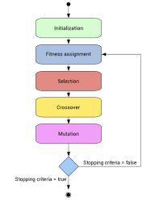

In a genetic algorithm, a population of candidate solutions (called individuals, creatures, or phenotypes) to an optimization problem is evolved toward better solutions. Each candidate solution has a set of properties (its chromosomes or genotype) which can be mutated and altered; traditionally, solutions are represented in binary as strings of 0s and 1s, but other encodings are also possible.
The evolution usually starts from a population of randomly generated individuals, and is an iterative process, with the population in each iteration called a generation. In each generation, the fitness of every individual in the population is evaluated; the fitness is usually the value of the objective function in the optimization problem being solved. The more fit individuals are stochastically selected from the current population, and each individual's genome is modified (recombined and possibly randomly mutated) to form a new generation. The new generation of candidate solutions is then used in the next iteration of the algorithm. Commonly, the algorithm terminates when either a maximum number of generations has been produced, or a satisfactory fitness level has been reached for the population.

Questions for Review:

- Enlist the basic steps of Genetic Algorithm with flowchart.
- Explain Genetic Operators.

