Introduction to Spring Framework
Spring Framework is a Java platform that provides comprehensive infrastructure support for developing Java applications. Spring handles the infrastructure so you can focus on your application.
Spring enables you to build applications from “plain old Java objects” (POJOs) and to apply enterprise services non-invasively to POJOs. This capability applies to the Java SE programming model and to full and partial Java EE.
Examples of how you, as an application developer, can use the Spring platform advantage:
- Make a Java method execute in a database transaction without having to deal with transaction APIs.
- Make a local Java method a remote procedure without having to deal with remote APIs.

Spring is a secure, low-cost and flexible framework that improves coding efficiency and reduces overall application development time through efficient use of system resources.
One of Spring's core traits is its ability to perform dependency injection, which is a programming pattern that allows developers to build more decoupled architectures. Spring understands different Java annotations that a developer puts on top of classes and can help make sure that all instances created have properly populated dependencies.
For the Spring Framework to instantiate objects and populate the dependencies, a programmer simply tells Spring which objects to manage and what the dependencies are for each class through annotations. For instance, the @component annotation lets Spring know which classes to manage, marks objects as managed components and identifies classes for dependency injection. As another example, the @autowired annotation tells Spring how to handle the instantiation of the class and to start looking for that dependency among components and classes to find a match.

Important Spring terms
There are a few important terms associated with Spring that developers should know before getting started with the framework:
- Autowiring. The process by which Spring identifies dependencies and matches and populates them.
- Dependency injection. A programming design pattern that promotes loose coupling in code, meaning that any change in one area of the application is less likely to affect another.
- Inversion of control (IoC). A design principle that takes control execution away from a given class and hands it off to a separate management framework.
- IoC container. This is the portion of the Spring Framework where objects are created, wired together, configured and managed throughout their life cycle.
- Bean. An object that is instantiated, created and managed by the IoC container. Beans make up the backbone of Spring-based applications.
- Aspect Oriented Programming. The functions that span multiple points of an application are called cross-cutting concerns and these cross-cutting concerns are conceptually separate from the application's business logic. There are various common good examples of aspects including logging, declarative transactions, security, caching, etc.

Dependency Injection and Inversion of Control
When writing a complex Java application, application classes should be as independent as possible of other Java classes to increase the possibility to reuse these classes and to test them independently of other classes while unit testing. Dependency Injection helps in gluing these classes together and at the same time keeping them independent.
IOC Container
The IoC container is responsible to instantiate, configure and assemble the objects. The IoC container gets informations from the XML file and works accordingly.
The org.springframework.beans.factory.BeanFactory and the org.springframework.context.ApplicationContext interfaces acts as the IoC container. The ApplicationContext interface is built on top of the BeanFactory interface. It adds some extra functionality than BeanFactory such as simple integration with Spring's AOP, message resource handling (for I18N), event propagation, application layer specific context (e.g. WebApplicationContext) for web application. So it is better to use ApplicationContext than BeanFactory.

Bean Scopes
Singleton – One object instance is created, and every other request uses this instance
Prototype – Every request needs a separate instance
<bean id = "..." class = "..." scope = "singleton">
https://www.tutorialspoint.com/spring/spring_bean_scopes.htm

DI can be done using two ways:
Constructor Injection:
https://www.javatpoint.com/spring-tutorial-dependency-injection-by-constructor
Setter Injection:
https://www.javatpoint.com/spring-tutorial-dependency-injection-by-setter-method

Aspect Oriented Programming

https://www.javatpoint.com/spring-aop-tutorial

Spring Security

Spring Security is a framework which provides various security features like: authentication, authorization to create secure Java Enterprise Applications.
Features:
- Comprehensive and extensible support for both Authentication and Authorization
- Protection against attacks like session fixation, clickjacking, cross site request forgery, etc
- Servlet API integration
- Optional integration with Spring Web MVC

Introduction to Spring Boot
Spring Boot is a project that is built on the top of the Spring Framework. It provides an easier and faster way to set up, configure, and run both simple and web-based applications.
It is a Spring module that provides the RAD (Rapid Application Development) feature to the Spring Framework. It is used to create a stand-alone Spring-based application that you can just run because it needs minimal Spring configuration.
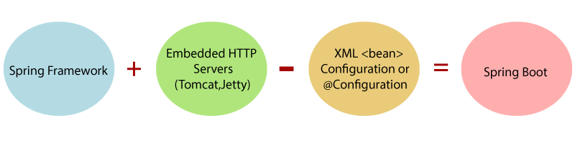

We should use Spring Boot Framework because:
- The dependency injection approach is used in Spring Boot.
- It contains powerful database transaction management capabilities.
- It simplifies integration with other Java frameworks like JPA/Hibernate ORM, Struts,
- It reduces the cost and development time of the application.
Advantages of Spring Boot
- It creates stand-alone Spring applications that can be started using Java -jar.
- It tests web applications easily with the help of different Embedded HTTP servers such as Tomcat, Jetty, etc. We don't need to deploy WAR files.
- It provides opinionated 'starter' POMs to simplify our Maven configuration.
- It provides production-ready features such as metrics, health checks, and externalized configuration.
- There is no requirement for XML configuration. Automatic configuration removes the need for xml.
- It offers a CLI tool for developing and testing the Spring Boot application.
- It offers the number of plug-ins.
- It also minimizes writing multiple boilerplate codes (the code that has to be included in many places with little or no alteration), XML configuration, and annotations.
- It increases productivity and reduces development time.
- No .war file as we have executable .jar files.
Limitation: Spring Boot can use dependencies that are not going to be used in the application. These dependencies increase the size of the application.
Goals of Spring Boot:
The main goal of Spring Boot is to reduce development, unit test, and integration test time.
- Provides Opinionated Development approach
- Avoids writing lots of import statements
- Avoids XML Configuration.
By providing or avoiding the above points, Spring Boot Framework reduces Development time, Developer Effort, and increases productivity.

Spring vs Spring Boot vs Spring MVC

https://www.javatpoint.com/spring-vs-spring-boot-vs-spring-mvc

Spring Boot Essentials

Spring Boot automatically configures your application based on the dependencies you have added to the project by using @EnableAutoConfiguration annotation.
The entry point of the spring boot application is the class contains @SpringBootApplication annotation and the main method.
Spring Boot automatically scans all the components included in the project by using @ComponentScan annotation.
If you added @SpringBootApplication annotation to the class, you do not need to add the @EnableAutoConfiguration, @ComponentScan and @SpringBootConfiguration annotation. The @SpringBootApplication annotation includes all other annotations.
Handling dependency management is a difficult task for big projects. Spring Boot resolves this problem by providing a set of dependencies for developers convenience.
For example, if you want to use Spring and JPA for database access, it is sufficient if you include spring-boot-starter-data-jpa dependency in your project.
Note that all Spring Boot starters follow the same naming pattern spring-boot-starter- *, where * indicates that it is a type of the application.

Examples
Look at the following Spring Boot starters explained below for a better understanding −
Spring Boot Starter Actuator dependency is used to monitor and manage your application. Its code is shown below −
<dependency>
<groupId>org.springframework.boot</groupId>
<artifactId>spring-boot-starter-actuator</artifactId>
</dependency>
Spring Boot Starter Security dependency is used for Spring Security. Its code is shown below −
<dependency>
<groupId>org.springframework.boot</groupId>
<artifactId>spring-boot-starter-security</artifactId>
</dependency>
Spring Boot Starter web dependency is used to write a Rest Endpoints. Its code is shown below −
<dependency>
<groupId>org.springframework.boot</groupId>
<artifactId>spring-boot-starter-web</artifactId>
</dependency>

Spring Boot Annotations
https://www.javatpoint.com/spring-boot-annotations

Eureka Server is an application that holds the information about all client-service applications. Every Micro service will register into the Eureka server and Eureka server knows all the client applications running on each port and IP address.
Spring Cloud Configuration Server is a centralized application that manages all the application related configuration properties.
Spring Boot Actuator provides secured endpoints for monitoring and managing your Spring Boot application. By default, all actuator endpoints are secured.
Cross-Origin Resource Sharing (CORS) is a security concept that allows restricting the resources implemented in web browsers. It prevents the JavaScript code producing or consuming the requests against different origin.
For example, your web application is running on 8080 port and by using JavaScript you are trying to consuming RESTful web services from 9090 port. Under such situations, you will face the Cross-Origin Resource Sharing security issue on your web browsers.
Two requirements are needed to handle this issue −
- RESTful web services should support the Cross-Origin Resource Sharing.
- RESTful web service application should allow accessing the API(s) from the 8080 port.

Swagger2 is an open source project used to generate the REST API documents for RESTful web services. It provides a user interface to access our RESTful web services via the web browser.

Web Services

Web services are a type of internet software that use standardized messaging protocols and are made available from an application service provider's web server for use by a client or other web-based programs.
- The web service must be accessible over the internet.
- The web service is discoverable through a common mechanism like UDDI.
- It must be interoperable over any programming language or Operating System.
https://www.javatpoint.com/restful-web-services-architecture-of-web-services

RESTful Web Services with Spring Boot
REST or Representational State Transfer is an architectural style that can be applied to web services to create and enhance properties like performance, scalability, and modifiability. RESTful web services are generally highly scalable, light, and maintainable and are used to create APIs for web-based applications. It exposes API from an application in a secure and stateless manner to the client. The protocol for REST is HTTP. In this architecture style, clients and servers use a standardized interface and protocol to exchange representation of resources.

Advantages
- RESTful web services are platform-independent.
- It can be written in any programming language and can be executed on any platform.
- It provides different data format like JSON, text, HTML, and XML.
- It is fast in comparison to SOAP because there is no strict specification like SOAP.
- These are reusable.
- These are language neutral.

@ControllerAdvice – It is a specialized form of the spring’s stereotype annotation which allows handling exceptions across the whole application in one global handling component. Think of this as an interceptor of exceptions thrown by methods annotated with @RequstMapping.

- In the config folder we created the class WebConfig for the content negotiation.
Content negotiation is used to display the data in various formats like JSON, XML, etc.
configurer.favorParameter(true)
.parameterName("mediaType")
.defaultContentType(MediaType.APPLICATION_JSON)
.mediaType("xml", MediaType.APPLICATION_XML)
.mediaType("json", MediaType.APPLICATION_JSON);

For this we need to add the jackson.dataformat dependency in the pom.xml

https://localhost:8080/v2/employees/mediaType=xml

Spring Data JPA

Spring Data is a high-level Spring Source project. Its purpose is to unify and easy access to the different kinds of persistence stores, both relational database systems, and NoSQL data stores.

Spring Data JPA handles most of the complexity of JDBC-based database access and ORM (Object Relational Mapping). It reduces the boilerplate code required by JPA. It makes the implementation of your persistence layer easier and faster.
Spring Data JPA aims to improve the implementation of data access layers by reducing the effort to the amount that is needed.
- We create the entity class for this purpose containing the setters and getters of the fields. We also need the Repository which extends the JPA Repository for every entity.
- @Autowire is used to automatically inject the dependencies into the classes, eliminating the need for manual configuration.

- @Qualifier is used when there are multiple beans of same type and it specifies the exact bean that needs to be injected.

<bean id="humanHeart" class="Heart"></bean>
<bean id="octpusHeart" class="Heart"></bean>

- For the EmployeeV2ServiceImpl we need to convert the Employee class to the Entity hence we created the entity object and copied the values from the employees to the entity using BeanUtils.copyProperties() method. We are converting here because we used the EmployeeRepository in this Version2 implementation.

Microservices

The microservice architectural style is an approach to develop a single application as a suite of small services. Each microservice runs its process and communicates with lightweight mechanisms. These services are built around business capabilities and independently developed by fully automated deployment machinery.

Microservices is an architecture wherein all the components of the system are put into individual components, which can be built, deployed, and scaled individually.
- These are the services which are exposed by REST.
- These are small well-chosen deployable units.
- The services must be cloud-enabled.
The microservice defines an approach to the architecture that divides an application into a pool of loosely coupled services that implements business requirements. It is next to Service-Oriented Architecture (SOA). The most important feature of the microservice-based architecture is that it can perform continuous delivery of a large and complex application.
These microservices communicate with each other using an Application Program Interface(API). After the Microservices communicate within themselves, they deploy the static content to a cloud-based storage service that can deliver them directly to the clients via Content Delivery Networks (CDNs).

Advantages
- Microservices are self-contained, independent deployment module.
- The cost of scaling is comparatively less than the monolithic architecture.
- The demanding service can be deployed on multiple servers to enhance performance.
- Less dependency and easy to test.
- Dynamic scaling.
- Faster release cycle.
Disadvantages
- Microservices has all the associated complexities of the distributed system.
- There is a higher chance of failure during communication between different services.
- Difficult to manage a large number of services.
- The developer needs to solve the problem, such as network latency and load balancing.
- Complex testing over a distributed environment.

https://www.javatpoint.com/difference-between-msa-and-soa

Microservices Implementation

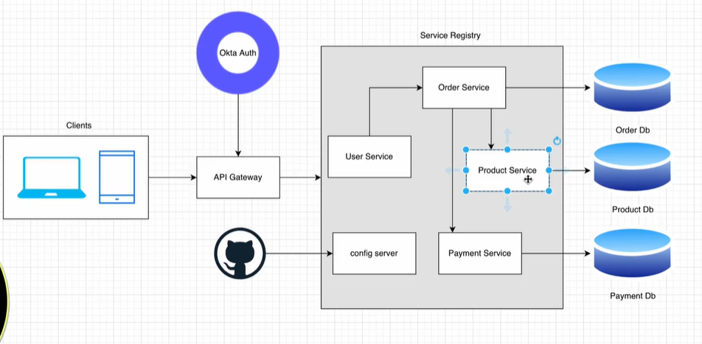

Service Registry:
  - Overall, the Service Registry pattern plays a crucial role in enabling dynamic discovery, load balancing, and fault tolerance in a microservices architecture, making it a key component for building scalable and resilient microservices-based applications.
Service registry is a database of services, their instances and their locations. Service instances are registered with the service registry on startup and deregistered on shutdown. Client of the service and/or routers query the service registry to find the available instances of a service.
Service Registry used the load balancer to retrieve the information and also the Eureka server for hosting multiple instances.

Dependencies:
Spring Boot Starter Web: This dependency includes everything you need to build a web application or expose RESTful services using Spring MVC.
Spring Boot Starter Actuator: Provides production-ready features to help monitor and manage your application, including health checks, metrics, and more.
Spring Boot Starter Data JPA: If your microservice needs to interact with a database, this dependency provides support for Spring Data JPA and Hibernate.
Spring Boot Starter Security: If your microservice requires authentication and authorization, you can include this dependency to add Spring Security support.
Spring Cloud Starter Netflix Eureka Client: If you are using Eureka for service discovery, this dependency enables your microservice to register itself with the Eureka server.
Spring Boot Starter Test: This dependency includes testing libraries for unit and integration testing of Spring Boot applications.
MySQL Connector J: This dependency is used to connect wit the MySQL database
Lombok - It is a popular library for Java that helps reduce boilerplate code by automatically generating getters, setters, constructors, and other repetitive code.
Spring Cloud Config Starter - The Spring Cloud Config Starter is a dependency in the Spring Cloud ecosystem that enables applications to retrieve their configuration from a centralized configuration server. This server can store configuration properties for multiple applications and environments, allowing for centralized management and versioning of configuration settings.

@Data – We use this annotation in the entity class so that it creates the getters and setters internally without us writing them explicitly.
@AllArgsConstructor and @NoArgsConstructor: These are used to create the parameter constructor and the default constructor to all the fields internally.
@Builder: It is used to reduce boilerplate code in Java applications. Specifically, it is used to automatically generate builder methods for constructing instances of a class. This Builder class provides fluent API methods for setting each attribute of the class and eventually building an instance of it. This is particularly useful when dealing with classes that have many attributes or require complex initialization logic.
- The above three annotations are part of the Lombok dependency.
- In the service registry, we use two default values register-with-eureka which is false because it no need to connect with itself and fetch-registry.
Fetch registry typically refers to the process by which services retrieve information about other services registered with the service registry.
In a microservices architecture, services often need to discover and communicate with other services in the system.
server:
port: 8761
eureka:
instance:
hostname: localhost
client:
register-with-eureka: false
fetch-registry: false

Feign Client
In Spring, a Feign client is a tool provided by the Spring Cloud Netflix project that simplifies the process of making HTTP requests to other microservices or RESTful APIs. Feign is a declarative web service client developed by Netflix that allows you to write HTTP client requests in a simple and concise manner.
Using Feign clients, you can define an interface annotated with Spring annotations, such as @FeignClient, @RequestMapping, and others, to specify the HTTP endpoints you want to interact with. Feign then automatically generates a concrete implementation of that interface, which you can use in your code to make HTTP requests. This allows you to treat remote API calls as local method calls, making the code cleaner and easier to maintain.
Without Feign, in Spring Boot application, we use RestTemplate to call the User service. To use the Feign, we need to add spring-cloud-starter-openfeign dependency in the pom.xml file.
RestTemplate:
- Part of the core Spring Framework
- Provides a low-level, imperative API for making HTTP requests
- Requires manual handling of HTTP details like building URLs, setting headers, and handling responses
- Does not provide built-in service discovery or load balancing capabilities
- Supports synchronous and asynchronous requests
Feign:
- Part of the Spring Cloud Netflix project
- Provides a higher-level, declarative API for defining HTTP client interfaces
- HTTP details are abstracted away through annotations on the interface methods
- Integrates seamlessly with other Spring Cloud components like Ribbon (load balancing) and Eureka (service discovery)
- Supports circuit breakers like Hystrix out of the box
- Primarily designed for synchronous requests

Here are some key differences between the two:
API Style: RestTemplate provides a low-level, imperative API, while Feign provides a higher-level, declarative API through annotated interfaces.
Service Discovery and Load Balancing: Feign integrates with Ribbon and Eureka, providing automatic service discovery and client-side load balancing. RestTemplate does not have built-in support for these features.
Circuit Breaker Integration: Feign integrates easily with circuit breakers like Hystrix, while RestTemplate requires manual integration.
HTTP Request/Response Handling: With RestTemplate, you have more control over building URLs, setting headers, and handling responses. Feign abstracts away these details through annotations.
Asynchronous Support: RestTemplate supports both synchronous and asynchronous requests, while Feign is primarily designed for synchronous requests.
In general, Feign is considered a more opinionated and higher-level abstraction for making HTTP requests in a microservice architecture, providing built-in integration with service discovery, load balancing, and circuit breakers. RestTemplate, on the other hand, is a lower-level, more flexible tool that gives you more control over the HTTP request/response lifecycle.

ZipKin Server:
Zipkin is a distributed tracing system that helps gather timing data needed to troubleshoot latency problems in microservice architectures. When multiple services are involved in processing a single request, it can be challenging to understand the flow of that request through the system and identify bottlenecks or latency issues. Zipkin helps address these challenges by providing visibility into the flow of requests across various services.

API Gateway:
An API Gateway is a server that acts as an intermediary between client applications and backend services. Its primary function is to manage, control, and secure the APIs (Application Programming Interfaces) exposed by those backend services. Here are some key aspects and functionalities of an API Gateway:
API Routing: It directs incoming API requests to the appropriate backend service based on the endpoint or path specified in the request.
Protocol Translation: It can translate between different protocols, allowing clients and services to communicate using different standards. For example, it might translate HTTP requests into other protocols like WebSockets or gRPC.
Request Transformation: API Gateways can modify or transform incoming requests before passing them to backend services. This could involve adding authentication headers, request payload manipulation, or request parameter validation.
Response Transformation: Similarly, API Gateways can modify or transform responses from backend services before sending them back to clients. This could involve data formatting, filtering, or adding custom headers.
Authentication and Authorization: API Gateways often handle authentication and authorization processes, ensuring that only authorized users or applications can access the backend services. This might involve integration with identity providers like OAuth providers or LDAP directories.
Rate Limiting and Throttling: They can enforce rate limits and throttle incoming requests to prevent abuse or overloading of backend services, thus ensuring better performance and stability.
Logging and Monitoring: API Gateways typically provide logging and monitoring functionalities, allowing administrators to track API usage, performance metrics, errors, and other relevant information.
Security: They offer various security features such as SSL/TLS termination, encryption, and protection against common web attacks like SQL injection, Cross-Site Scripting (XSS), and Cross-Site Request Forgery (CSRF).
API Gateways play a crucial role in modern microservices architectures, providing a centralized entry point for client applications to access multiple backend services while offering security, scalability, and management capabilities.
We’re using Web Flux Dependency in the api-gateway.
Web Flux
WebFlux is a reactive programming framework for building asynchronous, non-blocking, and event-driven applications on the JVM (Java Virtual Machine). It is part of the Spring Framework and provides support for building reactive microservices, web applications, and APIs. It supports both traditional Servlet-based applications and fully-reactive applications that run on Netty, a popular event-driven application framework.
Reactive microservices offer a modern approach to building distributed systems that are highly responsive, resilient, and scalable.
Here are some key features and concepts of WebFlux:
Reactive Streams API: WebFlux is built on top of the Reactive Streams API, which defines a standard for asynchronous stream processing with non-blocking backpressure. This allows developers to handle streams of data in a more efficient and responsive manner.
Reactive Programming Model: WebFlux promotes the use of reactive programming principles, where developers can compose asynchronous and event-driven pipelines using operators like map, filter, flatMap, etc. This enables more scalable and resilient applications by efficiently utilizing system resources.
Non-Blocking I/O: WebFlux is designed to handle I/O operations asynchronously without blocking threads, allowing applications to handle a large number of concurrent connections with fewer resources.
Event-Driven Architecture: WebFlux applications are built around the concept of handling events reactively. This allows developers to write code that responds to incoming requests, messages, or data streams in a non-blocking manner.
- Improved scalability and performance.
- Better resource utilization.
- Easy integration with other reactive libraries and systems.

Circuit Breaker
In the context of microservices architecture, a circuit breaker is a design pattern used to enhance the resilience and fault tolerance of distributed systems. It helps manage failures and prevent cascading failures from propagating throughout the system.
Here's how it works:
Monitoring:
The circuit breaker continuously monitors the interactions between microservices.
It tracks the number of failures that occur during these interactions.
State Management:
Based on the monitored failures, the circuit breaker can be in one of three states: closed, open, or half-open.
Closed State: In this state, the circuit breaker allows normal communication between microservices to occur without intervention.
Open State: If the number of failures surpasses a predetermined threshold, the circuit breaker switches to the open state. In this state, the circuit breaker prevents any requests from passing through. Instead, it immediately returns an error or a predefined fallback response.
Half-Open State: After a specified period of time, the circuit breaker transitions from the open state to the half-open state. In this state, the circuit breaker allows a limited number of requests to pass through to test if the underlying service has recovered. If these requests succeed, the circuit breaker returns to the closed state. If they fail, the circuit breaker remains open.
Fallback Mechanism:
When the circuit breaker is in the open state, it typically provides a fallback mechanism to handle requests without relying on the failing service. This could involve returning cached data, providing a default response, or redirecting requests to an alternative service.

Benefits of using a circuit breaker in microservices architecture include:
Fault Isolation: By isolating failing services, circuit breakers prevent the spread of failures to other parts of the system.
Resilience: Circuit breakers help the system recover quickly from failures by temporarily halting traffic to the failing service and providing fallback mechanisms.
Monitoring and Control: They provide insights into the health and behavior of microservices, allowing for better management and control of the system's behavior during failures.

Redis Dependency
We use this to implement ratelimiter functionality .
Caching: One of the primary uses of Redis in microservices is caching. Microservices often need to access frequently accessed data quickly, and Redis provides a fast and efficient caching solution. By caching data in Redis, microservices can reduce the load on backend databases and improve overall system performance.
Session Management: In microservices architectures, where sessions may not be stored locally, Redis can be used for session management. It allows microservices to store session data in memory, making it easily accessible across multiple instances of a service or different services.
Rate Limiting and Throttling: Redis can be used to implement rate limiting and throttling mechanisms in microservices. By tracking request rates and enforcing limits using Redis, microservices can prevent abuse, manage traffic spikes, and ensure system stability.
Queueing: Redis offers data structures such as lists and streams, which can be used to implement lightweight message queues. Microservices can use Redis as a message broker to decouple components, enable asynchronous processing, and improve system scalability.

- In the rate limiter, we use two parameters called replenishRate and burstCapacity
- replinishRate is the number of requests it allows per second and burstCapacity is the number of requests it allows per given time.
Replenish rate, also known as the refill rate, represents the rate at which tokens are added back to the token bucket over time.
Burst capacity, also referred to as the token bucket size or maximum burst size, defines the maximum number of tokens that the token bucket can hold at any given time.

In the context of microservices and reactive programming with Mono (a reactive type in Project Reactor), a KeyResolver typically refers to a component responsible for resolving keys or identifiers used to access or manipulate data.
Here's how KeyResolver might be used in both contexts:
Microservices:
In a microservices architecture, a KeyResolver could be a component responsible for resolving keys used to identify resources or entities across different services. For example:
API Gateway: In an API gateway service, a KeyResolver might extract keys or identifiers from incoming requests to route them to the appropriate microservice.
Service Discovery: A KeyResolver could be used in conjunction with service discovery mechanisms to resolve keys into service endpoints dynamically.
Mono and Reactive Programming:
In reactive programming with Project Reactor's Mono, a KeyResolver could be used to map or transform elements emitted by a Mono based on some key or identifier. For example:
Mono<String> source = Mono.just("key1");

Mono<Data> resolvedData = source.flatMap(key -> {
// Resolve data based on the key
return resolveDataByKey(key);
});
In this example, source is a Mono emitting a key, and resolveDataByKey() is a function that resolves data based on the provided key. The flatMap operator is used to transform the emitted key into the corresponding data.
Summary:
In both microservices and reactive programming contexts, a KeyResolver serves the purpose of resolving keys or identifiers to perform operations such as routing requests, accessing data, or mapping transformations. It abstracts away the details of how keys are resolved, allowing for more flexible and modular design in both microservices architectures and reactive systems.

Spring Security

Okta Credentials
Client ID - 0oafupj0psk5UWPf45d7
Client Secret - o1jxBu3MkpTlE-Vwb5JCMk1Xx5SzFEIYWxvlxU0CfB9O2lOl2NWB4rZc9Hs_oivq
Audience - api://default
Issuer - Okta URL (https://dev-29034418.okta.com/oauth2/default)
During setting up the Okta developer configuration we need to following operations:
Add your Web Application to Okta from Applications tab
Go to security tab and in api add scopes and claims
Before adding claims go to groups and add the groups ex. Customer and admin

http://localhost:9090/authenticate/login
This is used to get the access, refresh token

Docker With Microservices

It is a software platform that allows us to build, test and deploy applications quickly. It packages software into standardized units called containers that have everything the software needs to run including libraries, system tools, code and runtime. Using Docker, you can quickly deploy and scale applications into any environment and know your code will run.
Docker images
Docker images contain executable application source code as well as all the tools, libraries and dependencies that the application code needs to run as a container. When you run the Docker image, it becomes one instance (or multiple instances) of the container.
It’s possible to build a Docker image from scratch, but most developers pull them down from common repositories. Multiple Docker images can be created from a single base image and they’ll share the commonalities of their stack.
Containers: Containers are lightweight, standalone, and executable packages that include everything needed to run a piece of software, including the code, runtime, system tools, libraries, and settings.

Docker Engine: This is the runtime that manages and runs Docker containers. It handles the low-level container functions and allows users to build and run containers.
Docker registry
A Docker registry is a scalable open source storage and distribution system for Docker images. The registry enables you to track image versions in repositories, using tagging for identification. This tracking and identification is accomplished using Git.

Docker Hub: A cloud-based registry service that allows you to find and share container images with your team. You can use Docker Hub to get the images you need, and it also allows you to publish your own images.
Docker Pros | Docker Cons
Cross-platform consistency: Compatibility across a range of systems and environments makes developers’ jobs easier. | Outdated documentation: Docker’s extensive documentation doesn’t always keep pace with platform updates.
Serverless storage: Docker containers are cloud-based and don’t require tons of active memory to run reliably. | Steep learning curve: Developers transitioning from other infrastructure might find Docker easy to begin but hard to master.
High-speed deployment: Eliminating redundant installations and configurations makes deployment fast and easy. | Security issues: The lack of segmentation means that multiple containers can be vulnerable to host system attacks.
Flexibility and scalability: Developers can use any programming language and scale container resources up and down as needed. | Limited orchestration: It can be difficult to effectively manage multiple containers at once without orchestration capabilities.

Why Use Docker?
Consistency Across Environments: One of the main advantages of Docker is that it ensures consistency across multiple development, testing, and production environments. The same Docker container can run on a developer's laptop, a testing server, or in a production environment without changes.
Isolation: Docker containers are isolated from each other and the host system. This isolation helps in avoiding conflicts between applications and their dependencies.
Scalability: Docker makes it easy to scale applications. Containers can be easily added or removed, and orchestration tools like Kubernetes can manage the scaling process.
Efficiency: Containers are more lightweight than traditional virtual machines because they share the host system’s OS kernel and do not require a full OS instance for each application. This makes them faster to start and reduces overhead.
Simplified Deployment: Docker simplifies the deployment process by allowing developers to package an application and its dependencies into a single image. This image can be deployed anywhere, making it easier to manage applications across different stages of the development lifecycle.
Version Control: Docker images can be versioned, enabling developers to roll back to previous versions if something goes wrong. This is useful for maintaining application stability and tracking changes over time.
DevOps Integration: Docker integrates well with continuous integration and continuous deployment (CI/CD) tools, enabling automated testing, building, and deployment of applications. This integration accelerates the development process and reduces the risk of errors.

When to use a virtual machine
It’s best to use a virtual machine if you’re running applications with these requirements:
- Operating system-specific dependencies
- Substantial hardware resource requirements
- A need to set various controls in operating systems
- Legacy applications that no longer run on modern operating systems
- Different operating system requirements with a single underlying physical infrastructure available

When to use Docker
It’s best to use Docker when you’re running applications with these requirements:
- Lightweight resource requirements or a microservice architecture
- A distributed physical infrastructure environment, including cloud-based servers
- Rapid deployment cycles (as Dockerfiles are easier to manage than VM configurations)
- A rapid scalability requirement

Summary of difference: Docker vs. VM
 | Docker container | VM
What is it? | Docker is a software platform to create and run Docker containers. A Docker container is an emulation of a user-space instance, the part of the operating system where user processes run. | An emulation of a physical machine—including virtualized hardware—running an operating system.
Virtualization | Container abstracts operating system details from the application code. | VM abstracts hardware details from the application code.
Objective | Abstract hardware details and increase hardware utilization. | Improve application environment management and bring consistency across multiple environments.
Managed by | The Docker Engine coordinates between the operating system and Docker containers. | The hypervisor coordinates between the machine’s physical hardware and virtual machines.
Architecture | Shares resources with the underlying host kernel. | Runs its own kernel and operating system.
Resource sharing | On-demand. | A fixed amount, set in a virtual machine image’s configuration requirements.

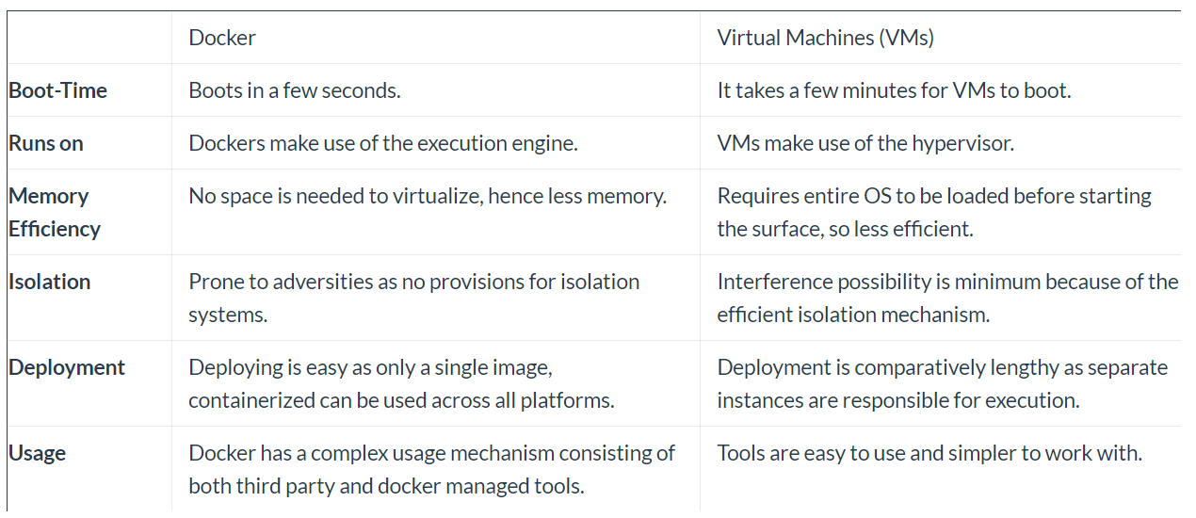

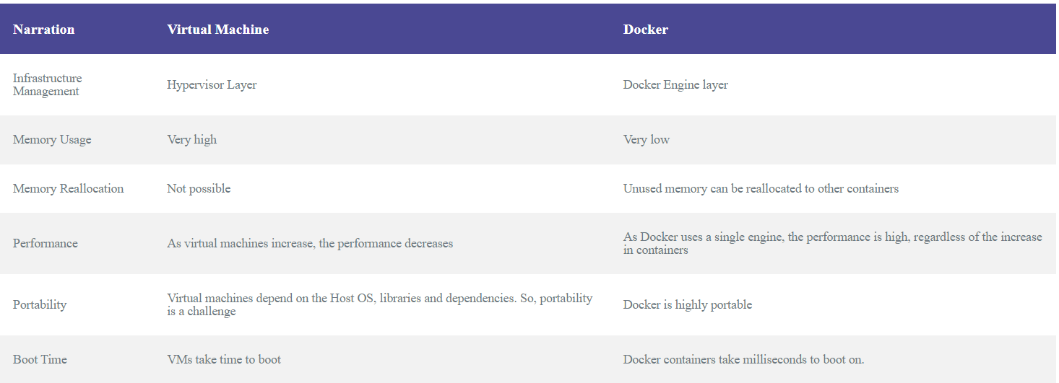
Use Cases | Microservices, development, CI/CD | Monolithic applications, multiple OS instances, legacy applications
 | Quick startup times, easy cleanup | Full OS requirements, strong security boundaries

Docker Commands

docker images – to see all the available images
docker run --name redis-latest redis:latest
Instead of latest you can also provide image_id
docker run --name redis-latest redis: b6d7af45c418

docker ps – to see what containers are running
docker ps -a
docker stop container id – to stop a particular container
docker start container id – to start a particular container
docker rm container id – to remove a particular container

docker run --name redis-latest -p6379:6379 -d redis:latest
Exposing the port from the host machine

docker pull redis:6.2.7 – to pull the specific version of redis
docker run --name redis-old -p6379:6379 -d redis:6.2.7

docker –help – to know about the various docker commands
docker run –help

docker inspect image_id – It gives us the complete information regarding the particular image
docker inspect container_id – It gives us the complete information regarding the particular container

docker logs container_id
docker exec -it container_id /bin/sh – this is used to go inside the container and debug

docker rmi image_id – to remove the image
docker system prune -a – it removes all the images and the containers

Building the Docker image – this is our own image
docker build -t nikhilspring/serviceregistry:0.0.1 .
docker run -d -p8761:8761 --name serviceregistry imageid

docker build -t nikhilspring/configserver:0.0.1 -t nikhilspring/configserver:latest .
docker run -d -p9296:9296 --name configserver imageid

docker run -d -p9296:9296 -e EUREKA_SERVER_ADDRESS=http://host.docker.internal:8761/eureka --name configserver 2cfb144bfc35

docker build -t nikhilspring/cloudgateway:latest .
docker run -d -p9090:9090 -e CONFIG_SERVER_URL=host.docker.internal -e EUREKA_SERVER_ADDRESS=http://host.docker.internal:8761/eureka --name cloudgateway 124c9535a9d5

docker login

A Docker Compose file is a YAML file that defines services, networks, and volumes for a multi-container Docker application. This file, typically named docker-compose.yml, is used by Docker Compose, a tool for defining and running multi-container Docker applications. With Docker Compose, you can start, stop, and manage multiple Docker containers as a single service.

The jib-maven-plugin is a plugin for Apache Maven that allows you to build optimized Docker and OCI (Open Container Initiative) images for your Java applications without needing a Docker daemon. It is developed by Google as part of the Jib project. The plugin integrates seamlessly with Maven to containerize your Java application and push it to a container registry.
Key Features of jib-maven-plugin
Daemonless Builds: Jib does not require Docker to be installed on your machine. It performs all necessary steps to build the image directly from your Maven build process.
Optimized Images: Jib builds optimized images by layering your application and its dependencies, enabling faster builds and incremental updates.
Reproducible Builds: Jib ensures reproducible container builds by avoiding common pitfalls like using the current date and time or including the build user's home directory in the image.
Easy Configuration: Configuring Jib is straightforward through the pom.xml file. You can specify the base image, target registry, and other settings directly within your Maven build configuration.
No Dockerfiles Required: Jib eliminates the need for writing Dockerfiles, making it easier to set up and maintain container builds.

mvn clean install jib:build

Kubernetes With Microservices

https://kubernetes.io/docs/concepts/overview/
https://www.aquasec.com/cloud-native-academy/kubernetes-101/kubernetes-architecture/

https://www.geeksforgeeks.org/kubernetes-architecture/

Kubernetes Commands:
minikube status – to check the status of the Kubernetes cluster
minikube start

kubectl get all – to give all available resources
kubectl get all -o wide – to get more information

kubectl get namespaces
kubectl get pods
kubectl get deployment
kubectl get services

kubectl delete all –all
kubectl create – to create a deployment
kubectl create -h – to get to know about the command we can create many and one of them is deployment

kubectl create deployment nginx --image=nginx

kubectl describe deployment nginx – gets information regarding the deployment

kubectl exec -it nginx-bf5d5cf98-rx2sj -- /bin/bash – We’ll go inside the pod and execute commands within the pod
kubectl edit deployment – to edit the deployment configuration

kubectl delete deployment nginx

kubectl create namespace my-namespace

kubectl apply -f .\deploy.yaml
kubectl delete -f .\deploy.yaml

kubectl get all -n my-namespace

CI/CD Pipeline

https://www.redhat.com/en/topics/devops/what-is-ci-cd

CI/CD, which stands for continuous integration and continuous delivery/deployment, aims to streamline and accelerate the software development lifecycle.

Continuous integration (CI) refers to the practice of automatically and frequently integrating code changes into a shared source code repository. Continuous delivery and/or deployment (CD) is a 2 part process that refers to the integration, testing, and delivery of code changes. Continuous delivery stops short of automatic production deployment, while continuous deployment automatically releases the updates into the production environment.

