Installation Instructions
Step by step guide on how to install contact form professional on your website.
* It is assumed that you already own a professional license and have created your form using the form builder.

Build your form
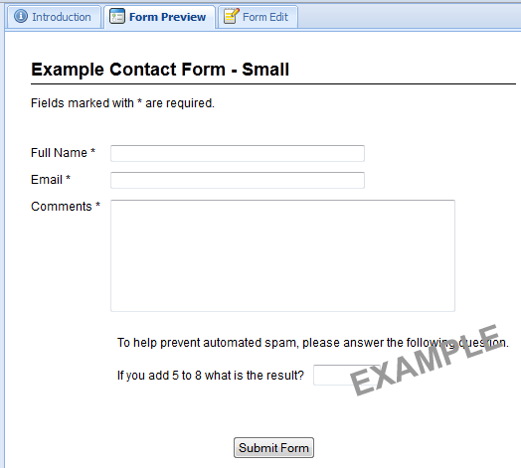
Once you have your form configured and the fields in place, it's time to download the form code.

Download your form
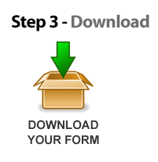
Click the download image in the "Introduction" tab of the Form Builder.
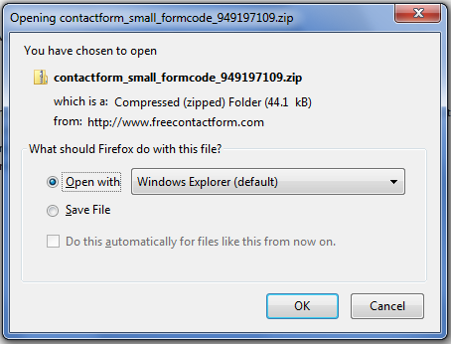
You should get a pop-up window similar to that above. You can either open it, or save it (probably best save it).
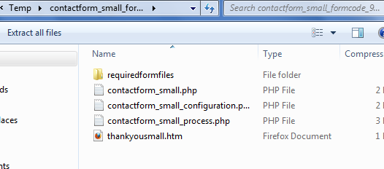
When you open the downloaded ZIP file, you will see a list of files as above (your file names may be different - it will depend on what you have called your form).
In this example, the main form file is contactform_small.php. You will see a _configuration.php and _process.php file also.

Extract your form files

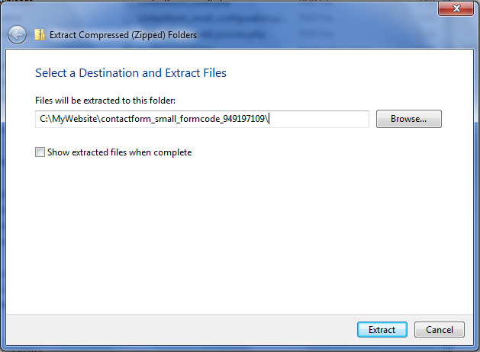

Extract all your files into a folder on your computer.

Putting your form onto your website
At this point you will want to include the form into your existing website. This is very easy.
Upload all the form files to your website... (FileZilla is a great free FTP client!)
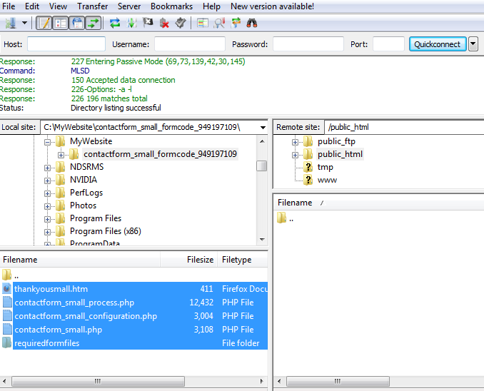
Take note of your main form filename (in this example the form filename is contactform_small.php).

If you already have a page made and want to place your new form in it, you can paste in the following code.
<iframe src="contactform_small.php" width="480" height="1500" frameBorder="0"></iframe>
Replace the part "contactform_small.php" with the name of your own form.
That's you done - it's time to try out your new form!

Some tips...
Want to run more than one form on your website? No problem. Follow these steps again for each form, but DO NOT upload the folder "requiredformfiles" again as this is a shared folder (all the files in this folder will be shared by all your forms).
Have fun!

The latest installation instructions can be found at:
www.freecontactform.com/installation.php

