Group 33 – Lego Sorter

Group Members:

Nike Adeyemi

David Carey

Katrina Little

Nick Steinmann

Throughout the history of Lego, the pieces have evolved beyond simple bricks. Now there are gears, rods, pegs, and a number of other pieces, which makes sorting and cleaning more of a chore than it used to be. The goal of the Lego sorter is to greatly reduce the amount of work for the user. The project can essentially be boiled down into two major goals.

The number one goal of this project is accuracy. While speed is another factor that will be taken into account, the idea of the project is to allow the user to simply dump their legos into the sorter and then be able to walk away while it performs. This makes speed much less important than the accuracy of the system. The user should be able to rely on the sorter to do it's job correctly so that they won't have to do any initial work.

The other major goal of the sorter is to be able to give the user an expansive amount of options for sorting, while maintaining an easy-to-use user interface. The interface should require nothing more than a small touch screen that simply allows the user to pick what pieces they would like in which buckets. One bucket would be permanently reserved for miscellaneous pieces.

Ultimately the lego sorter will be built as a convenience for potential users that is accurate, efficient, and easy to use.

**Specifications**

**Component List:**

**Hardware / Software:**

* Small Touch Screen Display: 10” Display for User Interface. The user interface will have 3 options for method of LEGO sorting:
  + Option 1: Sort by color
  + Option 2:Sort by shape. I.e. “Plates”, “Bricks,” “End Caps,” “Clips,” “Cylinders,” etc…
  + Option 3:Sort by Size: I.e. 4x4 notch, 4x2 notch, 8x2 notch, 1x1 notch, etc.
* 2 Microcontrollers:
  + Microcontroller A: Runs the motors
  + Microcontroller B: Image Processing, User Interface, Select LEGO Catalogue of parts, power supply
* Webcams: Three webcams will be utilized to photograph different orientations ( top view & two side views) of LEGO parts for correct catalogue verification. Bi – cone rollers are another possible solution to the orientation problem.

**Electrical / Electromechanical:**

* Two Conveyor Belts: The design requires two cascaded conveyor belts. The combined length of the two belts will be 3 ft. in length. We could do a shorter length, but 3 ft. will accommodate bulk LEGO’s. The belt widths will be at least 5.”
  + Belt A: The required length for this belt will be 2 ft. This is the first belt that the LEGOS will feed onto. Belt A will move 3x faster than Belt B.
  + Belt B: This is the belt that will feed into the image scanner. This belt will need to move slower to feed only 1 LEGO into the scanner at a time.
* Pulley System Between Belts A & B: The pulley system will need to drop 1 LEGO at a time onto Belt B
* Lift arm System: This is where the conveyor belt process will begin. There will be a platform where you can place a handful of LEGO parts. This platform will have a slight 20° slant measured from the horizontal belt surface. The lift arm platform will be nearly the same length of Belt A. We will make the lift arm platform 1.75 ft. (out of the 2ft. length of belt A) to allow bulk LEGO sorting. The Lift arm will start 6” below the actual belt to allow easy retention of LEGO parts without accidentally dropping too many directly onto the belt. The lift will rise to the edge of the belt and a small “trap door” will push LEGOS upward. The LEGOS will spill onto the belt due to the pitch of the platform.
* Power Supply: The power supply will need to be robust enough to run the conveyor belts.
* Stepper Motor: A stepper motor will be needed to rotate the arm that drops the sorted LEGO’s into the appropriate bins 360.°
* Actuators: Actuators will be needed to drive the Servo motors that run the two belts
* Servo Motors: the belt motors will need to operate at a constant DC voltage of 12V.
* Lego ARM Chute: The Stepper Motor will drive a chute for the legos. We plan on using a 3D printer to customize the chute. It will have a 4” opening to accommodate larger LEGO parts in the sorting process. The arm will measure 1.5 ft in length and will feed into several fixed bins below the conveyor belt.
* High Speed Op- Amp to enable Infrared Proximity Sensor: This will be used in conjunction with the LEGO chute. Modulate / Demodulate a 10kHz reflected signal to determine distance of objects from the chute.
* Image Processing: TBD

**Project Block Diagrams:**

**Software Block Diagram:**

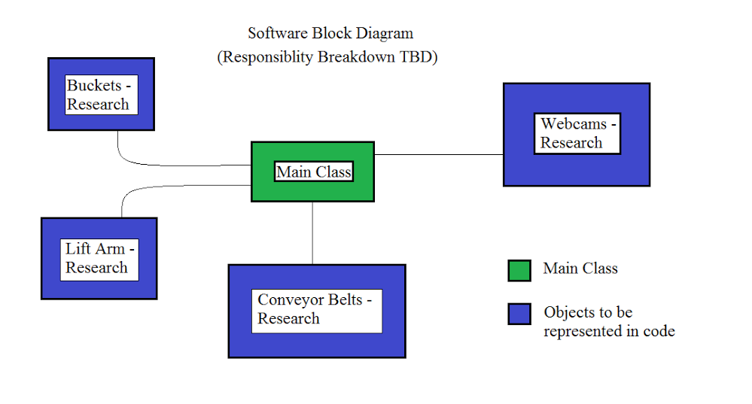

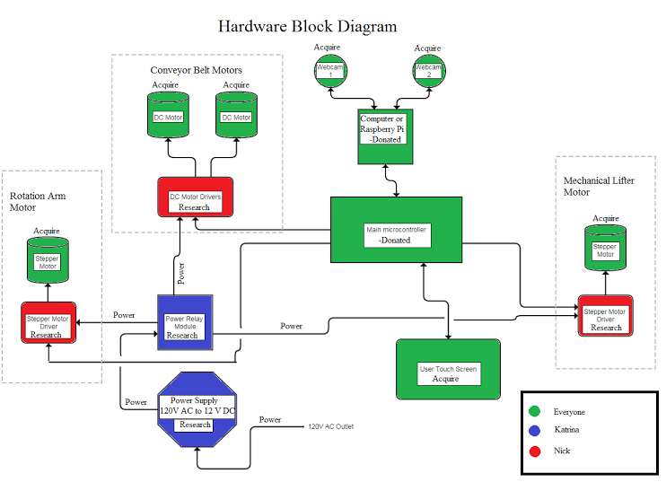

**Predicted Budget / Financing:**

For what we discussed about our project we found that a few of us has some of the material we need like microcontrollers and parts from a few Lego Mind Storm sets we can use. Also we have not gone into detail of what kind of specs we need for each part and is just a high level view of what is needed. Based off this here is the range of our predict budget of for this project. These are just estimated prices based on average prices we saw online.

|  |  |  |  |  |
| --- | --- | --- | --- | --- |
| **Material/Parts** | **Min** | **Misc. Description** | **Max** | **Misc. Description** |
| 3x Web cam (1280 x 720) | $45.00 |  | $75.00 |  |
| Color sensor | $8.00 |  | $55.00 | (Lego Mindstorm) |
| Touch screen monitor | $50.00 | (eBay) | $150.00 |  |
| Precision weight | $10.50 |  | $125.00 |  |
| Lego Mindstorm Smart Brick | $90.00 | (eBay) | $160.00 |  |
| DC motor | $5.00 |  | $96.00 | ~12V ~3000rpm |
| Stepper motors | $3.00 | 3V 13800rpm | $45.00 |  |
| 120 V Power supply | $99.00 |  | $200.00 |  |
| 2x Microcontrollers | $0.00 | Already Provided | $50.00 |  |
| Actuators | $25.00 |  | $90.00 |  |
| Proximity Sensor | $54.95 | (Lego Mindstorm) | $60.00 |  |
| TBD |  |  |  |  |
| TBD |  |  |  |  |
| TBD |  |  |  |  |
| TBD |  |  |  |  |
| TBD |  |  |  |  |
| TBD |  |  |  |  |
| **Total** | **$390.45** |  | **$1,106.00** |  |

(Note: I’m not solid on the Max pricing as we have no discussed a spending limit on what device or I just missed that part of the conversation.)

|  |  |  |
| --- | --- | --- |
|  | Senior Design I&II Timeline | |
|  |  |  |