Link: https://catalogue.data.gov.bc.ca/dataset/b-c-housing-affordability/resource/12942bae-e4f2-44e9-9202-0270e6221bf5

BC Housing Market Visualization Report

ADENIKE OLOYEDE  
 300373205

# Introduction

For my data visualization project, Tableau was selected as the primary tool due to its intuitive drag-and-drop interface, interactive dashboard capabilities, and strong integration with time-series data. Tableau allows for dynamic filtering and visual storytelling, making it an ideal platform to explore complex datasets and extract meaningful insights.

The dataset used in this project is a historical record of British Columbia’s housing data, including quarterly metrics on median housing prices, family after-tax income, interest rates, resale activity, and affordability indicators from 1980 onwards. This dataset was chosen because housing affordability remains a pressing issue in BC, and the dataset provides a rich basis for analyzing trends, seasonal patterns, and long-term changes in the real estate market.

# Story

This dashboard was developed to explore the following key question of how have housing prices changed over time in BC:

Price Trends (1980–2025)

Imagine buying a house in 1980 for $56,000. Fast forward to 2025, and that same home costs$1.14 million. This line chart tracks the relentless climb of housing prices across different property types: single-detached homes, apartments, and row houses.

1980s–1990s: Prices grew steadily, with occasional dips during recessions.

2000s–2010s: The market accelerated, fueled by low interest rates and population growth.

2020s: The pandemic triggered a record-breaking surge, with prices jumping 30% in just 5 years.

Key Insight:

Single-detached homes has become luxury items**.** While apartments remained more affordable, even they saw prices triple since 2000. This trend suggests that traditional homeownership is slipping out of reach for average-income families.

## Why It Matters

First-time buyers now need twice as much income to afford a home compared to previous generations.

If this trend continues, only the wealthiest will own detached homes, pushing more people into high-density housing.

The theme of the dashboard focuses on housing affordability and market activity. Users can interact with filters such as housing type, year range, and quarter to dynamically explore changes across time and categories.

# Median Housing Price Over Time

This line chart highlights the upward trajectory of housing prices in BC since 1980. Significant spikes reflect market booms, while flatter periods align with economic downturns or policy changes. The consistent rise underlines growing affordability challenges for residents.

# Average Payment to Income Percentage by Housing Type

This bar chart compares affordability across housing types. Apartments and row housing require a smaller portion of income compared to single-detached homes, highlighting more accessible entry points for lower- and middle-income families.

# Number of Resales by Year and Quarter

The visualization reveals clear seasonal patterns in housing resales, with Q2 and Q3 typically being the most active. This cyclical behavior offers valuable insights for both real estate professionals and policymakers in planning market interventions.

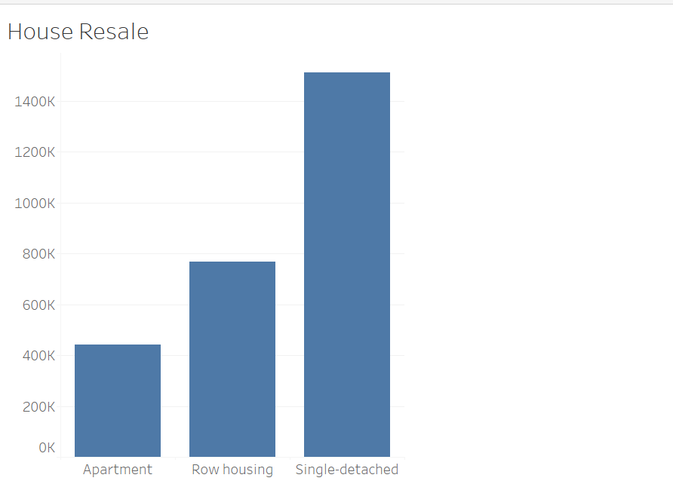

# Solutions and Strategies

Based on the visual insights, the following strategies are proposed:

* Increase investment in affordable housing types such as apartments and row housing.
* Provide financial support or incentives for first-time homebuyers to ease entry barriers.
* Time government or real estate campaigns to align with Q2 and Q3 when resale activity is highest.
* Monitor interest rate changes closely, as they significantly affect affordability and demand.

# Conclusion

This analysis reveals that BC's housing crisis results from decades of systemic failures across multiple policy areas. While the situation is severe, data-driven solutions exist. Overall, this dashboard serves as a data-driven decision support tool that can inform policy, guide public investment, and help residents understand the historical and current dynamics of BC’s housing market.