

Data Technician

Name: Alaa Mostafa
Course Date: 16/12/24
Table of contents
Day 1: Task 1 2
Day 2: Task 1 7
Day 2: Task 2 10
Day 2: Task 3 11
Day 3: Task 1 14
Day 3: Task 2 17
Dataset: 17
Step 1: Create a Pivot Table 17
Step 2: Use the SWITCH Function 17
Submission: 18
Day 3: Task 3 19
Day 4: Task 1 21
Course Notes 26
Additional Information 27

Day 1: Task 1

Please complete the below boxes on commons laws and regulations that must be followed when working with customers data, use the below bulleted list to support your answers.

- What is it
- Why is it important
- Provide a real-world example of how you can follow it
- How does it impact working with data
- What could happen if you breached it

Data Protection Act | Data Protection Act 2018 (DPA 2018) is a UK law that states how organisations must handle personal data, to protect privacy in the digital age, granting individuals access and erasure rights, and holding businesses accountable for fair, secure data processing  with penalties for non-compliance.  It is important to protect the public from abuse of data, by empowering individuals over the use of their data.  Following the Data Protection Act (DPA) 2018 means collecting only necessary data for clear purposes, keeping it accurate and secure, being transparent with individuals about its use, and respecting their rights to access, correct, or erase their information, like a business only asking for name/address for a catalogue, not birthdays, and securely deleting records when no longer needed.  DPA demands transparency, accountability, and robust security measures and strict data handling, introducing significant fines for breaches, and creating new rules for research and law enforcement, to comply with the UK GDPR  If DPA is breached, organisations can be fined. It can lead to loss of confidence and compromise business for organisations.
GDPR | GDPR is a strict EU data protection law giving greater control over personal data, requiring organizations to handle data transparently, securely, and only for necessary purposes.  GDPR increases transparency, strengthens privacy rights, and fosters trust, while also introducing a new "digital etiquette" for data handling. It is important for protecting privacy, boosting consumer trust, and avoiding hefty fines for non-compliance.  Example - An online retailer using clear, unchecked boxes for marketing consent during sign-up, providing easy withdrawal in account settings, ensuring transparency, and deleting data after a defined period, like HelloFresh does for non-essential communications.  Collect only the data necessary for the specified purpose and keep it only as long as needed. Organisations are accountable for the security of the data and therefore need to know where data is, what it is, and who accesses it.  If breeched, like the DPA fines of up to 4% global turnover or €20m could be incurred by the organisation. up to 4% global turnover or €20m. causing significant financial loss, reputational damage, and loss of customer trust, while individuals face risks like identity theft, fraud, discrimination, financial loss, and emotional distress. Organizations must report breaches to authorities (like the ICO) and affected individuals, facing penalties for failures, emphasizing robust security and proper breach response.
Freedom of Information Act | The Freedom of Information Act 2000 (FOI Act) grants public right to request recorded information (emails, documents, recordings) from UK public authorities(like government, police, NHS, and schools) in England, Wales, and Northern Ireland, promoting transparency. Within 20 working days, written response to requests should be provided, though some sensitive information can be withheld.  Example- requesting a local council's spending on children’s recreational services, leading to the discovery of misused funds, as exemplified.  How does it impact working with data?  Organisations must maintain good records management to ensure information can be identified, retrieved, and, if necessary, redacted within the 20-working day limit.  Public authorities are required to publish certain information proactively, reducing the need for specific requests. The intellectual property rights of the original researcher are maintained.  Information that identifies a living person (personal data under GDPR/DPA 2018) cannot be released under an FOI request, but by Subject Access Requests (SARs) instead.  Organisations must weigh the public interest in disclosure against the public interest in keeping it confidential, eg. data that would hinder crime investigation. request for data given in confidence can be refused if its release would be an actionable breach of that confidence.  Requests can be refused if the cost of compliance exceeds £450 (or £600 for central government), which is based on 18 (or 24) hours of staff time for locating and extracting the data.  What could happen if you breached FOI  The Information Commissioner’s Office (ICO) enforces FOIA in the UK and uses various tools to ensure compliance.  It is a criminal offence under Section 77 of FOIA to deliberately alter, deface, block, erase, destroy, or conceal records held by a public authority with the intention of preventing disclosure to an applicant.  If the FOI request involved personal data, a breach could trigger GDPR/Data Protection Act 2018 violations, leading to fines of up to £17.5 million or 4% of total worldwide annual turnover.  Individuals found guilty can face a fine (currently up to £5000, or Level 5 on the standard scale).  ICO can enforce compliance, by imposing legally binding notices directing the authority to release information or take specific steps to comply.  Failure to comply with an enforcement notice, decision notice, or information notice issued by the ICO can be certified to the High Court. The court can treat the authority as if it had committed contempt of court, which can lead to significant fines or, imprisonment for the responsible officer.
Computer Misuse Act | The Computer Misuse Act 1990 (CMA) is UK legislation designed to protect computer systems, networks, and data from unauthorized access, modification, or destruction.  The Act was introduced to combat growing cybercrime and ensures that unauthorized access to computer systems is treated as a criminal act, even if no damage is intended.  Avoiding unauthorized access under Section 1 of the Act, by using a strong, unique password for a personal laptop and not accessing a friend's device/accounts without their explicit permission.  It mandates strict security, where accessing, stealing, or altering data without permission can lead to imprisonment, fines, and severe legal consequences, directly affecting how individuals and organizations handle, store, and secure information.  Organizations must ensure data is obtained and handled securely, as the Act works in conjunction with regulations like GDPR to protect personal data.  It is illegal to access data on a computer without permission, such as logging into someone else's account to read messages or stealing personal information.  Making changes to data, such as installing malware, viruses, or deleting files, is a criminal offense  The Act can restrict ethical hackers from testing systems, as even well-intentioned, unauthorized access may technically break the law.  Accessing data to facilitate crimes like fraud or blackmail is strictly prohibited.  What could happen if you breached ?  Law enforcement (e.g., National Crime Agency) may conduct an early morning visit, arrest the individual, and seize all digital devices (computers, phones, storage) for forensics.  Gaining access to a system without permission (e.g., logging into someone else's email or account), even if nothing is stolen or damaged, carries up to 2 years in prison and/or an unlimited fine.  Accessing a system to facilitate, for example, fraud or stealing personal data, carries up to 5 years in prison.  Modifying, deleting, or impairing systems (e.g., ransomware, virus attacks, DDoS attacks) carries up to 10 years in prison.  If the attack causes, or risks, serious damage to national security, critical infrastructure, or human welfare (e.g., taking down a hospital network or power grid), the maximum penalty is life imprisonment.  Creating, supplying, or obtaining software or tools for the purpose of committing these offences can lead to up to 2 years in prison.  Convictions under the CMA result in a criminal record, which can affect future employment, particularly in IT or finance.  Under the Proceeds of Crime Act 2002, courts can order the seizure of assets gained through cybercrime, such as money, cars, or property.  Cease and Desist Notices may be issued, If an individual is suspected of being on the verge of offending, warning them to stop, which can be used as evidence in future prosecutions.  Employees who misuse their access to company systems, even without malicious intent, can be immediately dismissed for gross misconduct.  The conviction may be publicly reported, which can have long-lasting effects on personal and professional reputation.  A criminal conviction or even an arrest can lead to issues with visa-free travel to countries like the USA.  Apart from criminal fines, individuals might face civil lawsuits for damages caused to businesses.  In addition to the CMA, breaches involving personal data often lead to prosecution under the Data Protection Act 2018 or GDPR, which can result in further fines and penalties.

Day 2: Task 1

Please research and complete the following tasks within the retail-sales_dataset.xlsx document, paste a print screen into the provided boxes below:

- In the sheet ‘retail_sales_dataset’ add all available data between columns A –J into a ‘table’
- Using the ‘sort’ function, sort ‘Age’ to ‘largest to smallest’
- Using the ‘SUM’ function, show me the commission total in cell ‘L10’
- Using the ‘AVERAGE’ function, show me the average commission in cell ‘L11’

Print screen 1 | 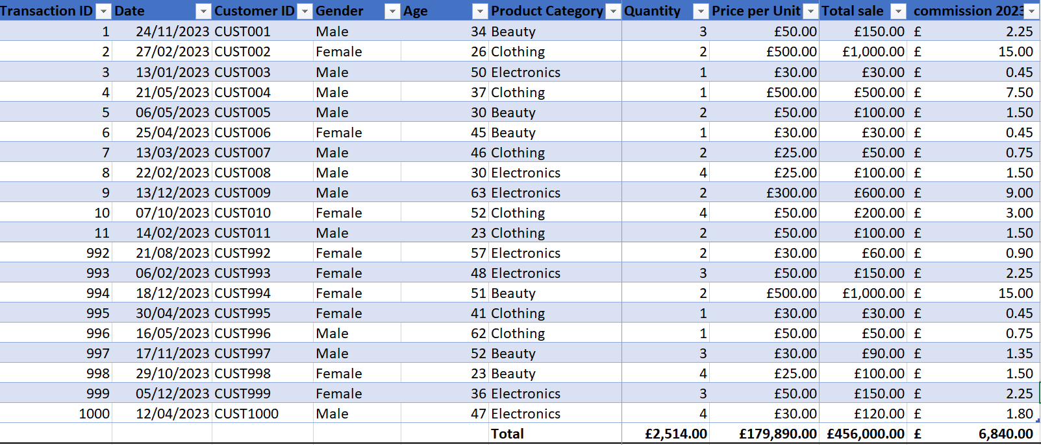
Print screen 2 | 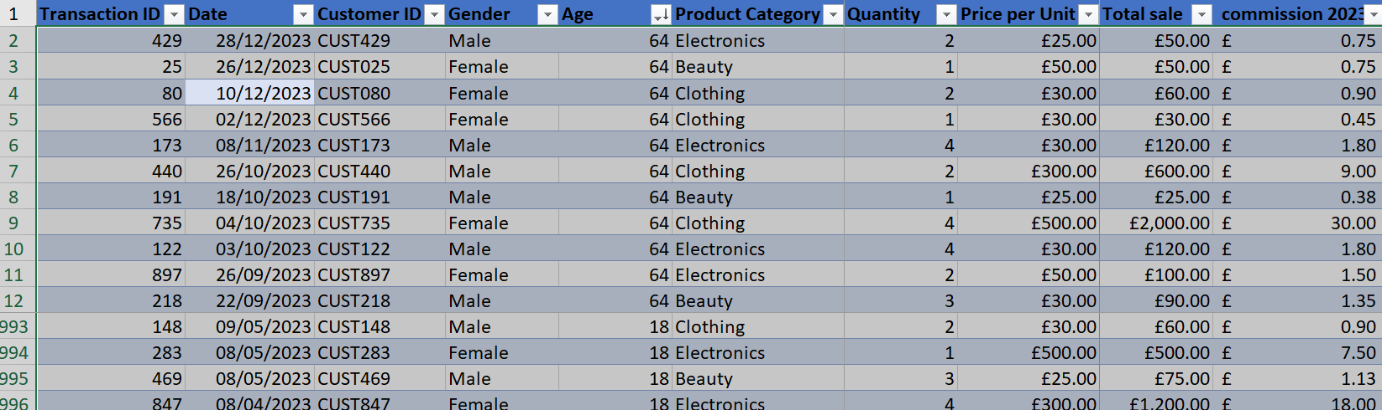
Print screen 3 | 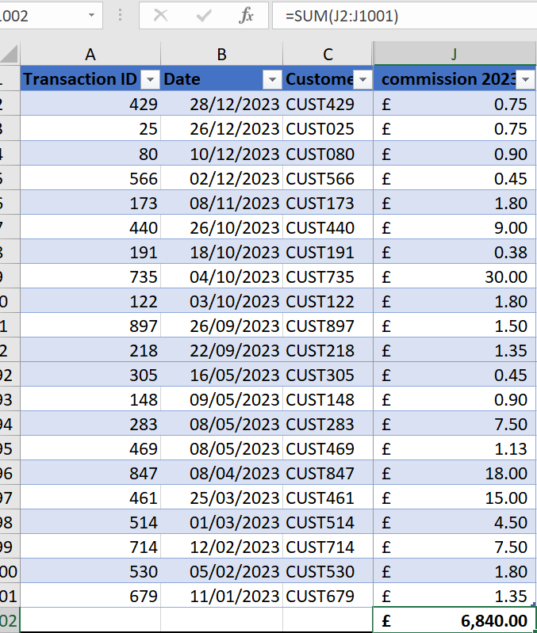
Print screen 4 | 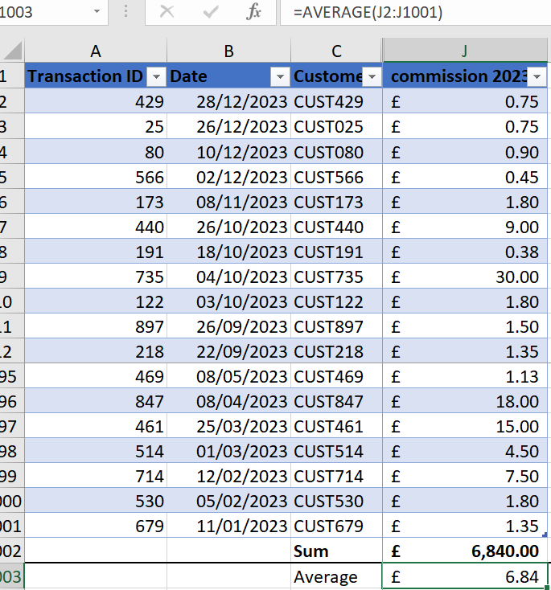

Day 2: Task 2

Please research and complete the following tasks within the retail-sales_dataset.xlsx document, paste print screens into the provided box below:



Print screen 1

Day 2: Task 3

Using the skills developed today, have some fun with the data set you have imported. Paste your work below and enjoy!

Print screen 1 | 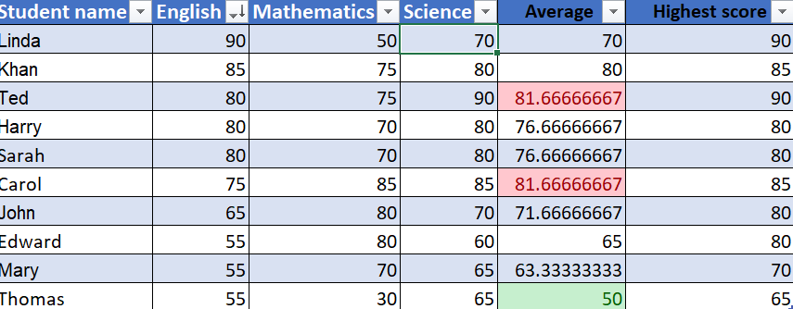  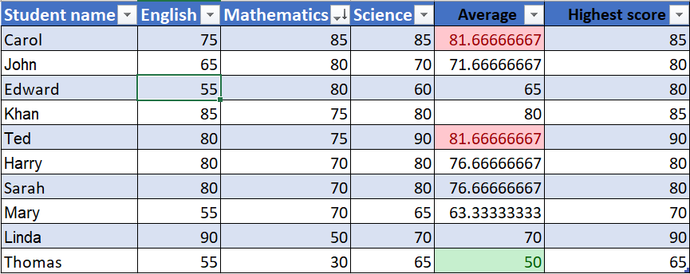  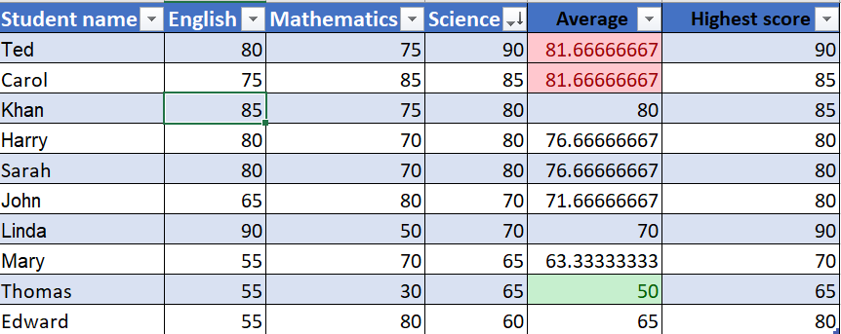  4.Best student by average- Ted and Carol  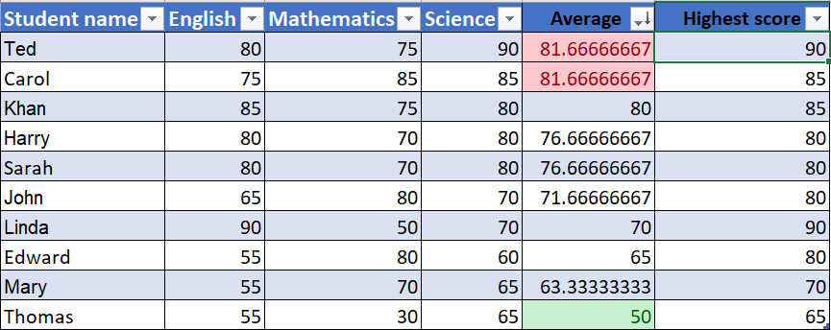  - Best student by highest score- Ted and Linda  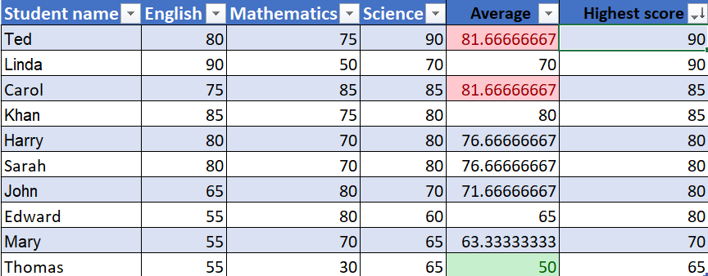  - The highest average score is 82, lowest is 50  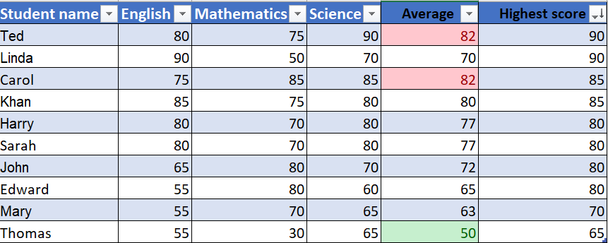

Day 3: Task 1

Please download the dataset ‘Day_3_Task_1_Bike_Sales_Pivot_Lab.xlsx’ and the lab instructions.

Do not worry if you do not complete the lab, just working with data and playing with the pivot table will be good experience.

Please paste your final pivot table below and complete the reflection questions:

Print screen 1
In which markets does Germany have customers? | 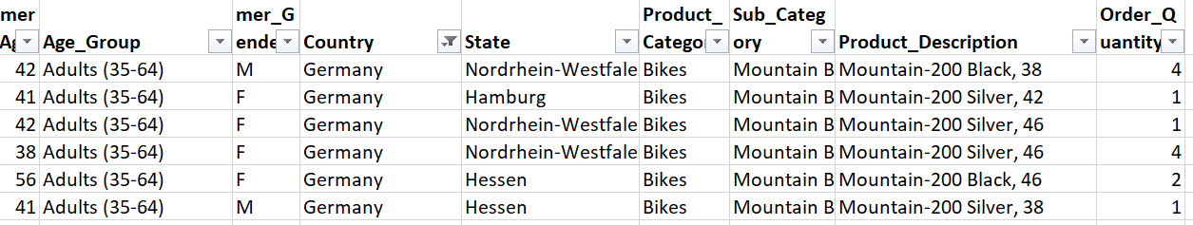
What country has sales in all markets? | United states  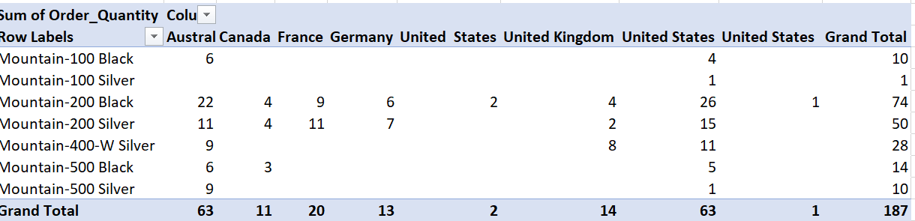
What are the most profitable markets by country, age group, and gender? | Max of Profit Column Labels Column1 Column2  Row Labels F M Grand Total  Mountain-100 Black  Adults (35-64)  United States $5,908 $5,908  Young Adults (25-34)  Australia $5,908 $5,908  Mountain-100 Silver  Young Adults (25-34)  United States $1,488 $1,488  Mountain-200 Black  Adults (35-64)  Australia $4,172 $4,172 $4,172  Germany $2,086 $4,172 $4,172  United Kingdom $1,043 $1,043 $1,043  United States $4,172 $4,172 $4,172  Young Adults (25-34)  Australia $2,086 $2,086 $2,086  Canada $1,043 $1,043 $1,043  France $4,172 $4,172  United Kingdom $1,043 $1,043  United States $2,086 $4,172 $4,172  Youth (<25)  France $3,129 $3,129  United Kingdom $1,043 $1,043  Mountain-200 Silver  Adults (35-64)  Australia $4,216.00 $1,054.00 $4,216.00  Germany $4,216.00 $1,054.00 $4,216.00  United Kingdom $1,054.00 $1,054.00  United States $2,108.00 $2,108.00 $2,108.00  Young Adults (25-34)  Australia $3,162.00 $3,162.00  Canada $4,216.00 $4,216.00  France $1,054.00 $3,162.00 $3,162.00  United States $3,162.00 $3,162.00  Youth (<25)  France $3,162.00 $4,216.00 $4,216.00  Mountain-400-W Silver  Adults (35-64)  Australia $698 $698  United States $1,396 $1,396  Young Adults (25-34)  Australia $1,396 $349 $1,396  United Kingdom $1,047 $1,047  United States $1,396 $1,396  Youth (<25)  United Kingdom $1,047 $1,047  Mountain-500 Black  Adults (35-64)  United States $2,086 $2,086  Young Adults (25-34)  Canada $735 $735  United States $245 $245  Youth (<25)  Australia $980 $490 $980  Mountain-500 Silver  Adults (35-64)  Australia $1,028 $1,028  United States $257 $257  Youth (<25)  Australia $1,028 $1,028  Grand Total $5,908 $4,216 $5,908
Any other findings? | The Us had the highest profit from the sale of bikes.  There were no sales for men in the following bikes;  Mountain-100 Black  Mountain-100 Silver  Mountain-500 Silver  Mountain-200 Black and Mountain-200 Silver were the most popular bikes for men and women that sold in 7 countries. There were more female bike sales as a whole and within this groups, within the age range of 25-34 and 35 to 64. UK and Canada seemed to have the lowest amounts of profit for bike sales. The under 25 sales were the lowest, showing were marketing can be better targeted.  Mountain-500 Black was less popular among females 34 years and under. Most profit was made from sales of bikes for ages 35-64years.

Day 3: Task 2

The dataset below tracks the sales performance of different products in various counties in England. Please paste the dataset into a blank Excel workbook. Your task is to:
- Create a Pivot Table to summarise the data by county and product.
- Use the SWITCH function to categorise products based on their sales volume.

Dataset:
County | Product | Sales Volume
Yorkshire | Laptops | 500
Yorkshire | Smartphones | 200
Cornwall | Laptops | 700
Cornwall | Printers | 400
Lancashire | Smartphones | 150
Lancashire | Laptops | 600
Essex | Printers | 800
Essex | Smartphones | 300
Durham | Laptops | 250
Durham | Printers | 300
Greater Manchester | Smartphones | 600
Greater Manchester | Laptops | 400

Step 1: Create a Pivot Table
- Select the dataset (columns A to C).
- Insert a Pivot Table to summarise the data by County in the rows and Products in the columns. Use Sales Volume as the value to be summarised.

Step 2: Use the SWITCH Function
In a new column next to your data, use the SWITCH function to categorise products based on Sales Volume as follows:
  - For sales greater than 600: "High"
  - For sales between 300 and 600: "Medium"
  - For sales less than 300: "Low"
SWITCH Function Example:
=SWITCH(TRUE, C2 > 600, "High", C2 >= 300, "Medium", "Low")
- Apply this formula to each row, and check if the products are categorised correctly.

Submission:
- A completed Pivot Table summarising sales by county and product.
- A new column in the dataset categorising products by sales volume using the SWITCH function.
  - Please paste your completed work below

Print screen 1 | Sum of Sales Volume Column Labels  Row Labels Laptops Printers Smartphones Grand Total  Cornwall 700 400 1100  Durham 250 300 550  Essex 800 300 1100  Greater Manchester 400 600 1000  Lancashire 600 150 750  Yorkshire 500 200 700  Grand Total 2450 1500 1250 5200  Sum of Sales Volume Column Labels Sales  Row Labels Laptops Printers Smartphones Grand Total Category  Cornwall 700 400 1100 High  Durham 250 300 550 High  Essex 800 300 1100 Medium  Greater Manchester 400 600 1000 High  Lancashire 600 150 750 High  Yorkshire 500 200 700 High  Grand Total 2450 1500 1250 5200

Day 3: Task 3

Please download the dataset ‘Day_3_Task_3_Bike_Sales_Visualisations_Lab.xlsx’ and the the lab instructions. Do not worry if you do not complete the lab, just working with data and playing with the charts will be good experience.

Please paste your results below:

Print screen 1

Day 4: Task 1

You have been asked to deliver your analysis findings to the board of directors, with your analysis you have identified that customers are leaving your company at the 12-month point, this is typically when they receive their renewal price.

Conduct research and complete the below questions:

How would you prepare for the delivery? | Decide what information will be critical for stake holders with the overall aim of improving sales and profits.  Risks  Revenue and profit compared over past 5 years  Sales revenue by product type over the 5year period  Revenue by age category  Efficiency -Cost/ profit ratio  The column chart showing revenue by country highlights country’s revenues from product sales and hence what products sold best or worst and in what countries.  Considering Canada’s weather, it may be worthwhile researching why sales are so low. It could be that they have hire bikes available to the public, which prove better value for customers. It may be not worthwhile bothering with selling bikes and accessories and probably promote sales of clothing.
What tools would you use for the delivery? | I will use the above three charts to show the critical aspects of my analysis. The line chart shows trend line for both profit and revenue.  The bar chart allows focus on which age group needs to be catered for and which ones can be concentrated on to promote profits.  Cost/Revenue ratio reflects how effectively a company manages its direct costs (labour, materials, overhead) to generate sales. A lower ratio signifies better profitability, greater operational efficiency, and higher margins, whereas a higher ratio signals potential financial inefficiency or high production costs.  how much a company spends to generate each dollar of revenue, calculated as (Total Costs /Revenue)×100  .
What is prospecting and why would you complete this before your delivery? | Prospecting is the, initial, proactive stage of the sales process involving the identification, research, and engagement of potential customers (prospects) who fit an Ideal Customer Profile (ICP).  Prospecting allows you to understand a potential client's specific pain points and needs, enabling tailoring pitch to show how product solves unique problems.  It avoids wasting time, money, and resources on prospects who are unlikely to buy.
Tell me best practices for public speaking and providing updates to senior leaders | Structure presentation - 1) Recommendation/Ask, 2) Impact/Value, 3) Risks/Mitigation, 4) Supporting Data.  If you have 30 minutes, plan to present for only 10. The rest of the time should be for discussion and questions.  Use slides to support narrative, not to act as a teleprompter. If there are 50-slides, create only 5 summary slides, and leave the rest in the appendix.  Presenting to senior leaders requires concise, decision-driven communication approach, focused on strategic impact, profit, and risk mitigation.  Be proactive and transparent about risks or bad news.  Replace spreadsheets with simple, high-level charts and infographics that highlight key insights.
What will you show the board in your delivery? | All the charts as seen in screen 1  Line graph showing revenue and profits over 5 years from 2017 to 2021.  The line graph shows Revenue and profit increasing with the years, but the gap between revenue and profit widens between the years 2019 and 2021. Therefore a further analysis of costs in the period may be necessary to establish how best to improve profits.  Stacked column chart showing Product Revenue by Country, with revenues from clothes, Bikes and accessories.  Bikes generated the highest revenue, with the US and Australia dominating sales, followed by accessories and the least was clothing. Revenue from Canada is the lowest, while US and Canada generate the highest overall sales revenues. France, UK and Germany had the least revenues from accessories, showing that work needs to be done to boost sales through advertising for example. However the highest revenues from accessories in comparison to Bikes and clothes was from Canada.  Pie chart showing sales revenue by age category.  Adults within age range of 35 to 64 generated over 50% of revenues mostly from the sale of bikes. Youth attracted 14% of the sales, which was the lowest compared to Young adults attracting 36% and no sales from Older people. A product diversification and promotion campaign for Youth may be needed to boost profit.  Column chart showing cost profit ratio.  Greater operational efficiency, and higher margins were achieved in 2019, following which cost seem to have crept up by 3% in 2020 an 2021. It is not clear if that is attributable to wages, materials or other operational costs such as marketing.
How will you articulate the changes that are needed? | Specifically outline the new, desired state, identifying what behaviours must change, what processes are shifting, and what remains the same  By explaining the business value (e.g. revenue increase, cost reduction) rather than just the process.  By signing a multi-year contract immediately, you lock customers in at the old price
Provide a list of online resources and videos that will support your preparation for public speaking | https://www.reddit.com/r/PublicSpeaking/  Public Speaking Training - Presentation Skills Courses  TED Talks  Speech Blubs app  LinkedIn Learning courses  Poised
Evaluate tools that provide visualisation.  Tell me what they are.  Tell me what you would choose when delivering your presentation and why | Column, pie, and line charts are fundamental data visualization types, supported by a wide range of tools ranging from simple spreadsheet applications to advanced Business Intelligence (BI) platforms. The best tool depends on the required complexity, interactivity, and data volume.  Column Charts: Ideal for comparing categories, showing changes over time, and handling data with a natural order.  Pie Charts: Best for showing parts-to-a-whole relationships, typically with fewer than three or four categories.  Line Charts: Used for displaying trends over continuous, long periods of time.  I will chose the column charts because it allows me to compare efficiency, revenue sales for bikes, clothes and accessories over the five year period. I will also use the pie charts to visualise the highest source of revenue sales between age groups in order to highlight where to focus marketing and advertising.

Course Notes

It is recommended to take notes from the course, use the space below to do so, or use the revision guide shared with the class:

Additional Information

We have included a range of additional links to further resources and information that you may find useful, these can be found within your revision guide.

END OF WORKBOOK

Please check through your work thoroughly before submitting and update the table of contents if required.

Please send your completed work booklet to your trainer.

