Lab 3

void numbers(const int x, const int y){

double kg = (x *2.205);// +0.5; // kg to pounds

kg = (int)(kg);

double st = (x*0.15747);// +0.5; // kg to stones

st = (int)(st);

double r = (kg / 14) +0.5; //pounds in stones

r =(int) (kg-st*14);

if (x <= y){

cout << x << "kg is " << kg << " lbs "<< " or " << st << " st " << r << " lbs " << endl;

numbers(x + 5, y);

}

}

Void main() {

Numbers(20,100);

}

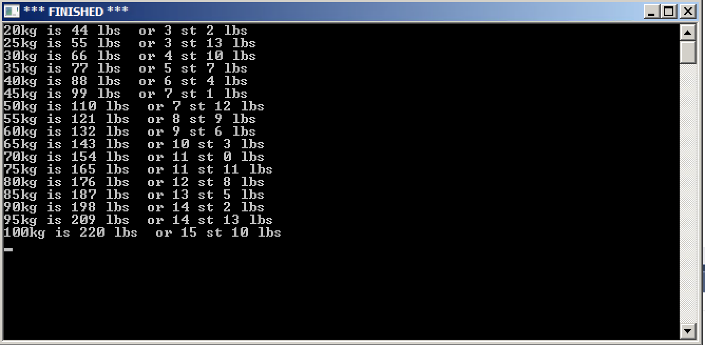

void triangle(int x, int y){

if ((x >= 1) && (y <= 11)){

dots(x); stars(y); dots(x); new_line();

triangle(x - 1, y + 2);

}

}

Void main(){

triangle(6,1);

}

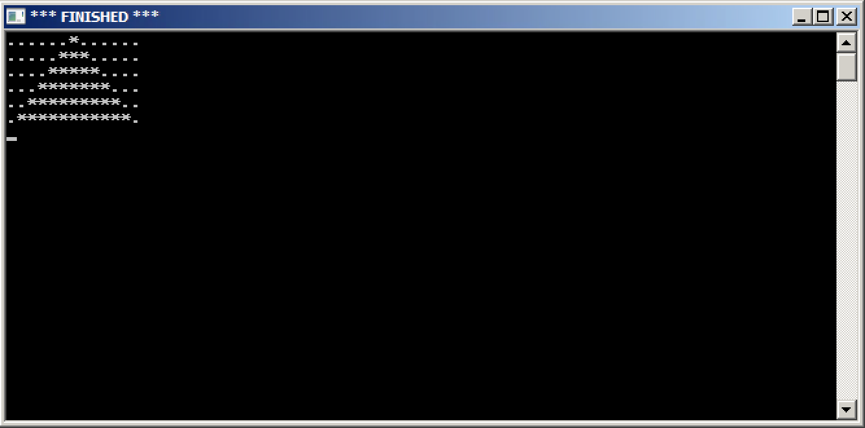

void drawside(double angle, int length) {

turn_right_by_degrees(angle);

draw_distance(length);

}

void circle(int n, int numsides, int len) {

double pi = acos(-1.0);

if (n > 0) {

drawside(360.0 / numsides, len);

circle(n - 1, numsides, len);

}

}

Void main(){

circle(72,72,10);

}

