#include <string>

#include <iostream>

#include <vector>

#include <fstream>

#include <sstream>

#include<cstdlib>

#include<iomanip>

using namespace std;

struct person //creates object for person

{

int SSN;

int bday;

string fn;

string ln;

int zip;

person(int ssn, int bd, string f_name, string l_name, int zc) //constructor

{

SSN = ssn;

bday = bd;

fn = f_name;

ln = l_name;

zip = zc;

}

void print()

{

cout << SSN <<" "<< bday<<" "<< fn<<" "<< ln<< " "<< zip<<endl;

}

void print_old()

{

cout << "The oldest person is " << fn << " " << ln << " " << zip << endl;

}

};

struct node

{

person * data;

node * left;

node * right;

node(person * d)

{

data = d;

left = NULL;

right = NULL;

}

node * find_and_delete(node * N)

{

node * current= N;

while(current && current->left != NULL)

{ current= current->left; }

return current;

}

person * old_age()

{

if(this == NULL)

return NULL;

person * l_age = left->old_age();

person * r_age = right->old_age();

person * oldest = data;

if(l_age != NULL)

{

if(l_age->bday < oldest->bday)

oldest = l_age;

}

if(r_age != NULL)

{

if(r_age->bday < oldest->bday)

oldest = r_age;

}

//oldest->print_old();

return oldest;

}

};

struct Tree

{

node * root;

Tree()

{

root = NULL;

}

void add(person * d, node *& N);

void print_tree(node * N);

void find(node * N, string f, string l);

void find_zip(node * N, int zip);

void find_oldest();

//void delete_node(node * N, string f, string l);

node* find_for_delete(node *N);

node* remove(node *the_one, string f, string l);

};

//creates tree

void Tree :: add(person * d, node *& N)

{

if(N == NULL) //tree is empty, we create new root

N = new node(d);

else if(d->ln > N->data->ln)

add(d, N->right);

else if(d->ln < N->data->ln)

add(d, N->left);

else if(d->ln == N->data->ln) //compares fn if ln are the same

{

if(d->fn > N->data->fn)

add(d, N->right);

else if(d->fn < N->data->fn)

add(d, N->left);

}

}

void Tree :: print_tree(node * N)

{

if(N == NULL)

return;

print_tree(N->left);

N->data->print();

print_tree(N->right);

}

void Tree :: find(node * N, string f, string l)

{

while(N != NULL)

{

if(N->data->ln == l)

{

if(N->data->fn < f)

return find(N->right, f, l);

else if(N->data->fn > f)

return find(N->left, f, l);

else if(N->data->fn == f)

return N->data->print();

}

else if(N->data->ln < l)

return find(N->right, f, l);

else if(N->data->ln > l)

return find(N->left, f, l);

}

cout << "Sorry, person could not be found." <<endl;

}

void Tree :: find_zip(node * N, int zip)

{

if(N == NULL)

return;

find_zip(N->left, zip);

if(N->data->zip == zip)

N->data->print();

find_zip(N->right, zip);

}

void Tree:: find_oldest()

{

person * oldest_person = root->old_age();

oldest_person->print_old();

}

node * Tree:: find_for_delete(node * N) //looking for the one on the left most side

{

node* current= N;

while(current && current->left != NULL)

{ current=current->left;

}

return current;

}

node * Tree:: remove(node *the_one, string f, string l)

{

if(the_one==NULL)

return the_one;

if(l< the_one->data->ln)

the_one->left = remove(the_one->left,f ,l);

else if(l > the_one->data->ln)

the_one->right = remove(the_one->right, f, l);

else

{

if(f == the_one->data->fn)

{ if(the_one->left == NULL && the_one->right == NULL)

return NULL;

else if(the_one->left == NULL) //one child on right

{

node* temp = the_one->right;

delete the_one;

return temp;

}

else if(the_one->right == NULL)// one child on left

{

node * temp= the_one->left;

delete the_one;

return temp;

}

node * temp= find_for_delete(the_one->right);

// replace the deleted one

the_one->data->SSN = temp->data->SSN;

the_one->data->bday = temp->data->bday;

the_one->data->fn = temp->data->fn;

the_one->data->ln = temp->data->ln;

the_one->data->zip = temp->data->zip;

the_one->right = remove(the_one->right, temp->data->fn, temp->data->ln);

}

else

{

if(f < the_one->data->fn)

the_one->left = remove(the_one->left, f, l);

else if (f > the_one->data->ln)

the_one->right = remove(the_one->right, f, l);

}

}

return the_one;

}

int read_file()

{

Tree T;

ifstream fin;

fin.open("myfile.txt");

int ssn, bd;

string fn, ln;

int zip;

if (fin.fail())

{

cout << "Couldn't open the file\n";

exit(1);

}

else

{

int i=0;

while(i<10000)

{

if(fin.fail())

{

cout<<"Could not open file."<<endl;

break;

}

fin >> ssn >> bd >> fn >> ln >> zip;

person * new_d = new person(ssn, bd, fn, ln, zip);

T.add(new_d, T.root);

i++;

}

}

fin.close();

while(true)

{

cout<<"Type command: "<<endl<<"Find - display all information on said person"<<endl<<"All - display the information of everyone in the Binary Tree"<<endl<<"Zip - displays the names of all people living in the given zip code"<<endl<<"Oldest - displays the name and zipcode of the oldest person" <<endl<<"Delete - Delete someone" <<endl<< "Exit - Exit out of this program." <<endl;

cout<<endl<<"-----------------------------------------------"<< endl;

string command;

cin>>command;

if(command=="Find")

{

cout<<"Who would you like to find? Enter first name."<<endl;

string first, last;

cin>>first;

cout<<"Enter last name."<<endl;

cin>>last;

T.find(T.root, first, last);

}

else if(command=="Exit")

break;

else if(command=="All")

{

T.print_tree(T.root);

}

else if(command=="Zip")

{

cout<<"Enter desired zip code."<<endl;

int zc;

cin>>zc;

T.find_zip(T.root, zc);

}

else if(command=="Oldest")

T.find_oldest();

else if(command=="Delete")

{ cout<<"Who would you like to delete from this database?"<<endl;

string first_name, last_name;

cout<<"Enter first name." <<endl;

cin>>first_name;

cout<<"Enter last name."<<endl;

cin>>last_name;

T.remove(T.root, first_name, last_name);

cout<<"The person "<<first_name<<" "<<last_name<<" has been deleted from your Binary Tree."<<endl;

}

else

cout << "Command not valid." << endl;

cout<<"-----------------------------------------------"<<endl;

}

return 0;

}

int main()

{

read_file();

return 0;

}

Find Function

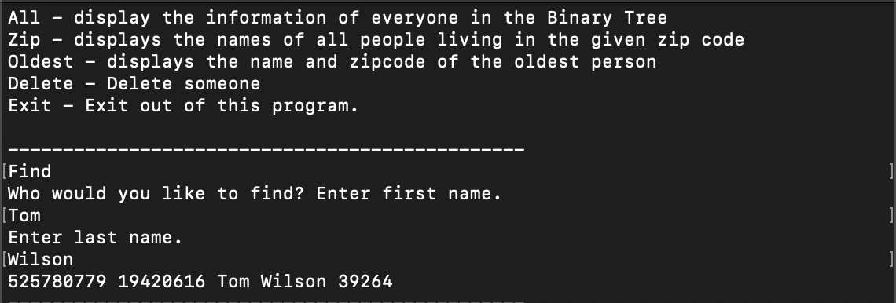

All

Zip

Oldest



Delete

Tom Wilson is no longer findable