Area of development: Electrical Equipment Store
Goal: Fully design and develop the database component (OLTP and OLAP) for an electrical equipment store application, including data processing, ETL operations, and data visualization.

1. OLTP Database Context & Design

The OLTP (Online Transaction Processing) database is designed in 3NF and stores all operational data required for the day-to-day functionality of the electrical equipment store.
The database records the full product catalog, user and staff information, and the entire transaction workflow. It ensures data consistency and integrity for the application.

Key business processes covered:
- Customer & Staff Management. Registration, profiles, and assignment of employees.
- Catalog & Inventory Management. Tracking products, categories, brands, and respective suppliers.
- Sales & Order Processing. Recording customer orders, tracking itemized details, and managing statuses.
- Payment Processing. Handling payment transactions and methods linked to orders.

The OLTP schema consists of 9 normalized tables using surrogate primary keys (serial) and natural business keys (e.g., emails, SKUs) for unique constraints:
- categories, brands, suppliers. Reference tables storing catalog metadata.
- products. The central catalog table linking to categories, brands, and suppliers via foreign keys.
- customers, employees. Store user profiles and HR data.
- orders. Tracks purchases, linked to both customers (who bought) and employees (who processed).
- order_items. Resolves the many-to-many relationship between orders and products, storing historical unit prices, discounts, and quantities.
- payments. Tracks financial transactions linked to specific orders.

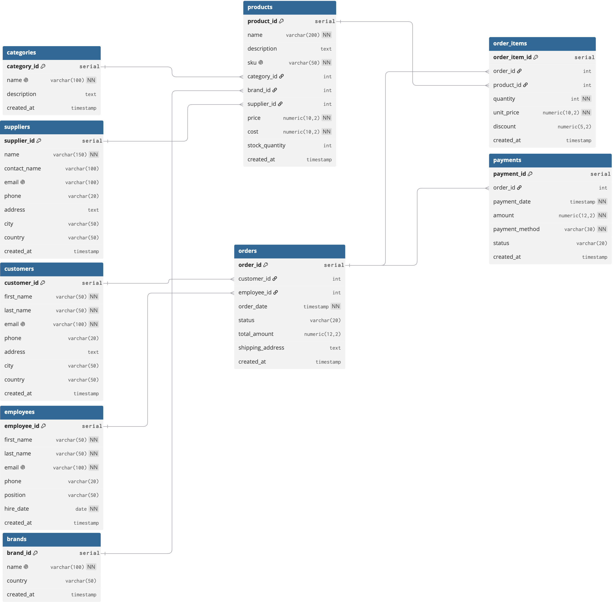

Initial data was generated and stored in CSV files without surrogate keys to simulate real-world data imports.
- brands.csv (15 rows)
- categories.csv (10 rows)
- customers.csv (500 rows)
- employees.csv (30 rows)
- products.csv (200 rows)
- suppliers.csv (20 rows)
- orders.csv (2000 rows)
- order_items.csv (6033 rows)
- payments.csv (2000 rows)

2. OLAP Database Context & Design (Data Warehouse)

The OLAP (Online Analytical Processing) solution is built using a multidimensional Snowflake schema. It is stored separately from the OLTP database and contains aggregated data optimized for business intelligence.

Analytical questions we want to answer:
- What are the monthly and yearly revenue and profit trends?
- Which product categories generate the highest profit?
- What is the geographic distribution of revenue by country?
- Which products are causing losses (negative profit)?
- How active are customers in different regions?

The Data Warehouse structure includes:
- Fact Tables (2):
  - fact_sales. Stores transactional metrics such as quantity, unit price, total amount, and calculated profit.
  - fact_inventory. Tracks stock quantities and stock values.
- Dimension Tables. dim_date, dim_customer, dim_product, dim_category, dim_brand, dim_employee, dim_supplier.
- SCD Type 2. Implemented on dim_customer and dim_product. When customer details (e.g., location) or product details (e.g., price, cost) change, the old record is closed (end_date is set, is_current = false) and a new record is created (start_date is set, is_current = true). This preserves historical accuracy for past sales.
- Bridge Table. bridge_product_supplier resolves the many-to-many relationship in the analytical context to track supply prices and lead times between multiple products and suppliers.

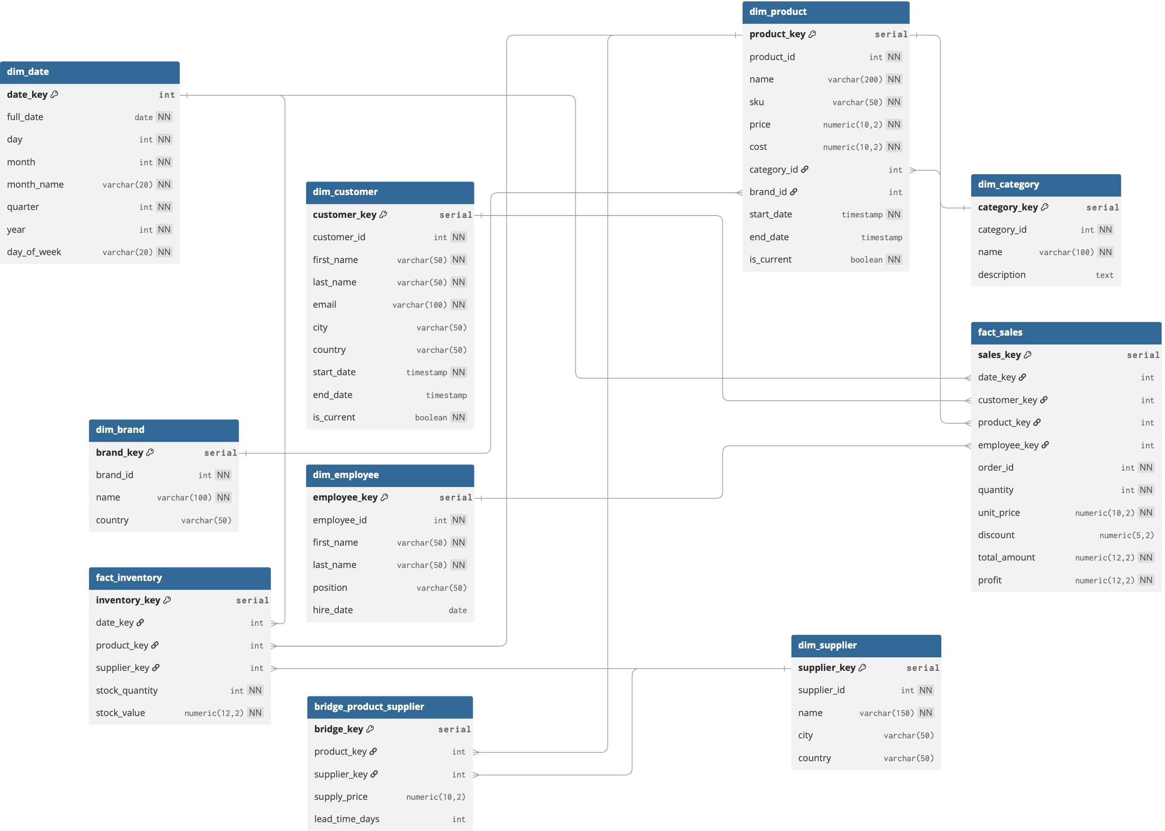

3. ETL Process Details

The ETL (Extract, Transform, Load) process moves data from the OLTP database to the OLAP data warehouse. It is fully rerunnable and ensures that previously added records are not overwritten unless actual changes occurred.
- Extract & Validate. Data is fetched from OLTP tables using dblink.
- Transform. The dim_date dimension is generated programmatically. Business rules calculate total_amount and profit on the fly before loading into fact_sales.
- Load (SCD2 Logic). For dimensions like customers and products, the script checks if existing attributes have changed. If so, it updates the end_date of the old record and inserts the new version. Fact tables are populated using INSERT ... WHERE NOT EXISTS to prevent duplication.

4. SQL Queries & Insights

To derive insights, specialized queries were developed for both databases:
- OLTP Queries. Focus on operational metrics, such as identifying the top 10 customers by total spend, calculating category performance over the last year, and grouping monthly orders to monitor average order value.
- OLAP Queries. Focus on multidimensional analysis. Queries are designed to calculate profit margins by month and year, find unprofitable products by joining facts with the product dimension, rank categories by overall profitability, and analyze the concentration of active customers per country.

5. Power BI Report

The Power BI visual report connects to the OLAP data warehouse to provide an interactive dashboard that answers key business questions.

Title: Electrical Equipment Store - Sales Analytics Dashboard
Interactive Slicers:
- Category. Allows users to filter the entire dashboard by specific product categories (e.g., Laptops, Smartphones, Cameras).
- Year. Allows users to narrow down the performance metrics to a specific year.
Visual Components:
- KPI Cards. Display high-level metrics including "Total revenue", "Profit", and "Number of orders".
- Map Chart (Revenue by country). Visualizes the geographic distribution of sales, showing which countries generate the most revenue.
- Bar Chart (Top 5 categories by profit). Helps determine which segments to invest in by comparing the absolute profit generated by the top 5 product categories (e.g., Speakers, Printers, Smartphones).
- Line Chart (Monthly incom). Displays the revenue trends over time, comparing different years to identify seasonality (e.g., peaks during holiday seasons) and overall business growth.
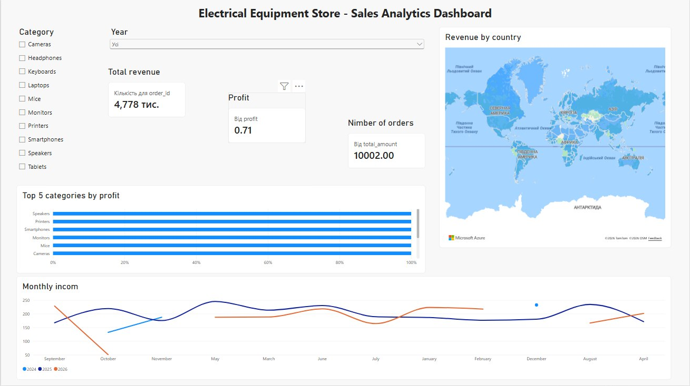

- Instructions for Running Scripts

To successfully deploy the databases and load the datasets, execute the SQL scripts in the exact following order:
- 02_oltp_schema.sql. Run this script in the OLTP database environment to generate the 3NF operational tables and constraints.
- 03_load_csv_to_oltp.sql. Update the absolute file paths in the COPY commands to match your local machine's directory where the CSV files are stored. Run the script to load data into the OLTP tables.
- 01_olap_schema.sql. Run this script in the OLAP database environment to create the Snowflake data warehouse schema (dimensions, facts, bridge).
- 04_etl_oltp_to_olap.sql. Verify the dblink connection parameters (host, port, user, password) inside the script. Run it to execute the ETL process, populate dimensions (including SCD2), and load the fact tables.
- 05_queries_oltp.sql & 06_queries_olap.sql. Run these independently in their respective databases to extract business insights.

