Breakdown of Project – Feature Explanation

# Web Scraping

Web scraping is the act of visiting a website and collecting data to save client side for later use.

# Intermediate Data Structure

The source data are all structured differently, and as such are hard to process efficiently. Thus we will use an intermediate data structure that we load data into before transferring to the main program. For example, we would convert from JSON to CSV, using CSV as our intermediate structure.

# Co-Ordinates in 3D Space

Co-Ordinates in 3D space are represented by three numbers, to show their positions on the three axes, for example(1,2,3). These three numbers are represented by X, Y, and Z, respectively.

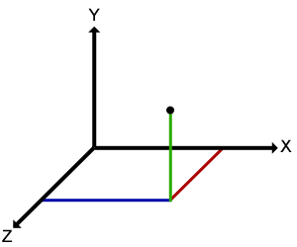

# Tracking Planes on a Time Based Scale

In order to learn about the planes’ flight paths and traffic patterns, we need to be able to track their location at certain times. This will be done using time-stamps (see below) of their position and interpolation between them to complete any missing data.

# Longitude, Latitude and Altitude

Longitude is a co-ordinate used to determine how far east or west from London somewhere is. Latitude is used in the same way to determine how far north or south somewhere is from the equator. Altitude is used to show how high from sea level something is.

On a standard flat (2D) map of the earth, longitude would be the x axis, latitude would be the y axis, and altitude would be the z axis.

# Time-Stamps

Time-stamps are a way to record some data at a specific time. The data are assigned to the time they were recorded, and later on if this time is requested, the appropriate data are returned alongside it.

# Data Source

Our data sources are mainly ADS-B, a collection of data from lots of air traffic.

# Data Processing

Processing (using) the data for our project is mainly done when we read from the source data and load it into the intermediate structure, and then again to the main program/visualisation.

# JSON

JSON is a data format designed for easily transferring lots of data with differing fields and sizes. ADS-B is saved in a JSON format, so we will have to be able to read from it and parse into our preferred format.

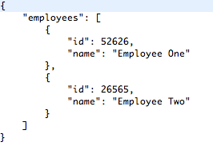

Above is an example of JSON data.

# The Cos Field

In the ADS-B data collection, there is a field called “Cos” which contains an array of data. These data are a collection of any data the receiver was unable to receive since the last data signal from that aircraft.

# Internal Data Structure

The data in our main program is referred to as our internal data structure. Examples would include any arrays or integers or other variable types used.

# CSV

CSV (Comma Separated Values) is a data format which is useful for saving lots of data with the same fields. As such, we will be using CSV to save our desired data from the sources, ready for usage by the visualisation. If you check the website that Jason provided us with, there are examples of CSV.

# Triangles/Ico

When drawing a sphere, there are multiple ways to do so. One is by drawing lots of rings on top of each other, which is very processor-heavy, and the other is by drawing lots of triangles, joined together to make a sphere-like shape, an icosahedron. The icosahedron is more efficient, and if we were to zoom in on part of it, we could stop rendering the other parts of it to save memory. We can also scale up the triangle we zoom in on to include more triangles, to give the illusion of a higher resolution.



This picture shows how by adding more triangles, the shape more closely resembles a true sphere.

# Rendering

Rendering is another term used for drawing in 3D.

# Different Terrain

Some airports have higher altitudes than others, and so when rendering the planes landing at them, they will seem to stop in mid air if the earth is shown with no elevated terrain. This problem can be solved two ways, either by showing terrain elevations or standardising “landed/grounded” altitudes.