Report HW1 Steven Gong ID: 999780855

The code is written in matlab. Please run under the matlab environment. Because some one mentioned that the orginal data is somewhat sorted, so I use randsample() to select 280/112 data, I use rng(100) to make sure every time I get the same data sets.

There are 5 files needed.

1. “main.m” is my main function
2. “linearSolver.m” is the function described in #3 where I use model $y= θ_{0}+ θ_{1}*x$
3. “solver2.m” is the function described in #5 where I use model $y= θ^{T}*x$, theta is a vector of 8 variables
4. “logistic.m” is the function described in #6.
5. The last file is the .txt file that contained the data, it should be named as “auto-mpg.data.txt”

**Important:** before running the code, please clear the last column and delete the rows with “?” manually by using vi or other text editors. The data is coming from the file named “auto-mpg.data.txt” downloaded from the source provided.

#1

The threshold is 18.500000mpg and 26.600000mpg

So If mpg is less than 18.5 it’s in the low bin. If mpg is equal or greater than 18.5 and less or equal to 26.6, it’s in the medium bin If mpg is greater than 26.6, it’s in the high bin.

#2

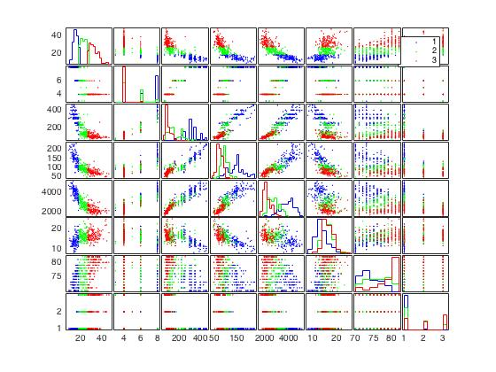

#4

all mean square error are calculated by the formula: $\frac{1}{M}*\sum_{1}^{M}{{(h\left(x\right)-y)}^{2}}$

Where M is the number of samples, and h(x) is the prediction, and y is the actually data.

2nd feature: number of cylinders

Training mean square error for 0th order 2nd feature is: 66.183206

Testing mean square error for 0th order 2nd feature is: 47.297773

Training mean square error for 1sh order 2nd feature is: 26.591100

Testing mean square error for 1sh order 2nd feature is: 17.820015

Training mean square error for 2nd order 2nd feature is: 26.417566

Testing mean square error for 2nd order 2nd feature is: 17.655850

Training mean square error for 3rd order 2nd feature is: 23.686335

Testing mean square error for 3rd order 2nd feature is: 17.441178

Training mean square error for 4th order 2nd feature is: 23.682054

Testing mean square error for 4th order 2nd feature is: 17.458651

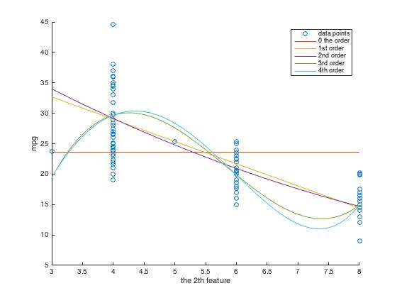

3rd feature: displacement

Training mean square error for 0th order 3rd feature is: 66.183206

Testing mean square error for 0th order 3rd feature is: 47.297773

Training mean square error for 1st order 3rd feature is: 23.860011

Testing mean square error for 1st order 3rd feature is: 15.391943

Training mean square error for 2nd order 3rd feature is: 21.272335

Testing mean square error for 2nd order 3rd feature is: 13.099683

Training mean square error for 3rd order 3rd feature is: 36.417729

Testing mean square error for 3rd order 3rd feature is: 25.676062

Training mean square error for 4th order 3rd feature is: 122.766849

Testing mean square error for 4th order 3rd feature is: 97.975855

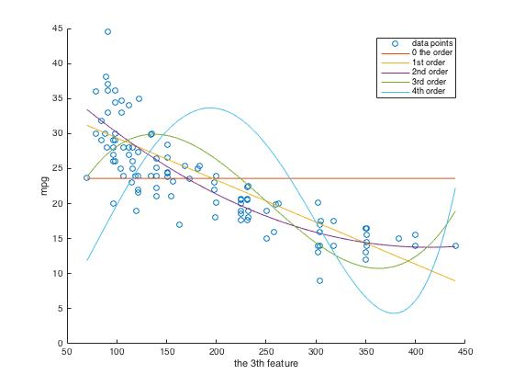

4th feature: horse power

Training mean square error for 0th order 4th feature is: 66.183206

Testing mean square error for 0th order 4th feature is: 47.297773

Training mean square error for 1st order 4th feature is: 26.122161

Testing mean square error for 1st order 4th feature is: 18.721404

Training mean square error for 2nd order 4th feature is: 20.239442

Testing mean square error for 2nd order 4th feature is: 16.022740

Training mean square error for 3rd order 4th feature is: 29.950833

Testing mean square error for 3rd order 4th feature is: 22.020651

Training mean square error for 4th order 4th feature is: 69.491923

Testing mean square error for 4th order 4th feature is: 52.799235

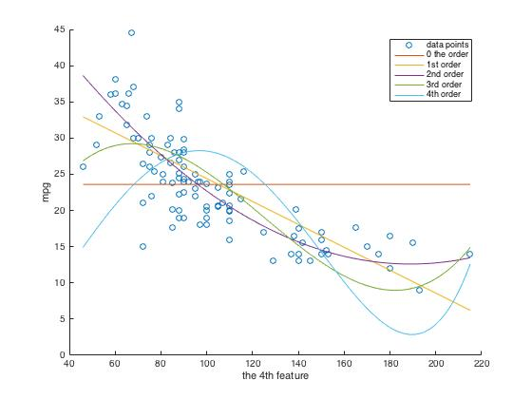

5th feature: weight

Training mean square error for 0th order 5th feature is: 66.183206

Testing mean square error for 0th order 5th feature is: 47.297773

Training mean square error for 1st order 5th feature is: 21.526210

Testing mean square error for 1st order 5th feature is: 11.650328

Training mean square error for 2nd order 5th feature is: 40.361884

Testing mean square error for 2nd order 5th feature is: 27.571096

Training mean square error for 3rd order 5th feature is: 98.051598

Testing mean square error for 3rd order 5th feature is: 71.156053

Training mean square error for 4th order 5th feature is: 193.560831

Testing mean square error for 4th order 5th feature is: 142.453627

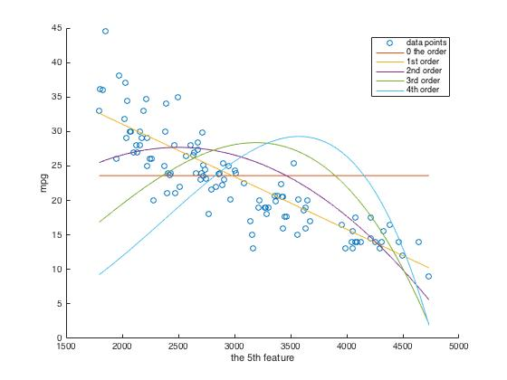

6th feature: acceleration

Training mean square error for 0th order 6th feature is: 66.183206

Testing mean square error for 0th order 6th feature is: 47.297773

Training mean square error for 1st order 6th feature is: 52.600477

Testing mean square error for 1st order 6th feature is: 43.424805

Training mean square error for 2nd order 6th feature is: 51.774116

Testing mean square error for 2nd order 6th feature is: 42.502577

Training mean square error for 3rd order 6th feature is: 51.727843

Testing mean square error for 3rd order 6th feature is: 42.279397

Training mean square error for 4th order 6th feature is: 50.577962

Testing mean square error for 4th order 6th feature is: 41.308052

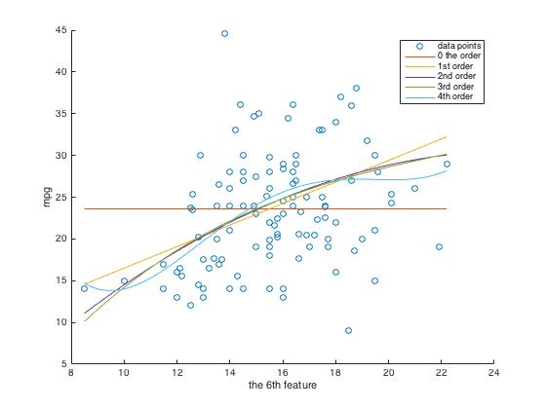

7th feature: model year

Training mean square error for 0th order 7th feature is: 66.183206

Testing mean square error for 0th order 7th feature is: 47.297773

Training mean square error for 1st order 7th feature is: 40.021795

Testing mean square error for 1st order 7th feature is: 42.016380

Training mean square error for 2nd order 7th feature is: 37.883638

Testing mean square error for 2nd order 7th feature is: 40.659756

Training mean square error for 3rd order 7th feature is: 37.933626

Testing mean square error for 3rd order 7th feature is: 40.636280

Training mean square error for 4th order 7th feature is: 37.986171

Testing mean square error for 4th order 7th feature is: 40.622381

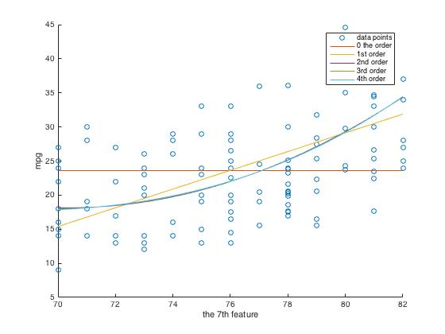

8th feature: origin

Training mean square error for 0th order 8th feature is: 66.183206

Testing mean square error for 0th order 8th feature is: 47.297773

Training mean square error for 1st order 8th feature is: 44.472786

Testing mean square error for 1st order 8th feature is: 33.619086

Training mean square error for 2nd order 8th feature is: 43.287780

Testing mean square error for 2nd order 8th feature is: 34.170965

Training mean square error for 3rd order 8th feature is: 43.287780

Testing mean square error for 3rd order 8th feature is: 34.170965

Training mean square error for 4th order 8th feature is: 43.287780

Testing mean square error for 4th order 8th feature is: 34.170965

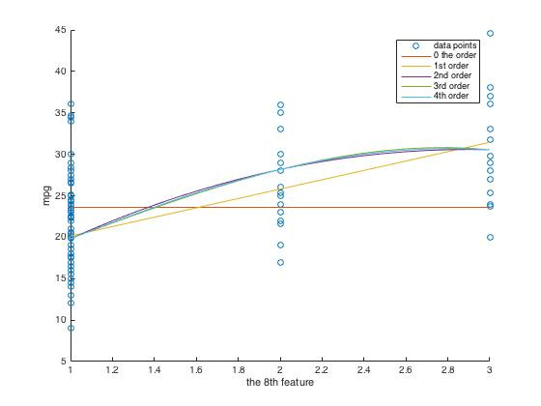

#5

For 0th order

Training mean square error is 66.183206

Testing mean square error is 47.297773

For 1st order

Training mean square error is 11.585452

Testing mean square error is 9.489124

For 2nd order

Training mean square error is 12.764385

Testing mean square error is 141.034719

#6

For the classifier of the 1st category

MSE1training = 1.9729e-14

MSE1test = 8.0884e-15

For the classifier of the 2nd category

MSE2training = 0

MSE2test =0

For the classifier of the 3rd category

MSE3training = 0

MSE3testing = 0

#7

From the polynomial: mpg = 11.7336 < 18.5

From the classifiers:

p1 = 0.9999

p2 = 1.4774e-133

p3 = 1.4774e-133

so it belongs to the 1st category

therefor it belongs to 1st category

#8

MPG(mile per gallon) for the car in the picture should be infinite, since it does not consume any gasoline.