HUMAN DEVELOPMENT INDEX — EXPLORATORY DATA ANALYSIS REPORT

Student Name: Nikesh Katuwal
Student ID: 2510344
Course Name: 5CS037 Concepts and Technologies of AI
Date of Submission: 10 January 2026
Git hub Repo Link: https://github.com/nikeshKatuwalL4/2510344_Nikesh_Katuwal_Assignment1

Table of Contents
- Introduction
- PROBLEM 1A — SINGLE YEAR HDI EXPLORATION (2022)
- PROBLEM 1B — HDI TREND ANALYSIS (2020–2022)
- PROBLEM 2 — ADVANCED EXPLORATION (2022 SOUTH ASIA)
- PROBLEM 3 — COMPARATIVE REGIONAL ANALYSIS: SOUTH ASIA VS MIDDLE EAST (2020–2022)
- CONCLUSION
- REFERENCES

INTRODUCTION
The Human Development Index is the global norm to determine human development. The 2022 data set of the HDI is analyzed to determine the nature of the data. This analysis conducts necessary exploratory analysis techniques such as filtering, sorting, and graphing. The purpose of the analysis is to determine necessary statistical information.

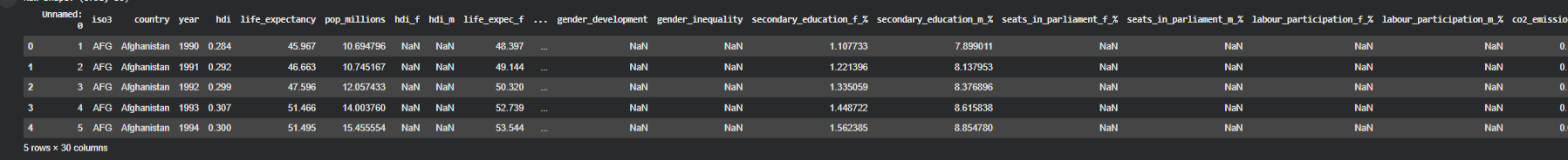
PROBLEM 1A — SINGLE YEAR HDI EXPLORATION (2022)

METHODS / APPROACH
Missing variables were indicated by non-numeric characters. All numeric variables were then turned into numeric to cater to the requirement. Duplicates were deleted. Missing values in unessential variables were imputed by median in 2022 to retain country recall.

KEY RESULTS
The average HDI was moderately high, and the median was slightly higher than the average value, reflecting a mild skewness to the positive side. The best-performing country showed outstanding results on both the parameters of life expectancy and income, followed by the lowest-performing country, which was hindered by a low income and poor access to education.
INTERPRETATION AND DISCUSSION
The yearly rankings indicated that human development is an area that has multiple aspects. This is because income levels could not ensure equal HDI rankings since some developed nations had lower life expectancy results. The huge difference in levels for HDI indicated that stability and investments were also important aspects.
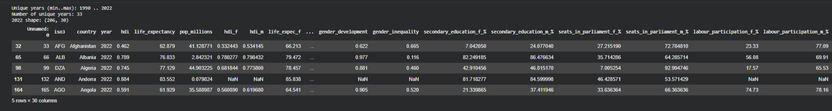

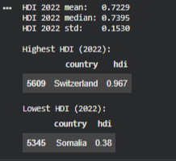

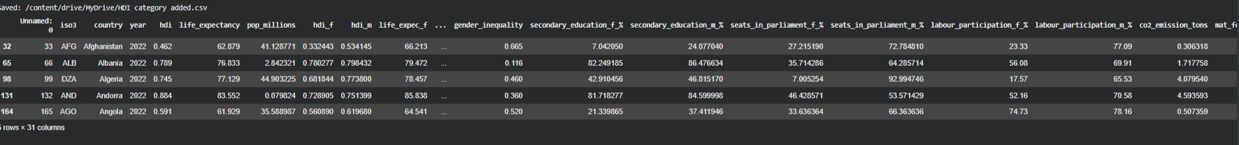
PROBLEM 1B — HDI TREND ANALYSIS (2020–2022)

METHODS / APPROACH
The cleaned subset encompassed only the years 2020, 2021, and 2022, and a "Region" variable was created to represent the geographical regions defined by the UN to allow the graphing of the mean HDI. Since the data set does not have a column called "Region," a "Region" variable was created.

VISUALIZATION INTERPRETATION

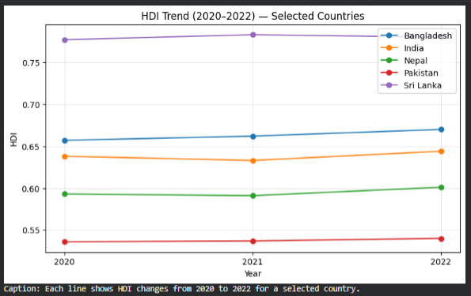
The line graph reveals an improvement in most South Asian nations from 2020 to 2022. Nepal and India have shown slight improvement, while Sri Lanka has remained stable, but Afghanistan trails behind. The graph reveals that HDI values change gradually over a short period of time.
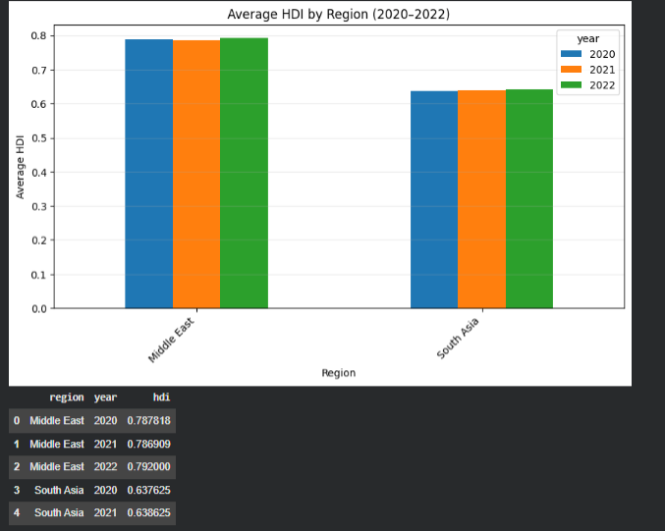

In the regional bar chart of the average HDI values over the years, the Middle East performs better than South Asia overall. South Asia still trailed the Middle East as of 2022, but the gap is small because South Asia grew slightly ahead of the Middle East during that year.
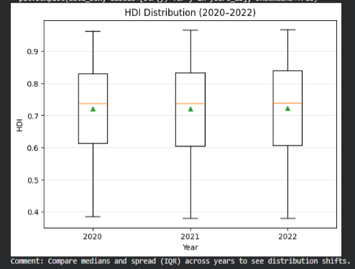
By the box plot, the greatest spread is in 2020, which gradually decreases through 2022. With every year, the median increases, and there is a clear tendency towards convergence.

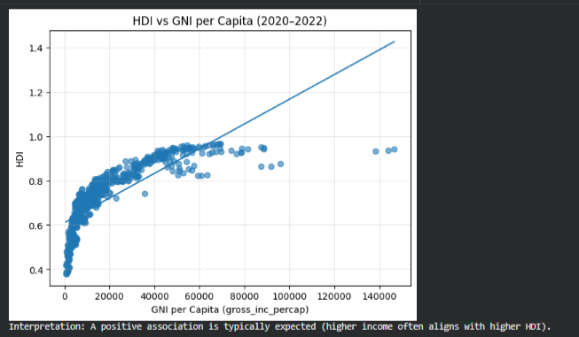
The scatter plot, where HDI is plotted against GNI per capita, indicates that the richer the country, the higher the HDI. However, the variation is considerable, and here again, equality and education emerge as very important considerations.
PROBLEM 2 — ADVANCED EXPLORATION (2022 SOUTH ASIA)

METHODS / APPROACH
The South Asian countries were pooled into the Composite Score in 2022 through the formula 0.30 times life expectancy + 0.30 times GNI per capita. Outliers in HDI values and income were detected using the 1.5 × IQR formula.
KEY RESULTS
The combined ranking differed from the HDI ranking because the HDI uses geometric normalization. Maldives topped both rankings, while there was a large negative divergence for Afghanistan. Pearson correlation revealed that the Gender Development Index was more closely related to the HDI than life expectancy.
INTERPRETATION AND DISCUSSION
Qatar and Yemen stood out as exceptions with income levels that far exceeded what was to be expected given its HDI. From the Gap tables, true equality matters greatly to South Asia because small steps lead to bigger strides.

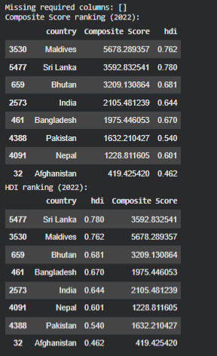

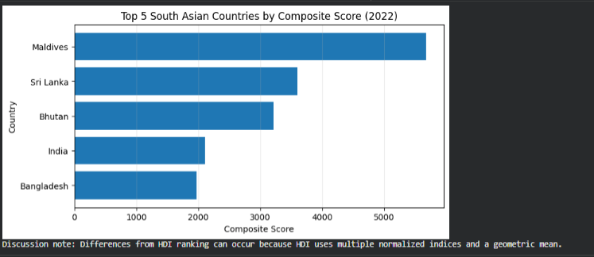

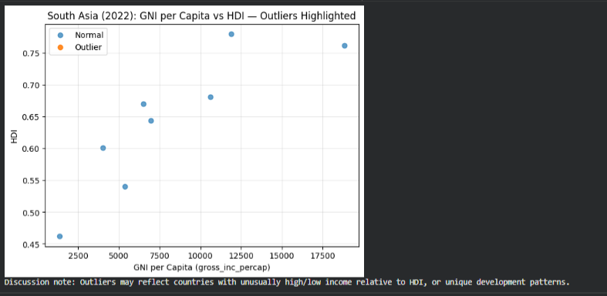

PROBLEM 3 — COMPARATIVE REGIONAL ANALYSIS: SOUTH ASIA VS MIDDLE EAST (2020–2022)

KEY RESULTS
Middle East had an average HDI value with a smaller coefficient of variation than South Asia. In terms of HDI element, income was the component with maximum values across the region.

INTERPRETATION AND DISCUSSION
South Asia had higher variability, depending on countries that were conflict-ridden, while Middle East levels were aided by a strong economic capacity as well as a robust health service program. The two regions posted a positive correlation, though slightly higher in South Asia.
CONCLUSION
The exploratory analysis revealed that average performance was stronger for the Middle East during 2020-2022, there is a strong positive correlation between income and HDI, and the pandemic contributed to slowing down improvement, especially for South Asia. By manually building the Region variable, we completed the requirement for the bar chart.
LIMITATIONS
The data is missing the original region and the indicator for the years of schooling of some countries.
APPENDIX
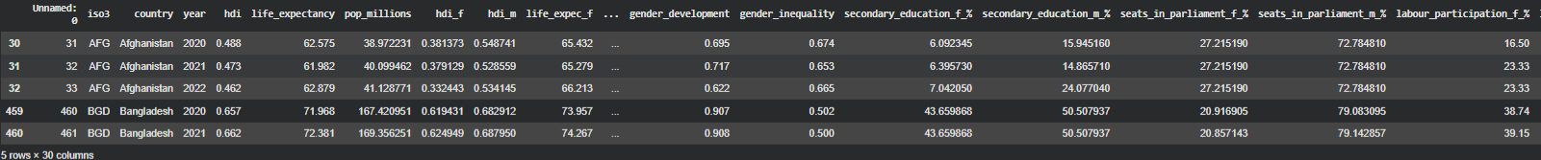

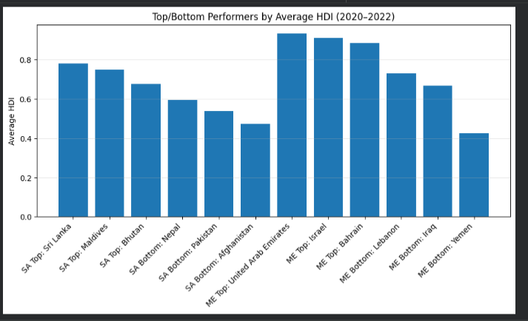
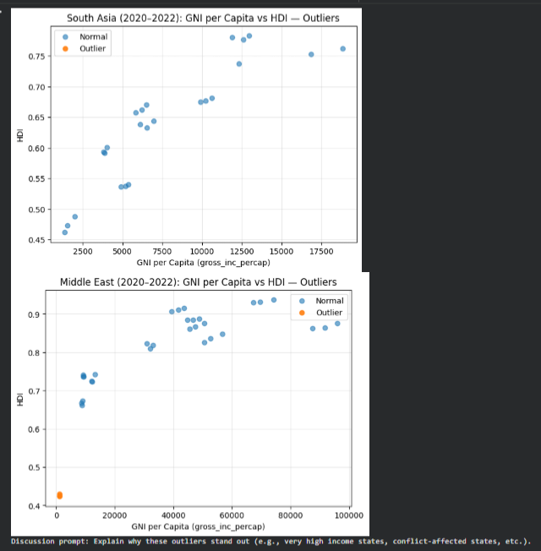
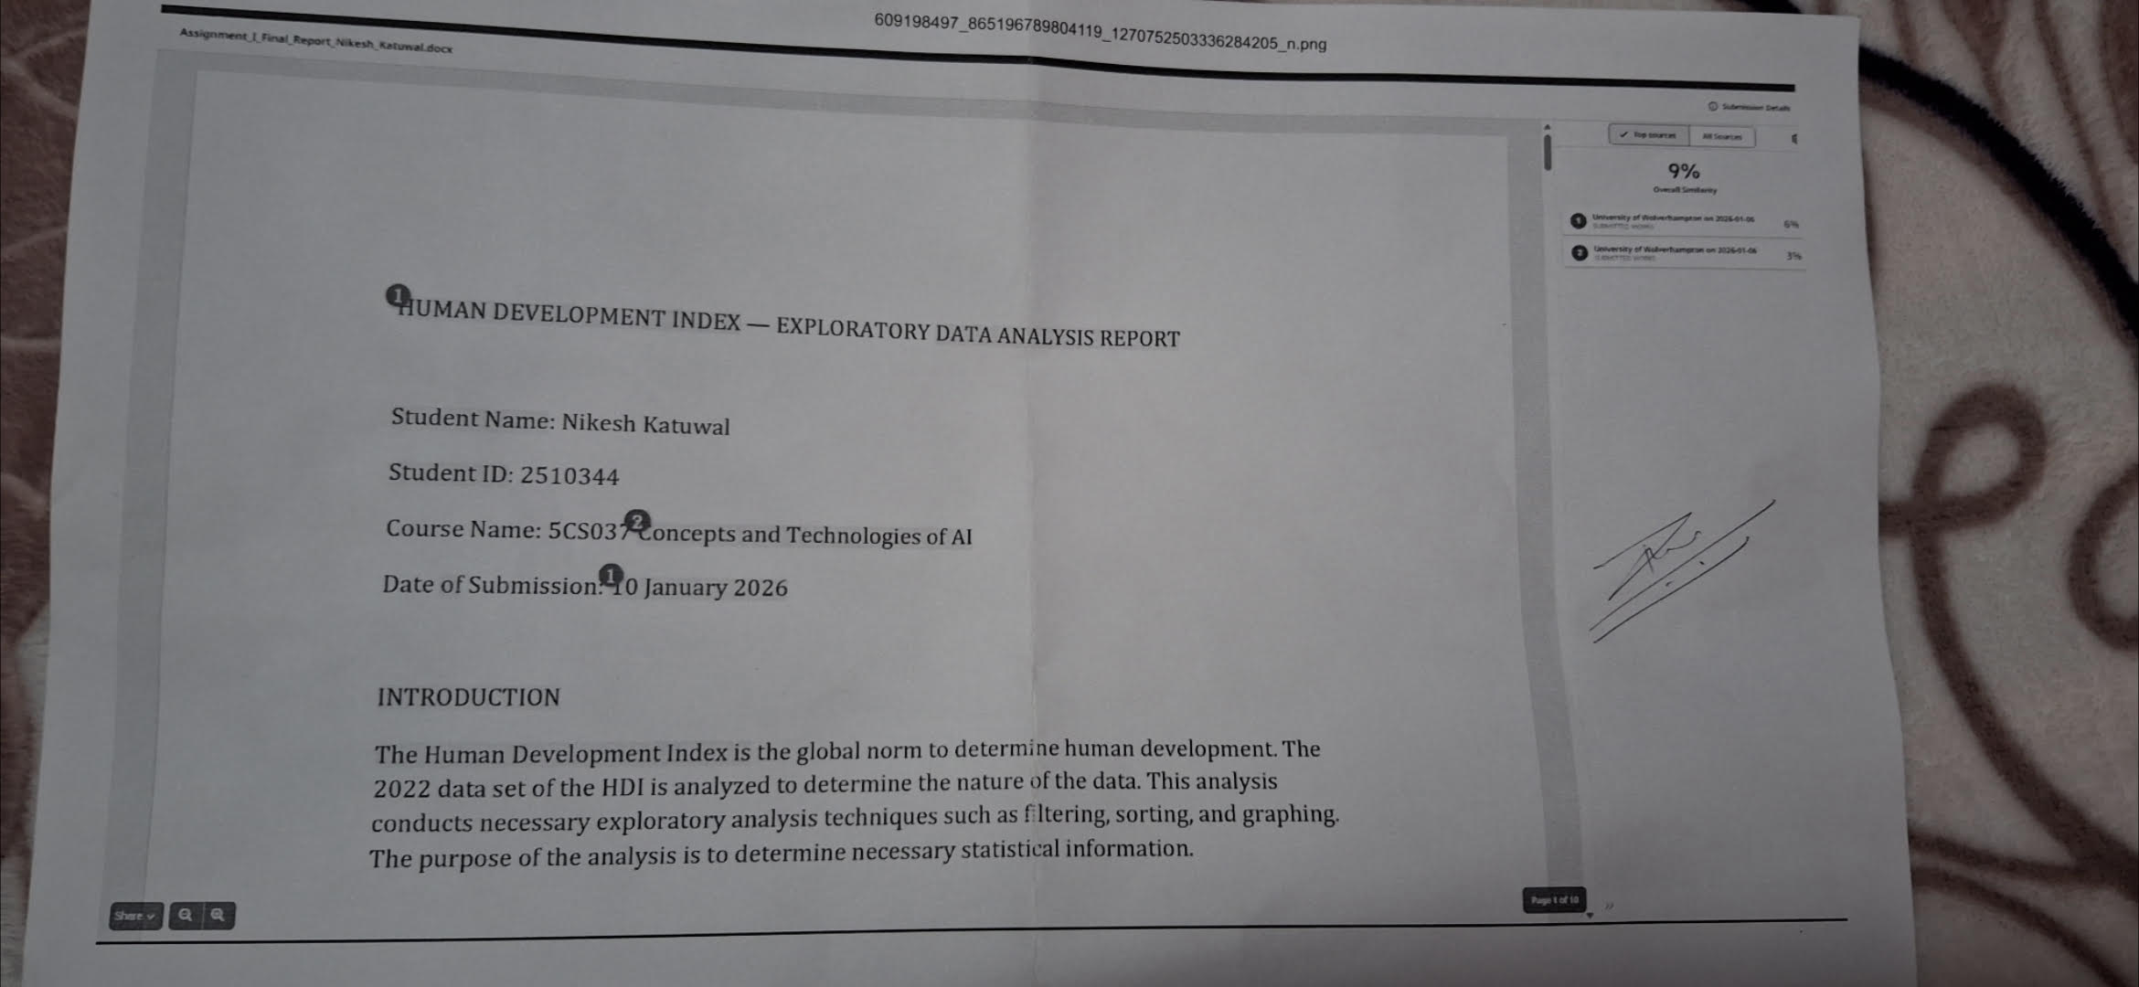
REFERENCES
United Nations Development Programme HDI methodology.

