**TRIBHUVAN UNIVERSITY**

**INSTITUTE OF ENGINEERING**

**THAPATHALI CAMPUS**



A Projecl on

**Digital record keeping system of hospital**

Submitted By:

Debendra Mahato (THA081BCT007)

Purnika Poudel (THA081BCT025)

Shraddha Regmi (THA081BCT040)

Submitted To:

Department of Electronics and Computer Engineering

Thapathali Campus

Kathmandu, Nepal

March 2025

**DECLARATION**

We hereby declare that the report of the project entitled **"Digital record keeping system of hospital**” submitted for the partial fulfillment regarding C programming for 1st semester **i**s a bonafide report of the work carried out by us. The materials contained in this report have not been submitted to any University or Institution for the award of any degree and we are the only author of this complete work and no sources other than the listed here have been used in this work.

**Debendra Mahato (THA081BCT007) _____________**

**Purnika Poudel (THA081BCT025) _____________**

**Shraddha Regmi (THA081BCT040) _____________**

**Date: March 2025**

**CERTIFICATE OF APPROVAL**

The undersigned certify that they have read and recommended to the **Department of Electronics and Computer Engineering, IOE, Thapathali Campus**, a project work entitled “D**igital record keeping system of hospital**” submitted by **Debendra Mahato, Purnika Poudel and Shraddha Regmi**  for the partial fulfillment regarding C programming for 1st semester . The project was carried out under special supervision and within the time frame prescribed by the syllabus.

_________________________

Project Coordinator

Er. Anup Shrestha

Department of Electronics and Computer Engineering,Thapathali Campus

__________________________

Head of Department

Umesh Kanta Ghimire

Department of Electronics and Computer Engineering,Thapathali Campus

_________________________

Project Supervisor

Er. Prajwol Pakka

Department of Electronics and Computer Engineering,Thapathali Campus

**ACKNOWLEDGEMENT**

We are grateful to the **Institute of Engineering, Thapathali Campus, Department of Computer Engineering**, for providing us with this opportunity to improve our skills and apply our theoretical knowledge, particularly in C programming.

We extend our special thanks to **Er. Prajwol Pakka** and **Er. Anup Shrestha** for their invaluable guidance, support, and insightful feedback throughout the study. This project provided us with valuable hands-on experience and helped us understand how to apply our learning in real-world scenarios.

And we are really thankful to everyone who helped us during this project along the way.

**Debendra Mahato (THA081BCT007)**

**Purnika Poudel (THA081BCT025)**

**Shraddha Regmi (THA081BCT040)**

**ABSTRACT**

This project focuses on developing a Database Management System (DBMS) using the C programming language to efficiently store, manage, and retrieve data. The system ensures data integrity, security, and ease of access while providing a structured approach to handling information.

Through this project, we applied our knowledge of C programming, and database to implement core database functionalities. The system allows users to perform essential operations such as data insertion, deletion, updating, and searching efficiently.

This hands-on experience has strengthened our understanding of database management principles and their practical implementation using C. We sincerely appreciate the guidance and support from our mentors throughout this project.

**TABLE OF CONTENTS**

**Topic**

**DECLARATION.......................................................................II**

**CERTIFICATE OF APPROVAL..................................................III**

**ACKNOWLEDGEMENT..........................................................IV**

**ABSTRACT............................................................................V**

**1.INTRODUCTION....................................................................1**

1.1 Background Introduction**......................................................1**

1.2 Motivation**..........................................................................1**

1.3 Problem Definition**...............................................................2**

1.4 Objective**............................................................................2**

**2. LITERATURE REVIEW .........................................................3**

**3. PROPOSED SYSTEM ARCHITECTURE..................................5**

**4. METHODOLOGY..................................................................6**

4.1. System Development Life cycle(SDLC) approach**......................6**

4.2. Technology used**.................................................................7**

4.3. Database design**.................................................................7**

4.4. User Authentication & Role Management**................................7**

4.5. Testing and Debugging**........................................................8**

**5.SCOPE AND APPLICATIONS.................................................9**

**6. TIME ESTIMATION...............................................................10**

**7. FEASIBILITY ANALYSIS.......................................................11**

**References............................................................................12**

**1. INTRODUCTION**

As part of the first semester of the Bachelor of Computer Technology (BCT), this project aims to develop a small yet important C-programming experiment. The goal is to use the fundamental ideas of the sophisticated programming language C to create a management system of a hospital using c programming language. By allowing users to register, log in, and search for reports, bills, book appointments, search for doctors, medicine this platform seeks to facilitate seamless digital management system of a hospital. This project highlights important features and serves as a hands-on implementation of the theoretical ideas learned throughout the course, providing a practical interface for our growing programming skills.

**1.1Background  Introduction**

As first-year Bachelor in Computer Technology (BCT) students, we begin learning C programming in our Computer Programming-I course to develop our logical reasoning and problem-solving abilities. Our goal for the semester project is to use basic C programming concepts like database, structures, functions and arrays to create a prototype for managing the data of a hospital. Users can register, log in, search for doctors, book appointments generate reports sees history of a patients. Our approach involves breaking up the log book system by introducing the new digital management system to team members and making use of online system. This project helps us put theoretical knowledge into practice while also preparing us to make digital system.

**1.2 Motivation**

Our research was inspired by the limitations of traditional hospital record-keeping systems, where patient information is manually recorded in registers or logbooks. These records can be easily misplaced, making it difficult to retrieve medical history, past reports, or appointment details. By introducing a digital management system, hospitals can efficiently store and access appointment records, disease history, and investigation reports in a centralized system. This ensures secure, long-term storage and allows easy access to information from anywhere.

We chose to develop this hospital management system using C programming because, asfirst-semester BCT students**,** we were intrigued by the complexities and possibilities of system development. This project marks our first attempt at creating a digital record-keeping system, providing a hands-on opportunity to apply our classroom learning in a practical setting. To aid our development process, we relied on various online tutorials and resources**,** allowing us to bridge the gap between theory and real-world application effectively.

**1.3 Problem Definition**

We find that in many hospitals, patient records are still maintained manually usingregisters and logbooks**,** leading to inefficiencies and risks such asmisplacement, damage, or difficulty in retrieving past medical history**.** This outdated system makes it challenging to trackappointments, disease history, investigation reports, and other crucial medical data. As a result, healthcare providers often face delays in accessing information, which can negativelyimpactpatient care and hospital management**.**

To address these issues, we propose developing aHospital Management Systemusing C programming**.** This system will serve as adigital record-keeping solution**,** allowing hospitals tostore, manage, and retrieve patient informationefficiently. With this system, hospitals can ensurelong-term data storage, accessibility from multiple locations, and improved operational efficiency**.**

This project is particularly significant for us asfirst-semester BCT students, as it provides apractical applicationof our programming knowledge. By utilizingonline resources and tutorials, we aim to bridge the gap betweentheory and real-world problem-solving, contributing to the modernization of hospital record-keeping systems.

**1.4 Objective**

The main objectives of our project are listed below:

* To develop a Prototype: Create functional record keeping system using Cprogramming to manage the data.
* To enhance Skills and Collaboration: Improve understanding of C programming and teamwork through practical application and group collaboration.

**2. LITERATURE REVIEW**

A Hospital Management System (HMS) is a system designed to help hospitals run smoothly by managing tasks like patient registration, appointment scheduling, billing, and medical record keeping. The main goal of this project is to improve the efficiency of hospital operations, reduce paperwork, and enhance patient care. By automating these processes, healthcare staff can focus more on providing quality care rather than handling administrative tasks.

With the rise of digital technology and internet in healthcare, HMS systems are becoming increasingly important in improving communication, reducing errors, and making data more accessible. These systems range from simple applications to complex platforms that manage a variety of hospital functions. The technology and programming languages used to build these systems influence how well they work, how easily they can grow, and how user-friendly they are. Over the years, many HMS projects have been developed using different programming languages and frameworks, each contributing to specific aspects of hospital operations. The following are some of the major projects developed revolving around hospital management system.

1. **OpenMRS**

OpenMRS is one of the most widely adopted open-source HMS projects. The development of OpenMRS began in 2004 as part of a collaboration between Partners In Health (PIH) and Harvard Medical School, particularly in efforts to manage patient data for the growing HIV/AIDS epidemic in Rwanda. Built using Java, it provides a customizable framework for managing patient data and hospital operations. The system allows healthcare professionals to record patient details, track medical histories, and generate reports, which simplifies administrative and clinical workflows. Its modular design facilitates the integration of additional features like lab management, scheduling, and billing.

1. **GNU Health**

GNU Health is an open-source Hospital Management System (HMS) and Electronic Health Record (EHR) software that aims to provide a comprehensive solution for healthcare organizations, focusing on managing patient data, medical records, and public health information. Developed byLuis F. Falcon and backed by the GNU Project in the year 2010, the system integrates patient management, electronic health records (EHR), medical billing, and more. It also includes features such as patient demographics tracking, consultation, and treatment history management. Due to its open-source nature, it has been widely adopted by healthcare organizations looking for customizable, cost-effective solutions.

1. **Docpulse**

DocPulse is a cloud-based healthcare platform designed for the purpose of hospital management systems and electronic health record (EHR) solutions for healthcare institutions. This system provides various features of appointment scheduling, billing, hospital stock and inventory management and provides records of health reports. Throughout the years, DocPulse has been actively growing and providing its healthcare management solutions in the healthcare industry for several years, offering cloud-based tools for hospital management, patient records, and more.

1. **HospiTrack**

HospiTrack was developed in 2010 as a web-based solution to help hospitals and healthcare organizations manage their administrative and operational tasks more efficiently. The primary goal of the system was to simplify tasks such as patient registration, appointment scheduling, billing, and pharmacy management. Built with PHP, MySQL, and HTML5, the system provides easy access to patient records and enables administrators to track inventories, manage hospital staff, and generate reports. This approach is useful for smaller healthcare facilities looking for an affordable and easy-to-use management system.

1. **Medico**

Medico is a hospital management system developed around mid-2010s with the purpose of promoting and providing health care in poor, rural communities in Central America where such care is extremely limited or not available. The system provides a real-time dashboard for administrators to monitor hospital activities, including patient management, appointment scheduling, and tracking of medical supplies. Medico's use of JavaScript technologies enables a high level of interactivity and scalability, making it suitable for both small clinics and large hospital chains.

**3. PROPOSED SYSTEM ARCHITECTURE**

Our goal is to make a real life functionable project that helps in managing the records of the hospital like details of patients and the doctors, appointment scheduling, management of billing and pharmacy and more with the help of c programming language and database.

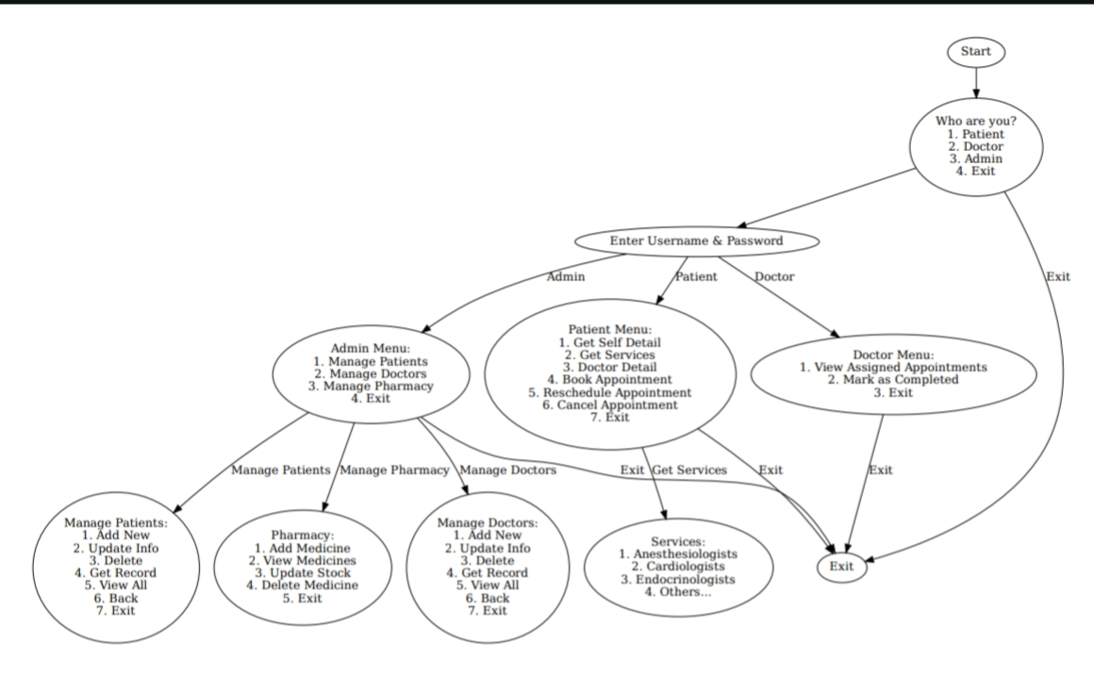

Figure: block diagram of hospital management system

**Tools and Environment**

* Github: GitHub is a web-based platform for version control and collaboration with teammates, allowing to store, manage, and track changes in code repositories using Git.
* VS Code Editor: Visual Studio Code (VS Code) is an IDE that helps in writing, testing, debugging, and managing code which integrates with Git for source control.

**4. METHODOLOGY**

Healthcare is one of the most critical sectors in our society. With the increasing population of people and complexity, managing people in hospital is also much more complex and headache, hospital needs efficient system to manage patients, doctors, pharmacy, staffs. A Hospital Management System (HMS) is a digital solution of these complex problem, reduces paper works, minimizes errors, improves overall patients care by ensuring smooth coordination between patients and doctors or other different departments.

The Hospital Management System contains three different section one for patients (parents of those patients) another to admin (those who manage all hospital’s stuffs). The patients section has different options, at first patients gave to enter their username and password(by default [user@123](mailto:user@123)) for first time, then they are asked for new password, if this is not their first login then they have to login with username and password, then only they are allowed to go further step. They can view doctor information of any particular specialization, they can book appointments with doctors, scheduling appointments, also can cancel it. Patients can view their bills.

The second section is of doctor, they can view their appointment detail and marked that appointment status complete or done after consultation.

And the admin section can do everything as hospital have to do so, they have to login first with their username and password (username: admin and pass: admin by default), like add new patient, update patient detail in case wrong information is taken, or wants to update their email or phone, delete their information and get full detail information of all or individual patients, Similarly for doctor, admin add new doctor, update doctor information, delete doctor information and get detail of all or individual doctors. Admin can get pharmacy detail, they can update stocks, can generate bill. Moreover, admin can view appointments detail that is whose appointment is with which doctor at what time, also allowed to schedule or cancel appointment.

**4.1 System Development Life cycle(SDLC) approach**

**Planning**

To develop this project, it requires proper planning of which data is visible and not to patients, similar for doctors. This system minimize paper work which requires a big room to store, it manage patients detail, appointment detail, billing and pharmacy management. This system has three section (admin, patients, doctors). We’ve select the SQLite database for efficient data handling.

**Designing**

It has different database table for different work like, patientdetail to store details of patients, doctordetail to store details of doctors, authentication to store username and password so on. It store password in hash form, and data is role-based access.

**Coding**

This project is developed using C, and SQLite for database management. This code can be enhanced for future if any further features want to add like GUI.

**Testing**

We performed unit testing to verify individual components. Also tested with simple and dummy data to ensure and validate its functionality, security and performance.

**4.2 Technologies Used**

**Programming language:** We’ve used C to develop this system.

**Database:** SQLite3 is used as database.

**Libraries Used:** SQLite for database management and LibHaru to generate bills.

**4.3 Database Design**

It contains different tables for different works, patient detail to store patient detail, doctor detail to store doctor detail, authentication to store username and password (in hash form), appointment to store detail with status (scheduled, completed, canceled), billing and pharmacy to store pharmacy details. Here phone and email act as username.

**4.4 User Authentication & Role Management**

It has three section, at first user has to tell who he is (if he is patient, doctor or admin), then if he has patient, he has to login with his username (phone or email) and password ([user@123](mailto:user@123) by default for first time then they have to update their password). After login patient can allow to see doctors details of specific specialization and book appointment with doctor doctor id, in case patient is not able to consult with doctor with doctor, they are allowed to reschedule the appointment or even cancel it.

The another section is of doctors, who is also has to login first, then they are allowed to see their appointment list and marked as a completer after consultation.

Last section is of Admin, who is also has to login with their username and password, then they are allowed to modify patients and doctors details, add or get full detail of any patients or doctors or even full detail of all patients and doctors. They are allowed to reset password of any patient or doctor. They are allowed to generate bills, manage pharmacy.

**4.5 Testing and Debugging**

We’ve tested the system individually with simple (dummy) data function wise. And multiple times with different data each time. We got some error, we tried our best to resolve it manually and using some source and we succeed to do that.

**5. SCOPE AND APPLICATIONS**

Our Hospital Management System aims to provide a basic yet efficient digital record-keeping solution to replace traditional manual hospital records. The system is designed to ensure data security, accessibility, and efficient managementof patient information.

* Patient Record Management: Store and retrieve patient details, including medical history, appointments, and reports.
* Secure Data Storage: Patient records will be stored digitally, reducing the risk of loss or damage.
* Efficient Accessibility: Authorized personnel can quickly access and update patient data, improving hospital workflow.
* Data Security: Ensures secure handling of sensitive medical data by implementing controlled access.
* Scalability: The system can be expanded to include additional features like billing, doctor schedules, and prescription management.

**Applications**

* Hospitals & Clinics: Helps in maintaining a systematic digital record of patients, reducing paperwork and improving efficiency.
* Health Centers & Laboratories: Can be used to track investigations, test results, and patient visits for better healthcare management.
* Medical Research & Data Analysis: Allows healthcare providers to analyze patient data trends, aiding in better treatment and medical research.
* Educational Purposes: Serves as a learning project for students to understand system development, data management, and security in C programming.

**6. FEASIBILITY ANALYSIS**

**Cost-Effectiveness**

* Since the project uses open-source tools, consider integrating light databases for better data management without additional costs.
* Encourage collaborative development with peers to share knowledge and optimize time and effort.

**Technical Feasibility**

* While C programming is an excellent starting point, exploring structs and linked lists can improve data organization and efficiency.
* Introduce modular programming to separate different functionalities like patient management, appointment scheduling, and billing.

**Resource Availability**

* Utilize version control systems like Git to manage and track changes in the code.
* Explore online coding platforms for testing and debugging, such as Replit or Vs code.

**Scalability**

* To expand the project, consider implementing multi-user roles (admin, doctor, and patient) for better user experience.
* Implement database connectivity to handle larger amounts of patient records.

**Maintainability**

* Implement error handling mechanisms to prevent system crashes due to incorrect data inputs.

**Educational Value**

* Extend the project to include real-world medical record functionalities, such as prescription history, diagnostic reports, and doctor recommendations.

**7. TIME ESTIMATION**

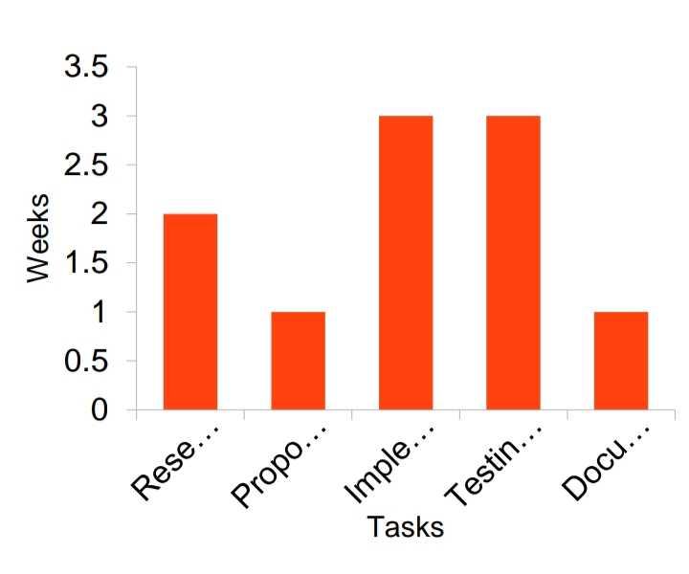

**REFERENCES**

Books:

Simply easy learning by tutorailspoint.com SQLite Tutorial

Online resources:

https://www.tutorialspoint.com/sqlite/sqlite_c_cpp.htm

https://www.geeksforgeeks.org/

https://www.chat.openai.com/

OpenMRS.org [Online]. Available: https://openmrs.org/

GNUhealth.org [Online]. https://www.gnuhealth.org/about-us.html

Docpulse.com [Online]. Available: https://docpulse.com/

Hospitrack.co [Online].Available: https://hospitrack.co.za/Pages/About-Us.asp

Medico.org [Online]. Available: https://medico.org/about-us/

Software & Technical References:

SQLite Consortium. (2023). SQLite Documentation. Retrieved from https://www.sqlite.org/docs.html

Haru Free PDF Library. (2024). LibHaru: Free PDF Library for C. Retrieved from http://libharu.org/