📰 Fake News Detection Using NLP and Machine Learning

📌 1. Problem Statement
With the explosion of digital news sources, fake news has become a major threat to public trust and informed decision-making. The objective of this project is to develop an NLP-based machine learning model to classify news articles as either true or fake, based on their textual content.

🧪 2. Methodology (Tasks from Starter Notebook)

1. Data Preparation
- Combined True.csv and Fake.csv datasets, each containing title, text, and publication date.
- Assigned labels: 1 for true, 0 for fake.

2. Text Preprocessing
- Performed tokenization, lowercasing, punctuation and digit removal.
- Used spaCy for lemmatization and stopword removal.

3. Train-Validation Split
- Split data using an 80:30 ratio for training and validation.

4. Exploratory Data Analysis (EDA)
- Plotted distribution of character lengths before and after preprocessing.
- Generated word clouds to analyze common terms in both true and fake news.
- Displayed top 10 unigrams, bigrams, and trigrams for both fake and true news.

5. Feature Extraction
- Applied TF-IDF Vectorization to transform text into numerical format.
- Additionally, used pre-trained embedding’s with word2vec-google-news-300 from the Gensim API:
  - import gensim.downloader as api
  - word2vec_model = api.load('word2vec-google-news-300')
- These embedding’s enabled semantic similarity checks and enhanced understanding of context beyond surface-level token frequency.

6. Model Training and Evaluation
- Trained and tested Random Forest, Logistic Regression, and Decision Tree classifiers.
- Chose Random Forest as the best model based on evaluation metrics.

📊 3. Visualizations

🏢 Distribution of Character Lengths – Cleaned Text
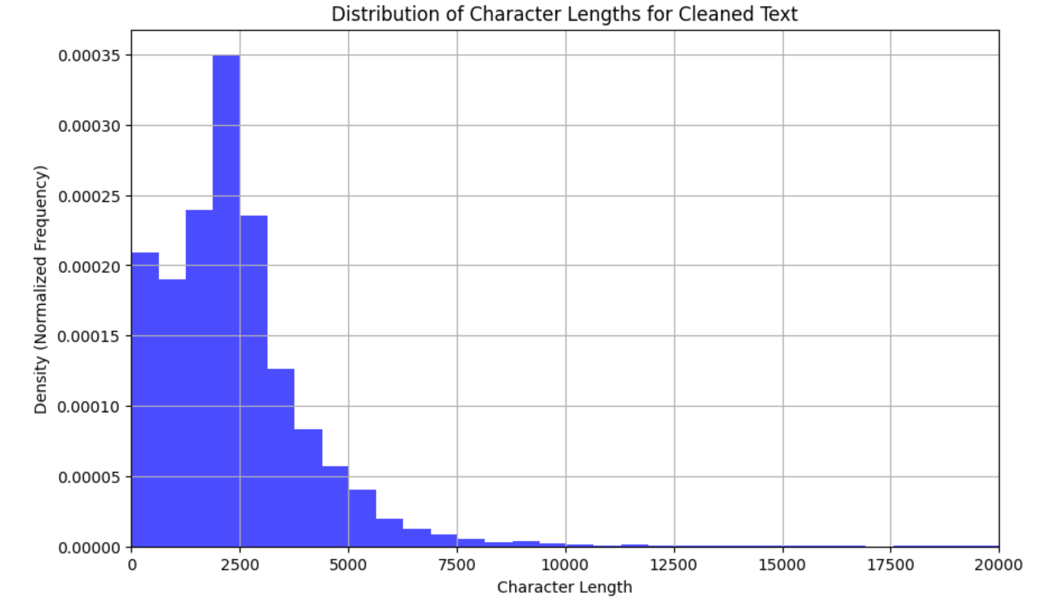
Cleaned Text Histogram

⚙️ Distribution of Character Lengths – Lemmatized Text
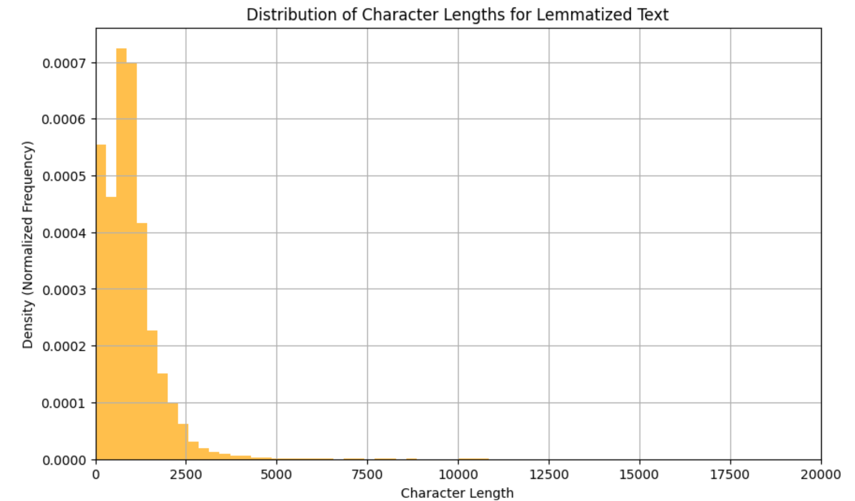
Lemmatized Text Histogram

✅ Word Cloud – True News

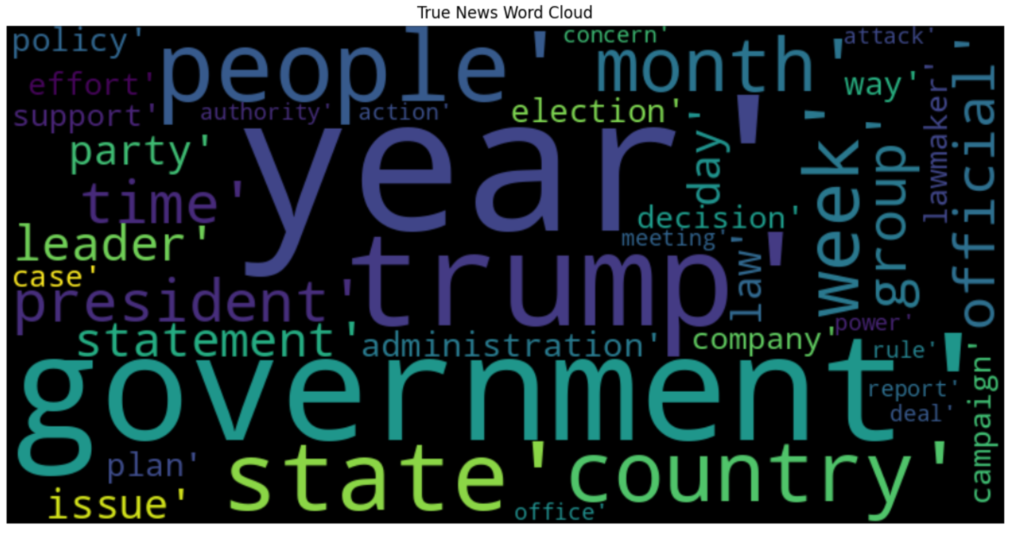

❌ Word Cloud – Fake News

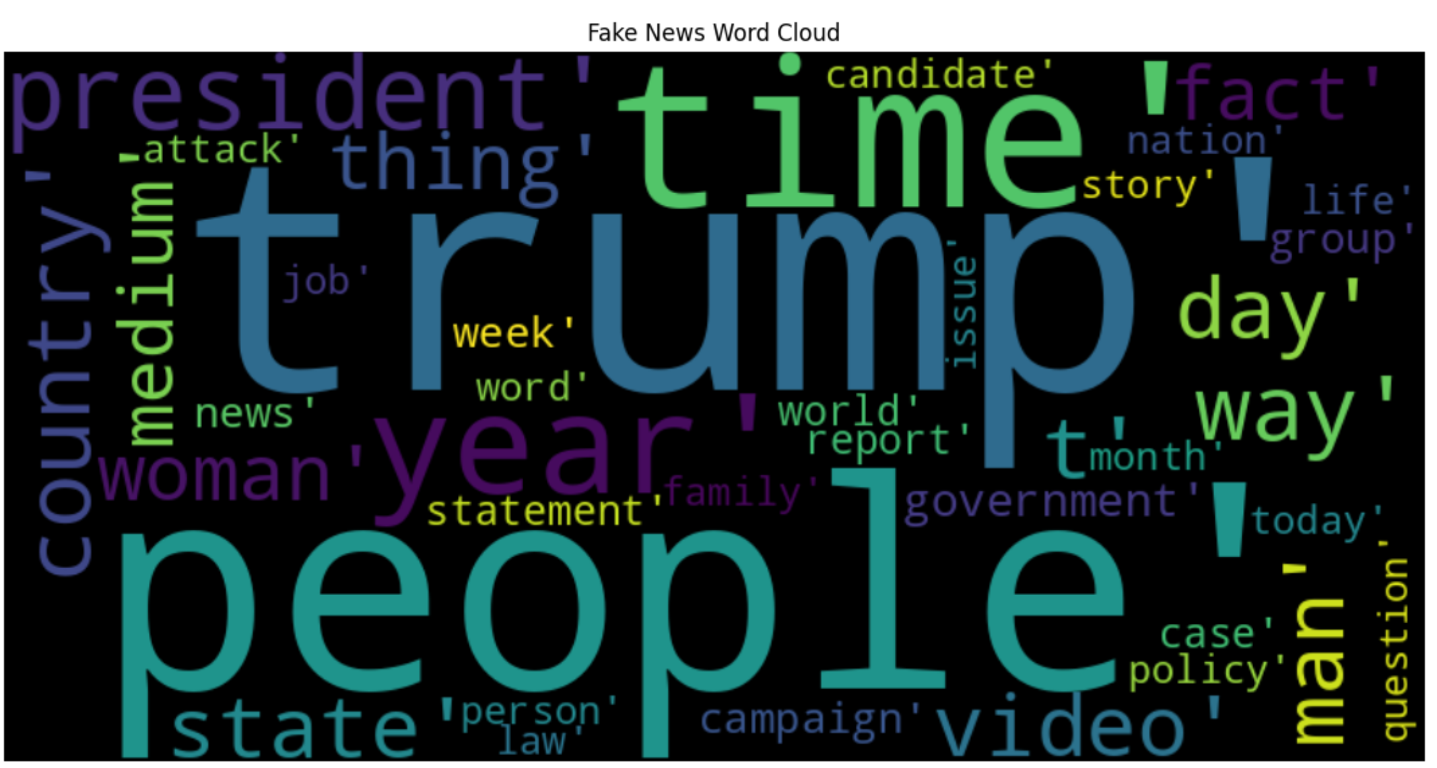

🔹 Top 10 Unigrams in True News

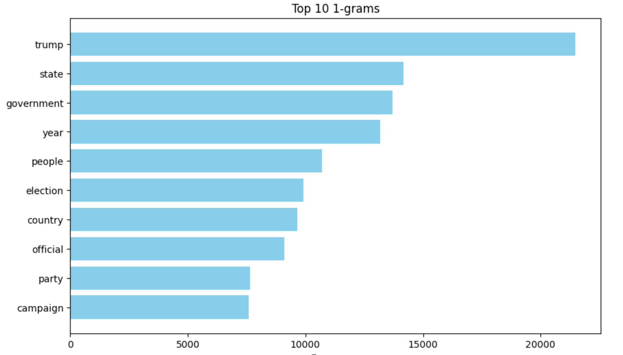

🔹 Top 10 Bigrams in True News

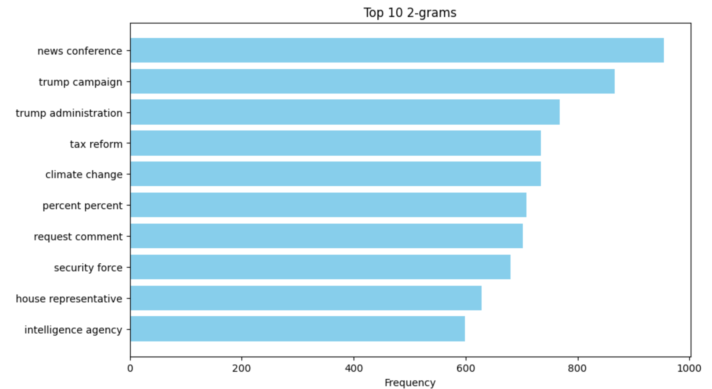

🔹 Top 10 Trigrams in True News

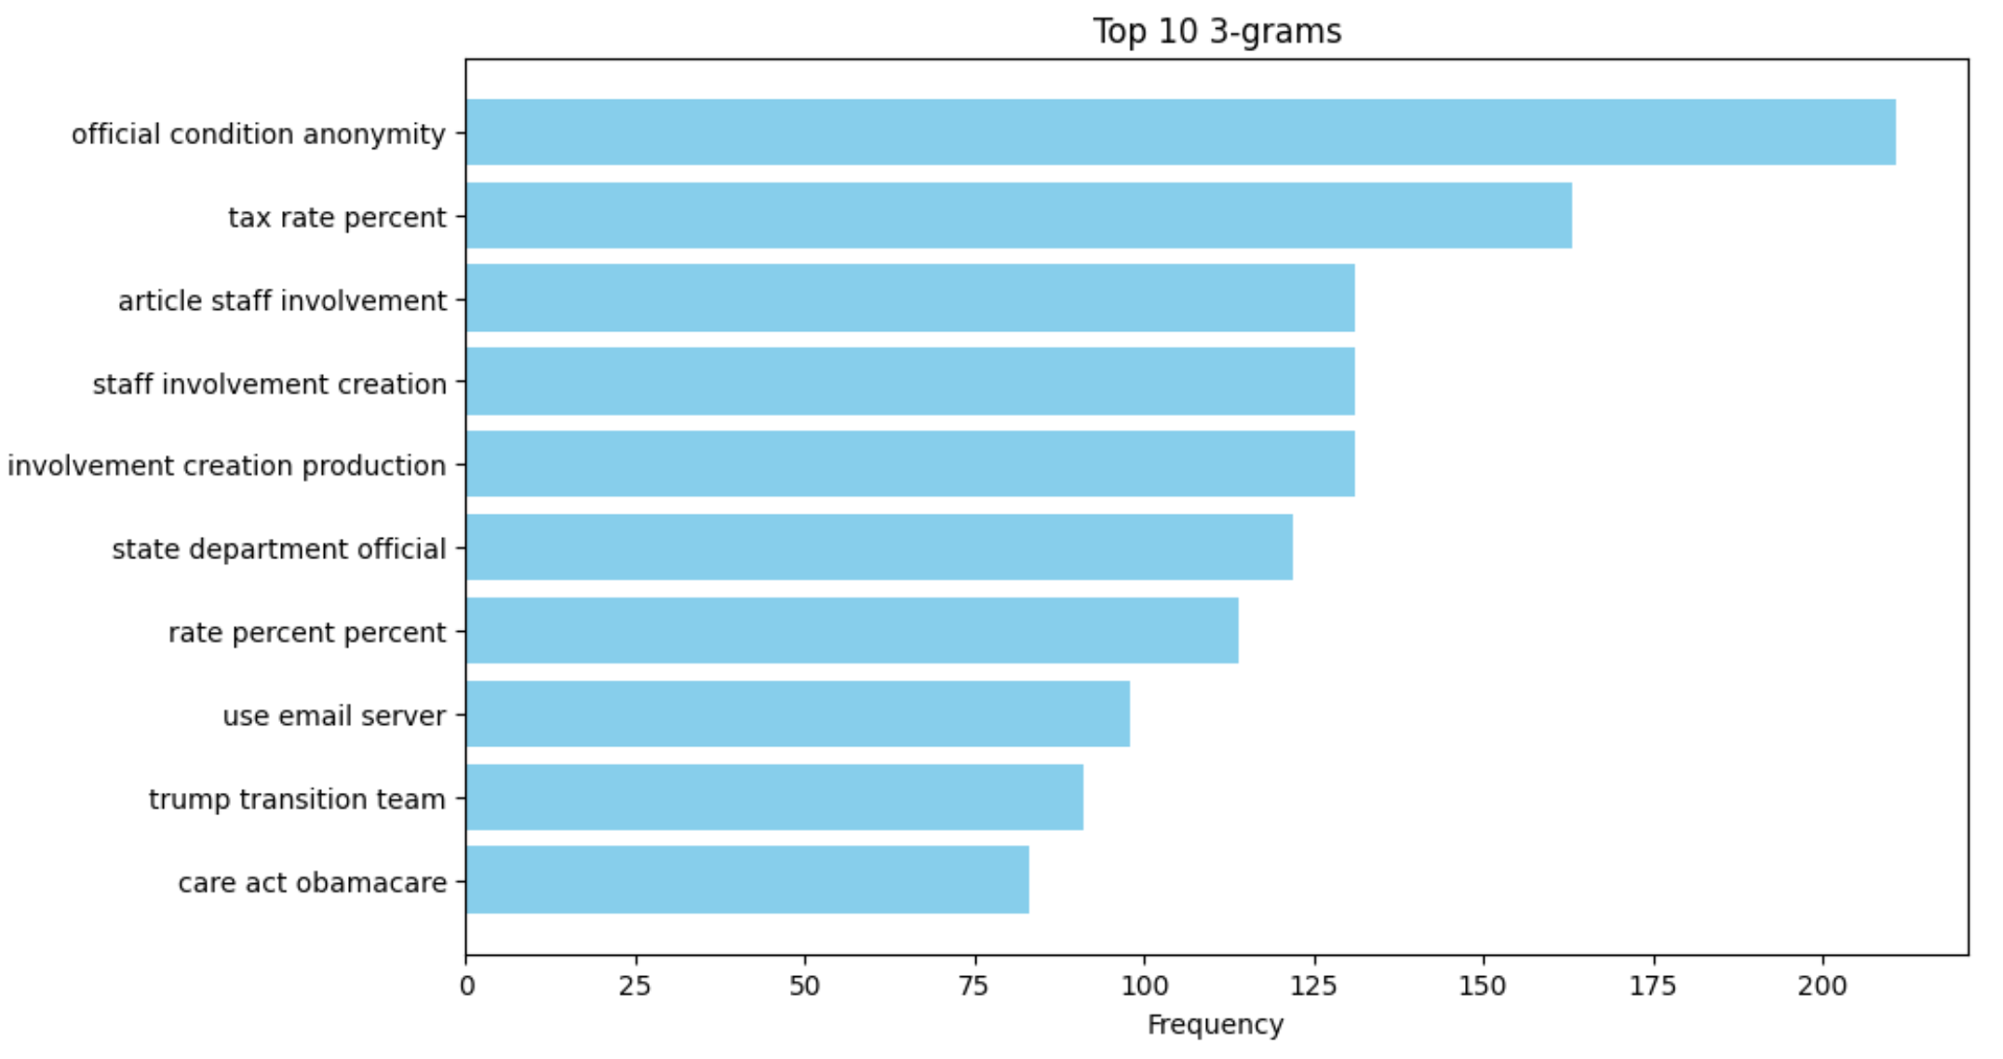

🔹 Top 10 Unigrams in Fake News

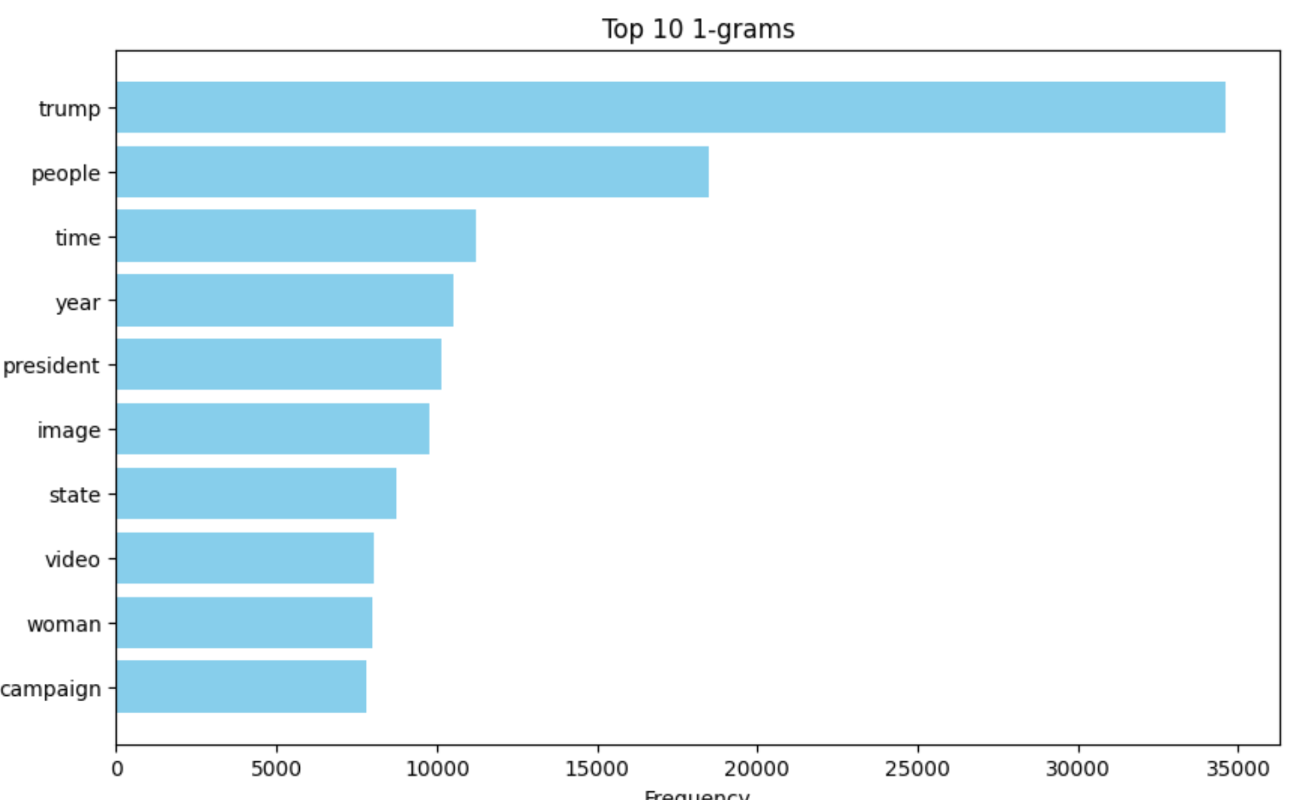

🔹 Top 10 Bigrams in Fake News

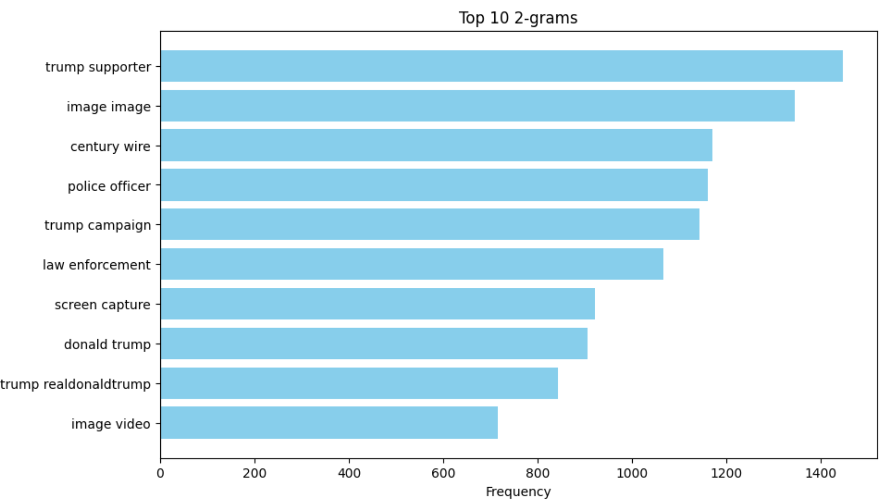🔹 Top 10 Trigrams in Fake News
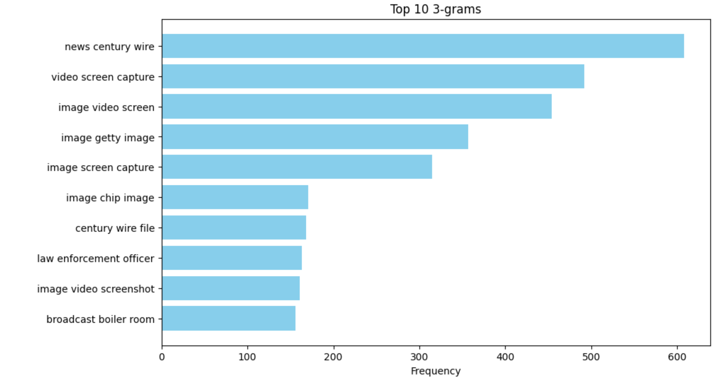

⚙️ 4. Techniques Used
- Preprocessing: spaCy for lemmatization and stopword removal
- TF-IDF Vectorization: Converted text to weighted word vectors
- Word Embedding’s: Pre-trained Word2Vec (word2vec-google-news-300) for semantic vectorization
- Classification Models: Random Forest (best), Logistic Regression, Decision Tree
- Metrics: Accuracy, Precision, Recall, F1 Score, Confusion Matrix

🏆 5. Model Results
- Best Model: ✅ Random Forest
- Accuracy: 0.9003
- Precision: 0.9082
- Recall: 0.8817
- F1 Score: 0.8947
F1 Score was prioritized to balance false positives and false negatives.

🔍 6. Insights & Conclusion
- True news used structured language tied to real events; fake news favored sensational tone.
- Semantic classification via TF-IDF and Word2Vec helped reveal deeper contextual meaning.
- Random Forest achieved nearly 90% accuracy and generalizable results.
- Effective for real-world tools in news filtering, fact-checking, and misinformation detection.

