# Spring Boot - Building RESTful Web Services

Spring Boot provides a very good support to building RESTful Web Services for enterprise applications.

**Note** − For building a RESTful Web Services, we need to add the Spring Boot Starter Web dependency into the build configuration file.

For running in PostMan

Get

1. 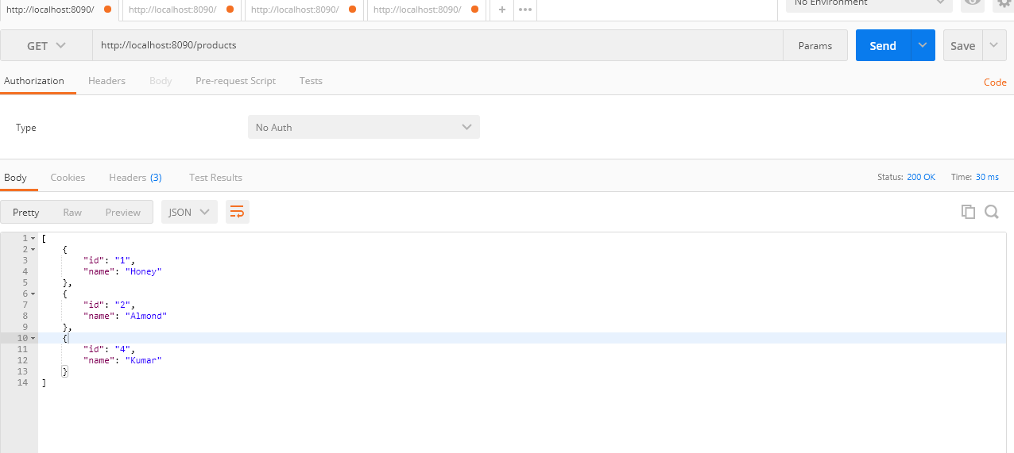

2. Post (Add)

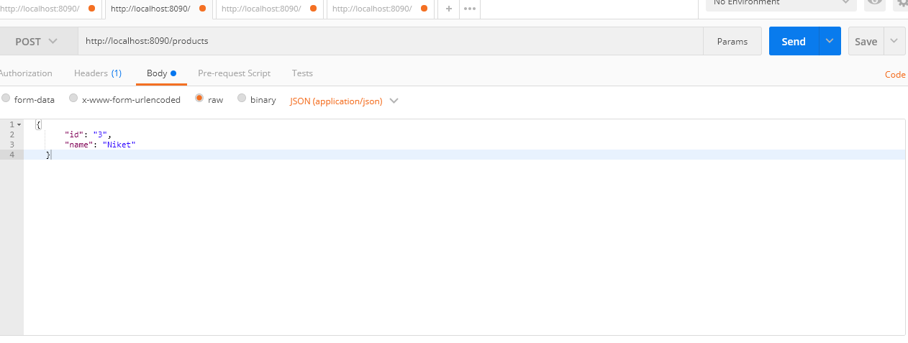

3. put(update)

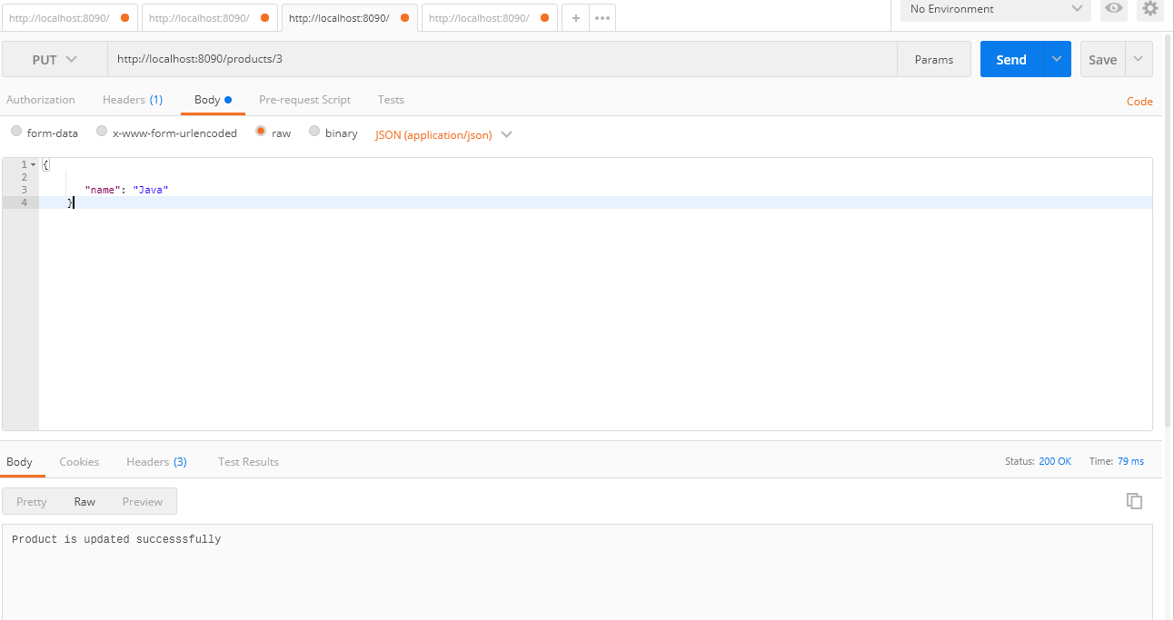

4.delete

