Assignment 02

## Java Assignment

Roman numerals are represented by seven different symbols: I, V, X, L, C, D and M.

Symbol Value

I 1

V 5

X 10

L 50

C 100

D 500

M 1000

For example, 2 is written as II in Roman numeral, just two ones added together. 12 is written as XII, which is simply X + II. The number 27 is written as XXVII, which is XX + V + II.

Roman numerals are usually written largest to smallest from left to right. However, the numeral for four is not IIII. Instead, the number four is written as IV. Because the one is before the five we subtract it making four. The same principle applies to the number nine, which is written as IX. There are six instances where subtraction is used:

I can be placed before V (5) and X (10) to make 4 and 9.

X can be placed before L (50) and C (100) to make 40 and 90.

C can be placed before D (500) and M (1000) to make 400 and 900.

Given a roman numeral, convert it to an integer.

Example 1:

Input: s = "III"

Output: 3

Explanation: III = 3.

Example 2:

Input: s = "LVIII"

Output: 58

Explanation: L = 50, V= 5, III = 3.

Example 3:

Input: s = "MCMXCIV"

Output: 1994

Explanation: M = 1000, CM = 900, XC = 90 and IV = 4.

Constraints:

s contains only the characters ('I', 'V', 'X', 'L', 'C', 'D', 'M').

## Selenium Assignment

Write selenium code to automate following features for “TutorialsNinja” application

1. Click on Add address button and verify that user is navigated to Add Address Page
2. Enter data in all the fields on add address page and submit the request.
3. Click on Edit icon next to the newly added address and verify / print the data displayed / selected in each field.
4. Navigate to Add Address page and click on continue button without entering any data verify / print the validation error message for all the fields.

Note: At the end of competing assignment 2, your test cases should be as follow (function names can be of your liking)

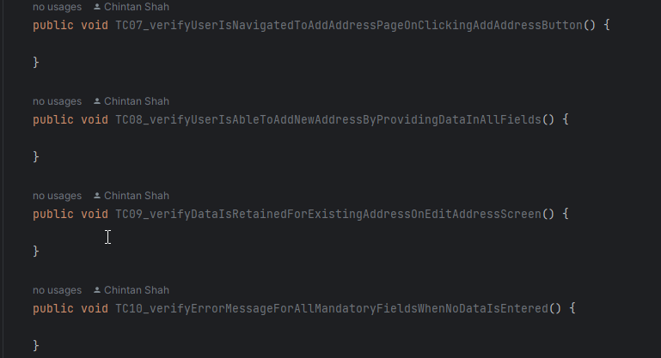

## Today’s practice code

public static void workingWithDropDownControl() throws InterruptedException {  
 WebDriver browser = new ChromeDriver();  
 browser.manage().window().maximize();  
 browser.navigate().to("https://omayo.blogspot.com/");  
 WebElement dd1 = browser.findElement(By.*id*("multiselect1"));  
 Select dd1MultiSelect = new Select(dd1);  
 dd1MultiSelect.selectByIndex(0);  
 dd1MultiSelect.selectByIndex(3);  
 dd1MultiSelect.selectByIndex(2);  
 Thread.*sleep*(3000);  
  
 List<WebElement> allSelectedOptions =  
 dd1MultiSelect.getAllSelectedOptions();  
 //forEach Loop  
 for (WebElement e:  
 allSelectedOptions) {  
 System.*out*.println(e.getText());  
 }  
 //forLoop  
 for(int i = 0; i < allSelectedOptions.size(); i++) {  
 System.*out*.println(allSelectedOptions.get(i).getText());  
 }  
 //Lamda expression  
 allSelectedOptions.forEach( x-> {  
 System.*out*.println(x.getText());  
 }  
 );  
 dd1MultiSelect.deselectAll();  
 Thread.*sleep*(3000);  
 browser.quit();  
}

public static void workingWithStringFormat() {  
 String user = "Chintan;";  
 double salary = 1000000;  
 int id = 1122;  
 //String concat  
 String s1 = "Welcome " + user + ", your salary is " + salary + ", your employee ID is " + id;  
  
 //String format  
 String s = "Welcome %-20s, your salary is %20.2f, your employee ID is %7d";  
 String formatted = String.*format*(s, user, salary, id);  
  
 System.*out*.println(formatted);  
}

public static void workingWithKeyboardCommands() throws InterruptedException {  
 WebDriver driver = new ChromeDriver();  
 driver.manage().window().maximize();  
 driver.navigate().to("https://tutorialsninja.com/demo/");  
 Thread.*sleep*(3000);  
  
 WebElement searchBar = driver.findElement(By.*name*("search"));  
 searchBar.sendKeys(Keys.*chord*(Keys.*LEFT_SHIFT*, "MacBook"));  
 Thread.*sleep*(3000);  
  
 searchBar.sendKeys(Keys.*ENTER*);  
 Thread.*sleep*(3000);  
}