From enterprise data to risk-aware decisions: a knowledge-based AI framework for digital transformation of retail operations
Short Communication
Niketh Sai Avirneniª
ª Midwest University, 851 Parr Rd., Wentzville, MO 63385, USA. Corresponding author: avirneninikethsai1144@gmail.com

Abstract
Forecasts are inputs to operational decisions, yet retail analytics often stops at point predictions. This short communication develops a knowledge-based AI framework that turns enterprise sales data into auditable replenishment decisions through four linked layers: a demand forecast, SHAP attribution, validation-calibrated risk strata, and an explicit rule base with a quantile order policy. We evaluate it on 10,000 item-store series from the public M5 retail data, using a chronological split and lead times of 1 and 28 days. On the held-out test window, gradient-boosted trees and a small LSTM reached an RMSE of 1.82 and 1.81 (1 day) and 2.05 and 2.03 (28 days), against 2.51 and 2.64 for a seasonal-naive benchmark, while a 28-day rolling mean was close behind, so forecast accuracy alone did not separate the approaches. Decision quality did. Under an assumed 8:1 understock-to-overstock cost ratio, risk-aware ordering lowered cost per unit of demand by 36% relative to ordering the point forecast (95% bootstrap interval 35.5–36.5%) and by 14% relative to a single global correction, with all calibration fitted on validation data only. Cost ratios are assumptions, not retailer data, and the study does not measure digital-transformation outcomes. Code and tests are public.
Keywords: knowledge-based systems; decision support; demand forecasting; explainable artificial intelligence; risk-aware inventory; digital transformation; retail analytics
1. Introduction
A forecast is an input to a decision, not the decision itself. In replenishment, the same demand forecast can justify different order quantities because running out of stock and holding excess stock rarely cost the same, which is why work on prescriptive analytics argues for optimising the decision directly [1]. Organisations that embed analytics in daily operations are often described as undergoing digital transformation [2]; the practical question for a knowledge-based system is how a prediction becomes an action that a manager can inspect, challenge and audit.
The M5 retail forecasting benchmark [3,4] showed that forecast accuracy and inventory performance are related but not interchangeable [5], and that probabilistic forecasts matter for stocking [6,7]. Less attention has gone to a compact, inspectable chain from forecast to explanation, calibrated reliability and rule-based recommendation, evaluated under a chronological holdout at more than one lead time. We state this gap narrowly and make no first-in-field claim; a systematic review is beyond a short communication. We ask: (RQ1) how seasonal-naive, XGBoost and LSTM forecasts compare at 1-day and 28-day lead times on chronological M5 data; (RQ2) whether explanations and validation-derived forecast-error risk can be turned into transparent inventory recommendations without leakage; and (RQ3) whether the risk-aware policy changes held-out decision cost relative to a point-forecast policy under stated cost assumptions.
We contribute (i) a four-layer framework in which every quantity that shapes an order is a model output, a validation-fitted statistic or an explicit rule; (ii) a leakage-controlled protocol that calibrates on validation data only and scores the test window once; and (iii) a decision-level evaluation of three ordering policies across assumed cost ratios with bootstrap intervals, which also shows where the forecasting model itself adds little. The explicit-rule philosophy follows knowledge-guided decision support published in this journal [8]; no method, data or result is transferred from it. The framework needs only sales history, prices and a calendar, which smaller and entrepreneurial retailers commonly hold (not tested here). We do not measure innovation, entrepreneurship or transformation outcomes.
2. Framework
Fig. 1 summarises the four layers and the evidence each produced in this study.
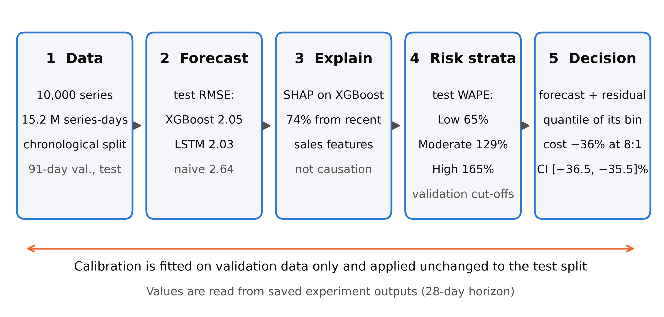
Fig. 1. The four-layer framework and the evidence each layer produced in this study (28-day horizon, test split). Values are read from saved experiment outputs. WAPE: weighted absolute percentage error; SHAP: Shapley additive explanations; CI: 95% bootstrap interval.
2.1 Forecast layer
For item-store series i and target day t, a direct forecast for lead time h days uses only information available h days earlier plus covariates that are known in advance:
ŷ_{i,t} = f_{h}( y_{i,s}, s ≤ t − h ; z_{i,t} ) (1)
where y is unit sales and z contains the listed price, calendar, event and SNAP (food-benefit) indicators of day t and static store and department codes. Planned prices and calendars are assumed known at order time, which is an assumption of the setting. Two forecasters implement f_{h}: gradient-boosted trees [9] and a small recurrent network [10].
2.2 Explanation layer
Shapley additive explanations [11] decompose each forecast into additive feature contributions. They describe what the fitted model used, not what causes sales [12], and are reported as such.
2.3 Validation-calibrated risk layer
On the validation split, forecast errors e_{i,t} = y_{i,t} − ŷ_{i,t} are grouped into ten forecast bins B_{k} (deciles of the validation forecasts). Each bin stores its residual distribution. Relative uncertainty is the bin’s error rate
u_{k} = Σ |e| / Σ y, summed over the cases in B_{k} (2)
and cases are labelled Low, Moderate or High risk at the 33rd and 67th percentiles of u over validation cases. Bins and cut-offs are then frozen and applied unchanged to the test split. These labels are experimental constructs, not organisational policy.
2.4 Decision layer
Let C_{u} and C_{o} be the unit costs of understocking and overstocking. For an order quantity Q, the cost of a case with demand y is
ℓ(Q, y) = C_{u} max(y − Q, 0) + C_{o} max(Q − y, 0) (3)
which is minimised in expectation by the τ-quantile of the demand distribution with τ = C_{u}/(C_{u} + C_{o}) [13]. Three policies are compared on identical cases: the point policy orders Q = ŷ; the global policy adds one validation residual quantile to every forecast; and the risk-aware policy adds the residual quantile of the case’s own forecast bin:
Q_{i,t} = max{ 0, ŷ_{i,t} + q_{τ}( e : ŷ ∈ B_{k(i,t)} ) } (4)
The cost reported is the total of ℓ divided by total realised demand. Finally, a six-rule base maps demand level (High or Low forecast, split at the validation 67th percentile) and risk label to a priority (P1–P4) and an action, for example High demand with High risk gives priority P2, an order at the risk-adjusted quantity, and a flag for human review. The rules are experimental and are not Walmart policy.
3. Experimental design
3.1 Data and split
We use the M5 Forecasting Accuracy data [3]: daily unit sales of 30,490 item-store series over 1,941 days (29 January 2011 to 22 May 2016), with prices and a calendar. The files came from a public community copy [14]; their dimensions and missing-value counts match the competition description, but byte-level equality with the original download was not verified. Zero sales make up 68.0% of daily entries (59.6% after the rule below), so percentage errors that divide by actuals were excluded.
To stay within a 5 GB memory cap (the full feature table is estimated at 6.24 GB) we drew 1,000 of 3,049 items at random, stratified by department (seed 42), keeping all 10 stores: 10,000 series across three states. A series-day is kept only if the item has a listed price that week, which is known in advance; in the full data this removes 20.8% of series-days, all with zero recorded sales, and stops not-yet-stocked days counting as zero demand. The chronological split is training 2011-01-29 to 2015-11-22; validation 2015-11-23 to 2016-02-21 (909,281 series-days); test 2016-02-22 to 2016-05-22 (910,000 series-days). The validation window contains the year-end holiday season; the test window does not.
3.2 Features, models and baselines
Each horizon uses 23 features: sales lags (1, 7, 14, 28 days at the 1-day lead; 28, 35, 42, 56 days at the 28-day lead), rolling mean, standard deviation and zero-share of the last 28 observable days, price and price ratios, calendar, event and SNAP indicators, and store and department codes. A unit test corrupts all sales after day t − h and confirms that no sales-derived feature changes. XGBoost used a Poisson objective on the GPU; four configurations were compared on validation and the best (depth 10, minimum child weight 200) was scored once on test. The LSTM has one layer of 64 units over the last 28 days of log sales, embeddings of calendar and store codes and a Poisson loss; it has 24,689 parameters, batch size 256, early stopping [15] and a GPU peak of 2592 MB (cap 4 GB, RTX 3060 laptop). Baselines are a seasonal naive forecast (sales 7 or 28 days earlier) and the 28-day rolling mean.
3.3 Metrics and decision evaluation
We report MAE, RMSE, WAPE (Σ|e| / Σy) and RMSSE, the mean over series of the RMSE scaled by the series’ training one-step naive error [16]. Decision cost is evaluated at C_{u}:C_{o} ∈ {1, 2, 4, 8, 16} with C_{o} = 1; because these ratios are assumptions, results are framed as relative changes. Intervals are 95% percentile intervals from 500 bootstrap resamples of series; they reflect sampling over series, not retraining or other test windows. Seeds, versions and split dates are logged, and 20 unit tests cover splits, leakage, metrics, risk labels and decision rules.
4. Results and discussion
4.1 Forecast accuracy
Table 1 gives test accuracy. XGBoost lowered RMSE by 27% (1-day lead) and 23% (28-day lead) against the seasonal naive forecast, but only by 6% and 2.7% against the 28-day rolling mean, a strong benchmark. The LSTM was marginally better than XGBoost at both leads (RMSE 1.81 vs 1.82 and 2.03 vs 2.05; differences of at most 0.7%, not tested for significance) but needed 1293 s and 715 s of GPU training against 30 s and 22 s. A 28-day lead raised XGBoost RMSE by 12%. WAPE stays high (70% and 76%) because daily item-level counts are small and noisy, which is where a point forecast is least safe to act on.
Table 1. Forecast accuracy on the test split (910,000 series-days) for 1-day and 28-day lead times. Best value per horizon in bold.
Horizon (days) | Model | MAE | RMSE | WAPE (%) | RMSSE | Training (s)
1 | Seasonal naive | 1.182 | 2.508 | 88.2 | 1.051 | –
1 | 28-day rolling mean | 0.975 | 1.943 | 72.7 | 0.779 | –
1 | XGBoost | 0.944 | 1.823 | 70.4 | 0.764 | 30
1 | LSTM | 0.937 | 1.811 | 69.8 | 0.764 | 1293
28 | Seasonal naive | 1.220 | 2.644 | 91.0 | 1.065 | –
28 | 28-day rolling mean | 1.026 | 2.104 | 76.5 | 0.804 | –
28 | XGBoost | 1.025 | 2.048 | 76.4 | 0.794 | 22
28 | LSTM | 1.017 | 2.033 | 75.8 | 0.793 | 715
Lower is better for all error metrics. RMSSE below 1 beats the in-sample one-step naive scale. Training time is wall-clock on one RTX 3060 Laptop GPU; baselines need no training.
4.2 What the models used
SHAP values on a random sample of 20,000 test cases show that recent-sales features account for 81% of mean absolute attribution at the 1-day lead and 74% at the 28-day lead. The leading feature at both leads is roll mean 28 (40% of attribution at 28 days); calendar and event features contribute 10%, store and department codes 9%, and price 8%. Attribution is on the model’s log-rate scale and describes model use only; it does not show that price or promotions cause demand to change.
4.3 Risk strata
At the 28-day lead, test WAPE rises from 65% in the Low stratum to 129% (Moderate) and 165% (High); the 1-day lead shows the same order (60%, 133%, 169%). The labels therefore carry information that held on data not used to build them. They largely track sales volume, however: mean demand per case is 2.64, 0.51 and 0.19 units in the three strata, so the strata express relative reliability and are not an independent uncertainty model. For transparency, a first version of the measure used absolute residual spread and labelled near-zero forecasts Low risk although their relative error was largest; it was replaced by Eq. (2) after inspecting stratum behaviour. The cost results do not depend on the labels.
4.4 Decision cost
Table 2 and Fig. 2 compare the three policies. At the 28-day lead and an 8:1 cost ratio, cost per unit of demand was 3.58 for the point policy, 2.67 with one global correction and 2.29 with the risk-aware policy, a 36.0% reduction against the point policy (95% interval 35.5–36.5%). The reduction grows with the cost ratio, from 8.0% at 1:1 to 54.8% at 16:1; at the 1-day lead it is 36.3% at 8:1, and with LSTM forecasts at the 28-day lead 35.2%. Because the point policy is a weak comparator when understocking is costly, the more informative comparison is with the global correction: the forecast-bin quantile lowered cost by a further 14% at 8:1 and 20% at 16:1. At 2:1 the global correction changed cost by under 0.1% while the risk-aware policy still lowered it by 4.7%. As a calibration check, at 8:1 the risk-aware order quantity covered realised demand in 88.7% of test cases against a target of 88.9%.
Table 2. Cost per unit of realised demand on the test split under three ordering policies (XGBoost forecasts).
Horizon (days) | C_{u}:C_{o} | Point | Global | Risk-aware | Change vs point (%) [95% CI]
1 | 1:1 | 0.70 | 0.67 | 0.65 | −7.8 [−8.0, −7.6]
1 | 2:1 | 1.06 | 1.06 | 1.01 | −4.4 [−4.5, −4.2]
1 | 4:1 | 1.77 | 1.62 | 1.47 | −16.5 [−16.8, −16.3]
1 | 8:1 | 3.18 | 2.38 | 2.03 | −36.3 [−36.7, −36.0]
1 | 16:1 | 6.02 | 3.37 | 2.68 | −55.4 [−55.8, −55.0]
28 | 1:1 | 0.76 | 0.72 | 0.70 | −8.0 [−8.4, −7.7]
28 | 2:1 | 1.17 | 1.17 | 1.11 | −4.7 [−4.9, −4.5]
28 | 4:1 | 1.97 | 1.79 | 1.64 | −16.6 [−17.0, −16.3]
28 | 8:1 | 3.58 | 2.67 | 2.29 | −36.0 [−36.5, −35.5]
28 | 16:1 | 6.79 | 3.84 | 3.07 | −54.8 [−55.4, −54.2]
C_{u}:C_{o} are assumed understock-to-overstock cost ratios, not retailer data. Intervals are 95% bootstrap intervals over series. Point: order the forecast; Global: add one validation residual quantile; Risk-aware: add the residual quantile of the forecast bin.
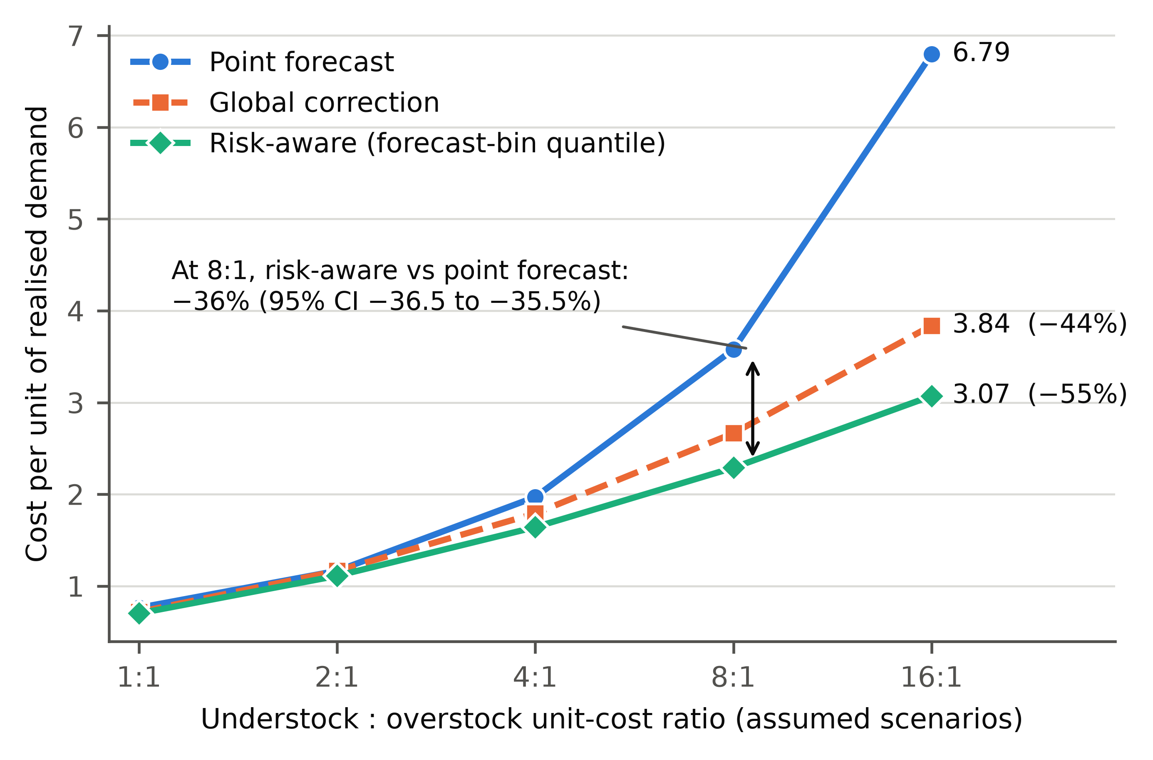
Fig. 2. Cost per unit of realised demand against the assumed understock-to-overstock cost ratio (XGBoost forecasts, 28-day lead, test split). The arrow marks the risk-aware reduction at 8:1 with its 95% bootstrap interval.
4.5 Implications for decision support
Once a reasonable forecast exists, further accuracy gains returned little here, whereas converting forecasts into orders with validation-calibrated error information lowered cost consistently whenever the two kinds of error carry different costs. Because each correction is a stored table of residual quantiles and each recommendation follows one of six stated rules, a planner can see why an order was raised and which cases were flagged for review. This supports the knowledge-based decision-support view; it is not evidence about digital-transformation outcomes.
5. Limitations
The cost ratios are assumptions, so reductions are scenario results, not retailer savings. The decision model is a single-period, case-by-case order with no replenishment lead time, carry-over, capacity or service-level constraint. The study uses 10,000 of 30,490 series from a community copy of the data, one 91-day test window and one random seed; intervals do not capture variation across windows or retraining. The validation window contains a holiday season that the test window lacks, which may make calibration conservative for other periods. Calibration is by forecast bin and coverage was checked in aggregate only. Hyperparameter search was small, and the LSTM was not tuned beyond one configuration. The risk definition was revised once after inspecting test strata (Section 4.3). M5 holds no data on innovation, entrepreneurship or organisational transformation, so none is claimed.
6. Conclusion
A forecast becomes a decision only when its reliability and the cost of being wrong are brought in. On 10,000 M5 series, a four-layer knowledge-based framework with validation-only calibration lowered assumed stock cost by 36% against ordering the point forecast at an 8:1 cost ratio, and by a further 14% against a single global correction, while the forecasting model itself added little over a 28-day mean. Future work should use real cost data, multi-period inventory dynamics, several test windows, and conditional or conformal coverage guarantees.
Data and code availability
The M5 files are public [3]; this study used the community copy cited above. All code, tests, configuration and the scripts that generate every table and figure are in https://github.com/nikethsaiavirneni/from-enterprise-data-to-risk-aware-decisions. [AUTHOR TO COMPLETE: deposit the derived result files (metrics, predictions, SHAP summaries) in a data repository such as Zenodo and cite its DOI here, as this journal requires.]
Declaration of competing interest
The author declares that there are no known competing financial interests or personal relationships that could have appeared to influence the work reported in this paper.
Funding
This research did not receive any specific grant from funding agencies in the public, commercial, or not-for-profit sectors.
Declaration of generative AI and AI-assisted technologies in the manuscript preparation process
During the preparation of this work the author used Claude (Anthropic) to assist with writing analysis code and drafting text. After using this tool, the author reviewed and edited the content as needed and takes full responsibility for the content of the published article.
CRediT authorship contribution statement
Niketh Sai Avirneni: Conceptualization, Methodology, Software, Formal analysis, Visualization, Writing – original draft, Writing – review and editing.
References
[1] D. Bertsimas, N. Kallus, From predictive to prescriptive analytics, Manag. Sci. 66 (2020) 1025–1044. https://doi.org/10.1287/mnsc.2018.3253.
[2] G. Vial, Understanding digital transformation: a review and a research agenda, J. Strateg. Inf. Syst. 28 (2019) 118–144. https://doi.org/10.1016/j.jsis.2019.01.003.
[3] S. Makridakis, E. Spiliotis, V. Assimakopoulos, The M5 competition: background, organization, and implementation, Int. J. Forecast. 38 (2022) 1325–1336. https://doi.org/10.1016/j.ijforecast.2021.07.007.
[4] S. Makridakis, E. Spiliotis, V. Assimakopoulos, M5 accuracy competition: results, findings, and conclusions, Int. J. Forecast. 38 (2022) 1346–1364. https://doi.org/10.1016/j.ijforecast.2021.11.013.
[5] E. Theodorou, E. Spiliotis, V. Assimakopoulos, Forecast accuracy and inventory performance: insights on their relationship from the M5 competition data, Eur. J. Oper. Res. 322 (2025) 414–426. https://doi.org/10.1016/j.ejor.2024.12.033.
[6] E. Spiliotis, S. Makridakis, A. Kaltsounis, V. Assimakopoulos, Product sales probabilistic forecasting: an empirical evaluation using the M5 competition data, Int. J. Prod. Econ. 240 (2021) 108237. https://doi.org/10.1016/j.ijpe.2021.108237.
[7] S. Makridakis, E. Spiliotis, V. Assimakopoulos, Z. Chen, et al., The M5 uncertainty competition: results, findings and conclusions, Int. J. Forecast. 38 (2022) 1365–1385. https://doi.org/10.1016/j.ijforecast.2021.10.009.
[8] S. Thota, Quantum-inspired knowledge-guided decision support for risk-aware UAV mission planning in contested environments, Knowl.-Based Syst. 351 (2026) 116815. https://doi.org/10.1016/j.knosys.2026.116815.
[9] T. Chen, C. Guestrin, XGBoost: a scalable tree boosting system, in: Proc. 22nd ACM SIGKDD Int. Conf. Knowl. Discov. Data Min., 2016, pp. 785–794. https://doi.org/10.1145/2939672.2939785.
[10] S. Hochreiter, J. Schmidhuber, Long short-term memory, Neural Comput. 9 (1997) 1735–1780. https://doi.org/10.1162/neco.1997.9.8.1735.
[11] S.M. Lundberg, S.-I. Lee, A unified approach to interpreting model predictions, in: Adv. Neural Inf. Process. Syst. 30, 2017. https://papers.nips.cc/paper/2017/hash/8a20a8621978632d76c43dfd28b67767-Abstract.html.
[12] C. Rudin, Stop explaining black box machine learning models for high stakes decisions and use interpretable models instead, Nat. Mach. Intell. 1 (2019) 206–215. https://doi.org/10.1038/s42256-019-0048-x.
[13] T. Gneiting, Quantiles as optimal point forecasts, Int. J. Forecast. 27 (2011) 197–207. https://doi.org/10.1016/j.ijforecast.2009.12.015.
[14] [dataset] Nixtla, M5 forecasting datasets (community copy of the M5 Forecasting Accuracy files) [dataset], GitHub. https://github.com/Nixtla/m5-forecasts (accessed 23 October 2026).
[15] A. Paszke, S. Gross, F. Massa, et al., PyTorch: an imperative style, high-performance deep learning library, arXiv:1912.01703 (2019). https://arxiv.org/abs/1912.01703.
[16] R.J. Hyndman, A.B. Koehler, Another look at measures of forecast accuracy, Int. J. Forecast. 22 (2006) 679–688. https://doi.org/10.1016/j.ijforecast.2006.03.001.

