**The task of creating an enterprise geodatabase and loading data for the wind farm for CEZ need several major steps. First, the entire configuration and schema of the database would be created in a file geodatabase. The second step is to transition from the file geodatabase to an enterprise geodatabase. The final step is to configure and set up branch versioning, editor tracking, and archiving enabled and the map.**

1. **CHECKING DXF SOURCE DATA**

The first task is to open the provided DXF files contain data from 8 circuits, originating from one substation - CEZ Wind Farm (110 kV / 20 kV). It has to examine their geometry, location, and attribute information. To correctly load the graphic information from them, it was necessary to edit the following items in the .dxf files. They were opened with Notepad++ and the following lines in each of them were changed:

AcDbDictionary

281

1

3

Възлова_станция_ВС

350

989

3

Подстанция_СрН

350

97F

3

Проводник_СрН_въздушна_изолирана_линия

350

9B0

3

Проводник_СрН_въздушна_линия

350

9A6

3

Проводник_СрН_други

350

9A1

3

Проводник_СрН_подземна_линия

350

9AB

3

Разпределителна_станция_ТП

The underscores are necessary for the correct loading of the attribute data (without them the attribute tables were empty). As a resume each DXF file contains:

1. CEZ Wind Farm-Текстил-PL1109-20 kV:

– ПС: S16480 – source (substation - CEZ Wind Farm (110 kV / 20 kV)

1. CEZ Wind Farm-Сомовит-PL1108-20 kV:

– X – source (substation - CEZ Wind Farm (110 kV / 20 kV)

1. CEZ Wind Farm-Роза-PL1101-20 kV:

– ПС: S18114 – source (substation - CEZ Wind Farm (110 kV / 20 kV)

1. CEZ Wind Farm-Победа-PL1107-20 kV:

– ПС: S20703 – source (substation - CEZ Wind Farm (110 kV / 20 kV)

1. CEZ Wind Farm-Комарево-PL1103-20 kV:

– ПС: S15385 – source (substation - CEZ Wind Farm (110 kV / 20 kV

1. CEZ Wind Farm-Дъбован-PL1106-20 kV:

– ПС: S14137 – source (substation - CEZ Wind Farm (110 kV / 20 kV)

1. CEZ Wind Farm-Гиген-PL1105-20 kV:

– ПС: S18319 – source (substation - CEZ Wind Farm (110 kV / 20 kV)

1. CEZ Wind Farm-Бръшляница-PL1102-20 kV:

– ВС: S19119 – source (substation - CEZ Wind Farm (110 kV / 20 kV)

|  |  |  |  |
| --- | --- | --- | --- |
| **Слой** | **Описание** | **Обектен Клас** | **Име на блок** |
| 1_2 | Подстанция СрН/СрН ПС-СН | Подстанция СрН | PS-1_2 |
| 1_4 | Разпределителна станция (ТП) | Разпределителна станция ТП | TP-1_4 |
| 1_5 | Възлова станция (ВС) | Възлова станция ВС | VS-1_5 |
| 3_1 | Стълб НН - стоманобетонен | Стълб НН стоманобетонен | PYLON-LV-3_1 |
| 3_2 | Стълб НН - всички останали | Стълб НН всички останали | PYLON-LV-3_2 |
| 3_10 | Стълб НН - дървен | Стълб НН дървен | PYLON-LV-3_10 |
| 8_1 | РОМ-РОС | РОМ РОС | SECTIONALIZER-8_1 |
| 21_1 | Проводник СрН - други | Проводник СрН други |  |
| 21_2 | Проводник СрН - въздушна линия | Проводник СрН въздушна линия |  |
| 21_3 | Проводник СрН - подземна линия | Проводник СрН подземна линия |  |
| 21_4 | Проводник СрН - въздушна изолирана линия | Проводник СрН въздушна изолирана линия |  |
| 28_1 | Стълб СрН - всички останали | Стълб СрН всички останали | PYLON-MV-28_1 |
| 28_2 | Стълб СрН - стоманобетонен | Стълб СрН стоманобетонен | PYLON-MV-28_2 |
| 28_3 | Стълб СрН - стоманорешетъчен | Стълб СрН стоманорешетъчен | PYLON-MV-28_3 |
| 28_4 | Стълб СрН - композитен | Стълб СрН композитен | PYLON-MV-28_4 |
| 28_5 | Стълб СрН - дървен | Стълб СрН дървен | PYLON-MV-28_5 |
| 57_1 | Текст със забележка |  |  |
| 57_2 | Описателен текст |  |  |

*Table 1 – Available Layers*

|  |  |  |  |
| --- | --- | --- | --- |
| **Блок** | **Описание** | **Атрибути** | **Изглед** |
| PS-1_2 | Подстанция СрН/СрН ПС-СН | FIELD_ID |  |
| TP-1_4 | Разпределителна станция (ТП) | FIELD_ID |  |
| VS-1_5 | Възлова станция (ВС) | FIELD_ID |  |
| PYLON-LV-3_1 | Стълб НН - стоманобетонен | FIELD_ID |  |
| PYLON-LV-3_2 | Стълб НН - всички останали | FIELD_ID |  |
| PYLON-LV-3_10 | Стълб НН - дървен | FIELD_ID |  |
| SECTIONALIZER-8_1 | РОМ-РОС |  |  |
| PYLON-MV-28_1 | Стълб СрН - всички останали | FIELD_ID |  |
| PYLON-MV-28_2 | Стълб СрН - стоманобетонен | FIELD_ID |  |
| PYLON-MV-28_3 | Стълб СрН - стоманорешетъчен | FIELD_ID |  |
| PYLON-MV-28_4 | Стълб СрН - композитен | FIELD_ID |  |
| PYLON-MV-28_5 | Стълб СрН - дървен | FIELD_ID |  |

*Table 2 – Available blocks*

1. **PROPOSED SCHEMA FOR ENTERPRISE GEODATABASE**

The provided data model specification can be extended to meet the requirements - Data Model Specification. In the Excel sheet the necessary attribute fields to be attached to the graphics in ArcGIS Pro are described.

The provided requirements a little bit transformed and these changes are proposed:

* Merging the fields for line features:

1. **224 km of 20kV Cables (95 mm sections)**:
2. **64 km of 110kV Cables (500 mm sections)**:

* Merging the fields for line features:

**1) 1 Connection Station (110kV)**:

**2) 7 Electrical Stations (110/20kV)**:

* Define Feature Classes

1. **LINE FEATURE CLASS – Conductor**
2. **POINT FEATURE CLASS – Station**

|  |  |  |  |  |  |  |
| --- | --- | --- | --- | --- | --- | --- |
| **Dataset** | **Table Name** | **Name** | **Alias** | **Type** | **Length** | **Required** |
| Electric | Station | SUBTYPE_CD | SUBTYPE_CD | Short |  | REQUIRED |
| Electric | Station | ADMIN_UNIT_TYPE | Administrative Unit Type | Text | 64 | NON_REQUIRED |
| Electric | Station | ADMIN_UNIT_CODE | Administrative Unit Code | **Text** |  | NON_REQUIRED |
| Electric | Station | LOCATION | Location | Text | 64 | NON_REQUIRED |
| Electric | Station | NAME | Name | Text | 64 | NON_REQUIRED |
| Electric | Station | **VOLTAGE** | **Voltage (kV)** | **Long** |  | NON_REQUIRED |
| Electric | Station | TRANSFORMER_UNIT_COUNT | Transformer Units Count | Short |  | NON_REQUIRED |
| Electric | Station | INSTALLED_POWER | Installed Power (MVA) | Double |  | NON_REQUIRED |
| Electric | Station | CUI_OPERATOR | CUI Operator | Text | 64 | NON_REQUIRED |
| Electric | Station | ASSET_NUMBER | Asset Number | Text | 64 | NON_REQUIRED |
| Electric | Station | ACCOUNT_VALUE_LEI | VALOARE_CONTABILA_LEI | Double |  | NON_REQUIRED |
| Electric | Station | NR_PVRTL | NR_PVRTL | Text | 64 | NON_REQUIRED |
| Electric | Station | DATA_PVRTL | DATA_PVRTL | Date |  | NON_REQUIRED |
| Electric | Conductor | SUBTYPE_CD | SUBTYPE_CD | Short |  | REQUIRED |
| Electric | Conductor | ADMIN_UNIT_CODE | Administrative Unit Code | Long |  | NON_REQUIRED |
| Electric | Conductor | LOCATION | Location | Text | 64 | NON_REQUIRED |
| Electric | Conductor | SUBNETWORK_NAME | Subnetwork Name | Text | 64 | NON_REQUIRED |
| Electric | Conductor | STATION_NAME | Station Name | Text | 64 | NON_REQUIRED |
| Electric | Conductor | **VOLTAGE** | **Voltage (kV)** | **Long** |  | NON_REQUIRED |
| Electric | Conductor | VOLTAGE_GROUP | Voltage Group | Text | 3 | NON_REQUIRED |
| Electric | Conductor | LENGTH_KM | Length (km) | Double |  | NON_REQUIRED |
| Electric | Conductor | CUI_OPERATOR | CUI Operator | Text | 64 | NON_REQUIRED |
| Electric | Conductor | ASSET_NUMBER | Asset Number | Text | 64 | NON_REQUIRED |
| Electric | Conductor | ACCOUNT_VALUE_LEI | VALOARE_CONTABILA_LEI | Double |  | NON_REQUIRED |
| Electric | Conductor | NR_PVRTL | NR_PVRTL | Text | 64 | NON_REQUIRED |
| Electric | Conductor | DATA_PVRTL | DATA_PVRTL | Date |  | NON_REQUIRED |

After the analysis, the following schema for creating two feature classes - **Station and Conductor**, united in a common feature dataset **Electric**, is proposed. The attached table illustrates the attribute structure of the two feature classes.

*Table 3 – Attribute Fields*

Data from the layers and blocks of the objects in DXF files is used. The name of the files was also a data source for auto-filling some attribute fields. The next table shows for the two feature classes which attributes from the source data were imported into the file geodatabase.

1. Data from name of a file: CEZ Wind Farm-Текстил-PL1109-20 kV:

* Station Name;
* Subnetwork Name;
* Voltage, based on it, voltage group can be identified – low, medium or high;
* Location – overhead conductor, underground conductor or other conductor.

1. Data from existing drawing attributes:

* Layer Name – for example layer 21.2 describes Underground Conductor;
* Field_ID – is an attribute corresponding desired ASSET_NUMBER;
* Length – is an attribute containing geometry for a line object. It can be used to fill attribute field LENGTH_KM in Conductor feature class;

In addition to fields***, subtypes, domains, and global IDs*** are created for some of the columns in the attribute table. The next table shows the subtypes as well as the created domains.

|  |  |  |  |  |
| --- | --- | --- | --- | --- |
| Dataset | Table Name | Subtype Field | Code | Description |
| Electric | Station | SUBTYPE_CD | 0 | Main Station |
| Electric | Station | SUBTYPE_CD | 1 | Secondary Station |
| Electric | Station | SUBTYPE_CD | 2 | Distribution Station |
| Electric | Conductor | SUBTYPE_CD | 0 | Underground Conductor |
| Electric | Conductor | SUBTYPE_CD | 1 | Overhead Conductor |
| Electric | Conductor | SUBTYPE_CD | 2 | Other Conductor |

*Table 4 – Subtypes*

|  |  |  |  |  |
| --- | --- | --- | --- | --- |
| Dataset | Table Name | Field Name | Type | Domain |
| Electric | Station | ADMIN_UNIT_TYPE | Text | Administrative_Unit_Type |
| Electric | Station | ADMIN_UNIT_CODE | **Text** | Administrative_Units |
| Electric | Station | LOCATION | Text | Station_Location_Type |
| Electric | Station | VOLTAGE | Long | Voltage |
| Electric | Conductor | LOCATION | Text | Line_Location_Type |
| Electric | Conductor | VOLTAGE | Long | Voltage |
| Electric | Conductor | VOLTAGE_GROUP | Text | Voltage_Group |

*Table 5 – Domains*

|  |  |  |  |  |
| --- | --- | --- | --- | --- |
| Dataset | Table Name | Name | Alias | Type |
| Electric | Station | GLOBALID | GLOBALID | Global ID |
| Electric | Conductor | GLOBALID | GLOBALID | Global ID |

*Table 6 – Global IDs*

The **Generate Schema Report** geoprocessing tool generates a readable Excel, JSON, PDF, or

HTML is helping to report detailly the geodatabase schema is definition. It is a way to visualize and explore the data model, as a data dictionary.

**3. DATA LOADING TOOLS**

The Data Loading Tools toolbox contains tools that streamline loading data from a source schema to a target dataset and allow in-process data transformation. Next tools are suitable for loading data for the task:

* **Create Data Loading Workspace** that can be used for data loading. The generated workspace contains a collection of Microsoft Excel workbooks. Create a predefined mapping table to match datasets, fields, and attribute domain coded value descriptions from a source and a target schema.
* **The Data Loading Workspace** is the output generated from the Create Data Loading Workspace tool. The workspace contains folders, Excel workbooks, and other items to assist in mapping data from a source to a target schema.
* **Load Data to Preview** uses a Data Loading Workspace to load data from a source to a preview geodatabase. Use this tool to preview the results before loading data to the target schema.
* **Load Data Using Workspace** uses the Data Reference Workbook from the Data Loading Workspace to load data from a source to a target dataset.

**4. ENTERPRISE GEODATABASE**

After successfully loading the data into the file geodatabase they can be transfered to the Enterprise geodatabase. 372 Conductors and 157 Stations are loaded. First, it was necessary to create an Enterprise Geodatabase using this tool: **Create Enterprise Geodatabase**.

* Create Enterprise Geodatabase

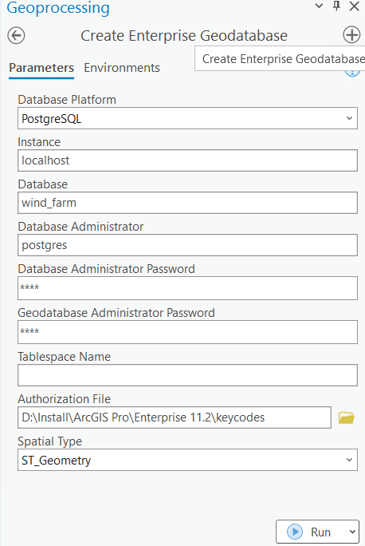

Figure 1 - Create a multiuser geodatabase in PostgreSQL.

Ensure that you are connect to PostgreSQL or another RDBMS server and confirm that the necessary Windows services are running. PostgreSQL should be configured to use ST_GEOMETRY data type.

Then, Geodatabase Connections were created for different owners: postgres (database administrator), sde (geodatabase administrator). If it is needed more database connections best is hold them in a folder data_connections.

* Create a Geodatabase Connection

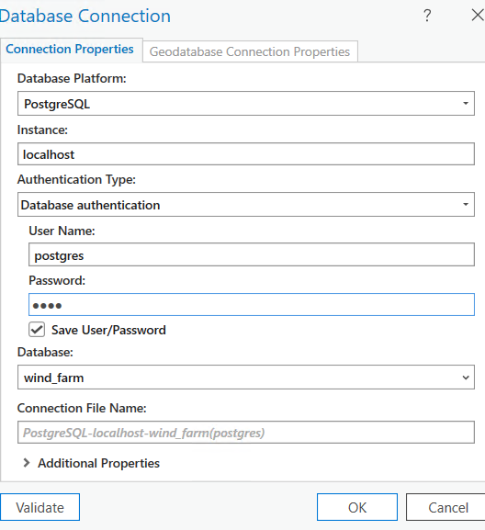

Figure 2 - Create a connection.

GISOWNER is the one who can add data. Therefore, only the database administrator can create the gisonwer through the following tool: **Create Database User**. Electric feature dataset was copied from a cezwindfarm.gdb file geodatabase into cez_wind_farm.sde enterprise geodatabase.

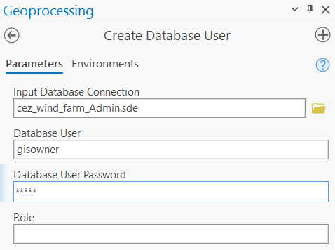

Figure 3 - Create a GIS owner to hold datasets and features.

Branch versioning is a type of geodatabase versioning that works with the ArcGIS Enterprise Web GIS model using a services-based architecture to allow multiuser editing workflows and long transaction scenarios through web feature layers. Web feature layers (also known as feature services) are layers that are shared to support displaying, querying, and editing data on the web. The data must be ***registered as branch versioned*** and published from an enterprise geodatabase. Once the web feature layers are published, branch versioning allows to track edits for insert, update, and delete operations on features in a version.

If the data is registered as branch versioned querying and editing the data occur on the default version. Cannot use any of the Version Management operations such as those that create or delete named versions or modify versions, and cannot use the reconcile and post operations.

**Consideration:** Editors edit branch versioned data only through the web feature layer. Don’t connect to the geodatabase in ArcGIS Pro using a database connection and edit the data. Here the step for setting Branch versioning are shown.

* Manage Active Connection

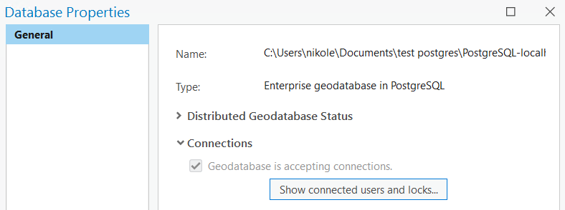

Figure 4 – Database Properties.

* Set to Branch Versioning

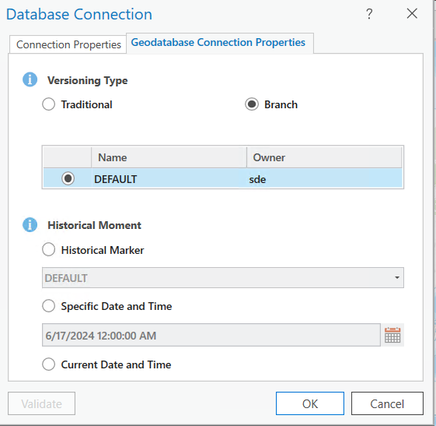

Figure 5 – Geodatabase Properties.

It was created a multiuser editing environment that is highly performant and scalable and is easy to access for any collaborations in group. As such, it was configured data to be used in branch versioning environment.

With the Branch versioning options set in the Geodatabase Connection Properties dialog box, next the data is enabled for branch versioning and global IDs and editor tracking have been enabled.

## **1. Enable archiving**

You have the option to enable archiving on traditional versioned or non-versioned data to track historical data.

***For branch versioning, the ability to track historical edits using archiving is enabled automatically*** during the register data as branch versioned process. This is because Branch versioning is based on temporal model that archives edits in a single table.

## **2. Register a database as a data store**

User-managed data can be registered with ArcGIS Enterprise prior to publishing. Also, it can be registered within the publishing process. The feature service is configured with version management and dedicated instance pooling.

After registering data as branch versioned, the data can be published to an ArcGIS Enterprise organization/group as a web feature layer (feature service) that references registered data. The data is then available for editing as part of branch versioning workflows.

All branch versioned data is published from the default version. To work with branch versioned datasets in a named version and have them participate in versioning workflows, enable the Version Management capability when you publish the web feature layer.

**3. Version management**

To create and work with named versions, you must enable the Version Management capability when you publish branch versioned data. If you do not enable this capability, the web feature layer will always access the default version.

The Version Management capability allows you to do the following with the web feature layer:

* Create, modify, and delete named versions.
* Change the version for active feature layers in the map.
* Edit data in a named version.

Undo and redo capabilities are available when you edit a named version - undo or redo individual edits + save or discard edits for the entire edit session.

* Reconcile and post edits.

To enable the Version Management capability, the following requirements exist:

* All datasets in the map being published must be branch versioned. Cannot publish traditional and branch versioned datasets in the web feature layer.
* You must own the data you're publishing. That means the credentials you use in the database connection that accesses the data must be those of the data owner.

**4. Publish versioned data**

In the Share As Web Layer pane two errors should be resolved before publishing. Both indicate that the data source must be registered.

Server Database Connection the same connection is being used as the Publisher Database Connection. The choice for sharing this Data Store item is in the same dialog window. Publishing data is appropriate if additional members of the group/organization would be publishing data from this database connection, then it is needed to share this data store item with those members or share the item with a publishing group to which those members belong.

**4. Access the data**

To access the version capabilities, feature layers are added to be map from Portal tab (instead

of using a direct connection to the Enterprise geodatabase).

Next, in the Manage Versions option a different number of versions can be created. They all will be derived from the DEFAULT.

Branch versioned data is published as a web feature layer. The web layers are shared with a group with Share and then Editing Group Sharing option allows selecting to which group its content will be available. The portal members who need to edit the feature layer are members with a role that includes the privilege to edit features. In this case all members are with Administrator role so they all can edit the web feature layers. As a member with Administrator role custom roles can be created.

Editors now are ready to begin their multiuser editing workflow.