**Team – HackeThors**

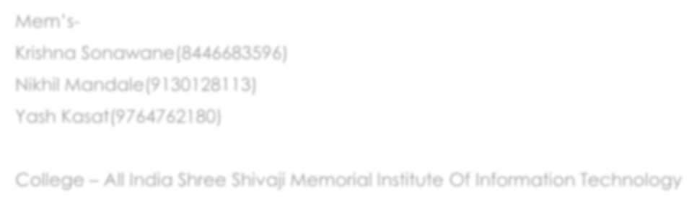

Mem’s

-

Krishna Sonawane(8446683596)

Nikhil Mandale(9130128113)

Yash Kasat(9764762180)

College

–

All India Shree Shivaji Memorial Institute Of Information Technology

**Theme – Biomedical and Healthcare**

**Problem statement –**

* **How one can reach to doctor without actually visiting doctors clinic?**
* **How to get medical assistance online?**
* **How to cure common diseases which are not serious and can cured by taking common prescriptions?**
* **Online medical assistance.**

# Solution – Online Doctor’s Site

* We can create a website which can track your health and by which it will provide necessary prescriptions for free!
* We can take inputs from user about his symptoms and according to it cure can be specified.
* Generally, lots of people search about symptoms and reasons for illness on google which generally scares them as the search results always lead to cancers.
* We can provide a safe website which a Hospital or Clinics can use and it will provide help to all people who cannot visit or are busy due to work and can’t reach doctors clinic.
* This site will only provide help about basic and common diseases which can be cured easily or without lot of prescriptions.
* Other diseases are cured by taking proper measures and referring to a doctor.
* By using dynamic pages we can also create profile of a patient which can be further keep track of his medical condition.
* We can make this service free as well as paid according to the business mindset of the client.
* As the team contains 2nd year students so we now have basic knowledge web Dev and can be able to demonstrate beginner lev of websites but still can make practical example of this solution.
* At this level we can add emergency services too if any user requires it.
* We can give details of the doctors to so that people can be sure about the provided prescriptions

Case Diagram

-

Patient

Symptoms

database

types

Duration

season

Result