REPRODUCING FASTTEXT FOR
EFFICIENT TEXT CLASSIFICATION
An empirical reproduction of Joulin et al. (2016/2017) on the AG News benchmark

ACADEMIC RESEARCH REPRODUCTION REPORT
Prepared by: Nikhat Raghna
Program: MS Data Science
Institution: FAST National University of Computer and Emerging Sciences
Experiment execution date: 8 November 2026

Abstract
This study reproduces the unigram and word-bigram variants of the fastText text classifier described by Joulin et al. using a CPU-only PyTorch pipeline and the AG News four-class benchmark. The notebook contains dataset integrity checks, a 95%/5% training-validation partition, a learning-rate sweep, five-epoch model training, test evaluation and an official fastText control. The reproduced unigram and bigram models achieve 91.30% and 92.24% test accuracy, respectively, compared with 91.5% and 92.5% in the paper. Bigram features improve accuracy by 0.94 percentage points and macro-F1 from 91.29% to 92.23%. An official fastText run also reports 92.24% accuracy; a weight-transfer check obtains identical predictions across implementations, which supports compatibility of inference rather than independent training equivalence. The method-level finding is reproduced closely, while differences in sampling, optimization and computing hardware prevent a claim of bit-for-bit replication.
Keywords: fastText; text classification; AG News; PyTorch; word bigrams; reproducibility.

1. Introduction
Text classification assigns semantic labels to documents and is used in news organization, information retrieval and content routing. Strong neural architectures can model word order and context, but they may demand more computation than a short-document classification task requires. The fastText study asks whether a lightweight linear architecture with carefully chosen input features can achieve competitive accuracy while retaining very fast CPU training [1, 2].
The selected work is especially appropriate for replication because its architecture is intentionally simple yet the published result depends on consequential engineering decisions: feature hashing, word n-grams, initialization, loss, learning-rate decay and preprocessing. Small implementation differences can therefore matter even when the mathematical architecture is unchanged.
The objective of this study is to implement fastText in PyTorch, evaluate unigram and bigram settings on the same AG News benchmark, compare the saved outputs against published figures, and test compatibility with the official fastText library. All figures and experimental values in this report are taken from the submitted Colab notebook; the original paper is used only for original-method and benchmark claims.

2. Original Paper Overview
Joulin, Grave, Bojanowski and Mikolov first circulated “Bag of Tricks for Efficient Text Classification” as a 2016 preprint; the peer-reviewed conference version appeared at EACL 2017 [1, 2]. The paper proposes fastText as a compact alternative to deeper neural text models. Rather than learning a complex sequence encoder, fastText combines input word representations into one document-level feature vector and predicts a label with a linear classifier.
Given document features x₁, …, xₙ with embeddings A(xᵢ), fastText represents the input as z = (1/n) Σᵢ A(xᵢ), then predicts class probabilities softmax(Bz). Here A is the embedding table and B is the linear output matrix. The implementation uses cross-entropy with full softmax for four classes. The paper also discusses hierarchical softmax, important particularly for large label spaces; it is not the loss required for this AG News reproduction [1].
Word bigrams add limited local-order information that a pure bag of words cannot express. Rather than retaining a dictionary entry for every possible bigram, the model hashes n-gram features into a fixed bucket space. This controls feature indexing, though with ten million buckets and ten-dimensional dense embeddings it still implies a large parameter allocation. The paper’s main evidence is that modest n-gram features raise accuracy substantially at low training cost.

3. Implementation Details

3.1 Software architecture
The submitted notebook writes a modular repository containing configs/config.py and src/data_loader.py, preprocessing.py, model.py, train.py, evaluate.py, official_baseline.py, utils.py and report.py. A structure-check cell confirms these modules exist, compile and import. The model is nn.EmbeddingBag(mode="mean") followed by a linear layer: this directly implements averaged feature embeddings followed by four output logits. A separate output matrix is initialized to zero, while the input embeddings are initialized uniformly with scale 1/h [N, cells 18, 28, 38].

3.2 Data and features
The code loads CSV records as (label, title, description), converts labels from 1–4 to 0–3, and concatenates title and description using the fastText-style CSV-line transformation. Normalization includes ASCII lowercasing and substitutions intended to follow the official script; tokenization splits on its documented whitespace delimiters and adds the end-of-sentence token. Vocabulary items are constructed from training documents with minimum frequency one. The saved vocabulary has 93,541 entries, including </s> [N, cells 24, 26, 41].
Unigram word IDs index the vocabulary directly. For bigrams, the code uses a signed-byte-compatible word hash and combines neighboring word hashes with a 64-bit recurrence and 10,000,000 buckets. After encoding, the training split averages 46.3 tokens/document; the bigram representation contains 91.6 features/document, versus 46.3 for unigrams. The cache key captures vocabulary and normalization settings so that changes produce distinct processed caches [N, cells 26, 41].

3.3 Training and evaluation
The training module implements PyTorch SGD without momentum or weight decay, mini-batches of 16, a summed cross-entropy loss and token-progress-based linear learning-rate decay. It shuffles documents each epoch, evaluates a held-out validation partition, saves checkpoints and supports resumption. Evaluation reports test cross-entropy, accuracy, classification reports and confusion matrices. The official-baseline module independently trains the fastText Python library, then imports official input/output weights into the PyTorch classifier for a controlled prediction check [N, cells 30, 32, 34].

3.4 Differences from the original system
This is a functional re-implementation, not the original C++ engine. The paper/official implementation uses CPU parallelization and per-example asynchronous SGD; this PyTorch run instead uses synchronized mini-batch updates and sums the batch loss. The held-out 6,000-document validation partition is reserved rather than included in the final 114,000-example PyTorch training run. The official control also reads the 114,000-example training partition under the same configuration, though its C++ optimization and execution environment still differ from PyTorch. These distinctions matter when interpreting accuracy and timing.

4. Experimental Setup
The experiment was executed in Google Colab with device configured as CPU, and checkpoints/data optionally persisted to mounted Google Drive. Logs show Python 3.13 bytecode files; the notebook installs or checks PyTorch, NumPy, scikit-learn and plotting dependencies. No exact processor model or measured CPU frequency is established in the saved outputs; accordingly, neither is asserted here. The code chooses its CPU thread count from os.cpu_count(), but the runtime’s numerical thread count is not printed in the cited experiment summary.
Table 1. Experimental configuration extracted from notebook configuration and execution logs.
Parameter | Unigram run | Bigram run
Dataset | AG News (4 classes) | AG News (4 classes)
Train / validation / test | 114,000 / 6,000 / 7,600 | 114,000 / 6,000 / 7,600
Embedding dimension | 10 | 10
Vocabulary | 93,541 tokens | 93,541 tokens
Hashed n-gram buckets | 0 | 10,000,000
Trainable parameters | 935,450 | 100,935,450
Optimizer / loss | SGD / cross-entropy | SGD / cross-entropy
Batch / epochs | 16 / 5 | 16 / 5
Selected initial learning rate | 0.10 | 0.25
Learning-rate candidate grid | 0.05, 0.10, 0.25, 0.50 | 0.05, 0.10, 0.25, 0.50
Seed / device | 42 / CPU | 42 / CPU
The original AG News CSV contains 120,000 training and 7,600 test examples. Checks in the notebook verify both row counts and their SHA-256 digests. The code makes a seeded 5% holdout from the original training set, preserving the official test set for final reporting; stratification is not imposed, so the validation class frequencies vary [N, cells 24, 40].
Table 2. Observed class distribution after the seeded training/validation split.
Class | Train | Validation | Test
World | 28,554 | 1,446 | 1,900
Sports | 28,418 | 1,582 | 1,900
Business | 28,540 | 1,460 | 1,900
Sci/Tech | 28,488 | 1,512 | 1,900
Total | 114,000 | 6,000 | 7,600
A random seed of 42 governs the custom split and training routines. The notebook also records the feature cache configuration and separately trains learning-rate candidates. This improves traceability; however, a single seed, unspecified environment package versions in the saved report and nondeterminism across CPU backends limit claims about exact repeatability.

5. Reproduced Results

5.1 Learning-rate selection
Four rates (0.05, 0.10, 0.25 and 0.50) were evaluated for each feature configuration. The saved sweep chooses 0.10 for the unigram model (final validation accuracy 91.78%) and 0.25 for the bigram model (92.55%). The sweeps use the 6,000-example held-out validation set, not the test set [N, cells 43–44].
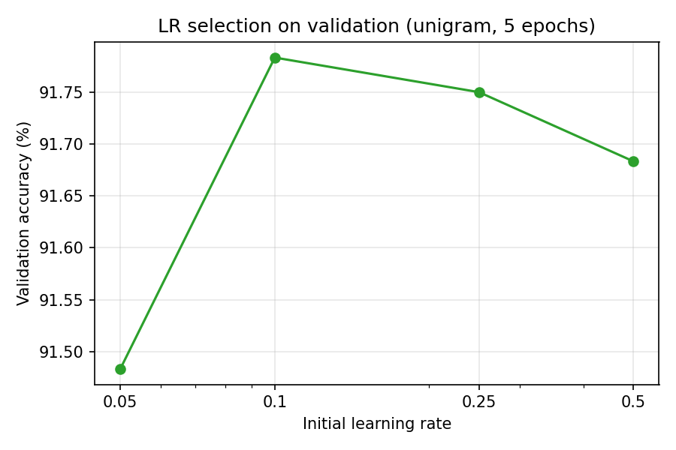  (a) Unigram learning-rate sweep | 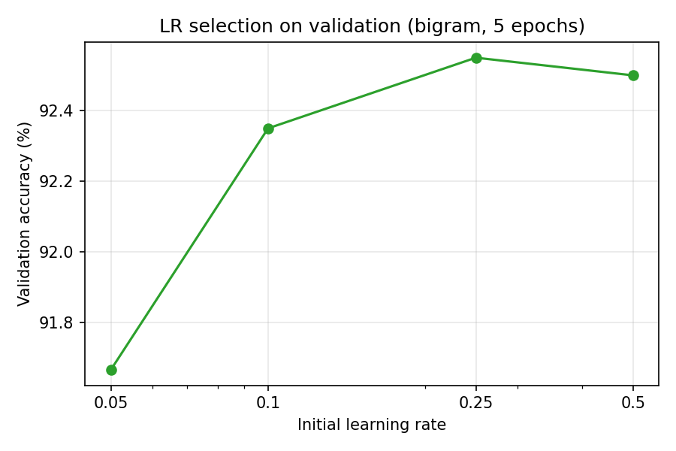  (b) Bigram learning-rate sweep
Figure 1. Original notebook learning-rate selection plots, displayed side by side. The preferred rate differs by feature configuration.

5.2 Training progress
Over five epochs, unigram training loss fell from 0.4795 to 0.1724, and bigram training loss from 0.4237 to 0.0354. Validation losses ended at 0.2485 and 0.2458, respectively. Bigram training accuracy increased to 99.31%, while held-out validation accuracy reached 92.55%; the large train–validation difference indicates that fitting the training data more strongly does not translate proportionally into unseen-data gains.
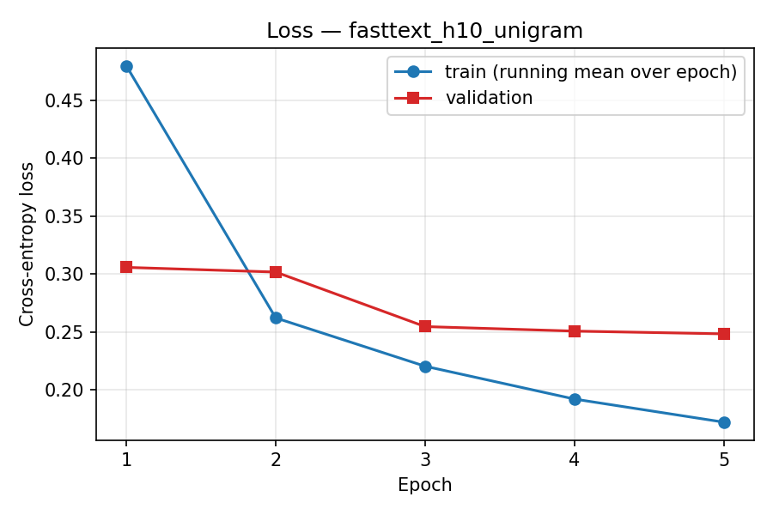  (a) Unigram loss: train / validation | 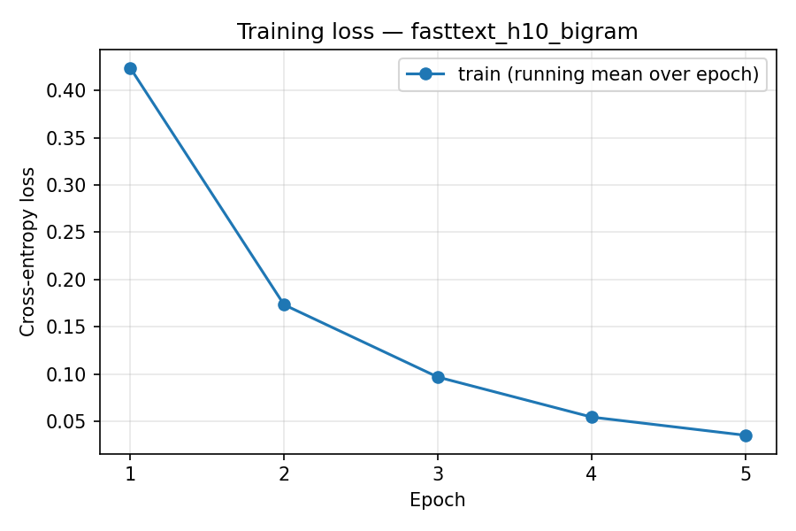  (b) Bigram training loss
Figure 2. Saved loss plots. The steep bigram training decline should be interpreted alongside its validation behavior.
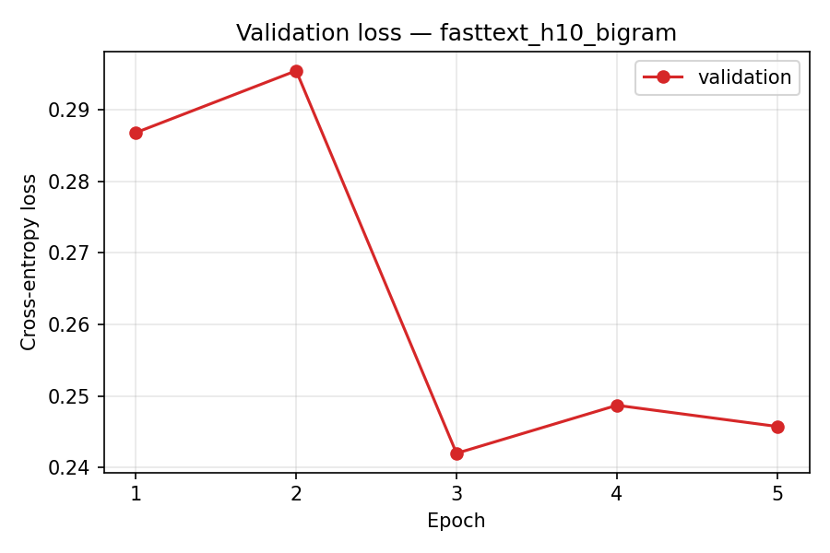
Figure 2 (continued). Original bigram validation-loss curve; it fluctuates rather than falling monotonically.

5.3 Accuracy trajectories and held-out evaluation
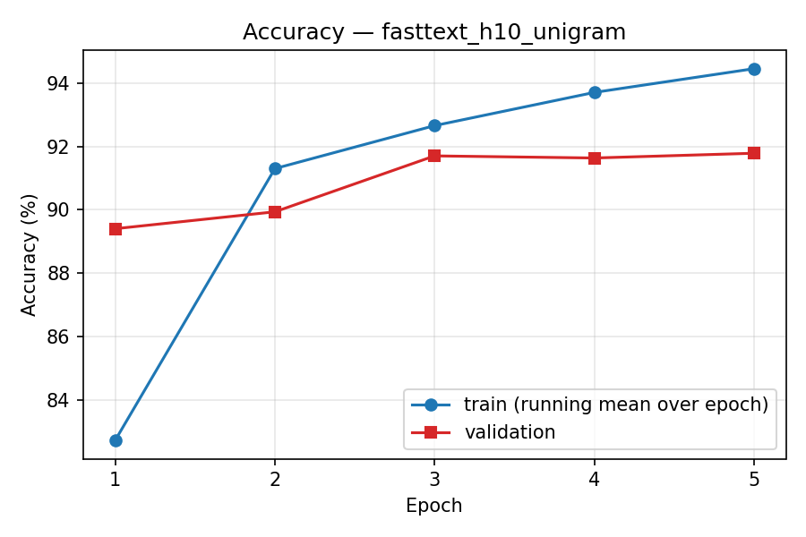  (a) Unigram accuracy curves | 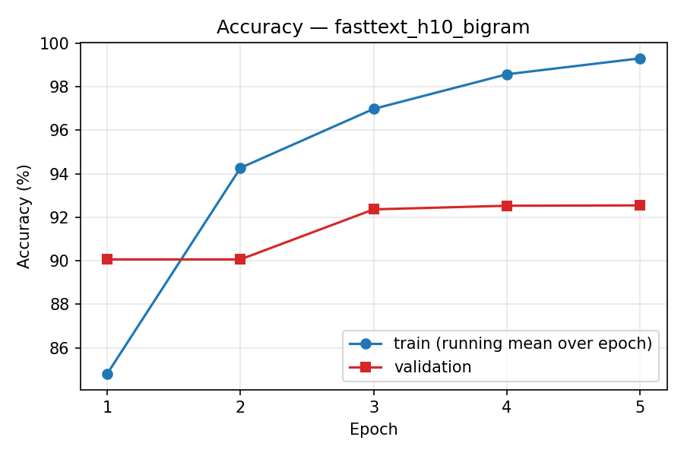  (b) Bigram accuracy curves
Figure 3. Original training and validation accuracy figures. The bigram run fits training examples substantially better while maintaining a smaller validation improvement.
On the 7,600-example test set, the unigram configuration achieves 91.30% accuracy and 91.29% macro-F1 (test loss 0.2679); the bigram configuration achieves 92.24% and 92.23% (test loss 0.2599). Because each class contains exactly 1,900 test examples, macro and support-weighted aggregate metrics closely coincide [N, cells 49, 56].
Table 3. Per-class test metrics (percent), copied from the saved classification reports.
Model / class | Precision | Recall | F1 | Support
Unigram: World | 92.05 | 90.84 | 91.44 | 1,900
Unigram: Sports | 95.87 | 97.68 | 96.77 | 1,900
Unigram: Business | 87.95 | 88.37 | 88.16 | 1,900
Unigram: Sci/Tech | 89.26 | 88.32 | 88.78 | 1,900
Bigram: World | 92.95 | 92.32 | 92.63 | 1,900
Bigram: Sports | 96.41 | 97.53 | 96.96 | 1,900
Bigram: Business | 89.53 | 89.16 | 89.35 | 1,900
Bigram: Sci/Tech | 89.99 | 89.95 | 89.97 | 1,900
Sports is the strongest category in both runs; Business and Sci/Tech show lower precision and recall. Bigrams raise F1 for World (+1.19 points), Business (+1.19 points) and Sci/Tech (+1.19 points), with a smaller Sports increase (+0.19 points). These are descriptive differences for one test set and training seed, not estimates of uncertainty across retraining runs.

5.4 Confusion matrix analysis
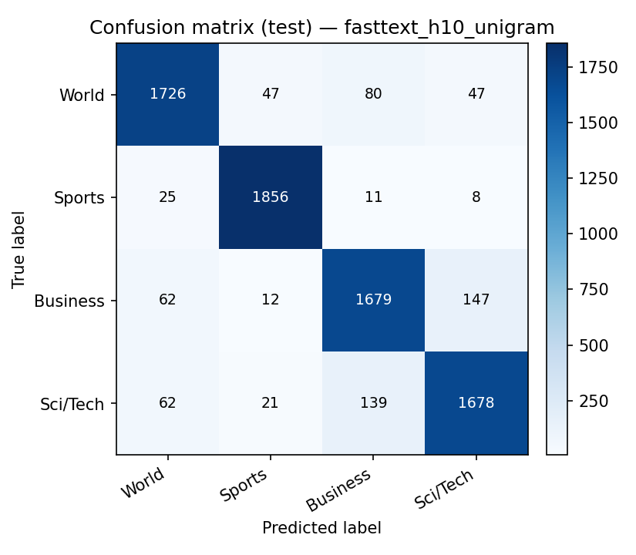  (a) Unigram model | 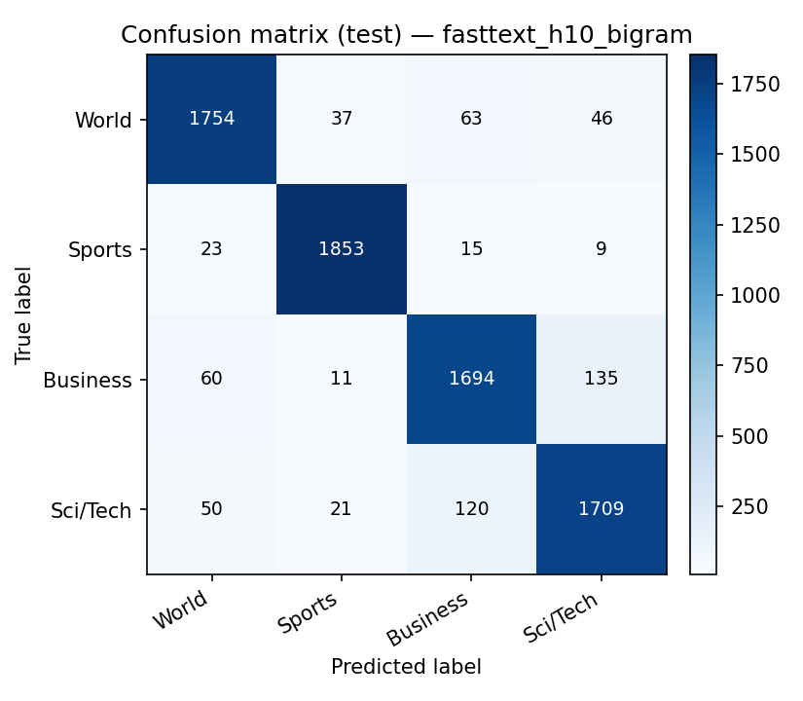  (b) Bigram model
Figure 4. Original test-set confusion matrices (rows = true class; columns = predicted class). Diagonal entries show correct predictions; off-diagonal entries reveal label confusions.
The matrices confirm that most predictions lie on the diagonal and that the unigram model makes more mistakes overall. The bigram model improves recall for World (90.84% to 92.32%), Business (88.37% to 89.16%) and Sci/Tech (88.32% to 89.95%), while Sports recall decreases slightly (97.68% to 97.53%). The dominant trend is therefore a broad but not uniform benefit of local word order; the visualizations should not be interpreted as proving which linguistic expressions caused individual errors.
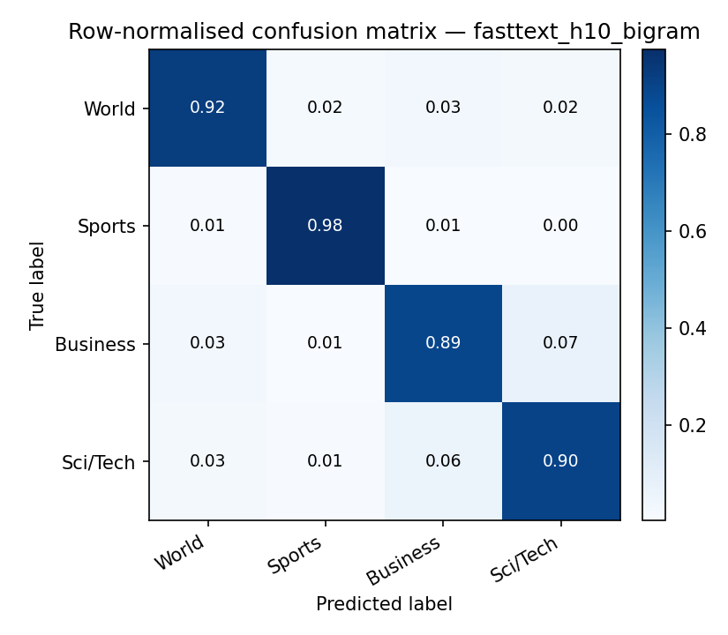
Figure 5. Notebook-provided row-normalized bigram confusion matrix, enabling comparison across true classes on a common scale.
Although test supports are equal here, normalization clarifies the class-level recall pattern. Stronger diagonals in Sports than in Business and Sci/Tech reflect unequal class difficulty. Without stored item-level explanations, attributing confusions to ambiguous headlines or specific lexical terms would be speculative.

6. Comparison with the Original Paper
Table 1 of Joulin et al. reports 91.5% accuracy for fastText with ten hidden dimensions and 92.5% when word bigrams are included on AG News [1]. The submitted PyTorch results are 0.20 and 0.26 percentage points lower, respectively. The source paper therefore reports a +1.00-point bigram effect, compared with the observed +0.94-point gain here. Both support the same qualitative finding, despite non-identical implementations.
Table 4. Paper benchmarks versus reproduced test accuracy on AG News.
Experiment | Paper accuracy | Notebook accuracy | Notebook – paper
fastText, h=10 (unigrams) | 91.50% | 91.30% | −0.20 pp
fastText, h=10, bigrams | 92.50% | 92.24% | −0.26 pp
Bigram minus unigram | +1.00 pp | +0.94 pp | −0.06 pp
Official fastText control (bigram) | Not separately tabulated | 92.24% | Not applicable
The official Python fastText control reaches 92.24% with initial learning rate 0.25, five epochs and a recorded total training time of 5.7 seconds. This additional run is valuable because it checks the standard library in the same Colab session. It is not a third independent value from the original paper, nor an exact match in training data with the PyTorch run: the official control prepares the full original training file, while the custom PyTorch final runs use 114,000 training documents [N, cells 34, 51].
Table 5. Saved runtime and comparison context (do not interpret as controlled speed ratios).
System / configuration | Reported training time | Context
Paper fastText h=10 + bigrams | 1 second per epoch | Published AG reference; CPU with 20 threads [1]
PyTorch unigram | 5.63 s / epoch (mean) | Colab CPU; 114k train documents [N]
PyTorch bigram | 6.75 s / epoch (mean) | Colab CPU; 114k train documents [N]
Official fastText control | 5.7 s total / 5 epochs | Colab CPU; 114k train examples; native fastText [N]
The paper’s reported speed cannot be compared causally with a different Colab CPU, parallelization scheme or implementation language. The 5.7-second official timing is total measured training time, not seconds per epoch. Time spent on setup, preprocessing, feature caching and sweeps is also separate from these reported training summaries.

7. Reproducibility Analysis and Discussion

7.1 Fidelity of architecture and feature construction
The reproduction preserves the method’s defining ingredients: mean-pooled low-dimensional embeddings, a linear softmax classifier, word-bigram hashing and a decaying learning rate. The implementation contains specific compatibility code for normalization, signed-byte hashing, end-of-sentence handling and conversion of the official model’s weights. These choices help explain why the resulting accuracies are near the original AG benchmarks. Nonetheless, correspondence of equations and overall results does not establish identical update trajectories or parameter values.

7.2 Meaning of the 100% agreement result
The notebook reports “Prediction agreement (our model with official weights vs official): 1.0000.” The control first trains the official library, copies that model’s learned embedding and output matrices into the PyTorch architecture, reconciles word indices and then compares class predictions on the same evaluation data [N, cell 34]. Thus, all compared predicted class labels agree under a shared set of trained parameters. This is meaningful evidence for inference/feature-processing compatibility. It does not mean that independently trained PyTorch and C++ models have identical weights, probability outputs, optimization paths or necessarily identical item-level predictions. The independently trained PyTorch bigram model happens to have the same rounded aggregate test accuracy as the official baseline (92.24%), which alone also does not imply prediction agreement.

7.3 Optimization and computational comparability
The C++ code uses asynchronous per-example training with multiple worker threads; the notebook’s PyTorch code batches 16 documents and sums the loss before each synchronous SGD update. Even with equivalent nominal learning-rate and token-based decay schedules, those optimizers need not follow the same route through parameter space. Additional differences include reshuffling every epoch, train/validation partitioning, dense allocation of hashed buckets and Python/PyTorch execution overhead. The paper’s one-second AG News epoch is a published reference measured on different hardware; it is not a speed target that a Colab run has reproduced.

7.4 Validation behavior and limitations
The fifth-epoch bigram training accuracy of 99.31% far exceeds its 92.55% validation accuracy, while validation loss is not monotonic (0.2868, 0.2954, 0.2420, 0.2487, 0.2458). This suggests potential overfitting or calibration differences, though no controlled regularization ablation was run. Validation accuracy is tracked every epoch, but the saved final evaluation uses the final checkpoint rather than demonstrating a separately justified early-stopping policy. Only one seed and one dataset are shown; there are no confidence intervals or retraining-variance estimates. Therefore the closeness to the paper is best described as a strong single-run replication of a headline result, not a statistical demonstration of equivalence.

7.5 Challenges, threats to validity and future checks
Reproduction challenges visible in the implementation include sourcing the original CSV files, preserving exact corpus transformations, matching fastText hash semantics across C++ and Python integer behavior, processing ten million n-gram buckets on a CPU, and recovering interrupted Colab training through checkpoints. Dataset file hashes and counts help guard against silently changing data. The 5% holdout is a transparent design choice, but it reduces training size versus a full 120,000-row run and slightly shifts the experimental setting.
A stronger follow-up would train both implementations on exactly the same 114,000 rows or both on all 120,000, use the same preprocessing file, repeat several seeds, measure wall time with identical thread counts and environment details, export per-example predictions and confidence intervals, and test whether bigram gains persist with alternative bucket sizes. Such studies would distinguish effects of feature representation from differences in optimization and sampling. Separate CPU profiling of preprocessing, n-gram encoding, training and inference would make efficiency comparisons more informative.

8. Conclusion
The reproduction supports the central result of Joulin et al.: a simple averaged-embedding linear classifier is competitive on AG News, and hashed word-bigram features give a measurable improvement over unigrams. The submitted notebook’s final test accuracy rises from 91.30% to 92.24%, a gain of 0.94 percentage points, approaching the paper’s 91.5% and 92.5% benchmarks. Macro-F1 rises from 91.29% to 92.23%, with class-level gains concentrated in World, Business and Sci/Tech.
The official fastText control reaches 92.24% on the test set and the weight-transfer experiment matches the official predicted class labels exactly; this validates a useful aspect of the PyTorch inference path. Because training procedures, data partitioning and hardware are different, the result should be described as a close methodological reproduction rather than an exact or controlled re-execution of the original C++ experiment. Future experiments should prioritize matched training data, repeatability across seeds and controlled speed measurements.

9. References
[1] Joulin, A., Grave, E., Bojanowski, P., & Mikolov, T. (2017). Bag of Tricks for Efficient Text Classification. Proceedings of EACL 2017, Vol. 2, pp. 427–431. Association for Computational Linguistics. https://aclanthology.org/E17-2068/
[2] Joulin, A., Grave, E., Bojanowski, P., & Mikolov, T. (2016). Bag of Tricks for Efficient Text Classification (arXiv:1607.01759). https://arxiv.org/abs/1607.01759
[N] Submitted experiment notebook. fasttext_reproduction_colab(1).ipynb (saved outputs dated 8 November 2026). Primary source for code, hyperparameters, figures and all reproduced measurements. Not publicly published; included with assignment submission.

Evidence and verification note
All notebook measurements were transcribed from the stored code/output cells rather than independently rerun. Every plotted graphic reproduced in this document was extracted from the notebook’s embedded displayed PNG outputs. The notebook does not demonstrate exact CPU model, independent multi-seed variance, or matching optimization trajectories. The last notebook source cell also contains a plaintext access token; revoke and replace that credential and remove it from any version circulated for grading.

