**Topics: Normal distribution, Functions of Random Variables**

1. Consider a company that has two different divisions. The annual profits from the two divisions are independent and have distributions Profit1 ~ N(5, 32) and Profit2 ~ N(7, 42) respectively. Both the profits are in $ Million. Answer the following questions about the total profit of the company in Rupees. Assume that $1 = Rs. 45
2. Specify a Rupee range (centered on the mean) such that it contains 95% probability for the annual profit of the company.
3. Specify the 5th percentile of profit (in Rupees) for the company
4. Which of the two divisions has a larger probability of making a loss in a given year?
5. ANS: From the empirical rule, Approximately 95% of the data falls within two standard deviation of the mean.

μ ± 2σ = 540±2*225=> (540-450, 540+450)=> **(90,990)**

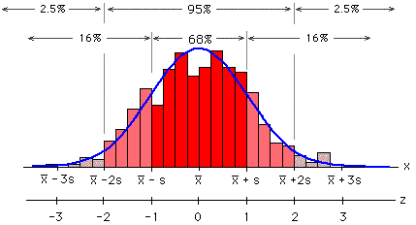

1. From the above normal distribution we can say that to find 5th percentile from the left side we can use the formula,

μ - 1.5σ => 540-(1.5*225) =>202.5 million rupees.

1. this question concerns the original profit distributions.

For division1= Z score for a profit of zero: Z=(X-µ)/ *σ =>*  (0-5)/3 => -1.66=0.0485

(or)

> pnorm(0,5,3)

[1] 0.04779035

For division2= Z score for a profit of zero: Z=(X-µ)/ *σ*  =(0-7)/4 => -1.75= .0401

> pnorm(0,7,4)

[1] 0.04005916

Division2 has a higher probability of making a loss.