When maven is installed a hidden directory “.m2” is created
$cd sample
$mvn archetype:generate creates a blue print of what needs to be created
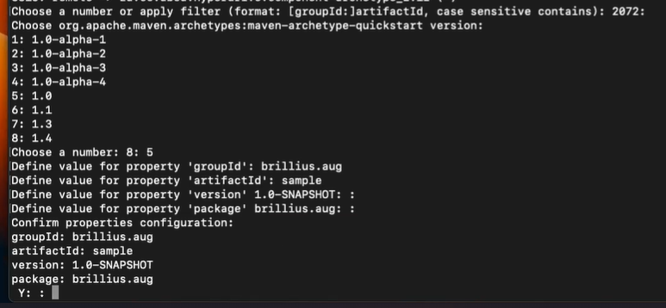
- Directory named sample is created.
$cd sample
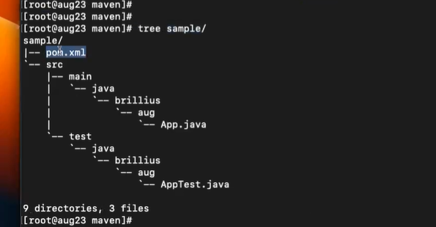
$ ll
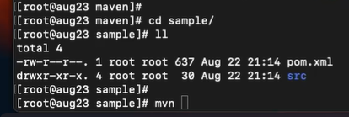
$ mvn compile
$tree
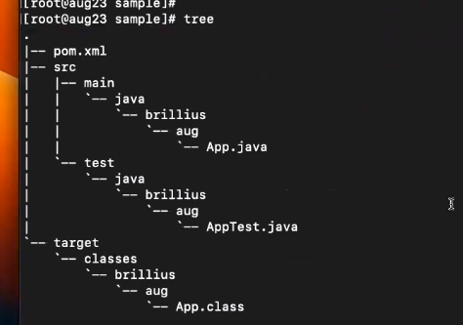
$mvn package
$tree
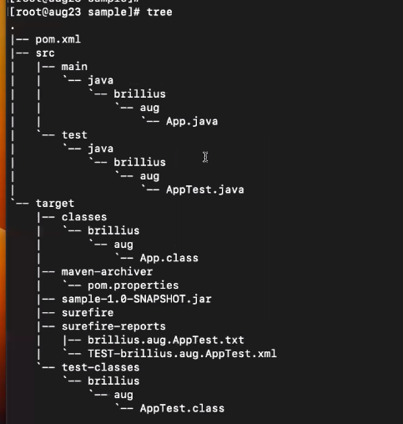
- Surefire means testing is done and test case reports are found at surefire-reports.
- sample-1.0-SNAPSHOT.jar is the artifact which needs to be deployed.
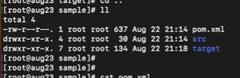
$ cat pom.xml
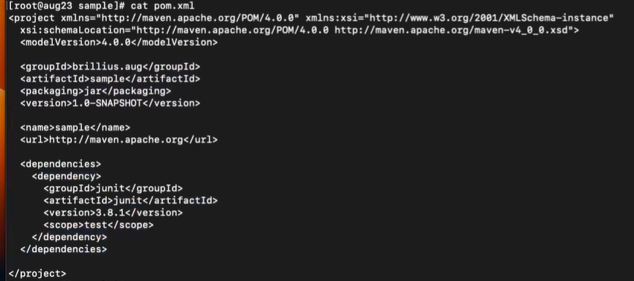

- Example For a web app –
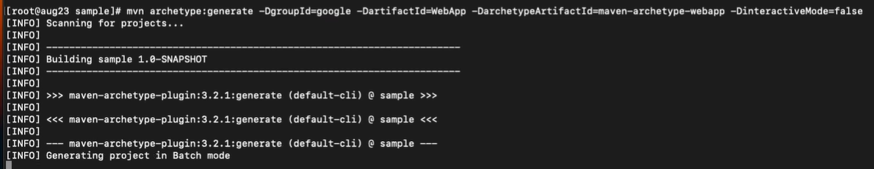
$mvn archetype:generate -DgroupId=google -DartifactId=WebApp -DarchetypeArtifactId=maven-archetype-webapp -DinteractiveMode=fal

NOTE:

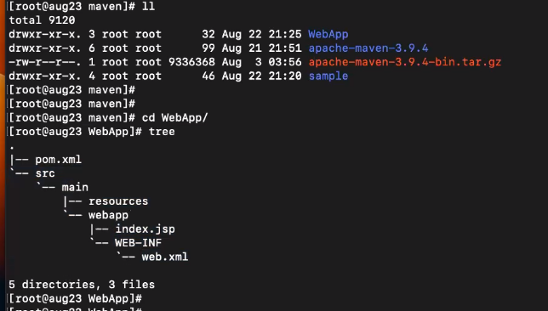
$mvn package
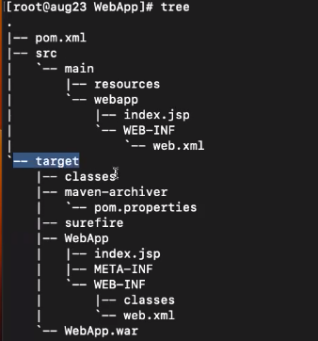

- The below .war file can be directly deployed on tomcat.

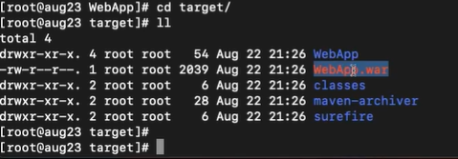
- Move .war file to tomcat/webapps
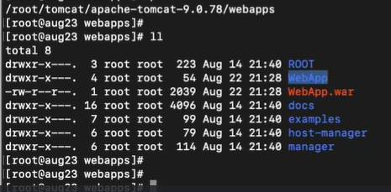
- In organizations build would be done in one server and the artifact(.war, .jar) would be deployed on tomcat which would be on a different server.

