- Nexus port- 8081
$wget url
$tar -xvf nexus.tar.gz
- Nexus folder is created
$cd nexus/bin
- To start nexus-
$ ./nexus start
- To access from browser- Ipaddress:8081
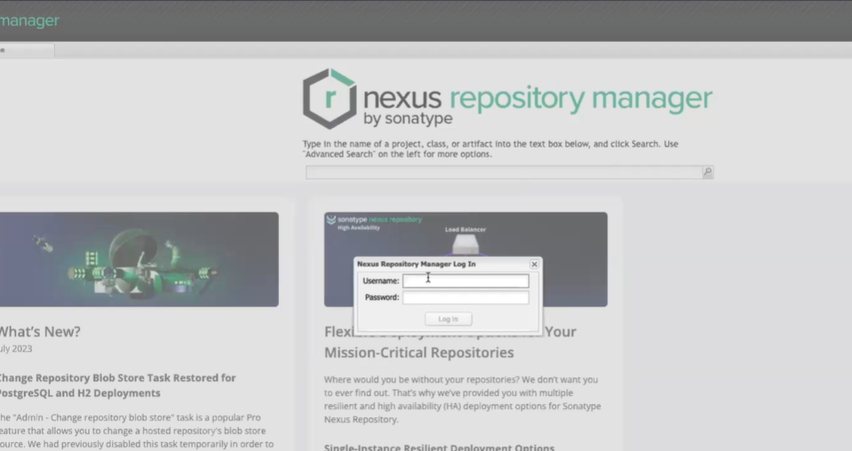

- Default username – admin
- Default password – admin123
- “-SNAPSHOT” means that it is in development phase., if removed its ready for deployment
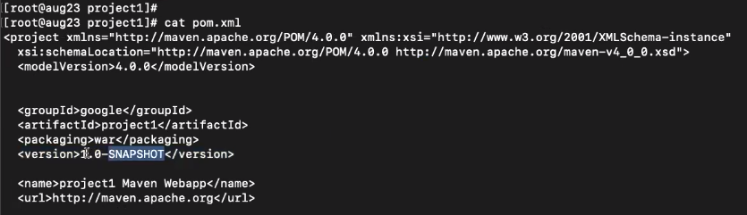

- After $mvn deploy the .war file is moved either to Snapshots or Releases based on its version.

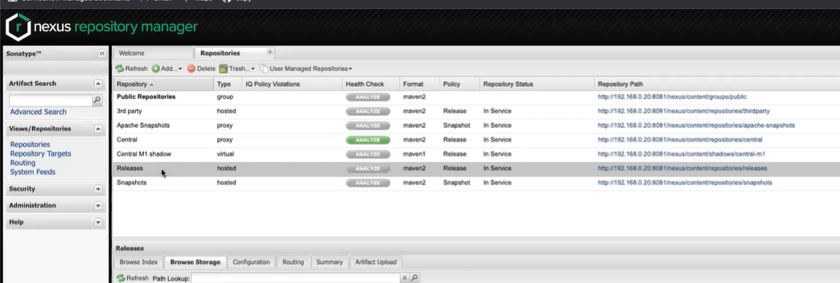

- The server in which the artifact is build needs to know which server has Nexus installed and in which directory(Releases or Snapshots) the artifact needs to be moved. For this we need to configure the pom.xml file
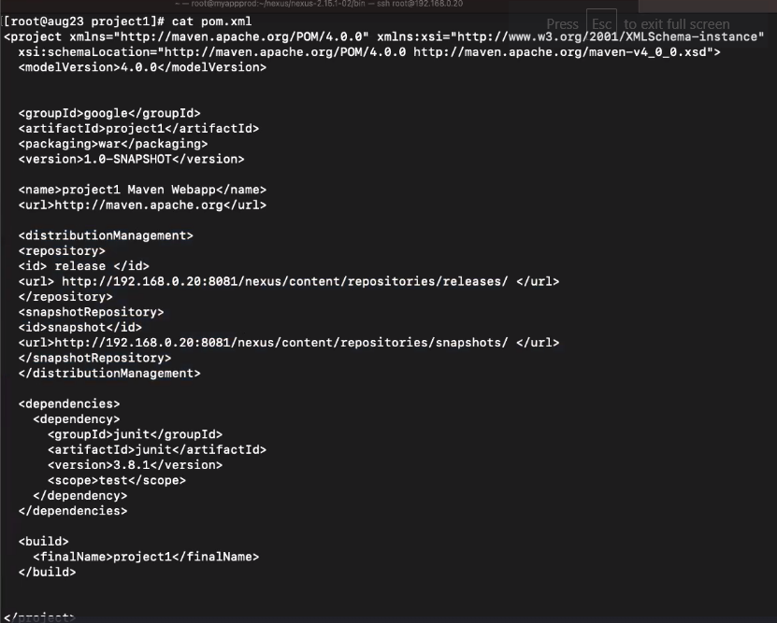
- Copy from here for your reference-
<distributionManagement>
<repository>
<id> release </id>
<url> http://192.168.0.20:8081/nexus/content/repositories/releases/ </url>
</repository>
<snapshotRepository>
<id>snapshot</id>
<url>http://192.168.0.20:8081/nexus/content/repositories/snapshots/ </url>
</snapshotRepository>
</distributionManagement>
- Create setting.xml under .m2 directory.
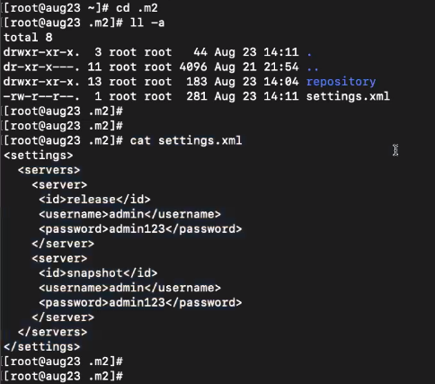
[root@aug23 .m2]# cat settings.xml
<settings>
<servers>
<server>
<id>releases</id>
<username>admin</username>
<password>admin123</password>
</server>
<server>
<id>snapshot</id>
<username>admin</username>
<password>admin123</password>
</server>
</servers>
</settings>
[root@aug23 .m2]#

$cd to the directory that contains pom.xml file and do
$mvn deploy
- It would be uploading to Snapshots if it has “-SNAPSHOT” in its version name else Releases.
JENKINS

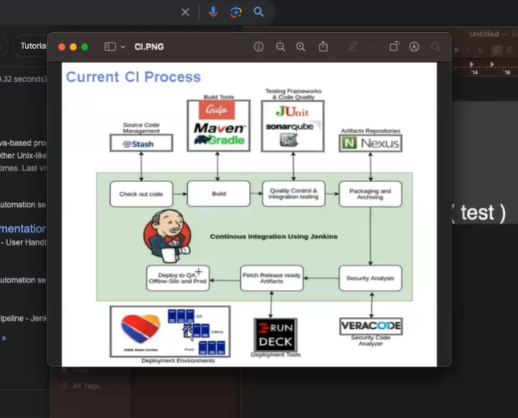

- Jenkins port no -8080
- If Jenkins is run as .war file under Tomcat, both Tomcat and Jenkins can be run under same port number.
- When sample.war file is executed on tomcat a directory named Sample is created.

- Change Tomcat port number-
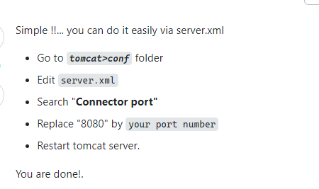
- Jenkins and Maven are installed on same server here.
$which java where is java installed.
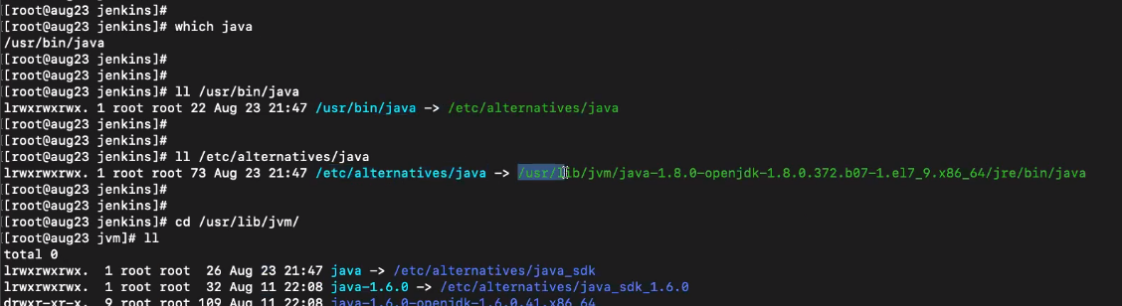

- Linking java 11 instead of java 8 (I may be wrong)
