**INTRODUCTION :**

This project is about creating a simple puzzle game. Program is written using Java swing. The main theme behind developing puzzle game using java is to provide a creative and competitive environment for the players who will use this system.

The user is given a 3*3 size board of numbers from 1 to 8 arranged randomly  
with a blank space in box. The user can move the blank space left, right, top and bottom and arrange the numbers in the order.

This puzzle has 8 buttons numbered from 1 to 8. As the program is run we get the output screen which has these 8 buttons and also the timer button. We need to move the buttons in such a way that we get a final sequenced numbers from 1 to 8. When the final sequence is generated we get the message stating that the player has won the puzzle game. The timer starts as soon as the button is clicked. It provides functionalities like we can swipe the buttons in whichever way we want and we even get timing as well.

**SOFTWARE REQUIREMENTS :**

* Programming language : Java
* Java technology : Swings
* Java version : JDK

**SOURCE CODE :**

**import** java.awt.BorderLayout;

**import** java.awt.Button;

**import** java.awt.Color;

**import** java.awt.Dimension;

**import** java.awt.event.ActionEvent;

**import** java.awt.event.ActionListener;

**import** javax.swing.JFrame;

**import** javax.swing.JLabel;

**import** javax.swing.JOptionPane;

**import** javax.swing.Timer;

**public** **class** puxx

{

**public** **static** **void** main(String[] args)

{

puzl obj = **new** puzl();

}

}

**class** puzl **extends** JFrame **implements** ActionListener{

Button b1,b2,b3,b4,b5,b6,b7,b8,b9,b10;

JLabel lab;

JLabel label2;

JLabel l;

Timer timer;

**int** count;

**public** puzl(){

b1=**new** Button("1");

b1.setBounds(50,100,40,40);

b1.setBackground(Color.***blue***);

b2=**new** Button("2");

b2.setBounds(100,100,40,40);

b2.setBackground(Color.***yellow***);

b3=**new** Button("3");

b3.setBounds(150,100,40,40);

b3.setBackground(Color.***blue***);

b4=**new** Button("4");

b4.setBounds(50,150,40,40);

b4.setBackground(Color.***yellow***);

b5=**new** Button("5");

b5.setBounds(100,150,40,40);

b5.setBackground(Color.***blue***);

b6=**new** Button("6");

b6.setBounds(150,150,40,40);

b6.setBackground(Color.***yellow***);

b7=**new** Button("7");

b7.setBounds(50,200,40,40);

b7.setBackground(Color.***blue***);

b8=**new** Button("");

b8.setBounds(100,200,40,40);

b8.setBackground(Color.***yellow***);

b9=**new** Button("8");

b9.setBounds(150,200,40,40);

b9.setBackground(Color.***blue***);

b10= **new** Button("Start Timer");

b10.setBounds(250,300,40,40);

b10.setSize(90, 40);

l= **new** JLabel("timmer");

l.setBounds(200,300,40,40);

b1.addActionListener(**this**);

b2.addActionListener(**this**);

b3.addActionListener(**this**);

b4.addActionListener(**this**);

b5.addActionListener(**this**);

b6.addActionListener(**this**);

b7.addActionListener(**this**);

b8.addActionListener(**this**);

b9.addActionListener(**this**);

b10.addActionListener(**this**);

add(b1);

add(b2);

add(b3);

add(b4);

add(b5);

add(b6);

add(b7);

add(b8);

add(b9);

add(l);

add(b10);

setTitle("Puzzle");

setSize(400,400);

setLayout(**null**);

setVisible(**true**);

setDefaultCloseOperation(3);

}

**public** **void** actionPerformed(ActionEvent e){

timer = **new** Timer(500, **new** ActionListener() {

@Override

**public** **void** actionPerformed(ActionEvent e) {

count++;

**if** (count < 100) {

l.setText(Integer.*toString*(count));

} **else** {

((Timer) (e.getSource())).stop();

}

}

});

timer.setInitialDelay(0);

timer.start();

**if**(e.getSource()==b10)

{

JFrame frame = **new** JFrame();

frame.setDefaultCloseOperation(JFrame.***EXIT_ON_CLOSE***);

frame.setLayout(**new** BorderLayout());

frame.add(**new** TestPane());

frame.pack();

//frame.setVisible(true);

}

**if**(e.getSource()==b1){

String label=b1.getLabel();

**if**(b2.getLabel().equals("")){

b2.setLabel(label);

b1.setLabel("");

}

**if**(b4.getLabel().equals("")){

b4.setLabel(label);

b1.setLabel("");

}

}

**if**(e.getSource()==b2){

String label=b2.getLabel();

**if**(b1.getLabel().equals("")){

b1.setLabel(label);

b2.setLabel("");

}

**if**(b3.getLabel().equals("")){

b3.setLabel(label);

b2.setLabel("");

}

**if**(b5.getLabel().equals("")){

b5.setLabel(label);

b2.setLabel("");

}

}

**if**(e.getSource()==b3){

String label=b3.getLabel();

**if**(b2.getLabel().equals("")){

b2.setLabel(label);

b3.setLabel("");

}

**if**(b6.getLabel().equals("")){

b6.setLabel(label);

b3.setLabel("");

}

}

**if**(e.getSource()==b4){

String label=b4.getLabel();

**if**(b1.getLabel().equals("")){

b1.setLabel(label);

b4.setLabel("");

}

**if**(b7.getLabel().equals("")){

b7.setLabel(label);

b4.setLabel("");

}

**if**(b5.getLabel().equals("")){

b5.setLabel(label);

b4.setLabel("");

}

}

**if**(e.getSource()==b5){

String label=b5.getLabel();

**if**(b2.getLabel().equals("")){

b2.setLabel(label);

b5.setLabel("");

}

**if**(b6.getLabel().equals("")){

b6.setLabel(label);

b5.setLabel("");

}

**if**(b4.getLabel().equals("")){

b4.setLabel(label);

b5.setLabel("");

}

**if**(b8.getLabel().equals("")){

b8.setLabel(label);

b5.setLabel("");

}

}

**if**(e.getSource()==b6){

String label=b6.getLabel();

**if**(b9.getLabel().equals("")){

b9.setLabel(label);

b6.setLabel("");

}

**if**(b3.getLabel().equals("")){

b3.setLabel(label);

b6.setLabel("");

}

**if**(b5.getLabel().equals("")){

b5.setLabel(label);

b6.setLabel("");

}

}

**if**(e.getSource()==b7){

String label=b7.getLabel();

**if**(b4.getLabel().equals("")){

b4.setLabel(label);

b7.setLabel("");

}

**if**(b8.getLabel().equals("")){

b8.setLabel(label);

b7.setLabel("");

}

}

**if**(e.getSource()==b8){

String label=b8.getLabel();

**if**(b9.getLabel().equals("")){

b9.setLabel(label);

b8.setLabel("");

}

**if**(b7.getLabel().equals("")){

b7.setLabel(label);

b8.setLabel("");

}

**if**(b5.getLabel().equals("")){

b5.setLabel(label);

b8.setLabel("");

}

}

**if**(e.getSource()==b9){

String label=b9.getLabel();

**if**(b6.getLabel().equals("")){

b6.setLabel(label);

b9.setLabel("");

}

**if**(b8.getLabel().equals("")){

b8.setLabel(label);

b9.setLabel("");

}

}

//congrats code

**if**(b1.getLabel().equals("1")&&b2.getLabel().equals("2")&&b3.getLabel()

.equals("3")&&b4.getLabel().equals("4")&&b5.getLabel().equals("5")

&&b6.getLabel().equals("6")&&b7.getLabel().equals("7")&&b8.getLabel()

.equals("8")&&b9.getLabel().equals("")){

JOptionPane.*showMessageDialog*(**this**,"Congratulations! You won.");

timer.stop();

}

}

**public** Dimension getPreferredSize() {

**return** **new** Dimension(200, 200);

}

}

**RESULT :**

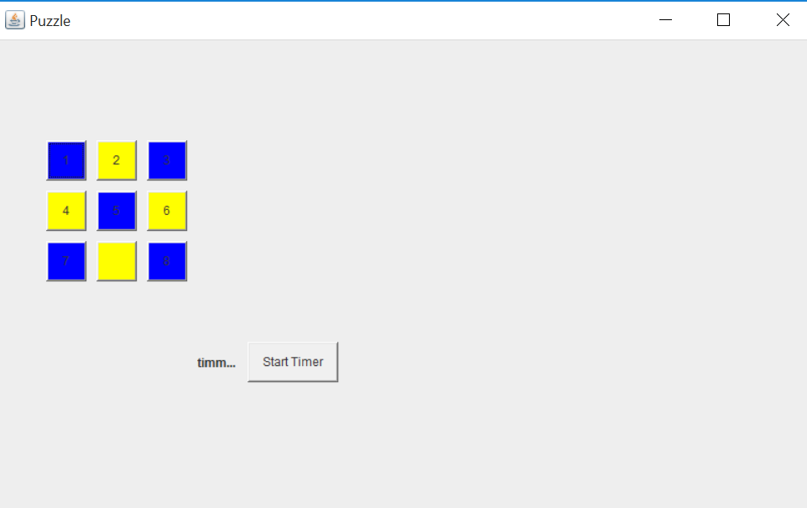

**The above figure shows the output screen when the program is executed.**

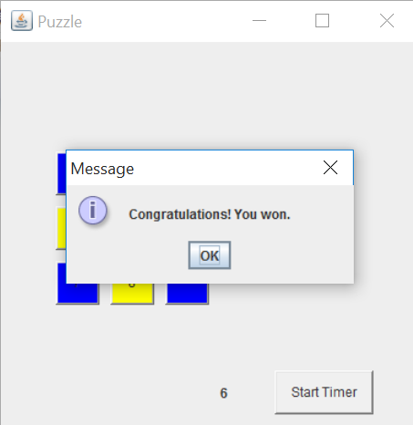

**The above figure shows the output screen when the player wins the game and the congratulations message box pop up.**

**CONCLUSION AND FUTURE SCOPE :**

We have created a simple puzzle game on numbers in which we can swipe the numbers in order to get the proper sequence of numbers so that we win the game. We have even added timer to it. This is just a mini project where we tried to implement the java swing concept in creating games. This can be improved in such a manner that we can even add images instead of plain buttons and can create an image puzzle. This puzzle could also contain random numbers being generated. We can improvise this project by adding marquee effect.

**REFERENCE :**

* [*http://zetcode.com/tutorials/javagamestutorial/puzzle/*](http://zetcode.com/tutorials/javagamestutorial/puzzle/)
* [*https://www.codeproject.com*](https://www.codeproject.com)
* *Tutorialjava.blogpost.com*
* [*https://www.researchgate.net*](https://www.researchgate.net)
* [*https://stackoverflow.com/question*](https://stackoverflow.com/question)