Alliance School of Advanced Computing

Course Name: Graph Analytics
Course Code: E1ITC 302
Assignment No: 1

Name of the Student: G Nikhil Srinivas

Registration Number: 2411021060939

A. Title of The Problem:
Journey to the Moon
B. Problem Statement in details:
The problem gives N astronauts numbered from 0 to N−1 and a list of pairs of astronauts who are known to belong to the same country. Astronauts connected through these relationships belong to the same country, even when the relationship is indirect. The task is to determine the number of ways to choose two astronauts such that the two selected astronauts are from different countries.
For example, for the input 5 3 with pairs (0,1), (2,3), and (0,4), the country groups are {0,1,4} and {2,3}. Therefore, the valid cross-country pairs are 3 × 2 = 6.
The solution must handle large inputs efficiently. Instead of checking every possible pair of astronauts, the same-country relationships are treated as connected components of an undirected graph. A Disjoint Set Union (Union-Find) structure can efficiently construct these components.

C. HackerRank/Leetcode Link of the problem (If applicable):
https://www.hackerrank.com/challenges/journey-to-the-moon/problem
D. Student’s Github link of report and code upload, along with the readme file:
https://github.com/nikhil-0420/Graph_Analytics_Course_Materials
E. Solution Steps/Algorithm:
Initialize a Disjoint Set Union (DSU) structure for all N astronauts. Initially, every astronaut is in a separate set.
For every given pair (a, b), perform a union operation so that both astronauts belong to the same set/country.
Use path compression in find() and union by size in union() to keep DSU operations efficient.
After processing all pairs, determine the size of every connected component. Each component represents one country.
Let the country/component sizes be s1, s2, ..., sk. Count valid pairs by selecting astronauts from two different components.
A convenient calculation is: keep a running value 'remaining'. For each component of size s, add s × (remaining − s) to the answer, then subtract s from remaining.

Use the long data type because the number of possible pairs can exceed the range of a 32-bit integer.
Time Complexity: O((N + P) × α(N)), where P is the number of astronaut pairs and α(N) is the inverse Ackermann function.
Space Complexity: O(N) for the DSU parent and component-size arrays.

F. Code developed:
import math
import os
import random
import re
import sys
from collections import defaultdict

def journeyToMoon(n, astronaut):
# Build adjacency list representation of the graph
adj = defaultdict(list)
for u, v in astronaut:
adj[u].append(v)
adj[v].append(u)

visited = [False] * n
country_sizes = []

# Run DFS iteratively to find the size of each connected component (country)
for i in range(n):
if not visited[i]:
size = 0
stack = [i]
visited[i] = True

while stack:
curr = stack.pop()
size += 1
for neighbor in adj[curr]:
if not visited[neighbor]:
visited[neighbor] = True
stack.append(neighbor)

country_sizes.append(size)

# Calculate valid pairs: Total Pairs - Same Country Pairs
total_pairs = n * (n - 1) // 2
same_country_pairs = sum(c * (c - 1) // 2 for c in country_sizes)

return total_pairs - same_country_pairs

if __name__ == '__main__':
fptr = open(os.environ['OUTPUT_PATH'], 'w')

first_multiple_input = input().rstrip().split()

n = int(first_multiple_input[0])

p = int(first_multiple_input[1])

astronaut = []

for _ in range(p):
astronaut.append(list(map(int, input().rstrip().split())))

result = journeyToMoon(n, astronaut)

fptr.write(str(result) + '\n')

fptr.close()

G. HackerRank test case passed Screenshot or Output screenshot (Mandatory):
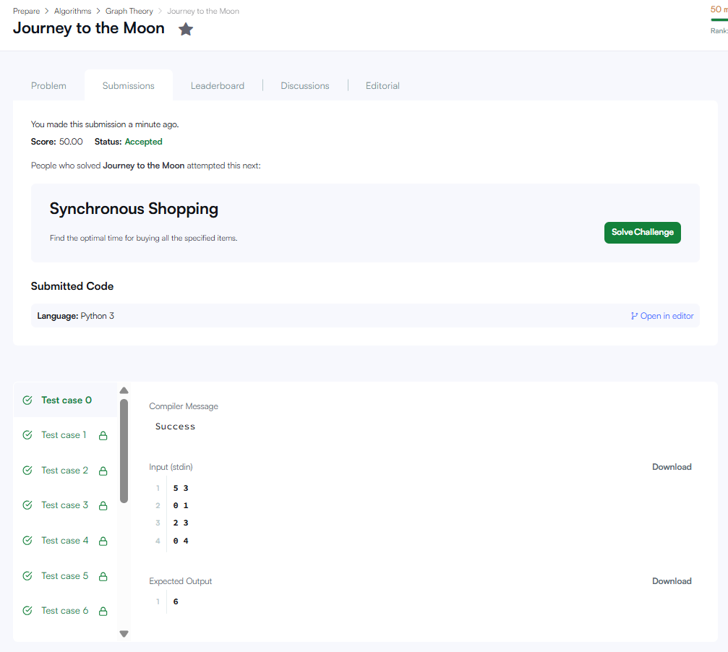

H. Observation:
The astronaut relationships form an undirected graph, and each connected component represents a country.
Disjoint Set Union is suitable because it efficiently merges astronauts that are known to have the same nationality.
Once the component sizes are known, the answer can be calculated without enumerating all O(N²) astronaut pairs.
For the sample input, the components have sizes 3 and 2, giving 3 × 2 = 6 valid pairs.
The use of long prevents overflow when N is large and the number of valid pairs is very high.
The approach is efficient for large inputs because DSU operations are almost constant amortized time.

