Alliance School of Advanced Computing

Course Name: Graph Analytics
Course Code: E1ITC 302
Assignment No: 1

Name of the Student: G Nikhil Srinivas

Registration Number: 2411021060939

A. Title of The Problem:
Components in a Graph
B. Problem Statement in details:
Given an n × m matrix containing 0s and 1s, a cell containing 1 is called a filled cell. Two filled cells are considered connected if they are adjacent horizontally, vertically, or diagonally. Therefore, each filled cell can be connected to up to eight neighboring cells.
A region is a group of one or more filled cells that are connected directly or indirectly. The task is to find the number of cells in the largest connected region in the matrix.
For the sample matrix, the connected region containing the cells in the upper-left part has 5 cells, while the isolated cell in the bottom-left forms a region of size 1. Therefore, the required output is 5. HackerRank specifies the function as maxRegion for the CTCI version of this problem.
C. HackerRank/Leetcode Link of the problem (If applicable):
https://www.hackerrank.com/challenges/ctci-connected-cell-in-a-grid/problem
D. Student’s Github link of report and code upload, along with the readme file:
https://github.com/nikhil-0420/Graph_Analytics_Course_Materials
E. Solution Steps/Algorithm:
Read the number of rows n and columns m, followed by the matrix.
Create a visited matrix to ensure that each filled cell is processed only once.
Traverse every cell of the matrix. If the cell contains 1 and has not been visited, start a DFS traversal from that cell.
During DFS, check all eight possible directions: up, down, left, right, and the four diagonal directions.
For every valid unvisited cell containing 1, mark it as visited and recursively continue the DFS.
Count the number of cells reached by the DFS. This count is the size of the current region.
Keep track of the maximum region size found while scanning the entire matrix.
Return the maximum region size as the answer.
Time Complexity: O(n × m), because every matrix cell is visited at most once and each visit checks a constant eight neighbors.

Space Complexity: O(n × m) for the visited matrix and, in the worst case, the DFS recursion stack.
F. Code developed:
import math
import os
import random
import re
import sys

def maxRegion(grid):
n = len(grid)
m = len(grid[0])

def dfs(r, c):
if r < 0 or r >= n or c < 0 or c >= m or grid[r][c] == 0:
return 0

# Mark cell as visited by setting it to 0
grid[r][c] = 0
region_size = 1

# Explore all 8 adjacent directions (horizontally, vertically, diagonally)
for dr in [-1, 0, 1]:
for dc in [-1, 0, 1]:
if dr == 0 and dc == 0:
continue
region_size += dfs(r + dr, c + dc)

return region_size

max_size = 0
for r in range(n):
for c in range(m):
if grid[r][c] == 1:
max_size = max(max_size, dfs(r, c))

return max_size

if __name__ == '__main__':
fptr = open(os.environ['OUTPUT_PATH'], 'w')

n = int(input().strip())

m = int(input().strip())

grid = []

for _ in range(n):
grid.append(list(map(int, input().rstrip().split())))

res = maxRegion(grid)

fptr.write(str(res) + '\n')

fptr.close()

G. HackerRank test case passed Screenshot or Output screenshot (Mandatory):
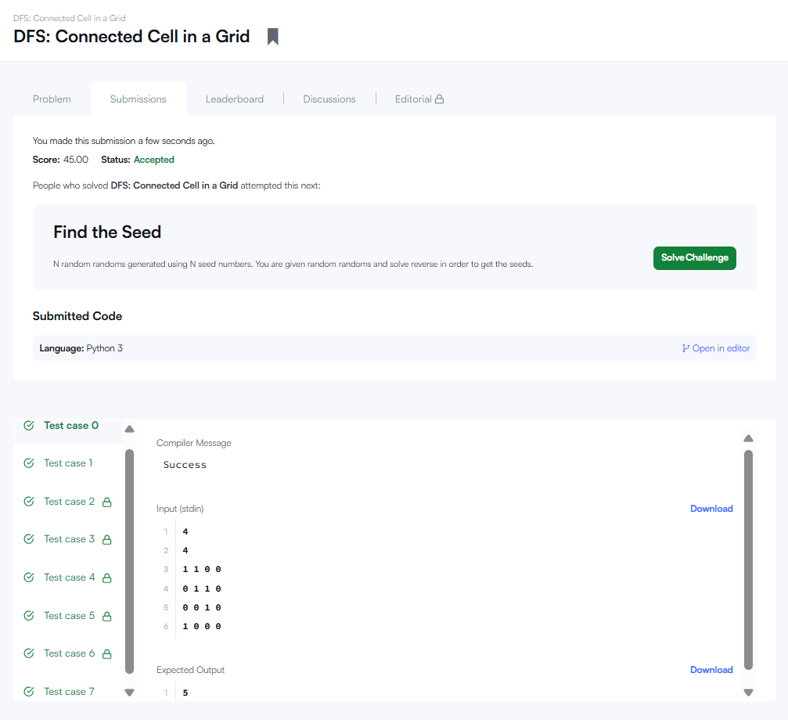

H. Observation:
The problem can be represented as a connected-component problem on a two-dimensional grid.
Unlike a four-directional grid problem, diagonal adjacency is also considered, so every cell has up to eight possible neighboring cells.
Depth First Search (DFS) efficiently explores one complete region before moving to another region.
The visited matrix prevents the same filled cell from being counted more than once.
For the sample input, the largest connected region contains 5 cells, so the output is 5.
The overall O(n × m) time complexity makes the approach efficient because each cell is processed only once.

