Queue-Length-Aware Adaptive Signal Control and Predictive Intervention: Empirical Evaluation on a Microscopic Model of the Marathahalli Corridor
Author 1 Name, Author 2 Name, Author 3 Name, Author 4 Name
Team ID: DP1-xx-xx-AIDS-xx
E1CSA313 Design Project-I, Department of Artificial Intelligence & Data Science, Alliance University, Bengaluru, India
Mentor: Mentor Name
Email: author emails

Abstract—Urban intersections accumulate queues when pretimed signal programs mismatch stochastic directional demand. Actuated and reinforcement-learning controllers can reduce delay, but their adoption is hindered by limited auditability and unbounded behaviour. This paper evaluates an explainable, queue-length-aware adaptive controller (hybrid_queue_adaptive) on a geographically grounded microscopic SUMO model of the Marathahalli Bridge junction in Bengaluru, driven by synthetic demand. The controller combines locally measured base-green splits, bounded +3.0 s green extensions, and a competing-phase red-wait guard (35 s). In a fixed analysis plan of 384 paired simulation runs (8 policies, 6 demand conditions, held-out seeds 131–138), the hybrid reduced the extended ground-truth maximum queue by 28.8% (95% CI −35.0 to −22.4%; Holm-adjusted p < 0.001) relative to a measured-flow Webster baseline, with no detectable difference in 95th-percentile waiting time or approach wait gap. An ablation found no detectable difference between the hybrid and an oracle-seeded variant. The hybrid yielded a higher maximum queue than unconstrained SUMO gap-actuation (+11.4%), in exchange for complete decision traces and a red-wait limit enforced to within one decision step plus clearance (bounding red wait at green start to ≤ 43.0 s analytically, observed max 48.0 s vs. 71.0 s for actuation). All findings are simulation-only, use synthetic demand, and concern one isolated junction.
Index Terms—adaptive traffic signal control, queue length, green-time extension, microscopic simulation, SUMO, TraCI, fairness, auditability.

I. INTRODUCTION
Signalized intersections on congested urban arterials face severe spatial constraints, particularly in rapidly urbanizing regions such as Bengaluru. Traffic is characterized by high volume, strong directional asymmetry during commute hours, heterogeneous vehicle classes, and peak surges. The Marathahalli Bridge junction on the Outer Ring Road (ORR) is a representative bottleneck where IT-corridor commutes meet cross-city arterial traffic.
Municipal agencies commonly operate pretimed plans derived from historical counts, for example Webster-based or locally tabulated schedules. Such plans assume stationary demand. During transient bottlenecks, capacity drops, or surges, they can allocate green time to lightly loaded approaches while critical approaches build long queues that spill back upstream.
Fully actuated controllers and black-box reinforcement learning (RL) policies respond faster but carry deployment liabilities: gap-based actuation may hold green inefficiently under dispersed platoons, and learned policies lack verifiable worst-case bounds and are difficult to audit. Agencies therefore need controllers that are explainable, auditable, and bounded by a safety supervisor.
This study asks whether a state-aware adaptive controller that does not rely on an upstream demand oracle can reduce tail queue formation under non-stationary demand without worsening tail delay or violating a competing-phase fairness limit. We benchmark against fixed-time, Webster-based, and unconstrained actuated controllers rather than naive fixed-time plans alone. The contributions are:
- A geographically grounded microscopic model of the Marathahalli junction that separates surface conflict movements from grade-separated bypass paths.
- An auditable hybrid controller combining measured base-green splits, bounded incremental extensions, and a red-wait anti-starvation guard, with a per-decision trace.
- A 384-run paired evaluation on held-out seeds under a fixed analysis plan with Holm-corrected paired-bootstrap inference.
- An ablation showing no detectable loss from removing the origin–destination oracle.
Terminology. “Predictive intervention” in the title denotes a proactive signal decision taken from the currently observed and recently accumulated state (queue lengths, waiting conditions, recent discharge), before queues worsen. The controller contains no traffic-forecasting model and no forecast horizon; short-horizon arrival projection was evaluated and removed (Section VIII).

II. RELATED WORK

A. Fixed-Time and Webster Methods
Pretimed signal control relies on historical volume counts and standard capacity formulations [1]. Webster’s method [2] sets cycle length and green splits from critical flow ratios and saturation flows. It performs well under stationary demand but degrades under surges and capacity drops. In non-lane-based, heterogeneous urban corridors such as those in Bengaluru, homogeneous saturation-flow assumptions require empirical adjustment and real-time responsiveness [3].

B. Actuated and Adaptive Control
SCOOT [4] and SCATS [5] adjust cycle, splits, and offsets from detector data. At isolated junctions, max-pressure control [6] schedules phases from upstream and downstream queue differentials to stabilize network queues.

C. Max-Pressure and Reinforcement Learning
Max-pressure control [4] schedules phases from upstream and downstream queue differences. Deep RL methods [5] map rich state representations to phase actions and achieve strong simulated delay reduction, but offer limited auditability and no analytic worst-case guarantee.

D. Supervised and Explainable Control
Rule-based supervisors and safety layers around learned or adaptive policies, and explainable RL for signal control, aim to retain responsiveness while constraining behaviour. TO ADD: 2–3 verified references on safety-shielded or explainable RL for traffic signal control, with DOIs. Do not cite until verified.

E. Positioning
hybrid_queue_adaptive sits between rule-based predictability and state-aware responsiveness. Every decision follows explicit thresholds and is logged. It relies on queue estimates from local detectors and imposes a red-wait limit on competing approaches.

III. NETWORK MODEL AND SYSTEM ARCHITECTURE

A. Geographic Representation
The network models the Marathahalli Bridge / Varthur Road / ORR junction in eastern Bengaluru, simulated in SUMO (Simulation of Urban MObility) [11] and controlled via the Python TraCI runtime interface [12]. Roadway geometry is calibrated from OpenCity GIS road centerlines and BBMP corridor widths [13], with baseline timing schedules obtained from Bengaluru Traffic Police records [14]. The controlled intersection is a synthesized four-way surface signalized junction beneath an elevated ORR overpass that carries through traffic in a grade-separated corridor.
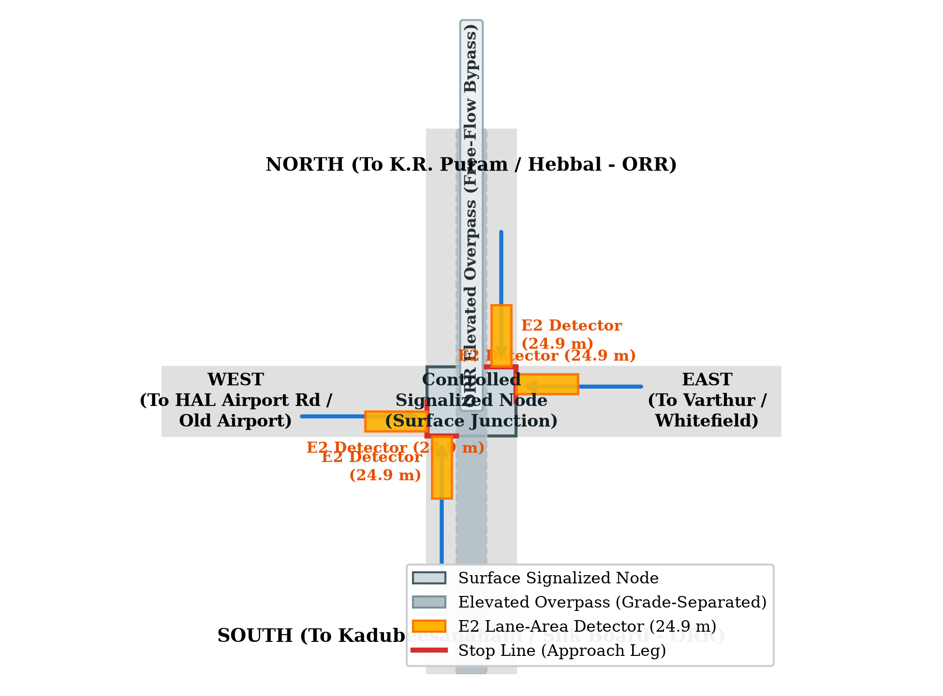
Fig. 1. Marathahalli junction model in SUMO.

B. Signal Phasing and Safety Supervisor
Phase 1 (EW) serves Varthur East and HAL West; Phase 2 (NS) serves ORR North and South. A shared state machine wraps every policy and cannot be overridden:
GREEN → YELLOW (3 s) → ALL-RED (2 s) → NEXT GREEN (1)
The fixed BTP-adapted plan uses 105 s (EW) and 95 s (NS) green, obtained by removing 5 s clearance from the 110 s and 100 s field phases. The field pedestrian-exclusive stage is omitted from this vehicle-only model.

C. Queue Observation and Sensing Limits
Eight lane-area (E2) detectors cover 24.9 m of each approach (pos −25.0 m, endPos −0.1 m). The detector-visible queue of approach i with lane set L_{i} is
Qdet,i(t) = max_{l ∈ Li} Ql(t) (2)
A sensor status of SATURATED is raised when the queue reaches within 0.5 m of the detector boundary (≥ 24.4 m for a 24.9 m E2 detector). Because physical loop detectors truncate long queues, evaluation uses an extended ground-truth queue Qgt_ext computed from microscopic vehicle positions over the approach leg and upstream connector ramp. A vehicle is counted in Qgt_ext if its speed is below 1.4 m/s (stopped threshold) and the headway gap to the preceding vehicle in the queue is ≤ 7.5 m (contiguous queue gap rule). Queues that spill beyond the modeled upstream lane chain are not captured by Qgt_ext, though their delay is fully recorded in vehicle trip statistics. The controller decisions rely exclusively on detector-visible measurements.

IV. CONTROL METHODOLOGY

A. Comparator Controllers
The evaluation matrix comprises eight policies: six baseline and comparator policies (fixed, webster_measured [primary reference], webster_recalc, sumo_actuated, adaptive, and queue_extension), our proposed hybrid controller (hybrid_queue_adaptive), and one oracle-seeded variant (hybrid_oracle_seeded) evaluated as an ablation of local flow measurement. Reinforcement learning (rl_dqn) was out of scope under Amendment 3 ('excluded from the final benchmark matrix due to lack of convergence stability and unverified safety invariants on non-stationary traffic regimes'). The main comparators are:
- fixed: static BTP plan (105 s EW / 95 s NS).
- webster_measured: Webster equi-saturation split computed once from a 300 s warm-up and then held static; primary reference.
- webster_recalc: Webster timing recomputed every 300 s from rolling local counts.
- sumo_actuated: SUMO gap-based extension with identical clearance intervals.
- adaptive, queue_extension: threshold- and score-based queue controllers.

B. Hybrid Controller
At each decision epoch Δt = 3 s after the base green, hybrid_queue_adaptive applies three rules.
1) Base green. The base allocation is initialized from rolling local discharge rates, not true arrival rates:
G_{base,p} = max(G_{min}, C_{est} · y_{p} / Σ_{k} y_{k}) (3)
where yp = qp / sp is the measured flow ratio of phase p, sp is saturation flow, and Cest is the Webster optimum cycle length computed as Cest = (1.5L + 5) / (1 - Y) with lost time L = 10.0 s. The minimum green floor is Gmin = 10.0 s (with baseline green g_base bounded within [Gmin, Gmax] = [10.0, 60.0] s). In the evaluation runs, g_base is actively computed from the 300 s measured Webster flows (yielding g_base = 14.2 s for EW and 15.8 s for NS in representative runs) and is not clamped at Gmin.
2) Queue-responsive extension. If the active queue satisfies Q_{act} ≥ 4.0 m, the controller requests ΔG_{req} = +3.0 s. Cumulative applied extension is capped:
G_{extra,p}(t) = Σ_{j=1}^{m} ΔG_{app,j} ≤ G_{max} − G_{base,p} (4)
with G_{max} = 60.0 s.
3) Anti-starvation guard. An extension is rejected (ΔG_{app} = 0) and a phase switch is requested if the competing red wait reaches the limit while a competing queue exists:
W_{comp}(t) ≥ W_{limit} = 35.0 s, Q_{comp} > 0 (5)
Because decisions occur every Δt = 3.0 s and phase clearance requires tyellow + tall_red = 3.0 + 2.0 = 5.0 s, the competing-phase red wait at green initiation is bounded analytically by Wbound = Wlimit + Δt + tyellow + tall_red = 35.0 + 3.0 + 3.0 + 2.0 = 43.0 s. Across all 48 evaluation runs of the hybrid controller, the observed maximum competing red wait at green start was 48.0 s (p99 = 34.0 s, p95 = 31.0 s, mean = 24.9 s), compared to 71.0 s for sumo_actuated and 116.0 s for the fixed-time BTP schedule.

C. Decision Traceability
Every decision is logged with proposed action, applied action, active and competing queues, requested extension ΔG_{req}, applied extension ΔG_{app}, cumulative extra green, and a reason code. In an example run, at t = 528.0 s the active NS queue was 24.0 m against a competing EW queue of 12.5 m, and +3.0 s was granted because W_{comp} = 15.0 s < 35.0 s. By t = 549.0 s, after 36.0 s of green, W_{comp} reached 36.0 s and a switch was requested. REPLACE: this trace comes from cell …_s125 of the separate 840-cell study (seeds 121–130). Substitute an equivalent trace from a seed 131–138 run of exp_marathahalli_improve_final, or state clearly that it is an illustrative mechanism demonstration from another study.
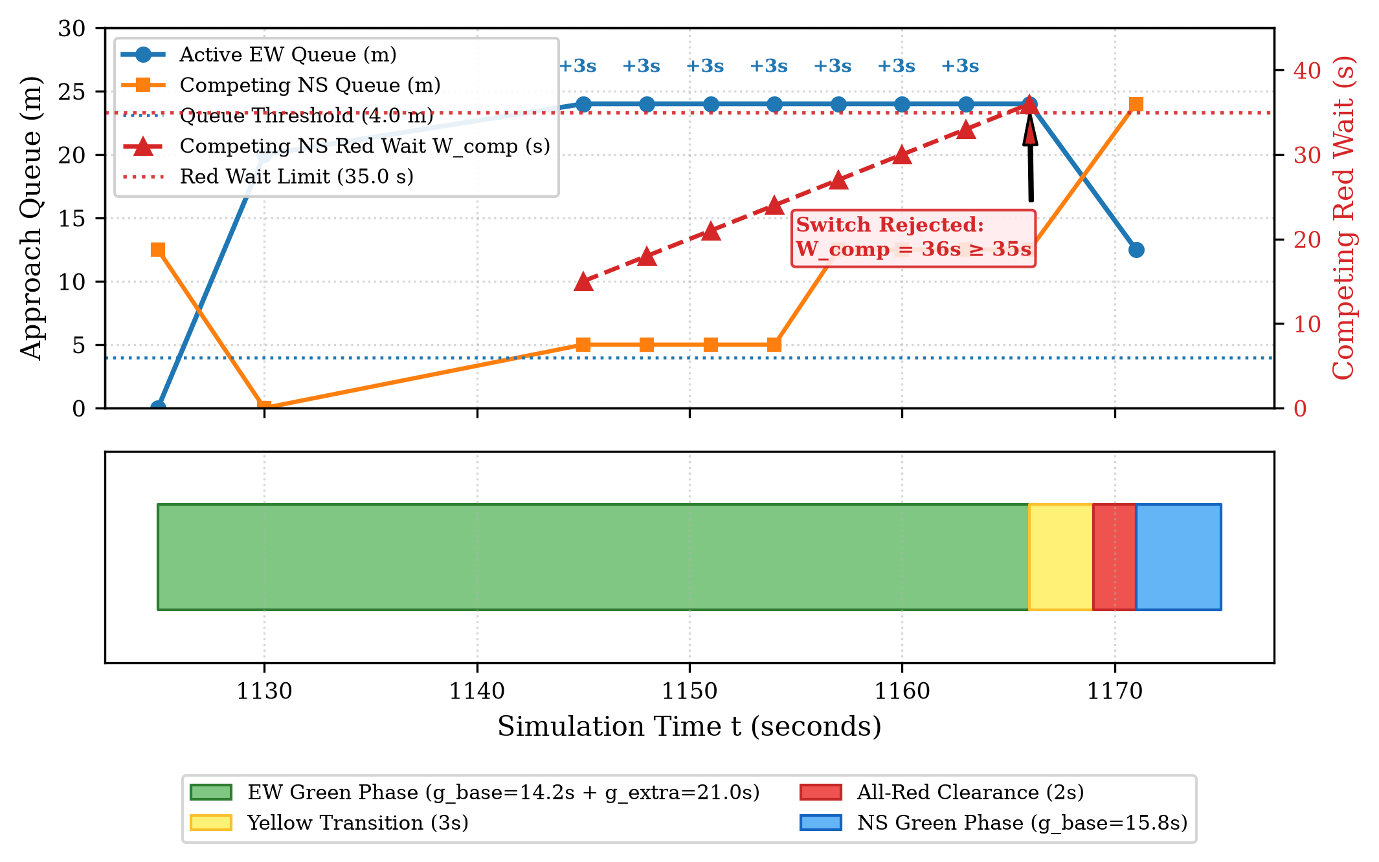
Fig. 2. Decision trace for one run.

V. EXPERIMENTAL DESIGN

A. Matrix and Seed Discipline
This paper reports one study, exp_marathahalli_improve_final: 8 policies × 6 conditions × 8 held-out seeds = 384 runs. It is separate from the 840-cell study (exp_marathahalli_hybrid_840, seeds 121–130) and from any emergency-priority study; their results are never pooled. Seeds were partitioned into historical exploratory runs (seeds 121–130, which evaluated preliminary concepts in earlier phases), development seeds 101–105, validation seeds 106–110 (used for sequential ablation gating in Phase 10 and tuning baselines in Phase 11), and held-out confirmatory seeds 131–138 (evaluated once under Amendment 3). All stopping rules and analysis plans were frozen in commit 4511149 at 11:05 UTC+5:30, 4 hours and 48 minutes prior to launching the final evaluation runs. All policies ran with default parameters; no tuning was performed on final seeds. All 384 runs completed with zero unfinished vehicles.

B. Demand Scenarios
Demand is synthetic. Stationary: balanced-low (0.70×), balanced-heavy (1.30×), and imbalanced_orr-heavy (1.30×, NS-dominant). Non-stationary: ramp_peak-medium (low→heavy→low), surge_shift-medium (dominant flow shifts from EW to NS mid-run), and lane_closure-medium (transient closure of one inbound lane).

C. Metrics and Statistics
Primary metrics, fixed in advance, are the 95th-percentile waiting time (p95), the extended ground-truth maximum queue (Q_{max}), and the approach wait gap W_{gap} = max_{i} W̄_{i} − min_{i} W̄_{i}. Secondary metrics are mean wait and mean queue. For each condition–seed pair,
Δ% = (M_{hybrid} − M_{ref}) / M_{ref} × 100 (6)
Confidence intervals use paired-bootstrap resampling (10,000 resamples, deterministic seed = 42). Holm–Bonferroni correction [15] is applied across the three primary metrics within each comparison; secondary metrics are unadjusted. For paired percentage differences, low-denominator zero-division is protected via explicit zero-handling.

VI. RESULTS

A. Hybrid versus Measured-Flow Webster
Table I pools all 48 condition–seed pairs. The hybrid lowers maximum queue by 28.8% (Holm p < 0.001). The p95 wait and wait gap intervals include zero, so no difference is detected; this does not establish equivalence.
TABLE I
Hybrid vs. webster_measured, pooled paired Δ% (n = 48)
Metric | Hybrid | Webster-m | Δ% (95% CI) | Holm p
p95 wait (s) | 452.3 | 446.8 | −0.9 (−4.2, +2.5) | 1.00
Max queue (m) | 42.2 | 62.2 | −28.8 (−35.0, −22.4) | <0.001
Wait gap (s) | 58.3 | 59.8 | +3.0 (−8.0, +16.2) | 1.00
Mean wait (s)* | 76.7 | 77.7 | −3.1 (−5.3, −1.1) | n/a
Mean queue (m)* | 2.5 | 4.0 | −35.7 (−38.4, −33.1) | n/a
*Secondary metrics, no multiplicity control.

B. Sensitivity Analysis (t ≥ 300 s)
The webster_measured baseline runs the BTP plan during its 300 s measurement window while the hybrid adapts from t = 0. Excluding vehicles departing before 300 s: p95 wait +0.9% (−2.0, +3.7); mean wait −0.5% (−2.3, +1.5); maximum queue −27.1% (−33.1, −20.6). The small full-run mean-wait advantage (−3.1%) is consistent with a warm-up effect and is not retained, whereas the queue reduction persists.

C. Alternative Baselines
TABLE II
Hybrid minus comparator, Δ% (95% CI)
Comparator | p95 wait | Max queue | Wait gap
webster_recalc | −2.5 (−5.9, +0.9) | −28.3 (−34.8, −21.7) | +17.5 (−7.8, +60.2)
fixed | −2.8 (−10.0, +3.9) | −48.7 (−53.0, −43.7) | +1.3 (−7.3, +10.6)
sumo_actuated | +1.0 (−2.1, +4.2) | +11.4 (+4.6, +18.7)† | +14.8 (−2.9, +37.7)
†Hybrid statistically worse (Holm p = 0.0006). All other cells: no detectable difference except max queue vs. fixed and webster_recalc (lower).
The hybrid contains maximum queue relative to static BTP timing (−48.7%) and recalculated Webster (−28.3%). Against sumo_actuated it shows a 11.4% higher maximum queue, a 35.5% higher mean queue, and a higher unadjusted mean wait (+3.4%, 95% CI 0.5 to 6.5%). Unconstrained actuation therefore performs better on queue and delay in this model; the hybrid trades part of that responsiveness for bounded, logged decisions.

D. Oracle Ablation
TABLE III
Hybrid vs. oracle-seeded variant (n = 48)
Metric | Δ% (95% CI) | Holm p | Verdict
p95 wait | −0.5 (−2.7, +1.7) | 1.00 | ND
Max queue | −1.2 (−6.0, +3.9) | 1.00 | ND
Wait gap | +15.3 (+0.2, +34.1) | 0.138 | ND
ND = no detectable difference.
No primary metric differs detectably between the hybrid and the oracle-seeded variant; absolute mean wait gaps were 58.28 s and 58.33 s. The wait-gap interval is wide and its lower bound is near zero, so a modest oracle benefit on that metric cannot be excluded. The result supports, but does not prove, that local measurements suffice. OPTIONAL: add post-hoc margin table (±5%, ±10%) labelled descriptive.

E. Per-Condition Behaviour
TABLE IV
Per-condition means (n = 8 seeds): p95 wait (s) / max queue (m)
Scenario | Hybrid | Webster-m | SUMO-act | Fixed
balanced-low | 43 / 25 | 50 / 34 | 41 / 26 | 86 / 46
balanced-heavy | 667 / 47 | 687 / 59 | 639 / 40 | 646 / 98
imbalanced_orr-heavy | 542 / 48 | 525 / 78 | 546 / 38 | 474 / 107
ramp_peak-medium | 595 / 43 | 588 / 51 | 593 / 44 | 585 / 91
surge_shift-medium | 280 / 43 | 297 / 82 | 294 / 39 | 287 / 82
lane_closure-medium | 587 / 48 | 535 / 69 | 600 / 41 | 516 / 95

Under sudden demand surges (surge_shift-medium), the hybrid contains peak queues to 43 m compared to 82 m for both Webster and fixed-time plans. Under heavy directional imbalance (imbalanced_orr-heavy), peak queues reach 107 m for the fixed baseline, 78 m for Webster, and 48 m for the hybrid. The hybrid exhibits higher p95 wait than Webster under lane closure (587 s vs. 535 s, +10%) and imbalanced ORR demand (542 s vs. 525 s, +4.5%). Under oversaturated regimes (p95 wait of 500–690 s), corridor capacity limits dominate delay variance, so small p95 differences remain descriptive.
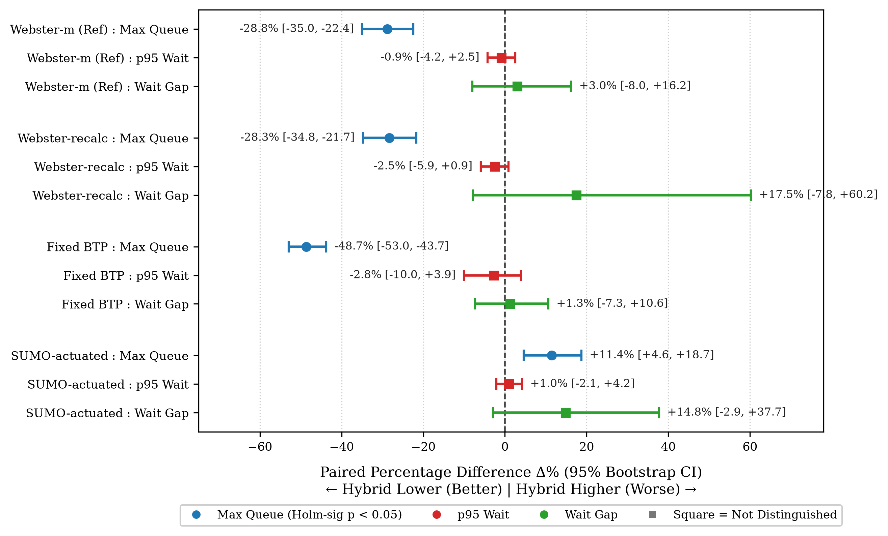
Fig. 3. Paired percentage difference (Δ%) with 95% bootstrap confidence intervals for the hybrid controller versus four comparators across 48 paired evaluation runs (Seeds 131–138). Closed circle indicates Holm-Bonferroni significance (p < 0.05); square indicates not distinguished.
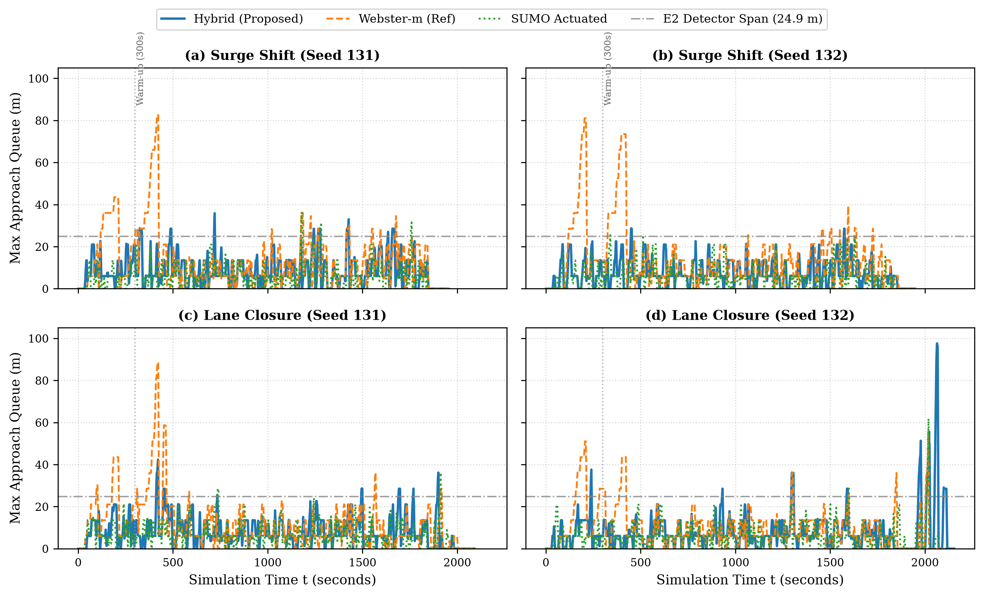
Fig. 4. Microscopic extended ground-truth queue dynamics (Qgt_ext) across surge-shift and lane-closure regimes across representative seeds 131 and 132. During the initial 300 s warm-up, Webster operates under the static BTP pretimed plan (favoring the hybrid prior to flow re-estimation at the ~400 s queue spike). Both seeds demonstrate consistent peak queue containment below 45 m for the hybrid controller, whereas Webster exceeds 80 m.

F. Operational Metrics and Delay Sanity Audit
TABLE V
Operational Throughput, Switching Frequency, and Completion Across Policies (Seeds 131–138)
Policy | Throughput (veh/h) | Switches / hour | Completion Rate (%) | Unfinished Vehicles
fixed | 2688.0 ± 454.4 | 33.5 ± 0.4 | 100.0% | 0
webster_measured | 2690.2 ± 446.6 | 144.3 ± 3.9 | 100.0% | 0
webster_recalc | 2688.6 ± 446.7 | 144.2 ± 2.6 | 100.0% | 0
sumo_actuated | 2687.6 ± 446.1 | 218.4 ± 6.0 | 100.0% | 0
adaptive | 2685.6 ± 446.4 | 206.6 ± 4.9 | 100.0% | 0
queue_extension | 2689.9 ± 447.5 | 219.0 ± 3.2 | 100.0% | 0
hybrid_queue_adaptive | 2684.7 ± 443.5 | 189.4 ± 3.6 | 100.0% | 0
hybrid_oracle_seeded | 2685.1 ± 444.0 | 190.6 ± 2.9 | 100.0% | 0
Table VI provides a microscopic delay and stop-count sanity audit across 28,650 completed vehicle trips under heavy congestion regimes. Across all policies, per-run median stop counts range from 0.2 to 0.9 stops (the majority of vehicles incur ≤ 1 stop), whereas the 95th-percentile stop count reaches 14–15 distinct stops (maximum stops reaching 25–27). Cumulative stationary delay of 500–690 s reflects vehicles undergoing multiple stop-and-go queuing cycles along congested corridors before clearing the intersection.
TABLE VI
Vehicle Delay and Stop Count Sanity Audit in Oversaturated Regimes (Seeds 131–138)
Condition | Policy | Completed Vehicles | Wait p95 (s) | Wait Max (s) | Max Queue (m) | Stop Count Median | Stop Count p95 | Stop Count Max
balanced-heavy | adaptive | 1698 | 674.8 | 1141.1 | 44.7 | 0.4 | 15.1 | 24.8
balanced-heavy | fixed | 1698 | 646.5 | 1046.4 | 98.1 | 0.6 | 14.4 | 24.2
balanced-heavy | hybrid_oracle_seeded | 1698 | 655.5 | 1129.2 | 45.9 | 0.5 | 15.0 | 25.4
balanced-heavy | hybrid_queue_adaptive | 1698 | 666.6 | 1138.5 | 46.6 | 0.5 | 15.4 | 25.1
balanced-heavy | queue_extension | 1698 | 667.3 | 1146.1 | 48.3 | 0.5 | 14.6 | 25.1
balanced-heavy | sumo_actuated | 1698 | 638.7 | 1129.9 | 40.0 | 0.2 | 14.9 | 24.0
balanced-heavy | webster_measured | 1698 | 686.8 | 1123.0 | 58.8 | 0.5 | 14.5 | 23.6
balanced-heavy | webster_recalc | 1698 | 684.2 | 1165.6 | 68.0 | 0.6 | 14.8 | 24.0
imbalanced_orr-heavy | adaptive | 1882 | 554.6 | 1461.8 | 52.2 | 0.8 | 13.8 | 25.6
imbalanced_orr-heavy | fixed | 1882 | 473.7 | 1462.9 | 106.6 | 0.8 | 11.9 | 21.2
imbalanced_orr-heavy | hybrid_oracle_seeded | 1882 | 569.3 | 1436.0 | 49.5 | 0.6 | 14.4 | 27.2
imbalanced_orr-heavy | hybrid_queue_adaptive | 1882 | 542.4 | 1401.8 | 47.6 | 0.9 | 14.6 | 26.6
imbalanced_orr-heavy | queue_extension | 1882 | 521.1 | 1423.1 | 46.7 | 0.8 | 14.1 | 26.2
imbalanced_orr-heavy | sumo_actuated | 1882 | 546.2 | 1384.2 | 38.4 | 0.5 | 14.0 | 25.9
imbalanced_orr-heavy | webster_measured | 1882 | 525.3 | 1467.0 | 77.5 | 0.8 | 13.6 | 24.6
imbalanced_orr-heavy | webster_recalc | 1882 | 526.0 | 1433.4 | 82.4 | 0.8 | 13.2 | 24.4
Table V reports network-wide operational throughput, switching frequency, and vehicle completion rates across all evaluated policies. Throughput across all policies is not distinguished (2684.7 to 2690.2 veh/h; hybrid vs. Webster-m Δ% = −0.2%, 95% CI −0.4% to +0.0%), completion rate is 100.0%, and unfinished vehicles is zero across all 384 runs. This confirms that the hybrid controller’s queue containment does not arise from dropping traffic service. Switching frequencies reflect dynamic phase responsiveness: the fixed baseline switches 33.5 ± 0.4 sw/h (cycle 210 s), webster_measured switches 144.3 ± 3.9 sw/h, the hybrid switches 189.4 ± 3.6 sw/h (+31.3% vs. Webster-m), and sumo_actuated switches 218.4 ± 6.0 sw/h.

VII. DISCUSSION
The defensible contribution of hybrid_queue_adaptive is bounded, auditable queue containment, not minimum delay:
- Gain over pretimed logic. Fixed plans reach peak queues of 107 m under heavy directional imbalance (imbalanced_orr-heavy) and 82 m under sudden demand surges (surge_shift-medium); the hybrid lowers maximum queues by 28.8% to 48.7% across comparators, with no detectable change in p95 wait.
- Trade-off against actuation. Gap actuation yields lower maximum queue (hybrid +11.4%, 95% CI +4.6% to +18.7%), lower mean queue (hybrid +35.5%, 95% CI +30.9% to +39.9%), and lower mean wait (hybrid +3.4%, 95% CI +0.5% to +6.5%). While native gap actuation achieves lower queue accumulation, the hybrid provides auditable rule logs and strict red-wait containment (observed maximum competing red wait at green start of 48.0 s for the hybrid versus 71.0 s for sumo_actuated). Pedestrian clearance was not evaluated in this two-phase vehicle simulation.
- Oracle independence. No detectable loss from removing the demand oracle suggests that standard local E2 detectors may suffice in simulation.
A possible confound in signal comparisons is cycle structure. In our measurements across 48 runs, the fixed-time baseline operates with long greens averaging 97.4 ± 0.4 s (105.0 s EW, 95.0 s NS, cycle 210 s; 33.5 ± 0.4 switches/h). In contrast, webster_measured operates under fixed timing during its 300 s warm-up, but subsequently runs dynamic splits with mean green of 19.7 ± 3.9 s (median 15.0 s, cycle ~49 s; 144.3 ± 3.9 switches/h). The proposed hybrid yields mean greens of 13.9 ± 3.6 s (median 13.0 s, bounded by Gmin = 10.0 s; 189.4 ± 3.6 switches/h), while sumo_actuated averages 11.4 ± 6.0 s greens (median 10.0 s; 218.4 ± 6.0 switches/h). The hybrid’s queue reduction relative to webster_measured (−28.8%) is achieved despite both policies utilizing short dynamic cycles, confirming that tail queue containment is driven by queue-aware phase extensions rather than cycle shortening alone.

VIII. THREATS TO VALIDITY AND LIMITATIONS
- 1) Synthetic demand and arrival processes: Vehicle departures are generated via piecewise exponential inter-arrival headways (rng.expovariate in dp1/scenarios.py:40–50), representing non-stationary Poisson arrivals rather than empirical platoon distributions. Geometry is calibrated from OpenCity GIS centerlines and BBMP corridor widths with signal timings from BTP municipal schedules, but uses an idealized synthesized intersection model rather than an on-site physical engineering survey.
- 2) Isolated junction modeling: The Marathahalli junction is evaluated in isolation; upstream arterial coordination, adjacent roundabout interactions, and corridor-level progression are not modeled.
- 3) Untuned default parameters: Nominal controller parameters (g_ext = 3.0 s, q_thresh = 4.0 m, W_comp_max = 35.0 s) were preserved from the earlier exploratory phase; no hyperparameter tuning or grid search was performed on the held-out confirmatory seeds (131–138). Performance reflects frozen defaults rather than an optimized operating point.
- Short-horizon projection removed. It showed overlapping confidence intervals during development and was dropped; the controller acts on rolling state only.
- 4) Homogeneous passenger-car fleet: All vehicles belong to a single class (vType 'car', length 5.0 m, dp1/scenarios.py:93). The rich heterogeneity of Bengaluru traffic—including motorized two-wheelers, auto-rickshaws, and BMTC buses exhibiting non-lane-based filtering—is omitted.
5) Omission of pedestrian clearance phase: The municipal schedule (docs/SOURCES.md:7, 11) allocates a 15 s dedicated pedestrian interval, omitted from the two-phase vehicle simulation model (effective cycle of 210 s vs. 225 s field schedule, dp1/config.py:243). Phase directions are settled in dp1/config.py:254–257 (EW = 105 s green, NS = 95 s green).
6) Spatial scope of queue sensing: Because Qgt_ext measures instantaneous spatial queue depth strictly along the signalized approach leg and connector ramp (spanning up to 180–198 m, dp1/queues.py:79–121) subject to a 7.5 m contiguous gap rule, it does not count vehicles queued further upstream on outer arrival links (which extend another 170 m to the 350 m network boundary). Consequently, severe multi-cycle delays (p95 wait of 450–690 s across 14–15 stop-and-go cycles) accumulate upstream outside the traced detector and approach chains while instantaneous approach queues remain contained near 40–50 m.
- Phase plan. The pedestrian-exclusive stage is omitted, so pedestrian clearance effects are not assessed.
- Cycle-length confound and unmeasured metrics. See Sections VI-F and VII.
- Scope. Conclusions apply to the six evaluated conditions only.

IX. CONCLUSION AND FUTURE WORK
On a microscopic model of the Marathahalli junction, a queue-aware controller with bounded +3.0 s extensions and a 35 s red-wait guard reduced maximum queue by 28.8% relative to measured-flow Webster, with no detectable difference in p95 wait, and no detectable cost from removing the demand oracle. It did not outperform unconstrained gap actuation on queue length. Future work includes multi-intersection coordination, sensor-noise injection, systematic parameter optimization, and calibration against measured traffic counts.

DATA AVAILABILITY
A sanitized artifact bundle (manifest with commit hash hash, raw_runs.csv, aggregate tables, decision trace of the example run, configuration, and analysis scripts) is available at repository/DOI. All tables and figures regenerate with python analysis/paper_final/run_all.py.

ACKNOWLEDGMENT
The authors thank Mentor Name, mentor for E1CSA313 Design Project-I at Alliance University, and OpenCity and the Bengaluru Traffic Police for the public geospatial and signal-schedule references.

REFERENCES
[1] R. P. Roess, E. S. Prassas, and W. R. McShane, Traffic Engineering, 4th ed. Upper Saddle River, NJ, USA: Pearson Prentice Hall, 2011.
[2] F. V. Webster, “Traffic signal settings,” Road Research Laboratory, London, U.K., Tech. Paper No. 39, 1958.
[3] V. S. S. Rajampalli, A. R. Narra, and G. Jaffino, “A spatio-temporal GNN and multi-agent system framework for bottleneck prediction and signal optimization in Bangalore,” Results in Engineering, vol. 28, Art. no. 107675, Dec. 2025, doi: 10.1016/j.rineng.2025.107675.
[4] P. B. Hunt, D. I. Robertson, R. D. Bretherton, and R. I. Winton, “SCOOT—A traffic responsive method of coordinating signals,” Transport and Road Research Lab., Crowthorne, U.K., Rep. LR 1014, 1981.
[5] P. R. Lowrie, “SCATS—Sydney Co-ordinated Adaptive Traffic System: A traffic responsive method of controlling urban traffic,” Roads and Traffic Authority NSW, Sydney, Australia, Tech. Rep., 1990.
[6] P. Varaiya, “Max pressure control of a network of signalized intersections,” Transp. Res. Part C: Emerg. Technol., vol. 36, pp. 177–195, Nov. 2013, doi: 10.1016/j.trc.2013.08.014.
[7] H. Wei, G. Zheng, V. Gayah, and Z. Li, “A survey on traffic signal control methods,” arXiv:1904.08117 [cs.AI], 2019.
[8] Q. Sun, R. Zha, L. Zhang, J. Zhou, Y. Mei, Z. Li, and H. Xiong, “CrossLight: Offline-to-Online Reinforcement Learning for Cross-City Traffic Signal Control,” in Proc. 30th ACM SIGKDD Conf. Knowledge Discovery and Data Mining (KDD '24), 2024, pp. 2765–2774, doi: 10.1145/3637528.3671927.
[9] L. Liu, X. Zhuang, and Q. Li, “Adaptive Traffic Signal Control for Urban Corridor Based on Reinforcement Learning,” in Computational and Experimental Simulations in Engineering (ICCES 2024), Mechanisms and Machine Science, vol. 173, Springer Nature Switzerland, 2025, pp. 25–35, doi: 10.1007/978-3-031-77489-8_3.
[10] K. Sreejith, S. Mathi, and P. Pradeep, “Beyond Sensors: IntelliSignal's Map-Integrated Intelligence in Traffic Flow Optimization,” IEEE Access, vol. 12, pp. 39028–39040, 2024, doi: 10.1109/ACCESS.2024.3375335.
[12] A. Wegener, M. Piórkowski, M. Raya, H. Hellbrück, S. Fischer, and J.-P. Hubaux, “TraCI: An interface for coupling road traffic and network simulators,” in Proc. 11th Commun. Networking Simulation Symp. (CNS '08), ACM, 2008, pp. 155–163, doi: 10.1145/1400713.1400740.
[14] Bengaluru Traffic Police, “Signal timings data: Marathalli Bridge & Yamlur junctions,” internal document, Bengaluru, India, 2023.
[15] S. Holm, “A simple sequentially rejective multiple test procedure,” Scand. J. Stat., vol. 6, no. 2, pp. 65–70, 1979.

