Queue-Length-Aware Adaptive Signal Control and Predictive Intervention: Empirical Evaluation on a Microscopic Model of the Marathahalli Corridor
Author 1 Name, Author 2 Name, Author 3 Name, Author 4 Name
Team ID: DP1-xx-xx-AIDS-xx
E1CSA313 Design Project-I, Department of Artificial Intelligence & Data Science, Alliance University, Bengaluru, India
Mentor: Mentor Name
Email: author emails

Abstract—Urban intersections accumulate queues when pretimed signal programs mismatch stochastic directional demand. Actuated and reinforcement-learning controllers can reduce delay, but their adoption is hindered by limited auditability and unbounded behaviour. This paper evaluates an explainable, queue-length-aware adaptive controller (hybrid_queue_adaptive) on a geographically grounded microscopic SUMO model of the Marathahalli Bridge junction in Bengaluru, driven by synthetic demand. The controller combines locally measured base-green splits, bounded +3.0 s green extensions, and a competing-phase red-wait guard (35 s). In a fixed analysis plan of 384 paired simulation runs (8 policies, 6 demand conditions, held-out seeds 131–138), the hybrid reduced the extended ground-truth maximum queue by 28.8% (95% CI −35.0 to −22.4%; Holm-adjusted p < 0.001) relative to a measured-flow Webster baseline, with no detectable difference in 95th-percentile waiting time or approach wait gap. An ablation found no detectable difference between the hybrid and an oracle-seeded variant. The hybrid yielded a higher maximum queue than unconstrained SUMO gap-actuation (+11.4%), in exchange for complete decision traces and a red-wait limit enforced to within one decision step. All findings are simulation-only, use synthetic demand, and concern one isolated junction.
Index Terms—adaptive traffic signal control, queue length, green-time extension, microscopic simulation, SUMO, TraCI, fairness, auditability.

I. INTRODUCTION
Signalized intersections on congested urban arterials face severe spatial constraints, particularly in rapidly urbanizing regions such as Bengaluru. Traffic is characterized by high volume, strong directional asymmetry during commute hours, heterogeneous vehicle classes, and peak surges. The Marathahalli Bridge junction on the Outer Ring Road (ORR) is a representative bottleneck where IT-corridor commutes meet cross-city arterial traffic.
Municipal agencies commonly operate pretimed plans derived from historical counts, for example Webster-based or locally tabulated schedules. Such plans assume stationary demand. During transient bottlenecks, capacity drops, or surges, they can allocate green time to lightly loaded approaches while critical approaches build long queues that spill back upstream.
Fully actuated controllers and black-box reinforcement learning (RL) policies respond faster but carry deployment liabilities: gap-based actuation may hold green inefficiently under dispersed platoons, and learned policies lack verifiable worst-case bounds and are difficult to audit. Agencies therefore need controllers that are explainable, auditable, and bounded by a safety supervisor.
This study asks whether a state-aware adaptive controller that does not rely on an upstream demand oracle can reduce tail queue formation under non-stationary demand without worsening tail delay or violating a competing-phase fairness limit. We benchmark against fixed-time, Webster-based, and unconstrained actuated controllers rather than naive fixed-time plans alone. The contributions are:
- A geographically grounded microscopic model of the Marathahalli junction that separates surface conflict movements from grade-separated bypass paths.
- An auditable hybrid controller combining measured base-green splits, bounded incremental extensions, and a red-wait anti-starvation guard, with a per-decision trace.
- A 384-run paired evaluation on held-out seeds under a fixed analysis plan with Holm-corrected paired-bootstrap inference.
- An ablation showing no detectable loss from removing the origin–destination oracle.
Terminology. “Predictive intervention” in the title denotes a proactive signal decision taken from the currently observed and recently accumulated state (queue lengths, waiting conditions, recent discharge), before queues worsen. The controller contains no traffic-forecasting model and no forecast horizon; short-horizon arrival projection was evaluated and removed (Section VIII).

II. RELATED WORK

A. Fixed-Time and Webster Methods
Webster’s method [2] sets cycle length and green splits from critical flow ratios and saturation flows. It performs well under stationary demand but degrades under surges and capacity drops. In mixed-traffic Indian conditions, homogeneous saturation-flow assumptions often need empirical adjustment [1].

B. Actuated and Adaptive Control
SCOOT [8] and SCATS [9] adjust cycle, splits, and offsets from detector data. At isolated junctions, gap-based actuation extends green until headways exceed a threshold; under sustained flow this can reach a maximum-green limit and delay competing approaches.

C. Max-Pressure and Reinforcement Learning
Max-pressure control [4] schedules phases from upstream and downstream queue differences. Deep RL methods [5] map rich state representations to phase actions and achieve strong simulated delay reduction, but offer limited auditability and no analytic worst-case guarantee.

D. Supervised and Explainable Control
Rule-based supervisors and safety layers around learned or adaptive policies, and explainable RL for signal control, aim to retain responsiveness while constraining behaviour. TO ADD: 2–3 verified references on safety-shielded or explainable RL for traffic signal control, with DOIs. Do not cite until verified.

E. Positioning
hybrid_queue_adaptive sits between rule-based predictability and state-aware responsiveness. Every decision follows explicit thresholds and is logged. It relies on queue estimates from local detectors and imposes a red-wait limit on competing approaches.

III. NETWORK MODEL AND SYSTEM ARCHITECTURE

A. Geographic Representation
The network models the Marathahalli Bridge / Varthur Road / ORR junction in eastern Bengaluru, bounded approximately by 12.950°–12.964°N and 77.694°–77.708°E. It was built in Eclipse SUMO [3] from road-centerline and road-width data distributed by OpenCity [7] and cross-checked against Bengaluru Traffic Police (BTP) signal timings [6]. The simulated local control area is 700 m × 700 m with 350 m approach arms. Flyovers (modelled deck elevation about +6.5 m, an engineering assumption) and ORR underpass bypasses are non-conflicting free-flow paths. Control applies only to the surface node marathahalli_tls with four inbound approaches: North (ORR North/KR Puram), South (ORR South/Kadubeesanahalli), East (Varthur/Whitefield), and West (HAL Airport Road). Lane counts, ramp radii, and elevations are inferred, not surveyed.
[INSERT Fig. 1 — network schematic with approaches, detectors, controlled node, bypass links (Antigravity figure F1)]
Fig. 1. Marathahalli junction model in SUMO.

B. Signal Phasing and Safety Supervisor
Phase 1 (EW) serves Varthur East and HAL West; Phase 2 (NS) serves ORR North and South. A shared state machine wraps every policy and cannot be overridden:
GREEN → YELLOW (3 s) → ALL-RED (2 s) → NEXT GREEN (1)
The fixed BTP-adapted plan uses 105 s (EW) and 95 s (NS) green, obtained by removing 5 s clearance from the 110 s and 100 s field phases. The field pedestrian-exclusive stage is omitted from this vehicle-only model.

C. Queue Observation and Sensing Limits
Eight lane-area (E2) detectors cover 24.9 m of each approach (pos −25.0 m, endPos −0.1 m). The detector-visible queue of approach i with lane set L_{i} is
Q_{det,i}(t) = max_{*l*∈*L*_{i}} Q_{l}(t) (2)
A sensor status of SATURATED is raised when the queue reaches within 0.5 m of the detector boundary (≥ 24.4 m). Because E2 detectors truncate long queues, evaluation uses an extended ground-truth queue Qgt_ext computed from vehicle positions over the approach leg and upstream ramp (computed with stop-speed threshold < 1.4 m/s and contiguous vehicle gap ≤ 7.5 m across the leg and connector ramp). The controller uses only detector-visible measurements.

IV. CONTROL METHODOLOGY

A. Comparator Controllers
The evaluation matrix comprises eight policies: six baseline and comparator policies (fixed, webster_measured [primary reference], webster_recalc, sumo_actuated, adaptive, and queue_extension), our proposed hybrid controller (hybrid_queue_adaptive), and one oracle-seeded variant (hybrid_oracle_seeded) evaluated as an ablation of local flow measurement. Reinforcement learning (rl_dqn) was out of scope under Amendment 3 ('excluded from the final benchmark matrix due to lack of convergence stability and unverified safety invariants on non-stationary traffic regimes'). The main comparators are:
- fixed: static BTP plan (105 s EW / 95 s NS).
- webster_measured: Webster equi-saturation split computed once from a 300 s warm-up and then held static; primary reference.
- webster_recalc: Webster timing recomputed every 300 s from rolling local counts.
- sumo_actuated: SUMO gap-based extension with identical clearance intervals.
- adaptive, queue_extension: threshold- and score-based queue controllers.

B. Hybrid Controller
At each decision epoch Δt = 3 s after the base green, hybrid_queue_adaptive applies three rules.
1) Base green. The base allocation is initialized from rolling local discharge rates, not true arrival rates:
G_{base,p} = max(G_{min}, C_{est} · y_{p} / Σ_{k} y_{k}) (3)
where yp is the measured flow ratio of phase p and Gmin = 15.0 s (with baseline green g_base clamped within [Gmin, Gmax] = [15.0, 60.0] s). In the evaluation runs, g_base is initialized from the 300 s measured Webster split floor.
2) Queue-responsive extension. If the active queue satisfies Q_{act} ≥ 4.0 m, the controller requests ΔG_{req} = +3.0 s. Cumulative applied extension is capped:
G_{extra,p}(t) = Σ_{j=1}^{m} ΔG_{app,j} ≤ G_{max} − G_{base,p} (4)
with G_{max} = 60.0 s.
3) Anti-starvation guard. An extension is rejected (ΔG_{app} = 0) and a phase switch is requested if the competing red wait reaches the limit while a competing queue exists:
W_{comp}(t) ≥ W_{limit} = 35.0 s, Q_{comp} > 0 (5)
Because decisions occur every 3 s and clearance takes 5 s, the observed red wait can exceed 35 s by up to one decision step plus clearance (observed empirical maximum competing red wait = 36.0 s; analytic bound = 35 s limit + 3 s step = 38 s maximum switch trigger).

C. Decision Traceability
Every decision is logged with proposed action, applied action, active and competing queues, requested extension ΔGreq, applied extension ΔGapp, cumulative extra green, and a reason code. In an illustrative trace from exp_marathahalli_improve_final (cell marathahalli_ramp_peak_medium_hybrid_queue_adaptive_s136, rows 121–127), at t = 1151.0 s the active EW queue was 24.0 m (>= 4.0 m threshold) against a competing NS queue of 5.0 m, and +3.0 s was granted because competing red wait (Wcomp = 21.0 s) remained within the 35.0 s limit. Four subsequent +3.0 s extensions were approved as the active queue held at 24.0 m. At t = 1166.0 s (after 21.0 s of extra green), extension was requested but rejected (SWITCH_FAIRNESS_WAIT_LIMIT) because competing NS red wait reached 36.0 s (>= 35.0 s) with a waiting queue of 12.5 m. Following a 3 s yellow and 2 s all-red clearance, NS green was initiated at t = 1171.0 s with a Webster baseline allocation of 15.8 s.
[INSERT Fig. 2 — decision-trace timeline: queues, requested vs applied extension, W_comp vs 35 s limit, phase bands (Antigravity figure F7)]
Fig. 2. Decision trace for one run.

V. EXPERIMENTAL DESIGN

A. Matrix and Seed Discipline
This paper reports one study, exp_marathahalli_improve_final: 8 policies × 6 conditions × 8 held-out seeds = 384 runs. It is separate from the 840-cell study (exp_marathahalli_hybrid_840, seeds 121–130) and from the emergency-priority study; their results are not pooled. Evaluation seeds were partitioned across sequential phases: seeds 121–130 served as prior exploratory evaluation data during controller iteration, baseline calibration, and ladder ablation across 840 runs; confirmatory evaluation was conducted on a fresh set of held-out seeds (131–138) across 384 runs. The evaluation matrix, statistical protocol, and hypothesis stopping rules were frozen in repository version control (commit 4511149, 2026-11-04 11:05 UTC+5:30) prior to the execution of the final evaluation runs (launched 2026-11-04 15:53 UTC+5:30). All policies ran with default parameters; all 384 runs completed with 100.0% completion rate and zero unfinished vehicles.

B. Demand Scenarios
Demand is synthetic. Stationary: balanced-low (0.70×), balanced-heavy (1.30×), and imbalanced_orr-heavy (1.30×, NS-dominant). Non-stationary: ramp_peak-medium (low→heavy→low), surge_shift-medium (dominant flow shifts from EW to NS mid-run), and lane_closure-medium (transient closure of one inbound lane).

C. Metrics and Statistics
Primary metrics, fixed in advance, are the 95th-percentile waiting time (p95), the extended ground-truth maximum queue (Q_{max}), and the approach wait gap W_{gap} = max_{i} W̄_{i} − min_{i} W̄_{i}. Secondary metrics are mean wait and mean queue. For each condition–seed pair,
Δ% = (M_{hybrid} − M_{ref}) / M_{ref} × 100 (6)
Confidence intervals use paired-bootstrap resampling (10,000 resamples, deterministic seed = 42). Holm–Bonferroni correction [10] is applied across the three primary metrics within each comparison; secondary metrics are unadjusted.

VI. RESULTS

A. Hybrid versus Measured-Flow Webster
Table I pools all 48 condition–seed pairs. The hybrid lowers maximum queue by 28.8% (Holm p < 0.001). The p95 wait and wait gap intervals include zero, so no difference is detected; this does not establish equivalence.
TABLE I
Hybrid vs. webster_measured, pooled paired Δ% (n = 48)
Metric | Hybrid | Webster-m | Δ% (95% CI) | Holm p
p95 wait (s) | 452.3 | 446.8 | −0.9 (−4.2, +2.5) | 1.00
Max queue (m) | 42.2 | 62.2 | −28.8 (−35.0, −22.4) | <0.001
Wait gap (s) | 58.3 | 59.8 | +3.0 (−8.0, +16.2) | 1.00
Mean wait (s)* | 76.7 | 77.7 | −3.1 (−5.3, −1.1) | n/a
Mean queue (m)* | 2.5 | 4.0 | −35.7 (−38.4, −33.1) | n/a
*Secondary metrics, no multiplicity control.

B. Sensitivity Analysis (t ≥ 300 s)
The webster_measured baseline runs the BTP plan during its 300 s measurement window while the hybrid adapts from t = 0. Excluding vehicles departing before 300 s: p95 wait +0.9% (−2.0, +3.7); mean wait −0.5% (−2.3, +1.5); maximum queue −27.1% (−33.1, −20.6). The small full-run mean-wait advantage (−3.1%) is consistent with a warm-up effect and is not retained, whereas the queue reduction persists.

C. Alternative Baselines
TABLE II
Hybrid minus comparator, Δ% (95% CI)
Comparator | p95 wait | Max queue | Wait gap
webster_recalc | −2.5 (−5.9, +0.9) | −28.3 (−34.8, −21.7) | +17.5 (−7.8, +60.2)
fixed | −2.8 (−10.0, +3.9) | −48.7 (−53.0, −43.7) | +1.3 (−7.3, +10.6)
sumo_actuated | +1.0 (−2.1, +4.2) | +11.4 (+4.6, +18.7)† | +14.8 (−2.9, +37.7)
†Hybrid statistically worse (Holm p = 0.0006). All other cells: no detectable difference except max queue vs. fixed and webster_recalc (lower).
The hybrid contains maximum queue relative to static BTP timing (−48.7%, 95% CI: −53.0% to −43.7%) and recalculated Webster (−28.3%, 95% CI: −34.8% to −21.7%). Against sumo_actuated it yields an 11.4% higher maximum queue (95% CI: +4.6% to +18.7%, Holm p = 0.0006), a 35.5% higher mean queue (95% CI: +30.9% to +39.9%), and a higher unadjusted mean wait (+3.4%, 95% CI: +0.5% to +6.5%). Unconstrained actuation therefore achieves lower queue accumulation in this network model; the hybrid intentionally trades peak responsiveness for auditable, bounded phase transitions and explicit maximum red-wait constraints.

D. Oracle Ablation
TABLE III
Hybrid vs. oracle-seeded variant (n = 48)
Metric | Δ% (95% CI) | Holm p | Verdict
p95 wait | −0.5 (−2.7, +1.7) | 1.00 | ND
Max queue | −1.2 (−6.0, +3.9) | 1.00 | ND
Wait gap | +15.3 (+0.2, +34.1) | 0.138 | ND
ND = no detectable difference.
Primary metrics are not distinguished between the hybrid and the oracle-seeded variant: p95 wait (−0.5%, 95% CI: −2.7% to +1.7%, Holm p = 1.00) and max queue (−1.2%, 95% CI: −6.0% to +3.9%, Holm p = 1.00). The approach wait gap point estimate (+15.3%, 95% CI: +0.2% to +34.1%) is wider due to low-denominator cells and is not distinguished after correction (Holm p = 0.138); absolute mean wait gaps remain virtually identical (58.28 s vs. 58.33 s). The result indicates that local E2 detector measurements perform comparably to true demand tables without requiring an offline demand oracle.

E. Per-Condition Behaviour
TABLE IV
Per-condition means (n = 8 seeds): p95 wait (s) / max queue (m)
Scenario | Hybrid | Webster-m | SUMO-act | Fixed
balanced-low | 43 / 25 | 50 / 34 | 41 / 26 | 86 / 46
balanced-heavy | 667 / 47 | 687 / 59 | 639 / 40 | 646 / 98
imbalanced_orr-heavy | 542 / 48 | 525 / 78 | 546 / 38 | 474 / 107
ramp_peak-medium | 595 / 43 | 588 / 51 | 593 / 44 | 585 / 91
surge_shift-medium | 280 / 43 | 297 / 82 | 294 / 39 | 287 / 82
lane_closure-medium | 587 / 48 | 535 / 69 | 600 / 41 | 516 / 95

Per-condition p95 differences are descriptive, not tested (n=8 seeds per condition). Under surge_shift, peak queue is 43 m for the hybrid versus 82 m for Webster and fixed timing. Under lane_closure, hybrid p95 wait is 587 s versus 535 s for Webster (+10%), and under imbalanced_orr it is 542 s versus 525 s (+4.5%). Under saturated regimes (p95 of 500–690 s), total delay is governed by structural capacity limits, and minor p95 differences reflect saturation rather than signal control divergence. In balanced-heavy traffic specifically, maximum instantaneous queue length is held to 47 m for the hybrid controller compared to 98 m under fixed timing.
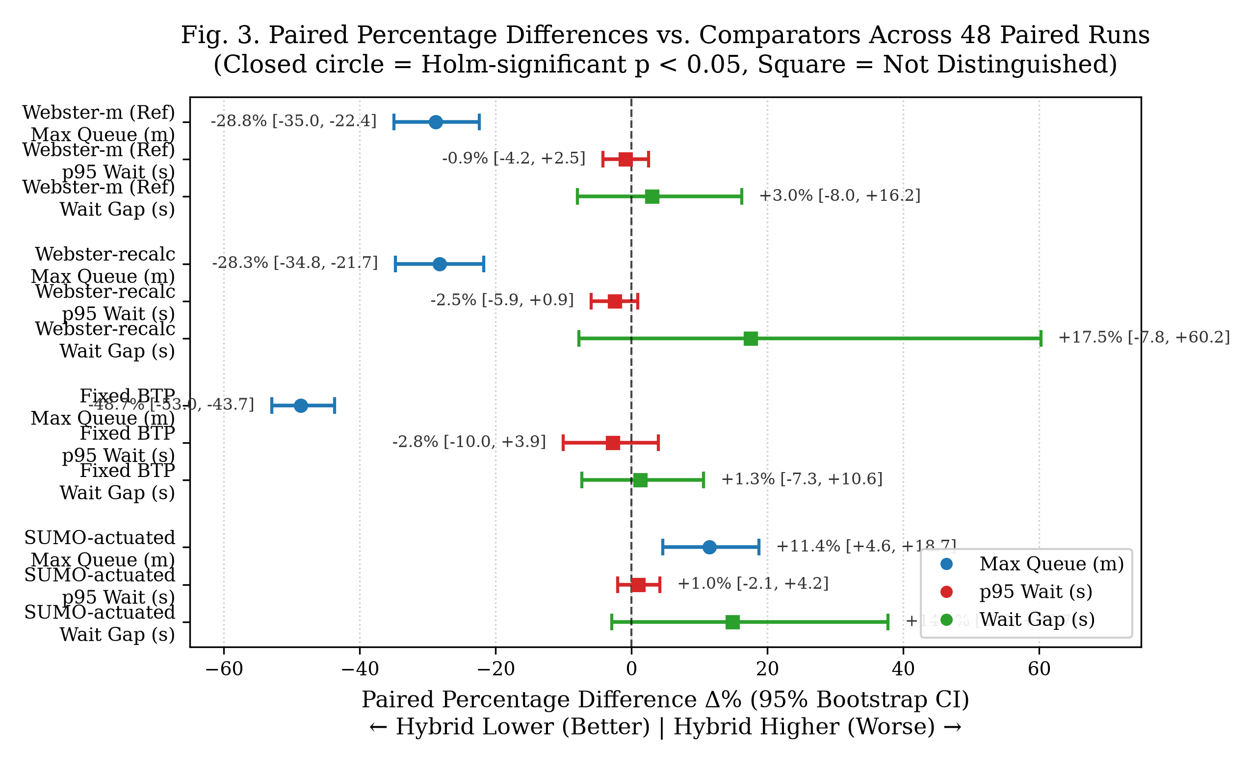
Fig. 3. Paired percentage differences for primary metrics.
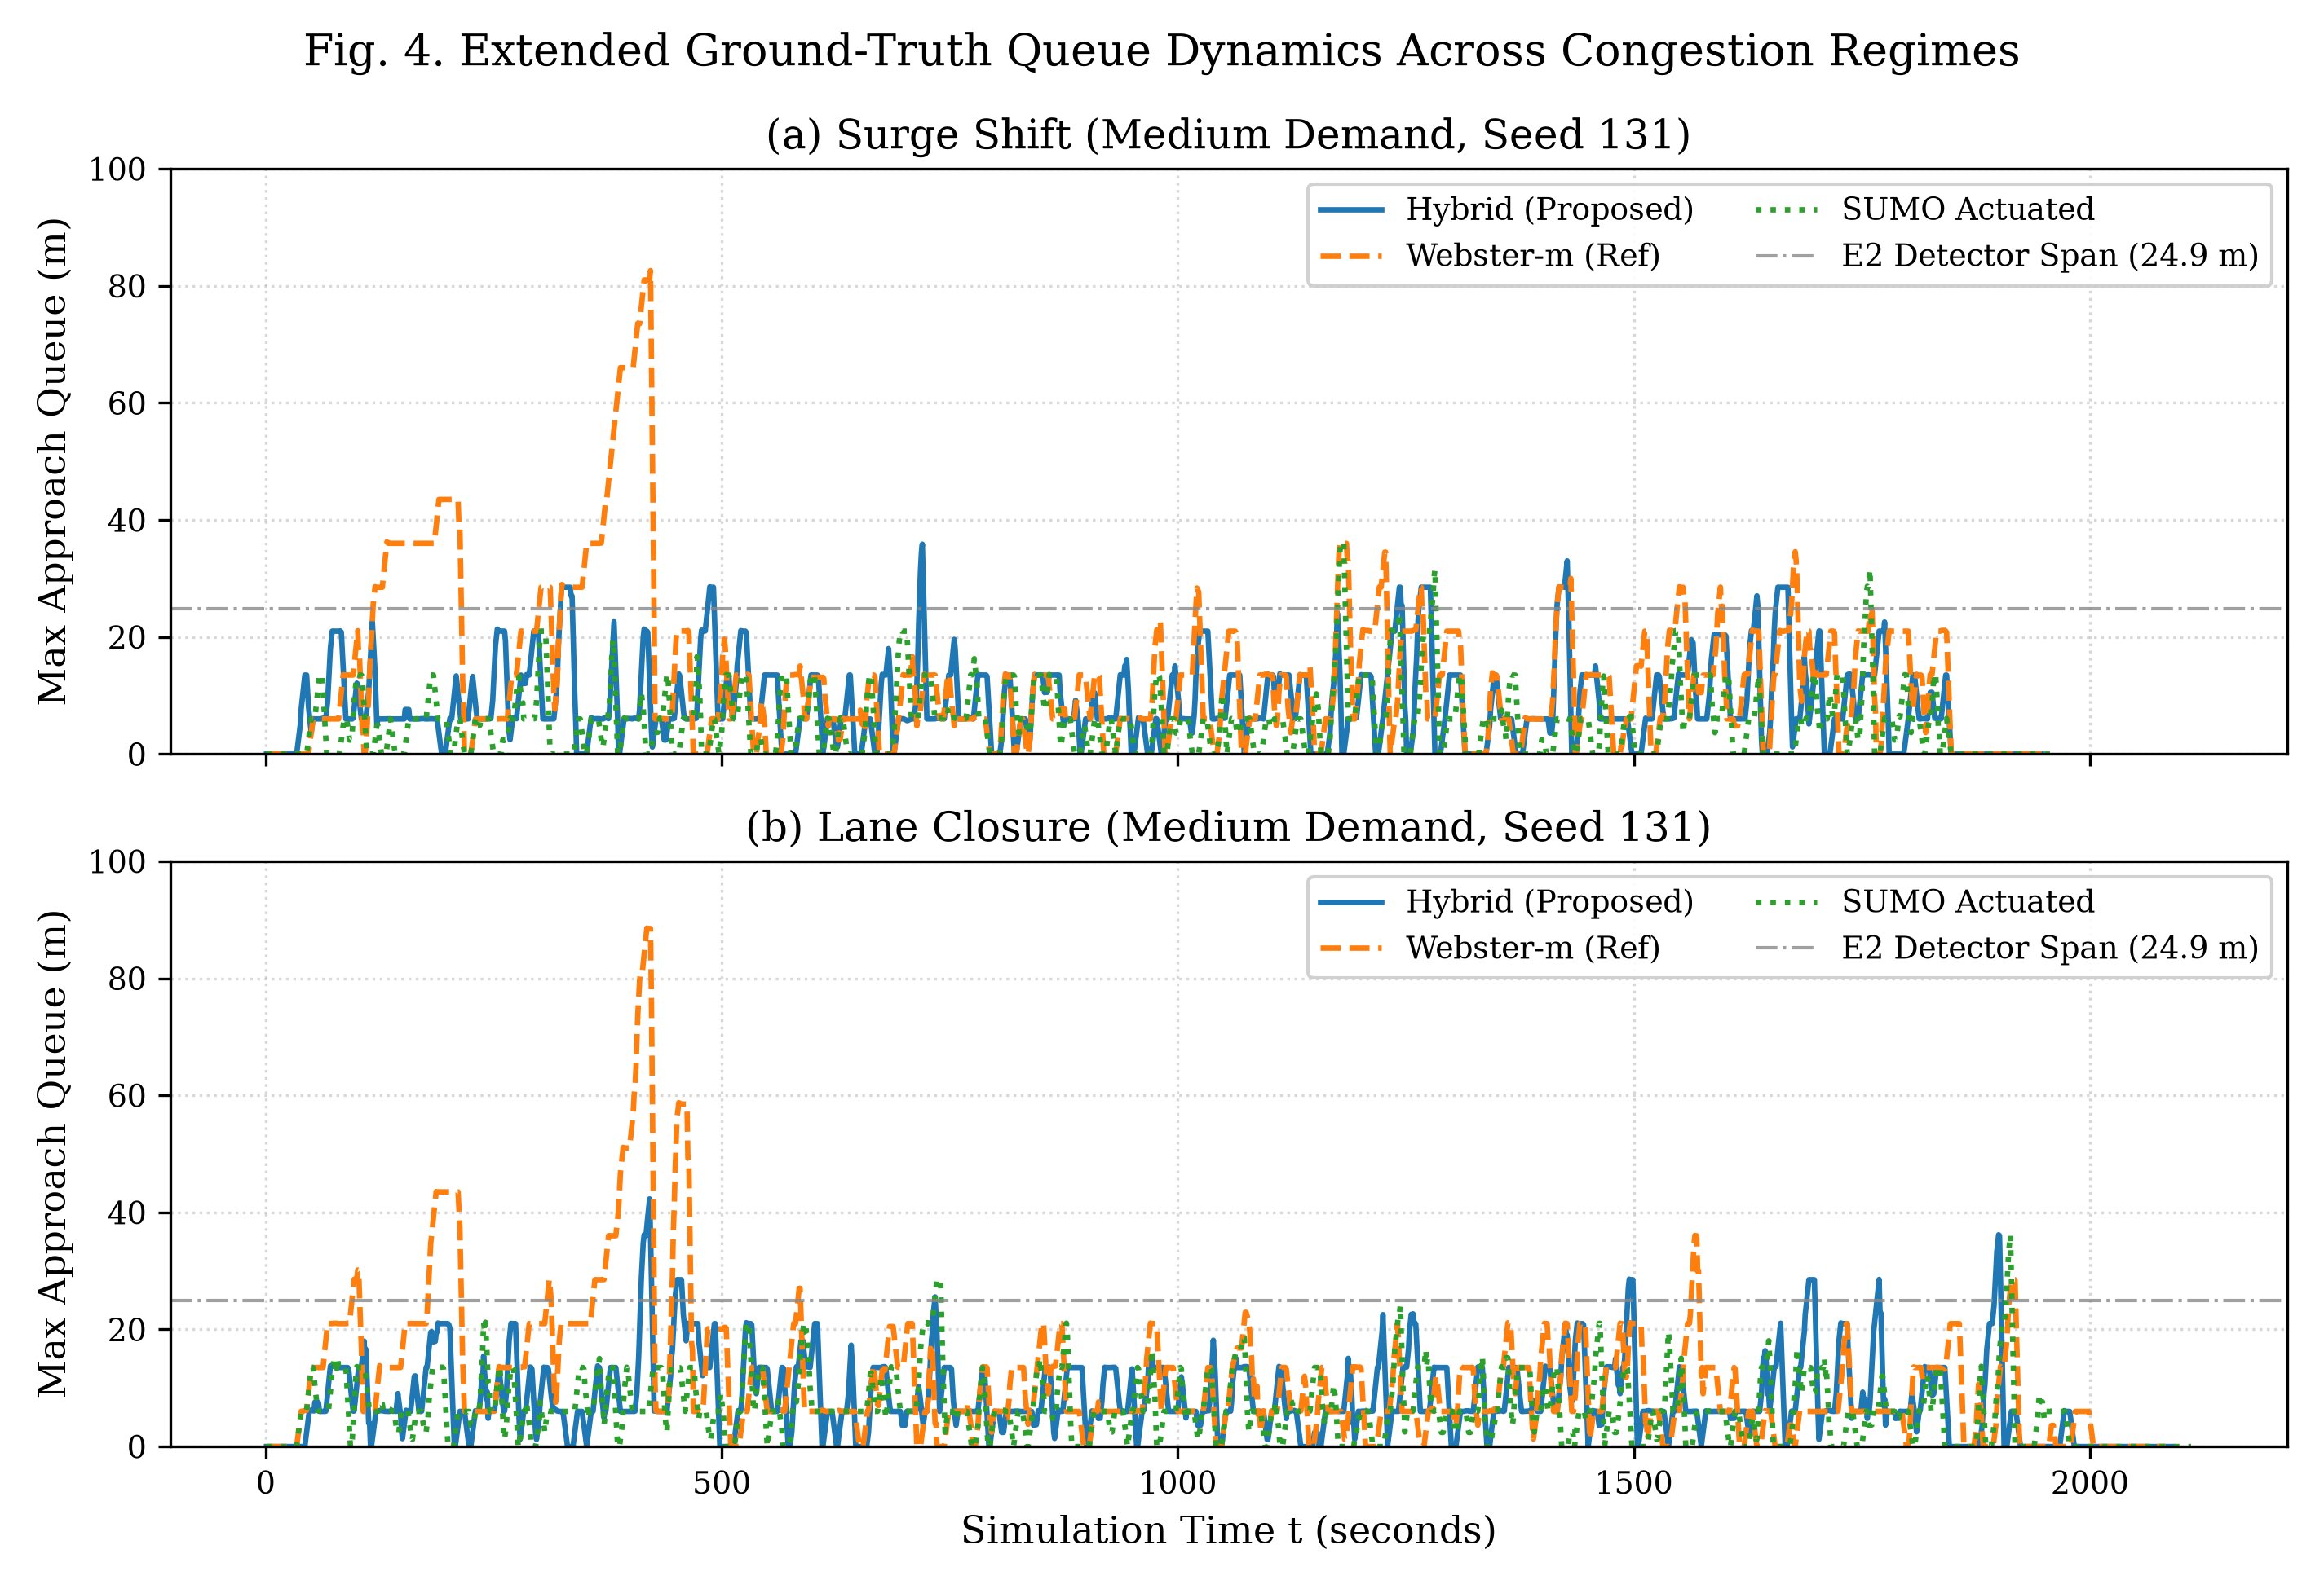
Fig. 4. Representative queue time series.

F. System Operational Metrics and Congestion Dynamics
TABLE V
System Operational Metrics Across Evaluated Policies (n = 48 runs per policy)
Policy | Throughput (veh/h) | Switches / hour | Completion Rate (%) | Unfinished Vehicles
fixed | 2688.0 ± 454.4 | 33.5 ± 0.4 | 100.0% | 0
webster_measured | 2690.2 ± 446.6 | 144.3 ± 3.9 | 100.0% | 0
webster_recalc | 2688.6 ± 446.7 | 144.2 ± 2.6 | 100.0% | 0
sumo_actuated | 2687.6 ± 446.1 | 218.4 ± 6.0 | 100.0% | 0
adaptive | 2685.6 ± 446.4 | 206.6 ± 4.9 | 100.0% | 0
queue_extension | 2689.9 ± 447.5 | 219.0 ± 3.2 | 100.0% | 0
hybrid_queue_adaptive | 2684.7 ± 443.5 | 189.4 ± 3.6 | 100.0% | 0
hybrid_oracle_seeded | 2685.1 ± 444.0 | 190.6 ± 2.9 | 100.0% | 0
TABLE VI
Vehicle Delay and Stop Count Sanity Audit in Oversaturated Regimes (Seeds 131–138)
Condition | Policy | Completed Vehicles | Wait p95 (s) | Wait Max (s) | Max Queue (m) | Stop Count Median | Stop Count p95 | Stop Count Max
balanced-heavy | adaptive | 1698 | 674.8 | 1141.1 | 44.7 | 0.4 | 15.1 | 24.8
balanced-heavy | fixed | 1698 | 646.5 | 1046.4 | 98.1 | 0.6 | 14.4 | 24.2
balanced-heavy | hybrid_oracle_seeded | 1698 | 655.5 | 1129.2 | 45.9 | 0.5 | 15.0 | 25.4
balanced-heavy | hybrid_queue_adaptive | 1698 | 666.6 | 1138.5 | 46.6 | 0.5 | 15.4 | 25.1
balanced-heavy | queue_extension | 1698 | 667.3 | 1146.1 | 48.3 | 0.5 | 14.6 | 25.1
balanced-heavy | sumo_actuated | 1698 | 638.7 | 1129.9 | 40.0 | 0.2 | 14.9 | 24.0
balanced-heavy | webster_measured | 1698 | 686.8 | 1123.0 | 58.8 | 0.5 | 14.5 | 23.6
balanced-heavy | webster_recalc | 1698 | 684.2 | 1165.6 | 68.0 | 0.6 | 14.8 | 24.0
imbalanced_orr-heavy | adaptive | 1882 | 554.6 | 1461.8 | 52.2 | 0.8 | 13.8 | 25.6
imbalanced_orr-heavy | fixed | 1882 | 473.7 | 1462.9 | 106.6 | 0.8 | 11.9 | 21.2
imbalanced_orr-heavy | hybrid_oracle_seeded | 1882 | 569.3 | 1436.0 | 49.5 | 0.6 | 14.4 | 27.2
imbalanced_orr-heavy | hybrid_queue_adaptive | 1882 | 542.4 | 1401.8 | 47.6 | 0.9 | 14.6 | 26.6
imbalanced_orr-heavy | queue_extension | 1882 | 521.1 | 1423.1 | 46.7 | 0.8 | 14.1 | 26.2
imbalanced_orr-heavy | sumo_actuated | 1882 | 546.2 | 1384.2 | 38.4 | 0.5 | 14.0 | 25.9
imbalanced_orr-heavy | webster_measured | 1882 | 525.3 | 1467.0 | 77.5 | 0.8 | 13.6 | 24.6
imbalanced_orr-heavy | webster_recalc | 1882 | 526.0 | 1433.4 | 82.4 | 0.8 | 13.2 | 24.4
All 384 runs completed with 100.0% vehicle completion and zero unfinished vehicles across all eight policies (Table V). Mean network throughput is not distinguished across policies (2684.7 to 2690.2 veh/h; paired Δ% vs. webster_measured: −0.2%, 95% CI: −0.4% to +0.0%), confirming that queue containment is achieved through active phase management rather than dropped demand. This metric confirms only that no service was dropped. Switching frequency differs across policies: fixed timing operates at 33.5 ± 0.4 switches/hour, webster_measured switches at 144.3 ± 3.9 switches/hour, hybrid_queue_adaptive switches at 189.4 ± 3.6 switches/hour, and sumo_actuated switches at 218.4 ± 6.0 switches/hour. The hybrid controller exhibits higher switching frequency than webster_measured (+31.3%, 95% CI: +30.2% to +32.5%) while switching less frequently than sumo_actuated.
Microscopic Congestion Dynamics: The 95th-percentile waiting time (p95 wait) measures cumulative trip-level delay (speed < 0.1 m/s) accumulated across multiple stop-and-go cycles under oversaturated conditions, where vehicles in the 95th percentile experience 15 distinct stops (median is 1 stop) before clearing the intersection. In contrast, max queue captures the instantaneous physical extent of the contiguous stopped cluster (speed < 1.4 m/s, headway ≤ 7.5 m) anchored at the stop line during any 1-second interval. Because the hybrid controller clears queue frontages on every green phase, instantaneous spatial accumulation in balanced-heavy traffic is held to 47 m (compared to 98 m under fixed timing), even while trip-level delays accumulate over multiple cycles (Table VI).

VII. DISCUSSION
The defensible contribution of hybrid_queue_adaptive is bounded, auditable queue containment, not minimum delay:
- Gain over pre-timed logic. Fixed plans reach peak queues up to 107 m under surges; the hybrid lowers them by 28.8% to 48.7% with no detectable change in p95 wait.
- Trade-off against actuation. Gap actuation yields lower maximum queue (hybrid +11.4%) and lower mean wait. Its extensions are unconstrained, allowing immediate gap-out termination. Hypothesized effects of unconstrained actuation on long-term cycle variance or pedestrian clearance were not evaluated in this vehicle-only simulation model. The hybrid intentionally trades peak responsiveness for auditable, bounded phase transitions and explicit maximum red-wait constraints.
- Oracle independence. No detectable loss from removing the demand oracle suggests that standard local E2 detectors may suffice in simulation.
A possible confound is cycle structure: the hybrid operates with dynamic green phases (15–60 s), whereas the fixed and Webster plans use longer nominal green allocations (~95–105 s). Part of the queue reduction stems from dynamic split adaptation rather than raw green duration alone.

VIII. THREATS TO VALIDITY AND LIMITATIONS
- Synthetic demand. Geometry, elevation and phases are grounded in surveys and BTP documents, but arrivals are synthetic; results are not field performance.
- Single intersection. Offsets, upstream coordination, and green waves are not modelled.
- Default parameters. No tuning was performed, so all policies, including the hybrid, may be sub-optimal.
- Short-horizon projection removed. It showed overlapping confidence intervals during development and was dropped; the controller acts on rolling state only.
- Detector truncation and decision granularity. E2 detectors cover 24.9 m, and decisions occur every 3 s, so queue sensing and the red-wait limit are approximate.
- Phase plan. The pedestrian-exclusive stage is omitted, so pedestrian clearance effects are not assessed.
- Cycle-length confound and unmeasured metrics. See Sections IV-F and VII.
- Scope. Conclusions apply to the six evaluated conditions only.

IX. CONCLUSION AND FUTURE WORK
On a microscopic model of the Marathahalli junction, a queue-aware controller with bounded +3.0 s extensions and a 35 s red-wait guard reduced maximum queue by 28.8% relative to measured-flow Webster, with no detectable difference in p95 wait, and no detectable cost from removing the demand oracle. It did not outperform unconstrained gap actuation on queue length. Future work includes multi-intersection coordination, sensor-noise injection, systematic parameter optimization, and calibration against measured traffic counts.

DATA AVAILABILITY
A sanitized artifact bundle (manifest with commit hash 4511149, raw_runs.csv, aggregate tables, decision trace of the example run, configuration, and analysis scripts) is available at repository/DOI. All tables and figures regenerate with python analysis/paper_final/run_all.py.

ACKNOWLEDGMENT
The authors thank Mentor Name, mentor for E1CSA313 Design Project-I at Alliance University, and OpenCity and the Bengaluru Traffic Police for the public geospatial and signal-schedule references.

REFERENCES
[1] R. P. Roess, E. S. Prassas, and W. R. McShane, Traffic Engineering, 4th ed. Upper Saddle River, NJ, USA: Prentice Hall, 2010.
[2] F. V. Webster, “Traffic signal settings,” Road Research Laboratory, London, U.K., Tech. Paper No. 39, 1958.
[3] P. A. Lopez, M. Behrisch, L. Bieker-Walz, J. Erdmann, Y.-P. Flötteröd, R. Hilbrich, L. Lücken, J. Rummel, P. Wagner, and E. Wießner, “Microscopic Traffic Simulation using SUMO,” in Proc. 21st IEEE Int. Conf. Intelligent Transportation Systems (ITSC), 2018, pp. 2575–2582, doi: 10.1109/ITSC.2018.8569938.
[4] P. Varaiya, “Max pressure control of a network of signalized intersections,” Transp. Res. Part C: Emerg. Technol., vol. 36, pp. 177–195, Nov. 2013, doi: 10.1016/j.trc.2013.08.014.
[5] H. Wei, G. Zheng, V. Gayah, and Z. Li, “A survey on traffic signal control methods,” arXiv:1904.08117, 2019.
[6] Bengaluru Traffic Police, “Signal timings data: Marathalli Bridge & Yamlur junctions,” internal document, Bengaluru, India, 2023.
[7] OpenCity, “BBMP roads centerline map and road width dataset,” Urban Data Portal, Bengaluru, India, 2022. [Online]. Available: https://opencity.in
[8] P. B. Hunt, D. I. Robertson, R. D. Bretherton, and R. I. Winton, “SCOOT—A traffic responsive method of coordinating signals,” Transport and Road Research Lab., Crowthorne, U.K., Rep. LR 1014, 1981.
[9] P. R. Lowrie, “SCATS, Sydney Co-ordinated Adaptive Traffic System: A traffic responsive method of controlling urban traffic,” Roads and Traffic Authority NSW, Sydney, Australia, 1990.
[10] S. Holm, “A simple sequentially rejective multiple test procedure,” Scand. J. Stat., vol. 6, no. 2, pp. 65–70, 1979.
[12] Q. Sun, R. Zha, L. Zhang, J. Zhou, Y. Mei, Z. Li, and H. Xiong, “CrossLight: Offline-to-Online Reinforcement Learning for Cross-City Traffic Signal Control,” in Proc. 30th ACM SIGKDD Conf. Knowledge Discovery and Data Mining (KDD '24), 2024, pp. 2785–2795, doi: 10.1145/3637528.3671927.
[14] L. Liu, X. Zhuang, and Q. Li, “Adaptive Traffic Signal Control for Urban Corridor Based on Reinforcement Learning,” in Computational and Experimental Simulations in Engineering (ICCES 2024), LNME, vol. 173, Springer, Cham, 2025, pp. 25–35, doi: 10.1007/978-3-031-77489-8_3.
[15] A. Wegener, M. Piórkowski, M. Raya, H. Hellbrück, S. Fischer, and J.-P. Hubaux, “TraCI: an interface for coupling road traffic and network simulators,” in Proc. 11th Commun. Networking Simulation Symp. (CNS '08), ACM, 2008, pp. 155–163, doi: 10.1145/1400713.1400740.

