SMART INVOICE PROCESSING SYSTEM
Using Azure Logic Apps, Azure Blob Storage, Azure AI Document Intelligence, Azure SQL Database, and Power BI
Table of Contents
- Introduction
- Problem Statement
- Objectives
- Scope
- Technology Stack
- Project Overview
- Project Implementation
  - 7.1 Resource Group Configuration
  - 7.2 Storage Account Configuration
  - 7.3 Container Configuration
  - 7.4 Azure Logic App Implementation
  - 7.5 API Connections
  - 7.6 Azure AI Document Intelligence Configuration
  - 7.7 Azure SQL Server & Database Configuration
  - 7.8 InvoiceData Table Creation
  - 7.9 JSON Output Generation
  - 7.10 Power BI Integration
  - 7.11 Resource Visualization
  - 7.12 Monitoring & Metrics
  - 7.13 Run History Validation
- End-to-End Workflow
- Advantages
- Limitations
- Future Enhancements
- Project Summary
- Conclusion

1. Introduction
The Smart Invoice Processing System is a cloud-based automation solution designed to simplify and accelerate invoice processing. The solution leverages Microsoft Azure services to automatically validate invoice documents, extract invoice information using Artificial Intelligence, generate structured outputs, store extracted data in a database, and provide reporting through Power BI.
By automating repetitive manual tasks, the solution improves operational efficiency, minimizes human errors, and provides a scalable architecture capable of handling increasing invoice volumes.
2. Problem Statement
Organizations often receive invoices from multiple vendors in different formats and layouts. Traditional invoice processing requires manual validation and data entry, resulting in:
- High processing time
- Human errors
- Increased operational cost
- Lack of centralized reporting
- Limited scalability
To overcome these challenges, an automated invoice processing solution is required that can intelligently extract invoice data and store it in a structured format for reporting and analysis.
3. Objectives
The primary objectives of this project are:
- Automate invoice processing
- Reduce manual intervention
- Validate uploaded invoice documents
- Extract invoice information using AI
- Generate structured JSON output
- Store invoice data in Azure SQL Database
- Enable reporting through Power BI
- Monitor workflow execution and performance
4. Scope
This project covers the complete invoice processing lifecycle including:
- Invoice upload
- File validation
- Invoice analysis
- Data extraction
- JSON generation
- Database storage
- Reporting and analytics
- Workflow monitoring

5. Technology Stack
Service | Purpose
Azure Logic Apps | Workflow Automation
Azure Blob Storage | Invoice Storage
Azure AI Document Intelligence | Data Extraction
Azure SQL Server | Database Hosting
Azure SQL Database | Invoice Data Storage
API Connections | Service Integration
Power BI | Reporting & Dashboards
Azure Monitor | Monitoring & Metrics

6. Project Overview
The Smart Invoice Processing System follows an event-driven architecture. Whenever a new invoice is uploaded into Azure Blob Storage, Azure Logic Apps automatically triggers the workflow.
The solution validates the uploaded file, extracts invoice information using Azure AI Document Intelligence, generates a JSON output file, stores invoice details in Azure SQL Database, and makes the data available for reporting through Power BI.
The entire process is monitored using Azure Monitor and Logic App Run History.
7. Project Implementation
7.1 Resource Group Configuration
A Resource Group is used to organize and manage all Azure resources related to a project. It acts as a logical container that simplifies deployment, administration, monitoring, and security management.
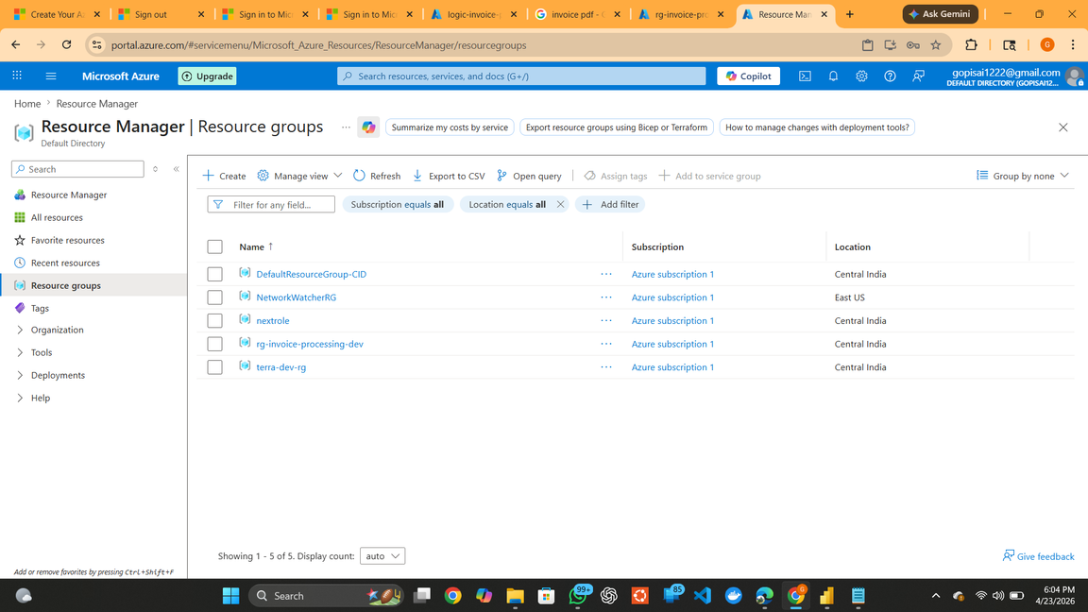
Figure 1 – Resource Group Creation
This figure displays the creation of the Resource Group rg-invoice-processing-dev, which acts as the central management boundary for all resources deployed in this project.

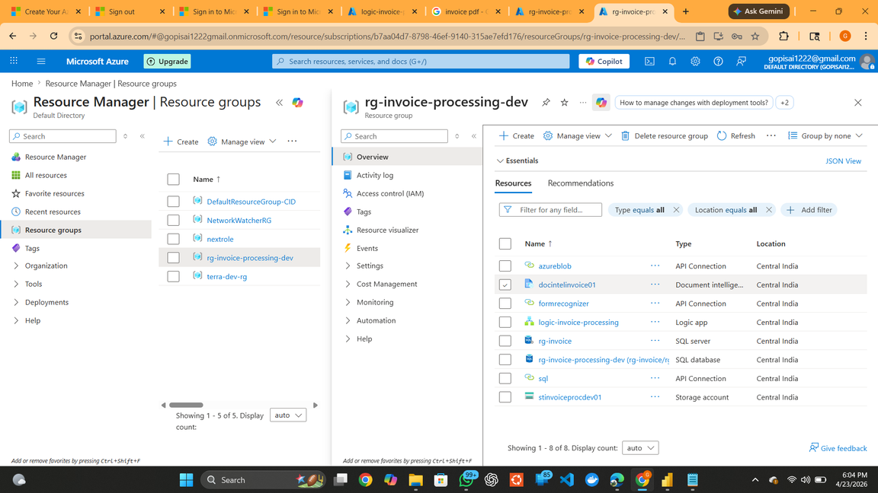
Figure 2 – Resource Group Resources
This figure displays all Azure resources deployed inside the Resource Group including Azure Logic App, Storage Account, Azure SQL Server, Azure SQL Database, Azure AI Document Intelligence, and API Connections.

7.2 Storage Account Configuration
Azure Blob Storage serves as the primary storage layer of the solution. It securely stores uploaded invoices, processed invoices, rejected files, and generated JSON outputs.
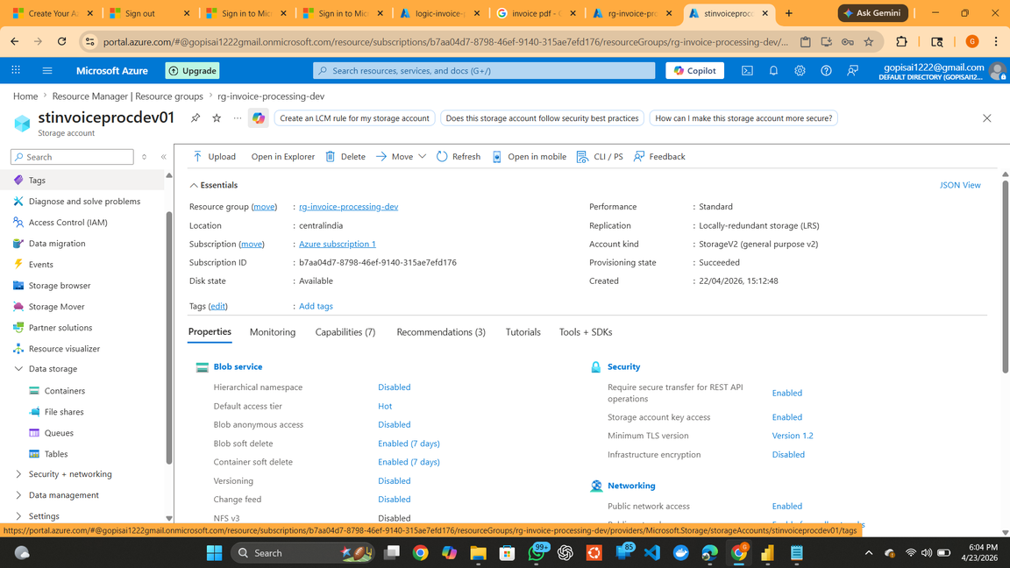
Figure 3 – Storage Account Overview
This figure displays the Storage Account stinvoiceprocdev01 created to manage and store all invoice-related files throughout the processing lifecycle.
7.3 Container Configuration
To organize invoice files efficiently, four dedicated containers were created inside the Storage Account. Each container represents a different stage of the invoice processing workflow.
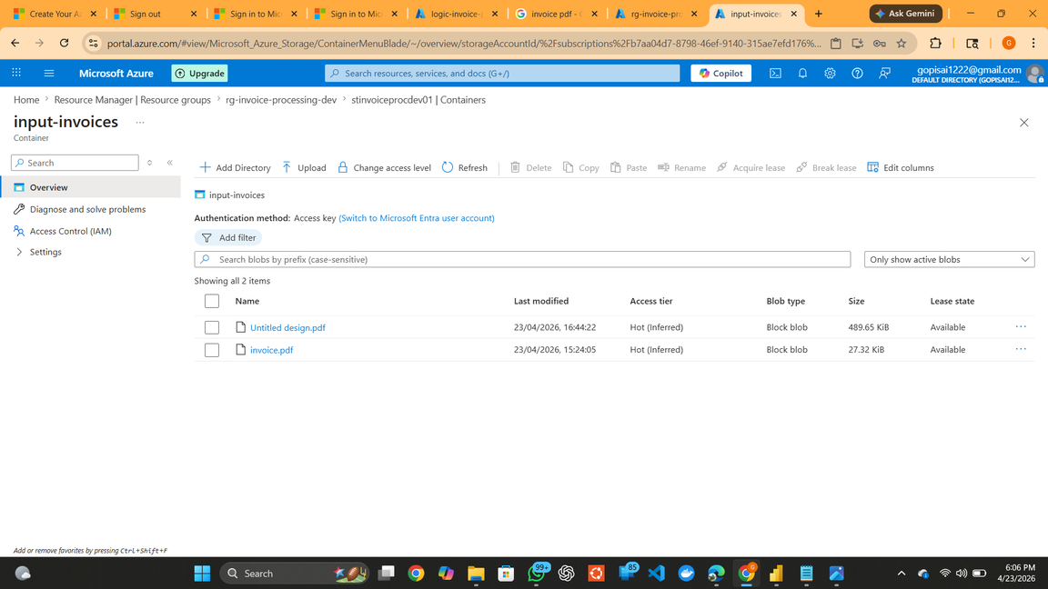
Figure 4 – Input Invoices Container
This figure displays the Input Invoices container, which acts as the entry point of the solution.

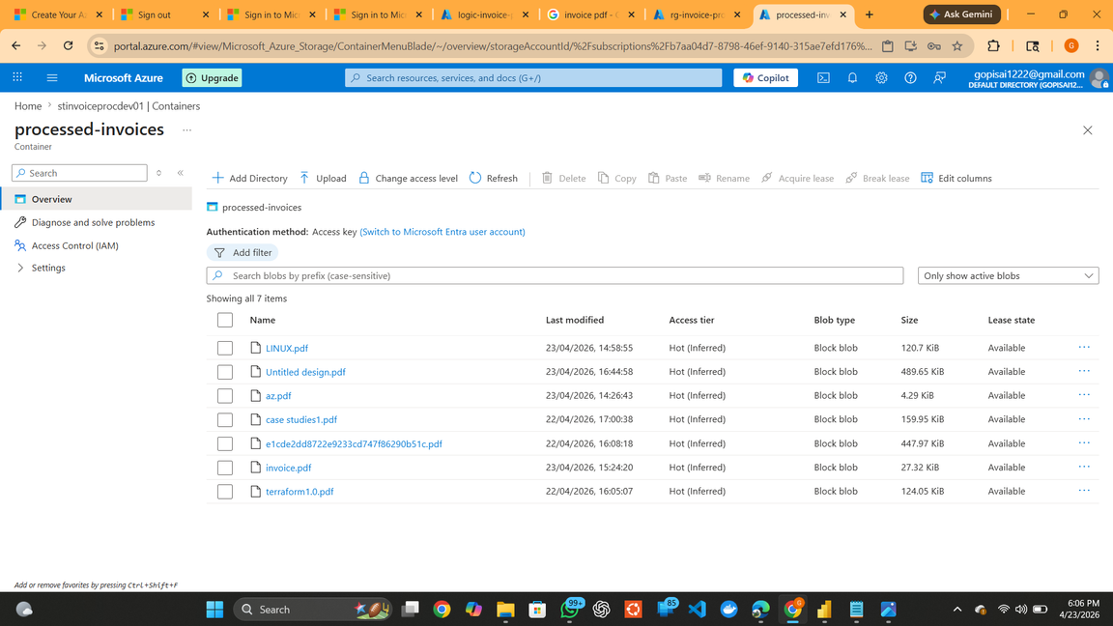
Figure 5 – Processed Invoices Container
This figure displays successful validation, PDF invoices are copied into the Processed Invoices container, indicating that they have entered the processing pipeline successfully.

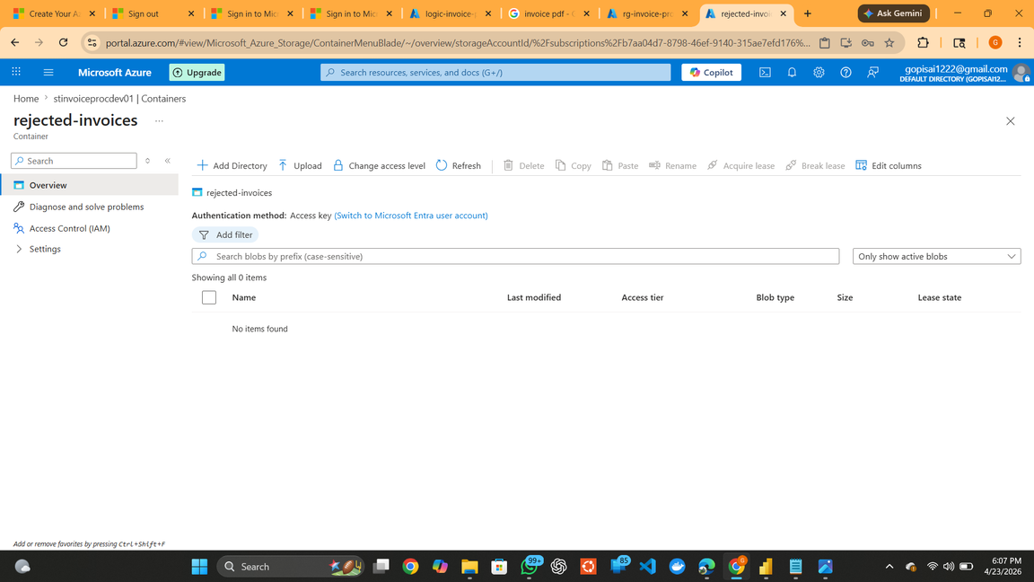
Figure 6 – Rejected Invoices Container
This figure shows that files failing validation or not in PDF format are redirected to the Rejected Invoices container.

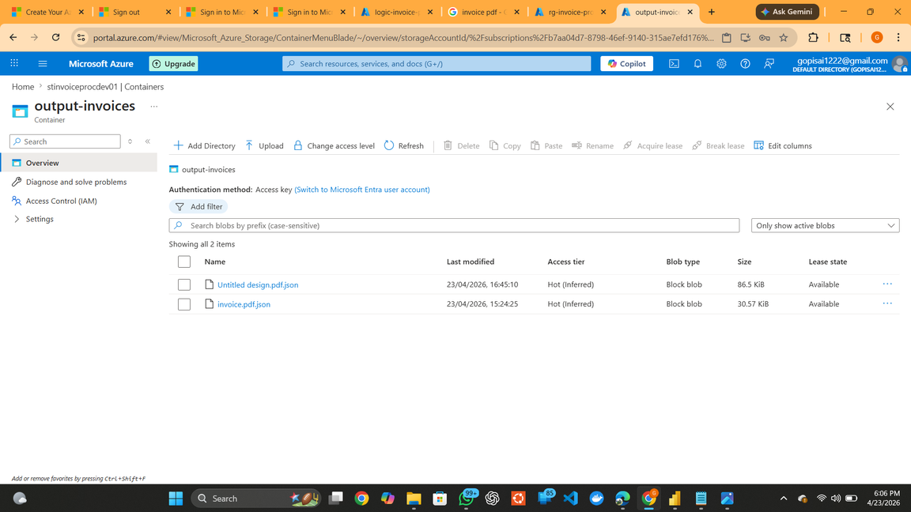
Figure 7 – Output Invoices Container
This figure displays the Output Invoices container storing generated JSON files containing extracted invoice information.

7.4 Azure Logic App Implementation
Azure Logic Apps serves as the orchestration engine of the entire solution. It automates invoice validation, AI processing, JSON generation, and database insertion.
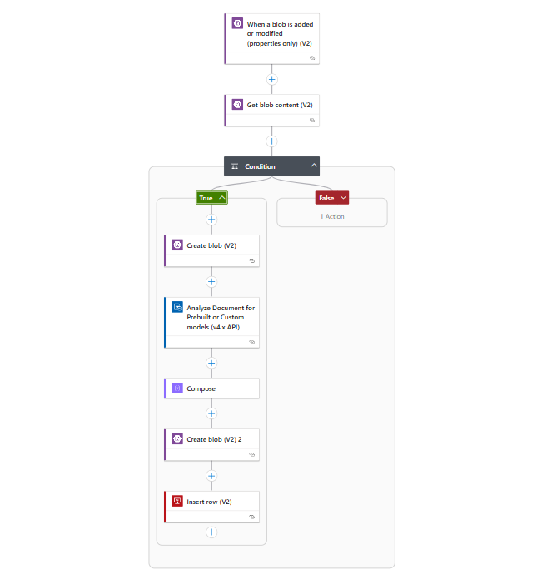
Figure 8 – Logic App Workflow
This figure displays the complete workflow implemented within Azure Logic Apps.
The workflow consists of:
- Blob Trigger
- Get Blob Content
- Validation Condition
- Processed Invoice Creation
- Azure AI Analysis
- JSON Generation
- SQL Database Insertion
Logic App Processing Flow
Step 1 – Blob Trigger
The workflow begins when a new invoice is uploaded into the Input Invoices container.
Step 2 – Get Blob Content
The uploaded invoice file is retrieved from Azure Blob Storage.
Step 3 – Validation Condition
The workflow checks whether the uploaded file is a valid PDF document.
Step 4 – Valid PDF Path
For valid PDF files:
- Copy invoice to Processed Invoices container
- Send invoice to Azure AI Document Intelligence
- Extract invoice information
- Generate JSON output
- Store JSON file in Output Invoices container
- Insert invoice data into Azure SQL Database
Step 5 – Invalid File Path
For non-PDF files:
- Move file to Rejected Invoices container
- Stop further processing

7.5 API Connections
API Connections provide secure communication between Azure Logic Apps and other Azure services.
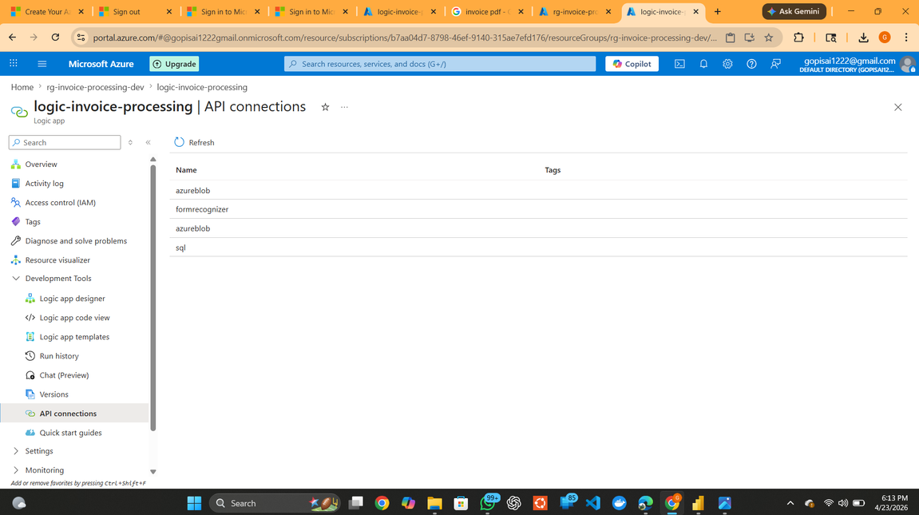
Figure 9 – API Connections Overview
This figure displays all API Connections configured within the solution.
Azure Blob Storage Connection
Azure Blob Storage is the primary storage service used in this project to store and manage invoice files throughout the processing workflow. It contains the Input Invoices, Processed Invoices, Rejected Invoices, and Output Invoices containers. Azure Logic Apps uses this connection to read, move, and create files automatically during invoice processing.
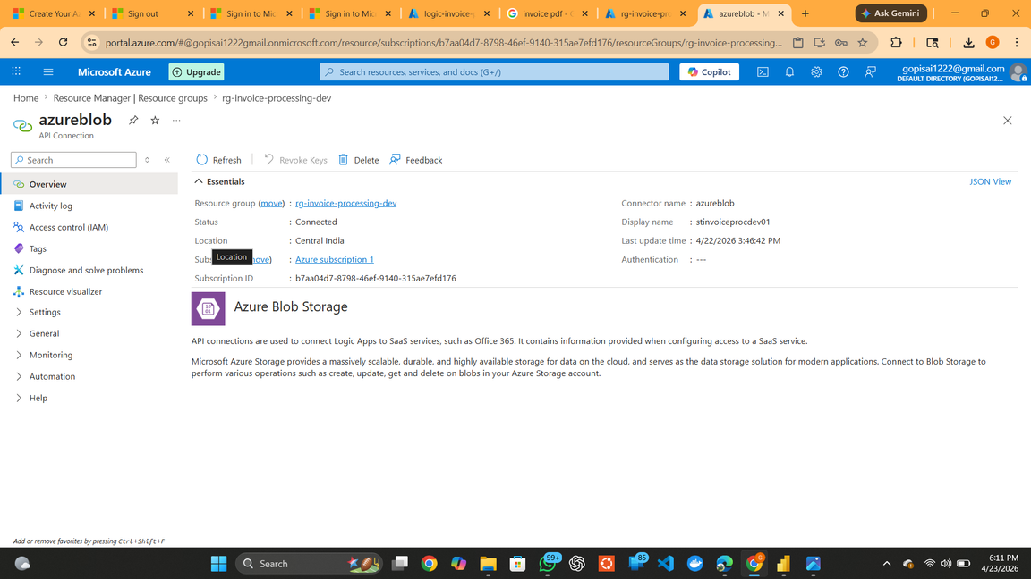
Figure 10 – Azure Blob Storage Connection
This figure displays the Azure Blob Storage connection configured within Azure Logic Apps. The connection enables the workflow to access storage containers and perform file operations required for automated invoice processing.
Azure AI Document Intelligence Connection
Azure AI Document Intelligence is used to automatically extract invoice information from uploaded PDF documents. It analyzes invoice content and identifies key fields such as Vendor Name, Invoice Number, Invoice Date, and Total Amount. Azure Logic Apps uses this connection to send invoices for AI-based analysis and retrieve the extracted data.

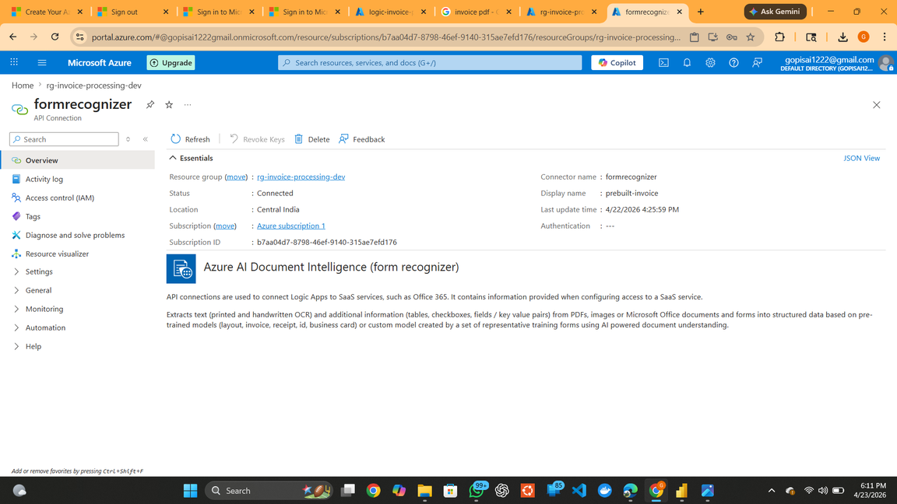
Figure 11 – Azure AI Document Intelligence Connection
This figure displays the Azure AI Document Intelligence connection configured within Azure Logic Apps. The connection enables the workflow to analyze invoice documents and extract key invoice information automatically.
Azure SQL Connection
Azure SQL Database is used to store the invoice information extracted by Azure AI Document Intelligence. It acts as a centralized repository for processed invoice records and provides data for reporting and analytics through Power BI.
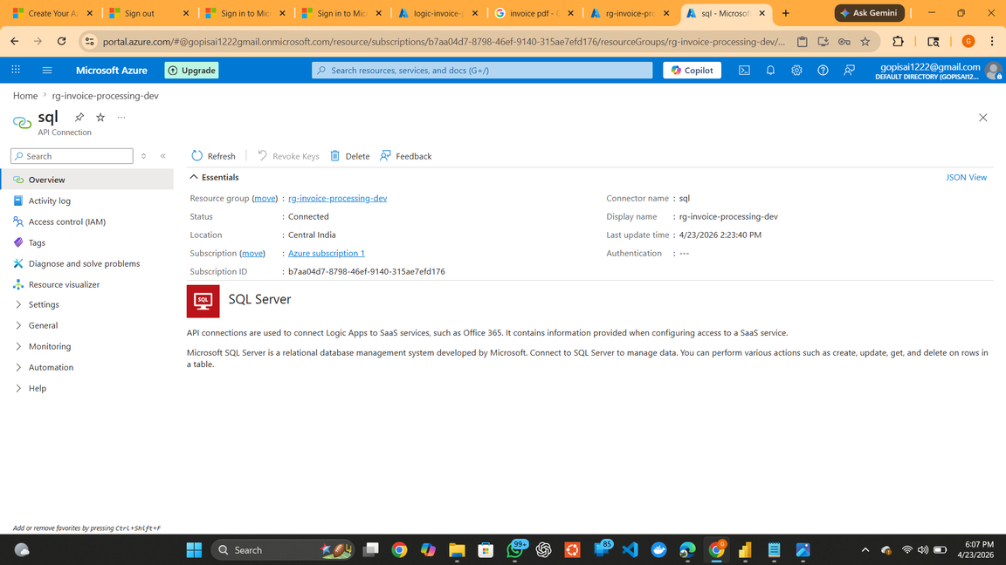
Figure 12 – Azure SQL Connection
This figure displays the Azure SQL connection configured within Azure Logic Apps. The connection enables the workflow to store extracted invoice information in Azure SQL Database for reporting and analysis.

7.6 Azure AI Document Intelligence Configuration
Azure AI Document Intelligence provides AI-powered invoice extraction capabilities. It automatically identifies and extracts important invoice information without manual data entry.
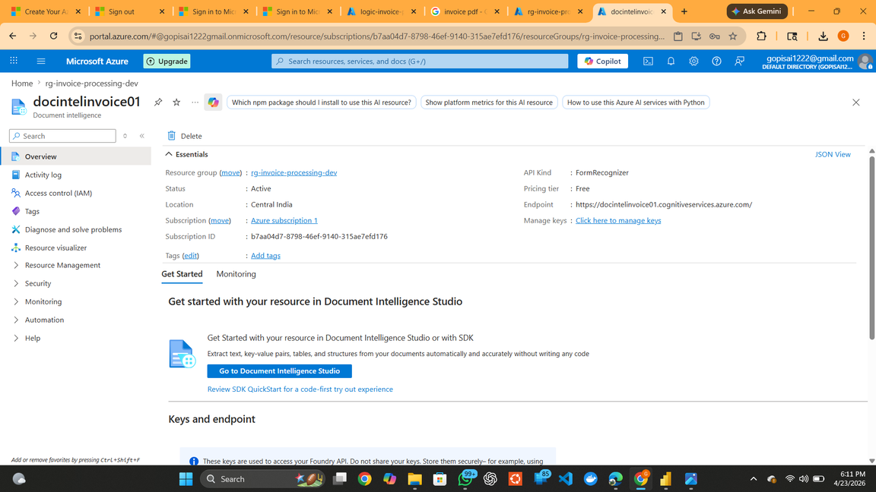
Figure 13 – Azure AI Document Intelligence Resource
This figure displays the Azure AI Document Intelligence resource configured for invoice processing. The prebuilt Invoice Model automatically extracts key invoice details such as Vendor Name, Invoice Number, Invoice Date, Invoice ID, and Total Amount.
7.7 Azure SQL Server & Database Configuration
Azure SQL Database acts as the central repository for storing invoice information extracted from uploaded documents.
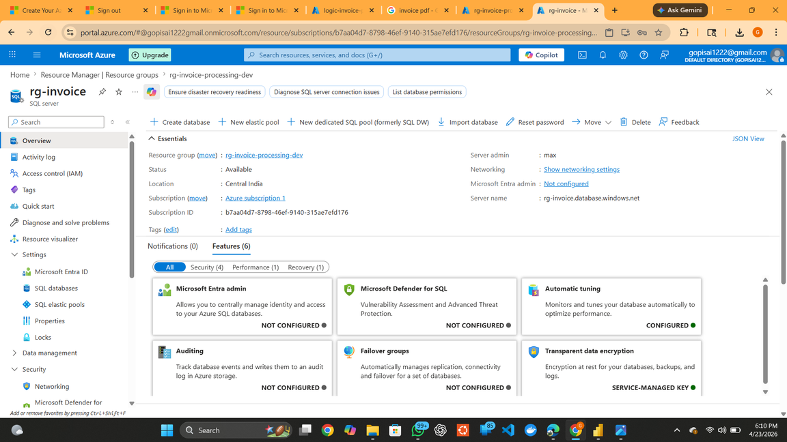
Figure 14 – Azure SQL Server
This figure displays the Azure SQL Server created for the Smart Invoice Processing System. The server provides a secure and managed environment for hosting the Azure SQL Database used in the invoice processing workflow.

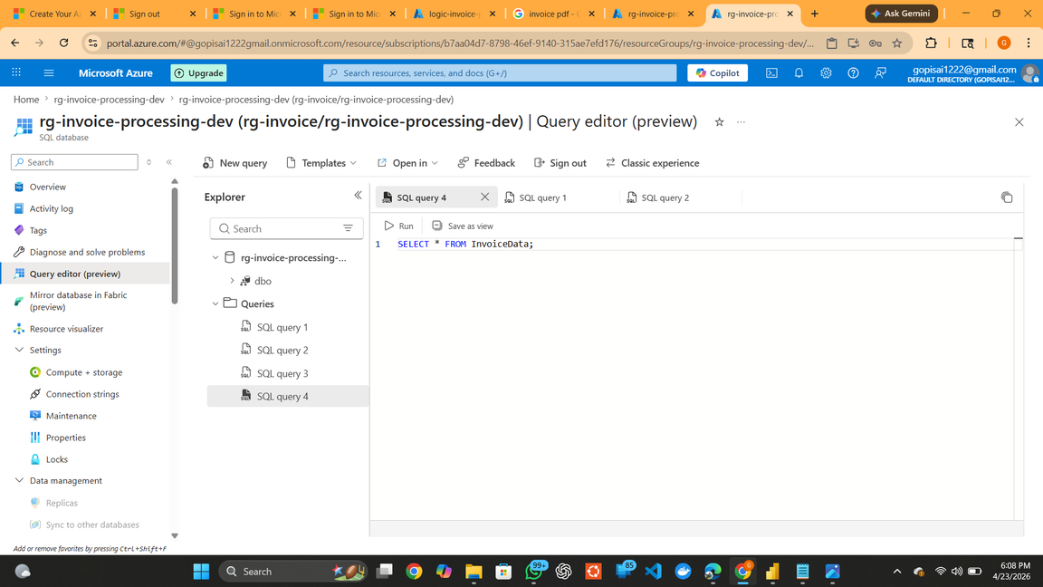
Figure 15 – Azure SQL Database
This figure displays the Azure SQL Database used to store invoice details extracted during the processing workflow. The database acts as a centralized repository for processed invoice records and supports reporting and analysis through Power BI.
7.8 Invoice Data Table Creation
The Invoice Data table was created in Azure SQL Database to store invoice details extracted during the invoice processing workflow. It serves as a centralized repository for processed invoice records and supports reporting, analysis, and visualization through Power BI.
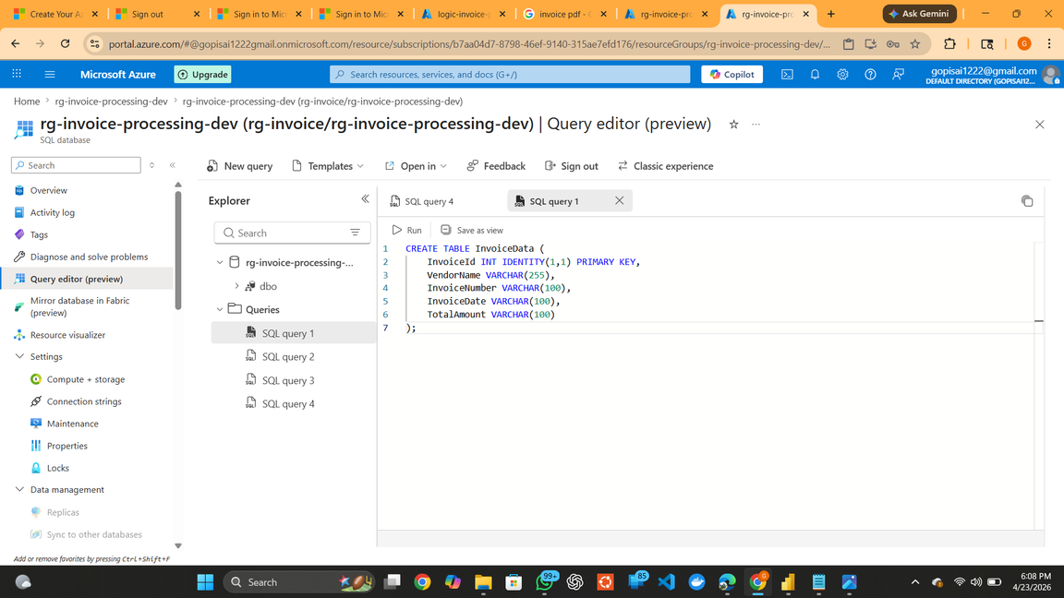
Figure 16 – InvoiceData Table Creation Script
This figure displays the SQL script used to create the InvoiceData table in Azure SQL Database. The table is designed to store invoice details extracted during the invoice processing workflow, providing a structured repository for data storage, reporting, and analysis.
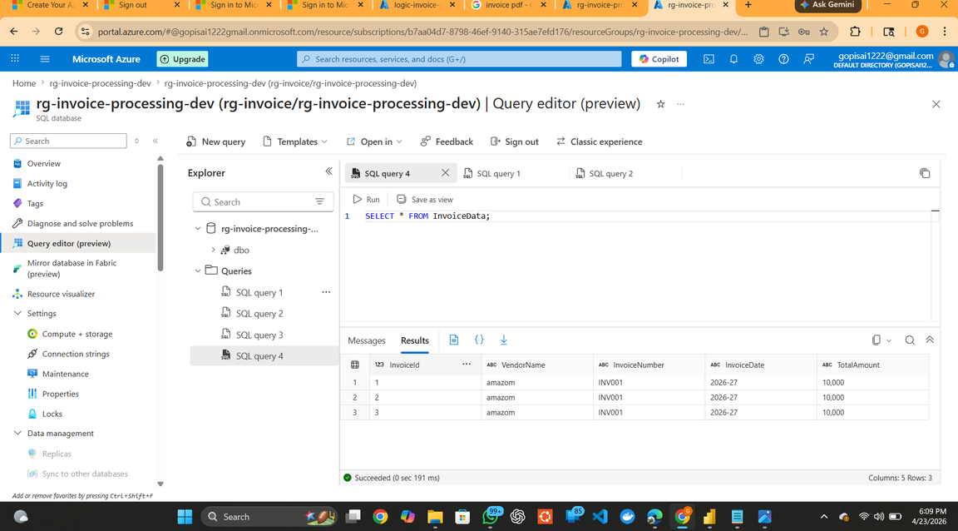
Figure 17 – Query Validation
This figure displays the SQL queries executed to validate successful table creation and verify database connectivity.
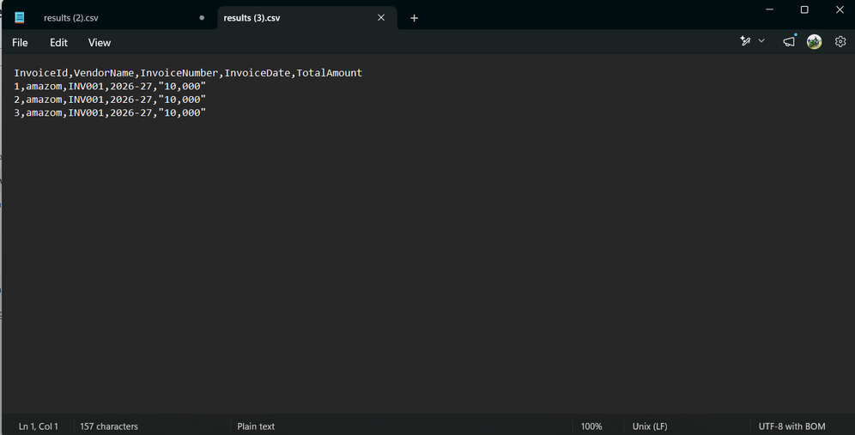
Figure 18 – Stored Invoice Records
This figure displays the invoice records successfully stored in the InvoiceData table after processing. The extracted invoice information is available for reporting, auditing, and analysis.
7.9 JSON Output Generation
JSON output provides a structured representation of invoice information and supports integration with downstream systems.

Figure 19 – Output JSON Files
This figure displays Compose action generates JSON files containing extracted invoice information. These files are stored in the Output Invoices container for auditing and integration purposes.
7.10 Power BI Integration
Power BI is used to visualize invoice data and create business reports.
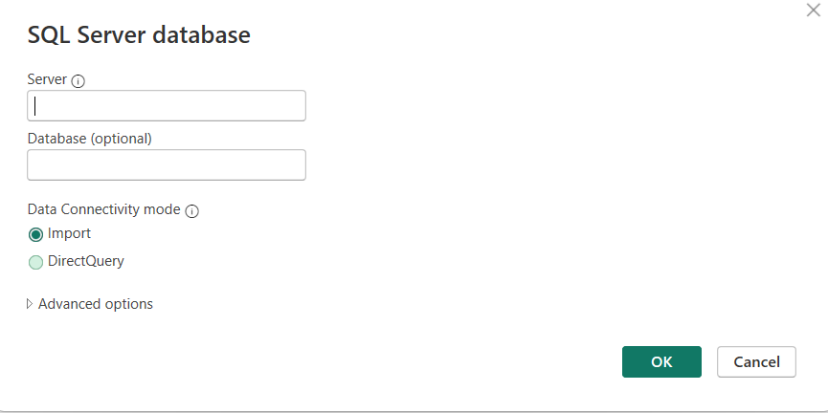
Figure 20 – SQL Connection from Power BI
This figure displays Power BI establishes a direct connection with Azure SQL Database using the SQL Server connector.
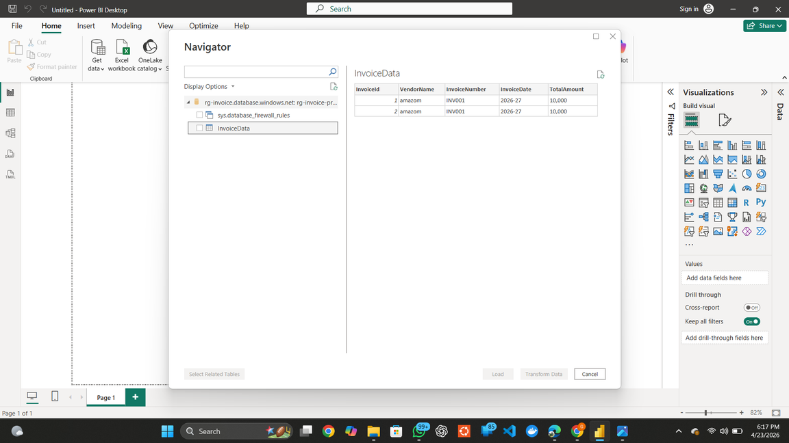
Figure 21 – InvoiceData Dataset Import
This figure displays InvoiceData table is imported into Power BI to create reports and dashboards.
7.11 Resource Visualization
Azure Resource Visualizer provides a graphical representation of relationships between Azure resources.
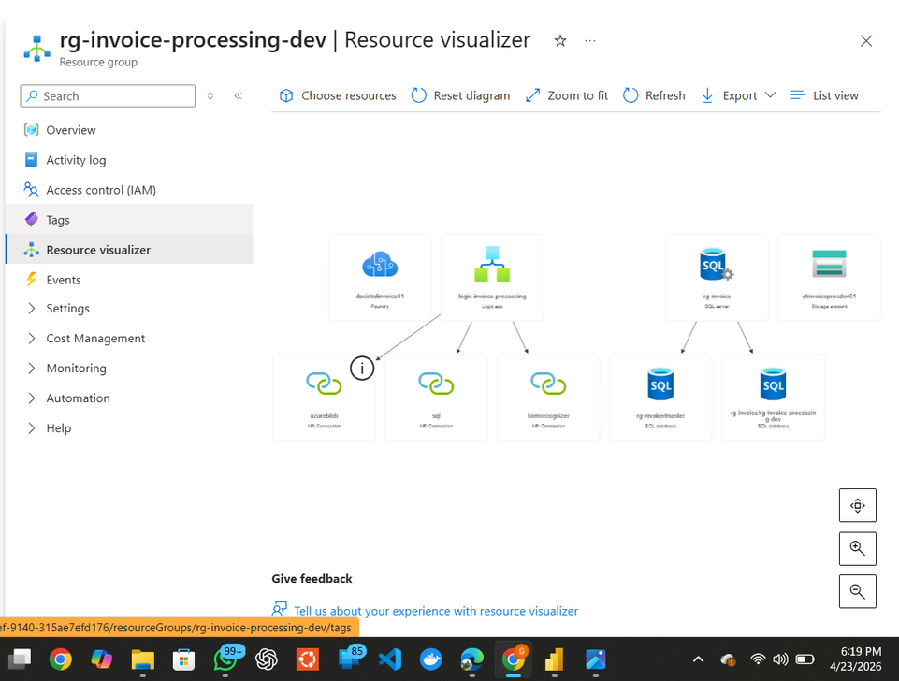
Figure 22 – Resource Visualizer
This figure displays how all resources interact within the Smart Invoice Processing System.
7.12 Monitoring & Metrics
Monitoring helps track solution health, workflow performance, and execution metrics.
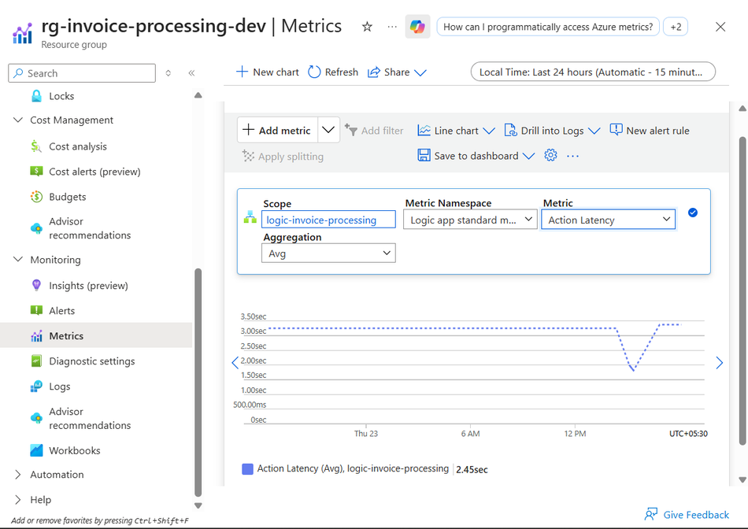
Figure 23 – Azure Metrics Dashboard
This figure displays Azure Monitor tracks Action Latency, Trigger Executions, Workflow Runs, and overall workflow performance.

7.13 Run History Validation
Run History provides visibility into workflow execution and supports troubleshooting activities.
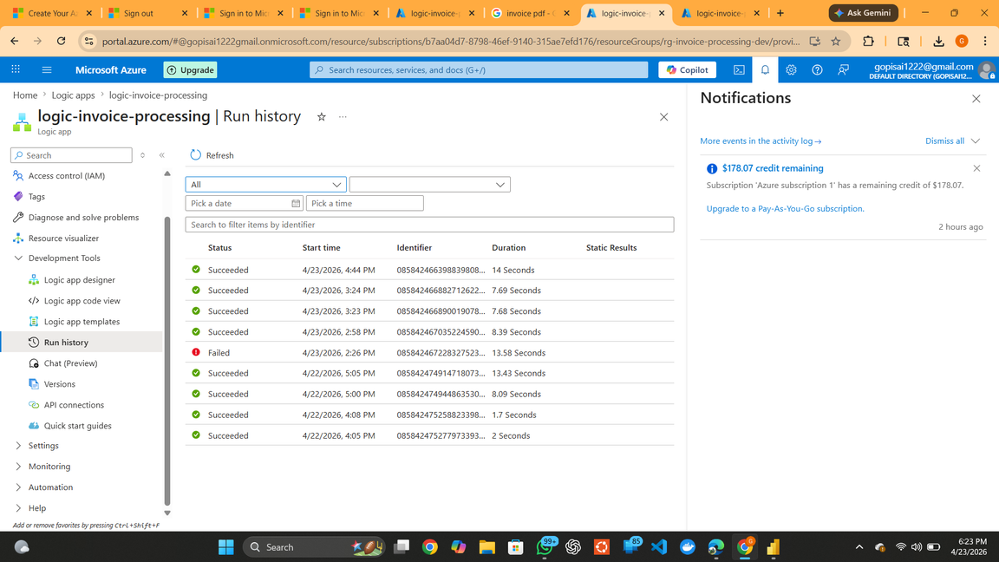
Figure 24 – Logic App Run History
This figure displays Run History helps administrators monitor workflow executions, identify failures, and troubleshoot issues efficiently.
8. End-to-End Workflow
The following workflow diagram provides a high-level overview of the Smart Invoice Processing System. It illustrates the flow of invoice data across Azure services, from file ingestion and validation to AI-driven data extraction, database storage, monitoring, and business reporting.
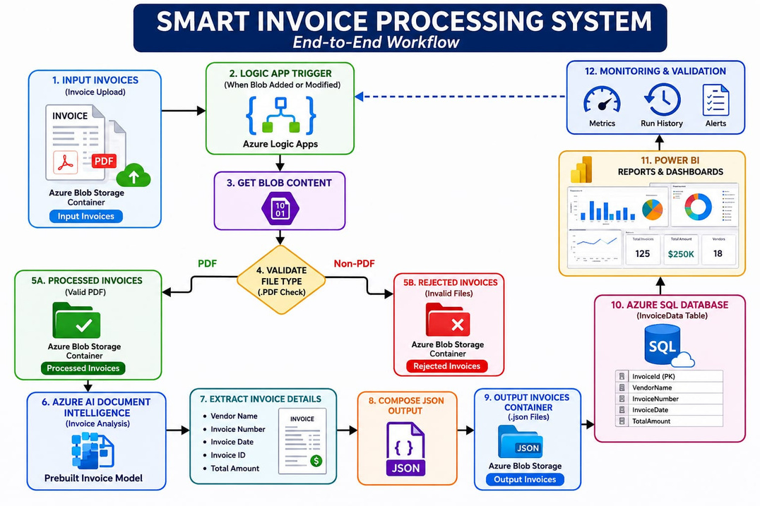

Workflow Explanation
- Invoice is uploaded to Input Invoices container.
- Logic App trigger detects the file.
- File content is retrieved.
- Validation checks whether the file is PDF.
- Non-PDF files are moved to Rejected Invoices.
- PDF files are copied to Processed Invoices.
- Azure AI Document Intelligence extracts invoice data.
- Compose action generates JSON output.
- JSON file is stored in Output Invoices.
- Invoice information is inserted into Azure SQL Database.
- Power BI retrieves invoice data for reporting.
- Azure Monitor and Run History provide monitoring and auditing.
9. Advantages
- Fully automated invoice processing
- Reduced manual effort
- Faster processing time
- Improved accuracy
- Centralized data storage
- Real-time reporting
- Scalable cloud architecture
- Built-in monitoring and auditing
10. Limitations
- Supports only configured file formats
- AI accuracy depends on invoice quality
- Requires Azure services and internet connectivity
- Complex invoice layouts may require custom AI models
11. Future Enhancements
The solution can be enhanced further through:
- Gmail Trigger Integration
- Outlook Trigger Integration
- HTTPS Trigger Integration
- Email Notifications
- Approval Workflows
- Multi-language Invoice Processing
- Advanced Power BI Dashboards
- Custom AI Models
12. Project Summary
The Smart Invoice Processing System demonstrates an end-to-end intelligent document processing solution built using Microsoft Azure services. The solution validates invoices, extracts key information using AI, generates structured JSON outputs, stores data in Azure SQL Database, and enables reporting through Power BI. The automated workflow improves efficiency, accuracy, and scalability while reducing manual effort.
13. Conclusion
The Smart Invoice Processing System successfully automates the invoice processing workflow using Microsoft Azure services. By integrating Azure Logic Apps, Azure Blob Storage, Azure AI Document Intelligence, Azure SQL Database, and Power BI, the solution streamlines invoice validation, data extraction, storage, and reporting.
The automated workflow reduces manual effort, improves data accuracy, and enhances operational efficiency while providing a scalable and reliable platform for invoice processing and analytics.

