**Desktop Push Notification**

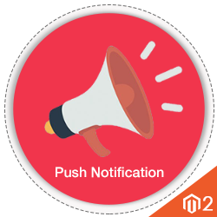

Quick Start Guide

# Introduction

**Desktop Push Notification** is an extension which allows the admin to send the real-time push notifications to the subscribed customers.

## Why Desktop Push Notification Extension?

Desktop Push Notification Extension has the ability to deliver the message to the customer immediately. These messages can contain any information such as new product launch, new offers, important news and updates etc. Unlike the emails, which may or may not be read by users or land up in the span/junk folder, web push notification’s prompt and assure the content delivery feature ensures that the notifications are for sure delivered and seen.

This extension will be very helpful in the scenarios where the site owner wants to convey the information to the users in a real time such as any offers which are valid for short time of periods, any new upcoming features etc.

## Key Features:

* There is no monthly subscription fee required to send the notifications.
* There is no limitation on the number of subscribed users, any number of users can be added.
* The admin can view the subscribed users list.
* It is designed to work with the SSL certificate websites.
* The admin can create, edit and delete notification templates in the back end.
* Any particular subscribed user can be removed from the list if user doesn’t want to receive any further notifications.
* Notifications can be sent either to all the registered users or selected users.
* Search options can be used to find any specific template or subscribed users from the lists.
* A custom icon and redirect URL can be added with the push notification.
* The admin can manage all the subscribed users of the store from the backend.

# 2. Installation

## Installation Requirements:

1. Magento 2 installed on the hosting server.
2. Access to the Magento Admin dashboard.
3. Command line access to the hosting server.
4. Knowledge of basic Linux commands.

## Installation Steps:

1. Login into your hosting server where Magento 2 is installed.
2. Switch to Magento installation directory on the sever.

***cd $MAGENTO_INSTALL_DIR/***

1. Create the Infobeans directory.

***mkdir -p $MAGENTO_INSTALL_DIR/app/code/Infobeans***

1. Extract the downloaded code of the Extension and copy the MODULENAME module into the created directory:

***cp -R $MODULENAME_MODULE $MAGENTO_INSTALL_DIR/app/code/Infobeans***

1. Run the command below to complete the installation of the module and clear static content.

***$PHP_INSTALL_DIR/php $MAGENTO_INSTALL_DIR php bin/magento module:enable --clear-static-content Infobeans_PushNotification***

***$PHP_INSTALL_DIR/php $MAGENTO_INSTALL_DIR php bin/magento setup:upgrade***

1. Now we need to clear the Magento, so the module installed module can be visible and active.

Using the command line utility.

***$MAGENTO_INSTALL_DIR/bin/magento cache:clean***

1. Give required permission to Magento root directory.
2. Copy the firebase-messaging-sw.js and add it into the Magento root folder.
3. Update the sender id which you get from the Firebase project into firebase-messaging-sw.js.

## 

## Using the Magento Admin Panel

1. Log into the Magento Admin Panel.

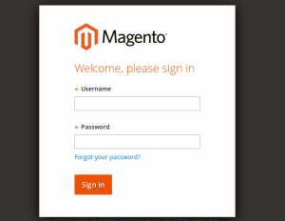

1. Click through to [ System > Cache Management ].

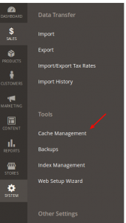

1. In the top left hand corner, select “Refresh” from the dropdown.
2. In the table just below the dropdown where you selected “Refresh”, beside the heading “Cache Type” select “Select all”.
3. Next to the dropdown where you selected “Refresh”, click on the “Submit” button.

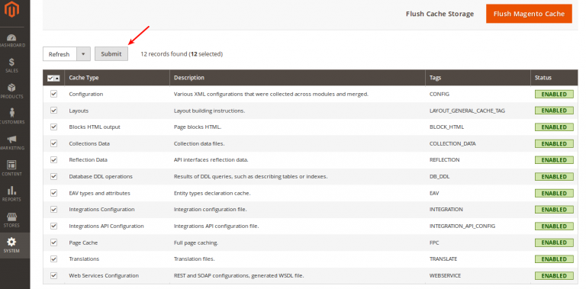

1. After completing these steps, Extension is successfully installed.

# Create the Firebase Project Crendtials

1. In order to use this module, admin needs to create the Firebase credentials. Go to the <https://console.firebase.google.com> and create the new project with the Gmail account.

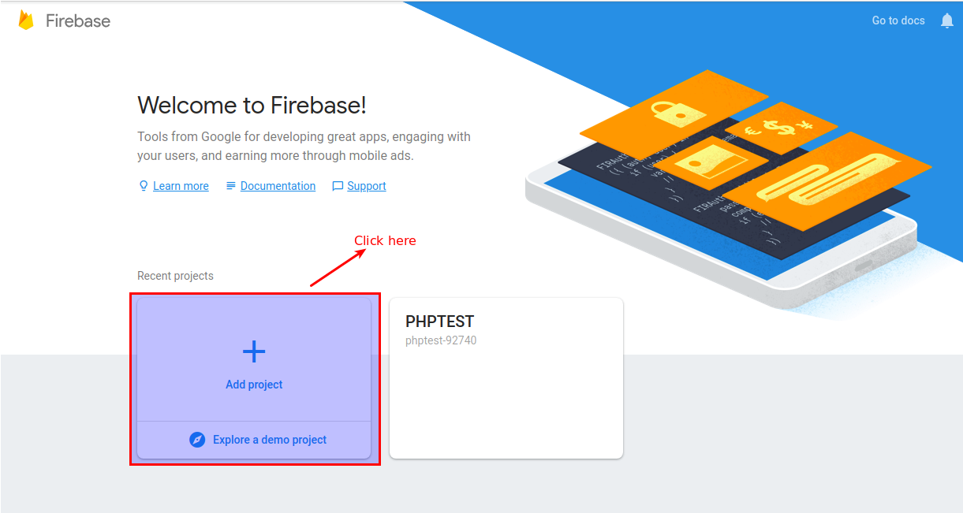

1. After clicking on Add project a new small pop-up window will appear with the name of Add a project, here you have to enter your Project Name and then select your Country/Region.

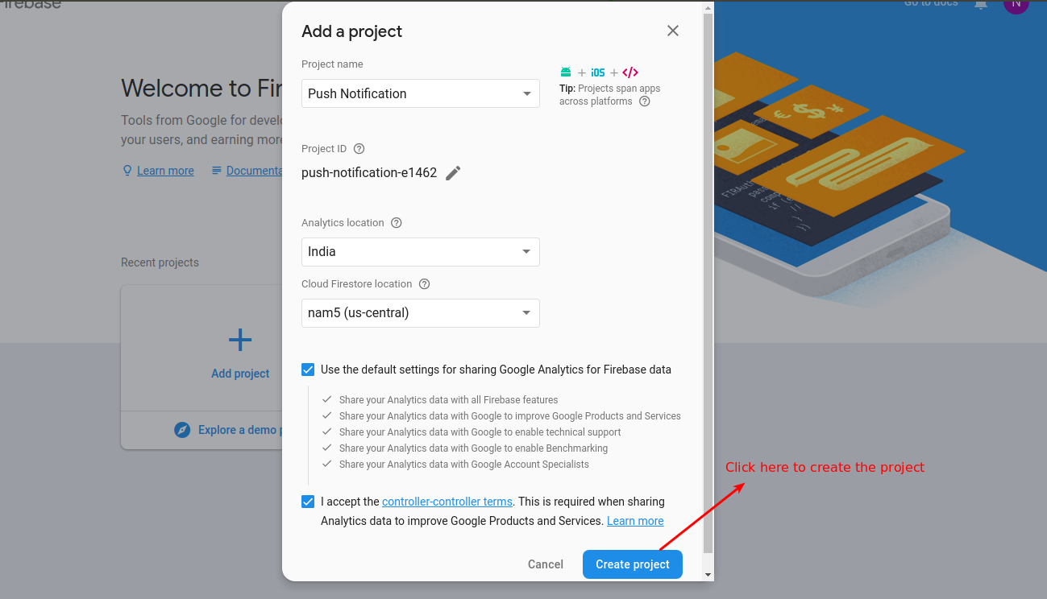

1. After creating your new project click Settings menu icon and select Project Settings option. Please view below screenshot. A new Settings page will be opened.

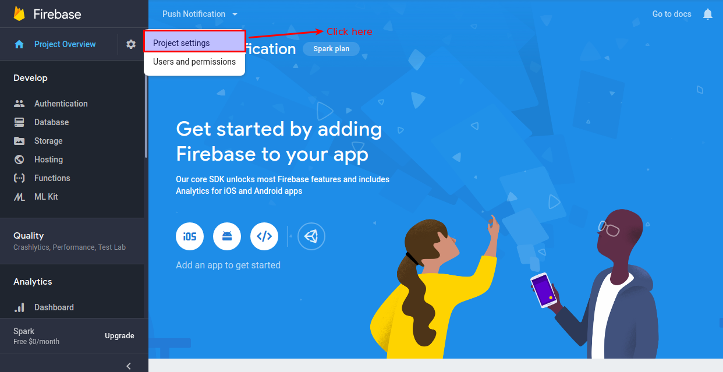

1. Now you are on the Settings page, click CLOUD MESSAGING tab, here you will find your Project Credentials, copy and save your Sender ID and Server Key as displayed below.

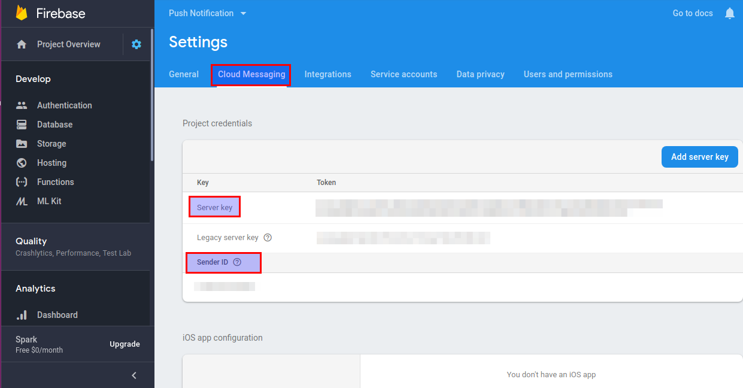

# Admin Flow

1. After successfully installing this module Go to the admin [ STORES > Configuration ].

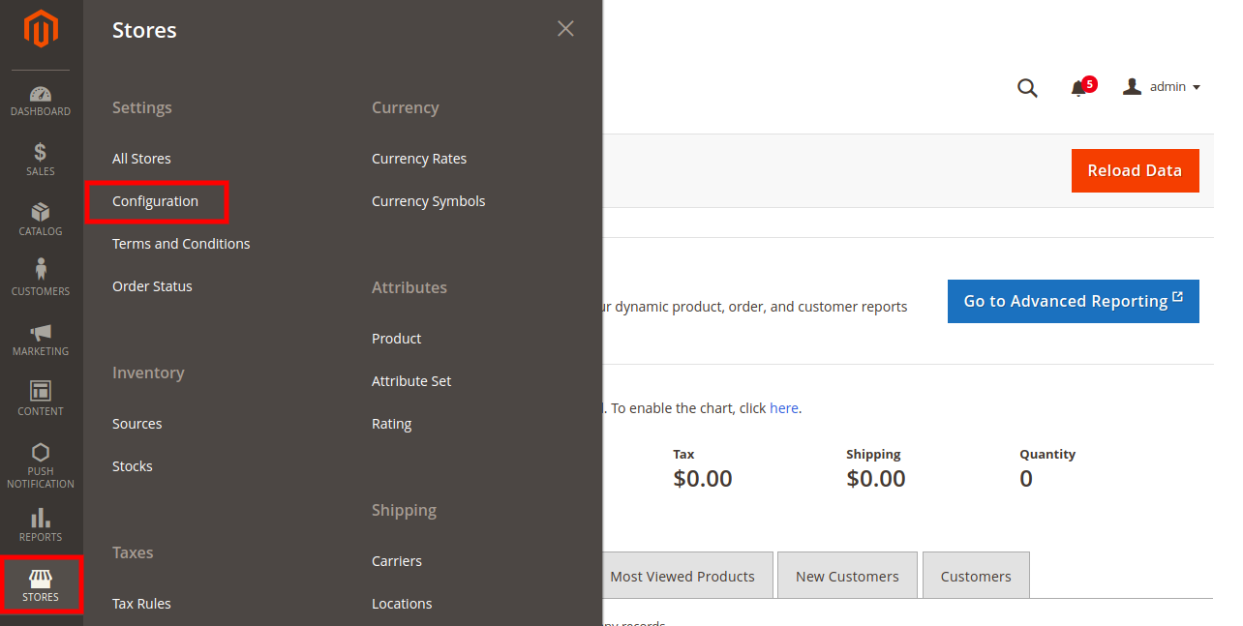

2. Navigate to [ INFOBEANS > Push Notification] option. Enter the Firebase project credentials. Enter the Server key, Sender Id and set Status to Yes in order to send the Push Notifications. Click Save Config button to apply changes.

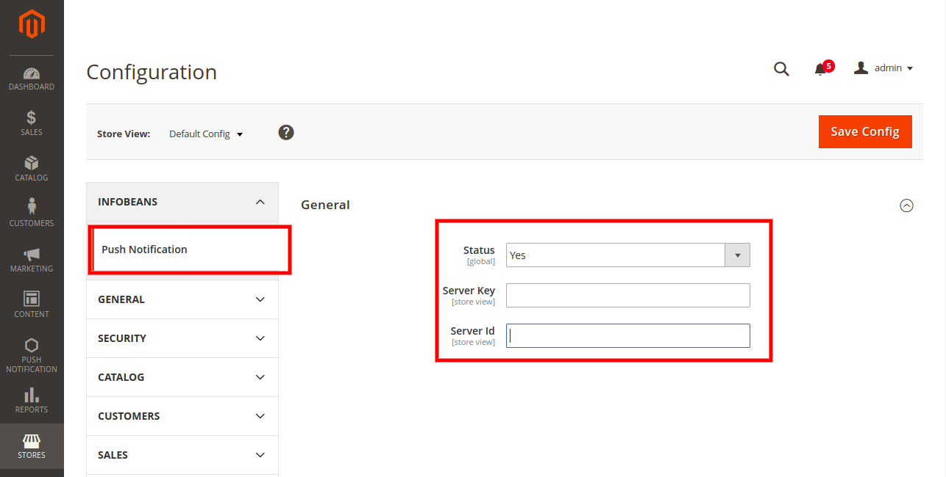

1. Click on Push notification.

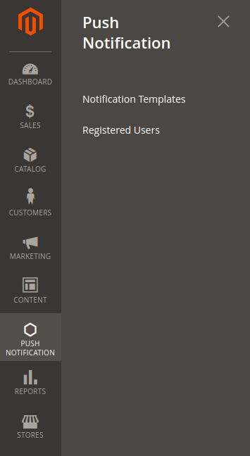

1. Navigate to Notification Templates. Here admin can see all the list of created templates. The admin can create a new template by clicking Create New button. To edit any template click Edit button. Refer the below screen-shots.

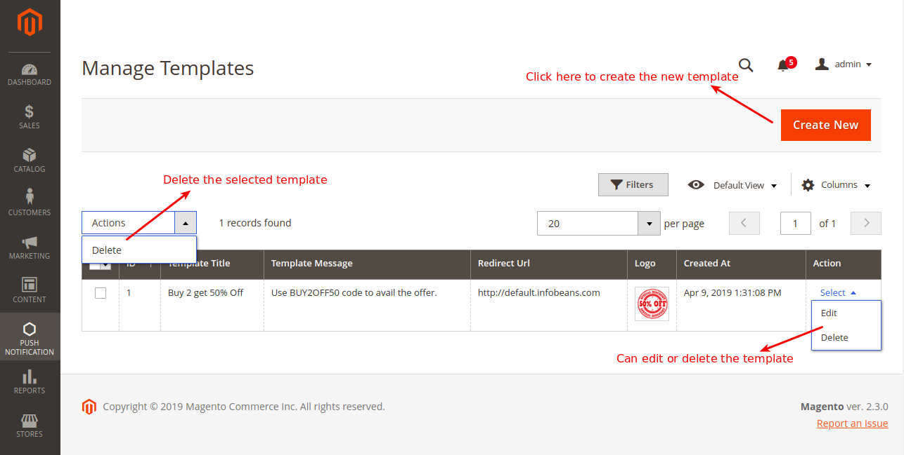

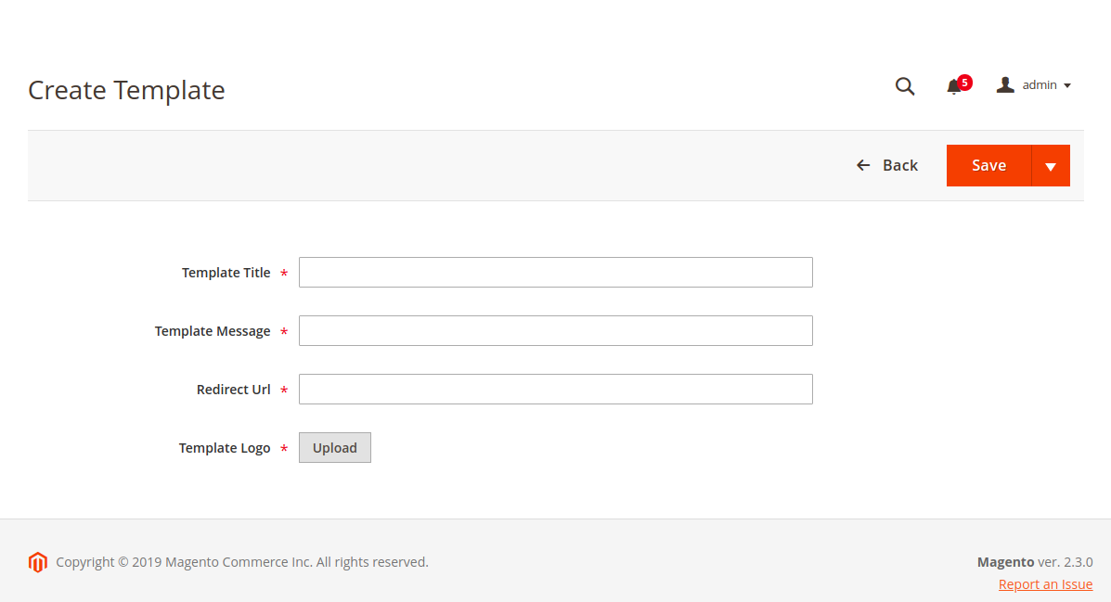

5. To delete notification template(s) navigate to [ Push Notification > Notification Templates ]. After that select the particular template(s) using the checkbox option. Then go to Actions drop-down menu and click Delete. A confirmation message will appear, click OK.

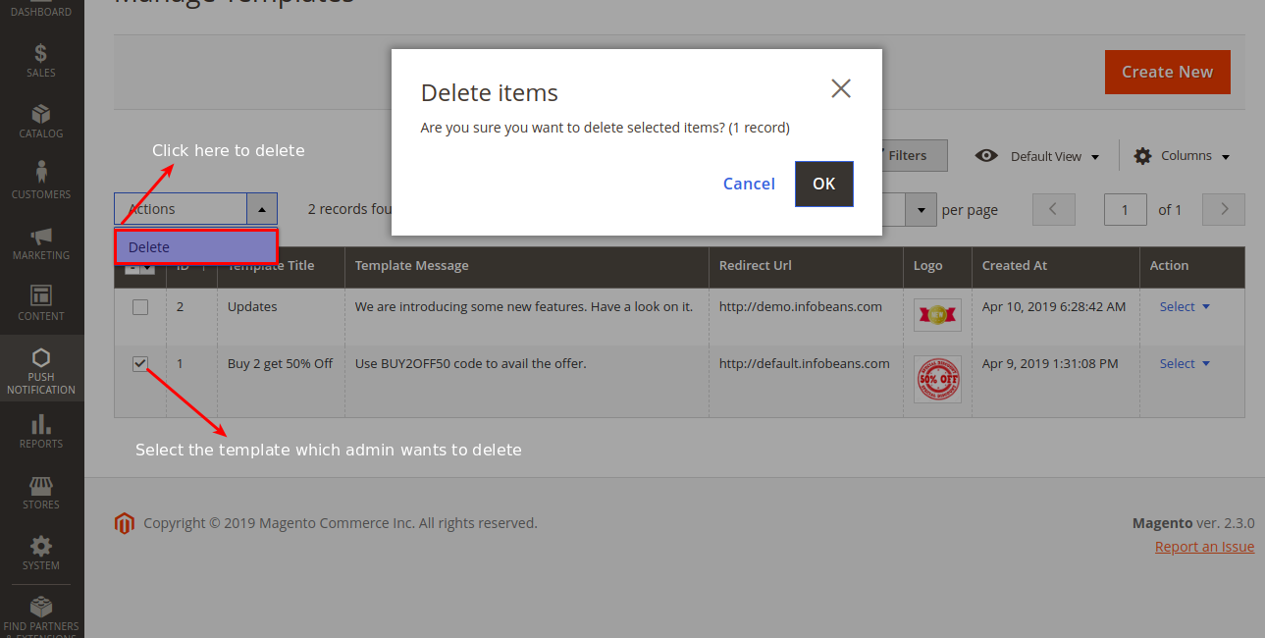

6. Navigate to Registered Users. Here admin can see all the list of registered users.

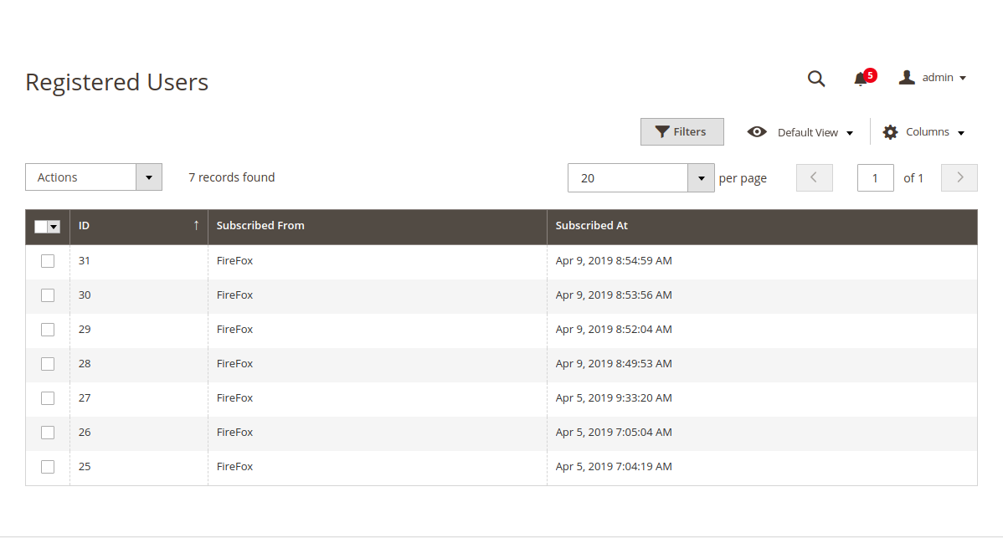

7. To send a new web push notification message, navigate to [ Push Notification > Registered Users ]. After opening Registered User page, select any registered users using the checkbox.

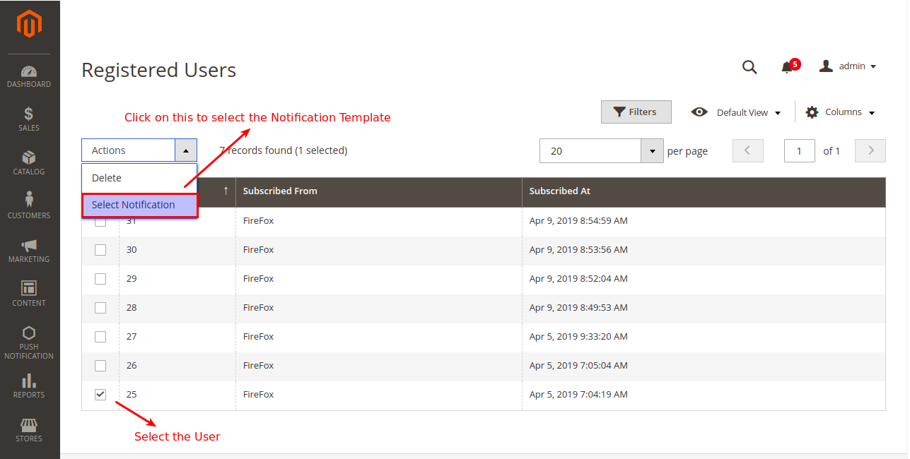

8. Then select the Notification template.

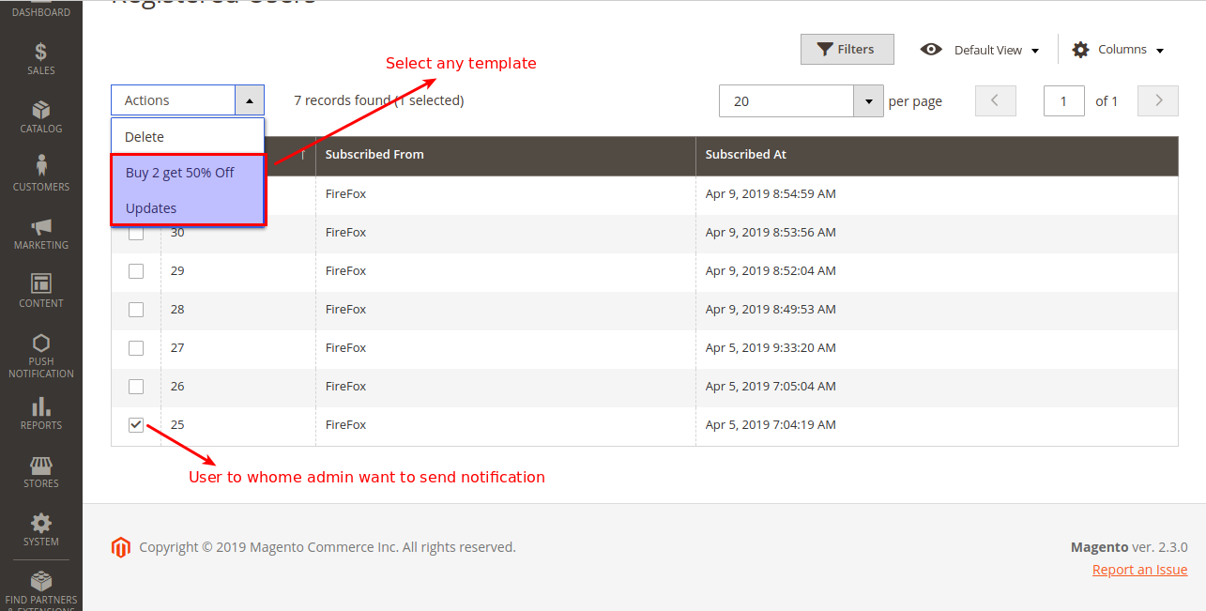

9. Then click on selected notification template and send the notification.

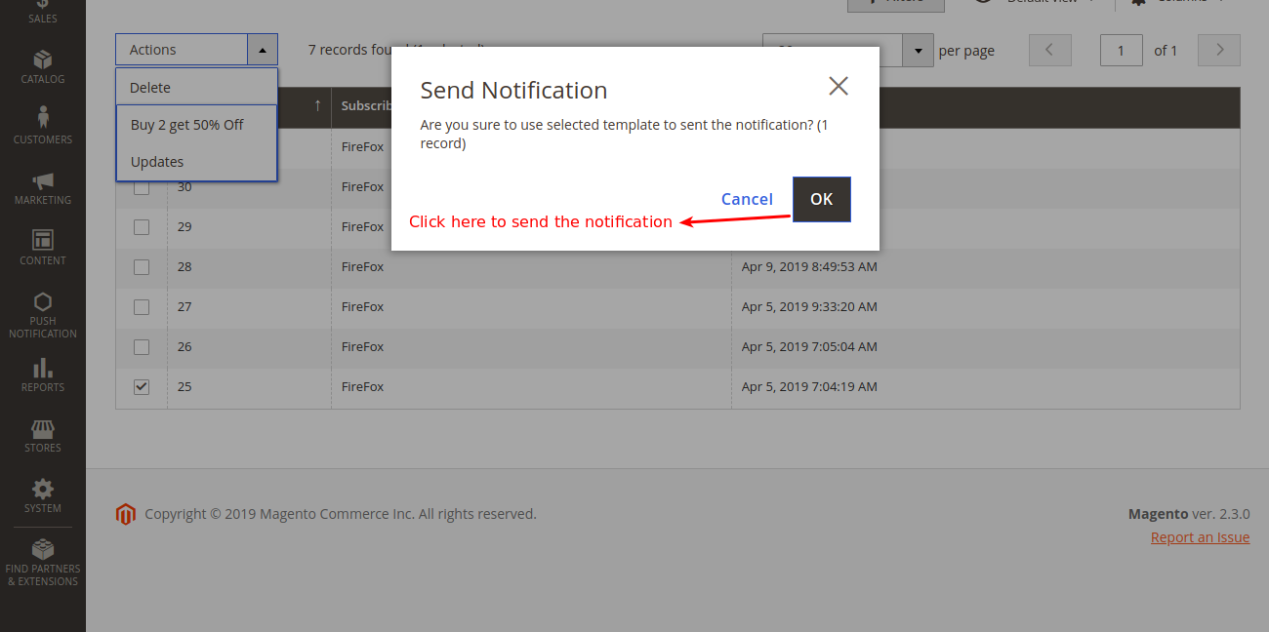

10. Also admin can send the notifications by clicking Send Notification Button on the top of both Manage Templates and Registered Users grid.

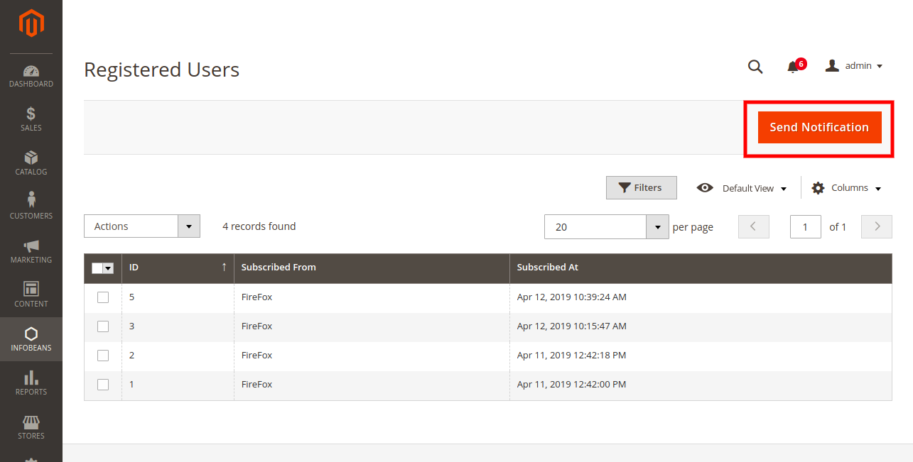

1. On Send Notification page either admin can Select Users to All or Custom. If admin select All then notifications are send to all the registered users. If admin select Custom then notifications are send to those users which are registered/subscribed under the selected time duration.

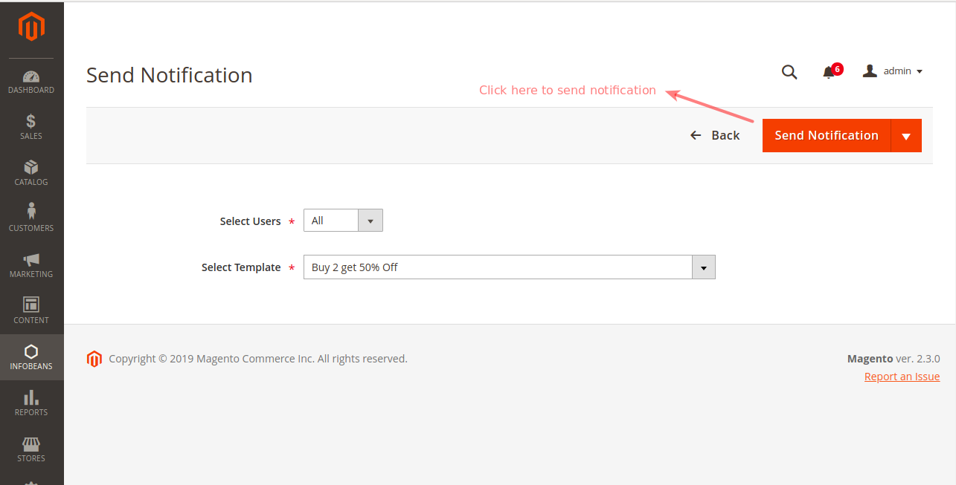

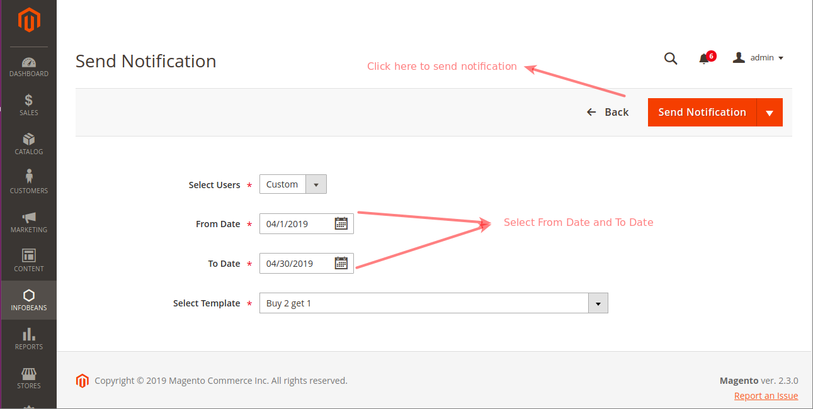

12. To delete any of the registered user(s), navigate to [ Push Notification > Registered Users ]. Click on delete option.

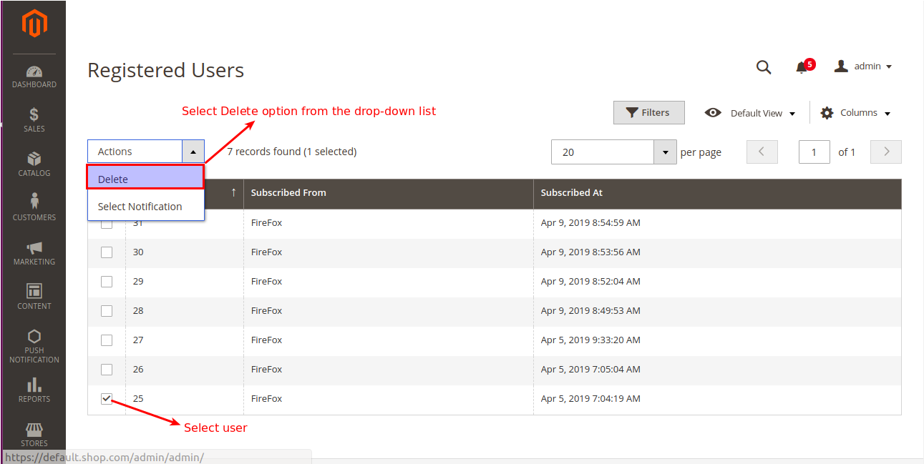

13. A final confirmation box will appear, click OK. Please refer to the screenshot below:

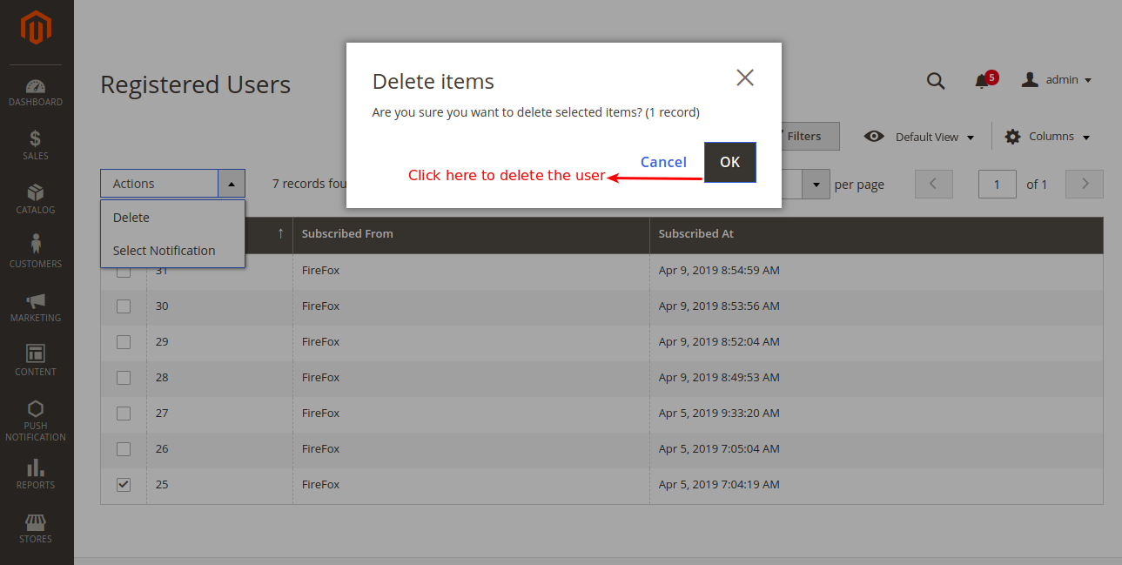

# Frontend Flow

1. After successfully installing Push Notification module in Magento2, website users will get a pop-up message on top of their browser window. This pop-up message will ask users to show notifications from your website, the users will have to click either Allow or Block option.

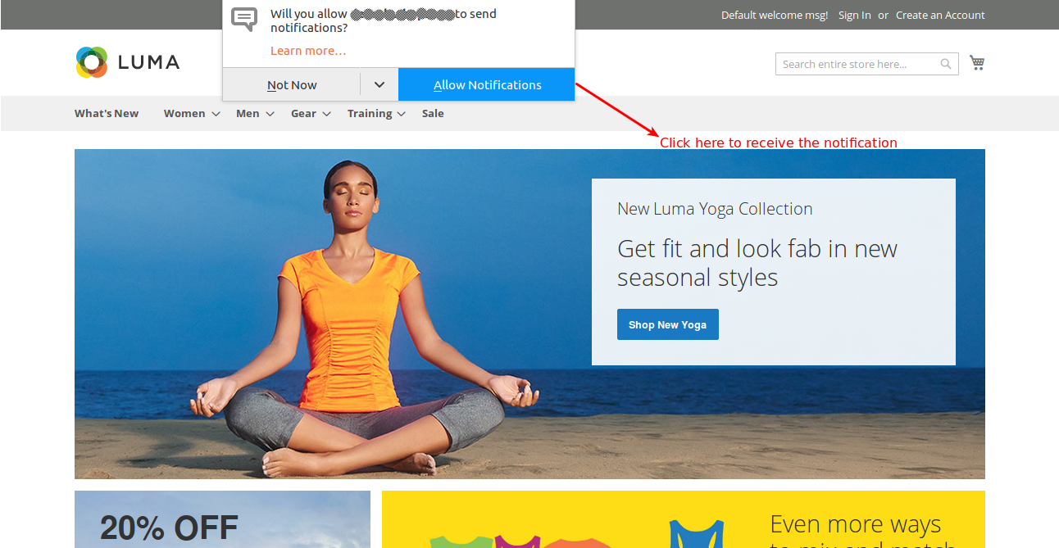

2. Sample push notification.

