**Computing Project 1**

*Axial Bar*

**1. Introduction**

This project describes a MATLAB program that allows the solution of the problem of a prismatic bar in a uniaxial state of stress with a variable load. The program works for a variety of load distributions and boundary conditions. *Simpson’s Rule* and *generalized trapezoidal rule* have been used to solve for the axial force and displacement fields.

**2. Program Description**

The execution flow of the program is as follows:

1. Ask the user to input the physical quantities – Section Stiffness (EA) in kN/m, Length (L) in m
2. Ask the user to input the type of load. The program allows for 6 types of loads, and each load is represented by a number that the user has to input.

1 = Constant, 2 = Linear Ramp up, 3 = Linear Ramp Down, 4 = Trapezoidal, 5 = Half Sinusoidal, 6 = Load on a patch

1. Depending upon the type of load, the user is then asked to input the load parameters.
   1. For constant distributed load, the user has to input the load intensity in kN/m.
   2. For a linear ramp up or linear ramp down kind of load, the user has to input the max. load intensity.
   3. For a trapezoidal load (symmetric), the user has to input the max. load intensity and the fraction of the length over which this max. load occurs.
   4. For a half sinusoidal load, the user has to input the max. load intensity.
   5. For a patch load (constant load from *x = a* to *x = b*), the user has to input the load intensity and the start and end of the patch as fractions of length.

This is implemented through a switch routine.

1. The program then asks the user for the type of boundary conditions.. The types of boundary conditions allowed in the program are:
   1. 1 = Fixed at both ends
   2. 2 = Fixed at the left end and free at the other end
   3. 3 = Fixed at the right end and free at the other

Since there is no unique solution for the case with both ends free, it is not allowed in the program.

1. The program then asks for the parameters of the numerical algorithms.
   1. No. of Simpson points
   2. No. of points for the *generalized trapezoidal rule (GTR)*
   3. Beta value for the GTR
2. *Simpson’s Rule* and linear algebra is then used to solved for the for state variables:
   1. *u(x = 0)*
   2. *N(x = 0)*
   3. *u(x = L)*
   4. *N(x = L)*

A switch routine is used to make the appropriate function call depending upon the type of load. The function Simpson() does the numerical integration using *Simpson’s Rule* and is put in a different file.

1. Using GTR, the axial force and displacement field is calculated. The GTR has not been implemented as a separate routine to keep things simple and easy to debug.
2. Plots of load, axial force and displacement as a function of position along the span of the beam are displayed.

**3. File Structure**

The program consists of 3 files:

* AxialBar.m
* LoadFunctionCP.m
* Simpson.m

The file “AxialBar.m” is the core script that runs and interacts with the other two files that contain helper routines. “Simpson.m” contains the routine that performs numerical integration according to *Simpson’s Rule.* “LoadFunctionCP.m” is a script that generates load value at a given position for various kinds of loads. It is different than the one supplied with the project description and has been modified to handle different kinds of loads.

**4. Results**

Plots of load, axial force and displacement fields are now shown for various combinations of loads and boundary conditions.

Each case has the following fixed parameters:

* EA = 100 kN
* L = 10 m
* Total load = 10 kN
* No. of Simpson points = 101
* No. of GTR points = 501
* Beta value = 0.5

For trapezoidal and patch loads, the max. load intensity occurs for half the length.

**Case 1 : Constant Load, Fixed at both ends**

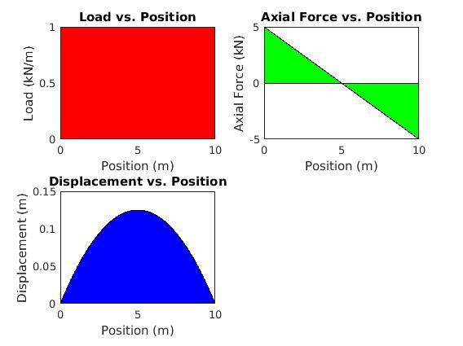

**Case 2 : Constant Load, Fixed at left end only**

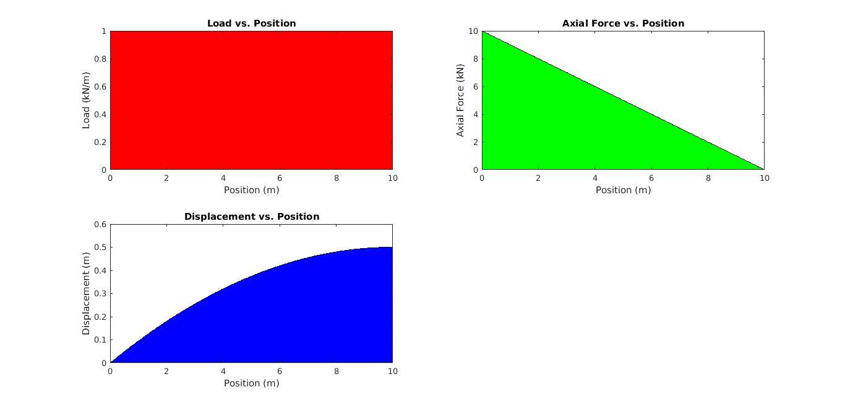

**Case 3 : Constant Load, Fixed at right end only**

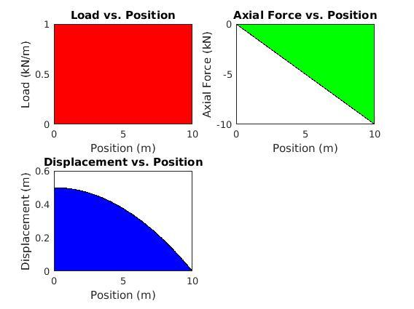

**Case 4 : Linear ramp up load, Fixed at both ends**

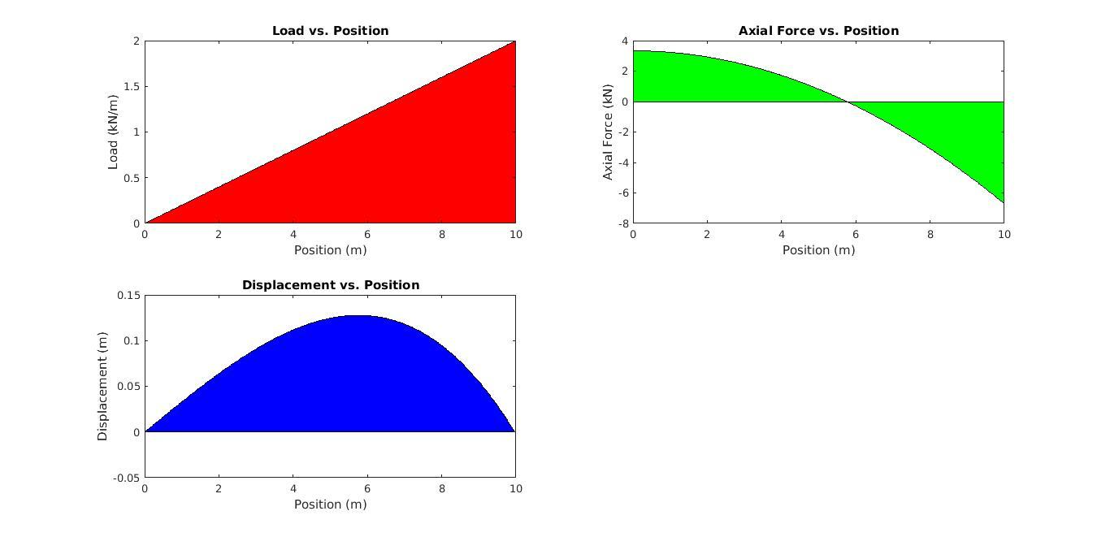

**Case 5 : Linear ramp up load, Fixed at left end only**

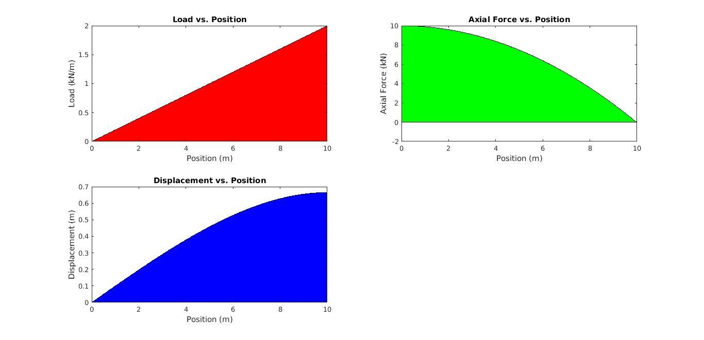

**Case 6 : Linear ramp up load, Fixed at right end only**

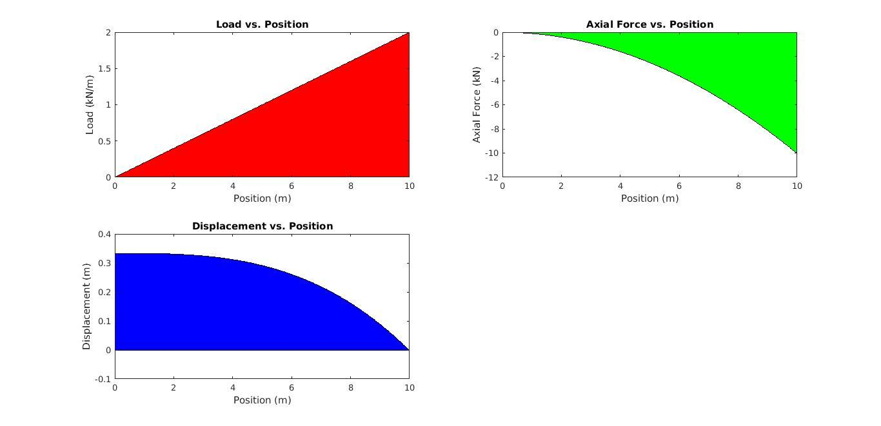

**Case 7 : Linear ramp down load, Fixed at both ends**

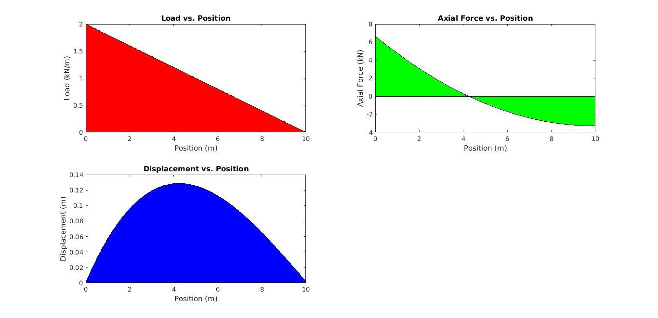

**Case 8 : Linear ramp down load, Fixed at left end only**

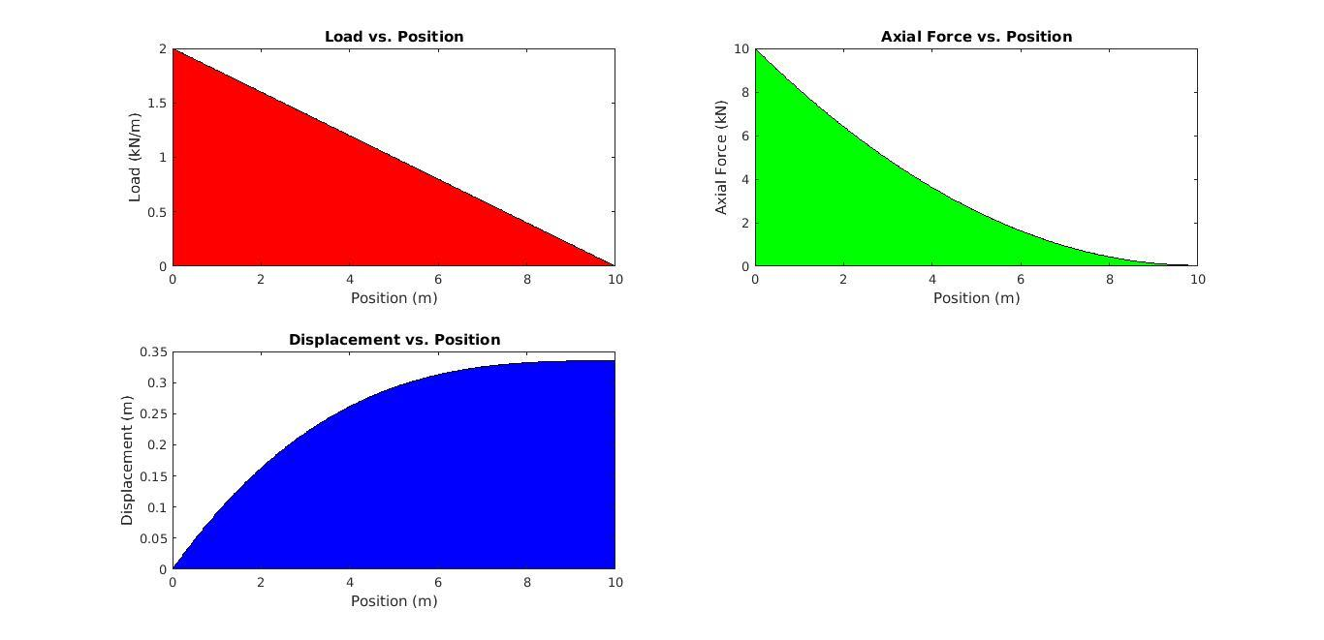

**Case 9 : Linear ramp down load, Fixed at right end only**

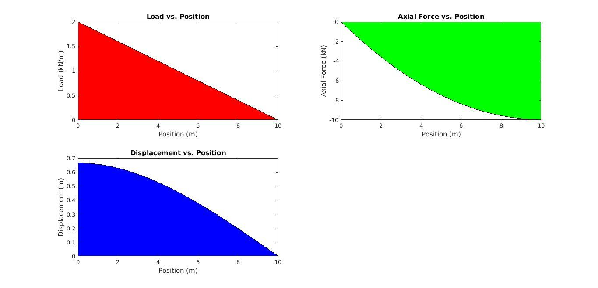

**Case 10 : Trapezoidal load, Fixed at both ends**

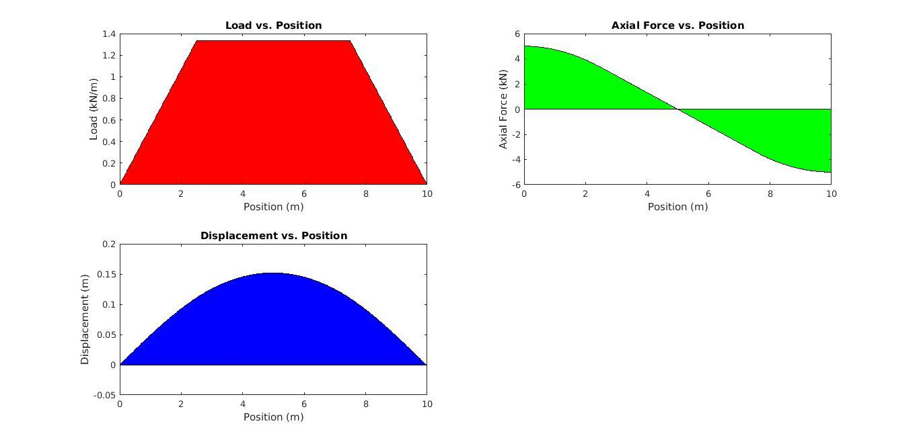

**Case 11 : Trapezoidal load, Fixed at left end only**

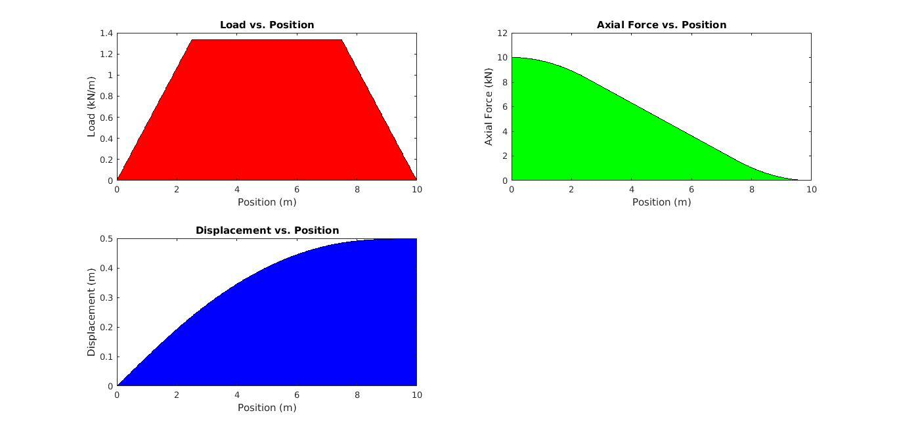

**Case 12 : Trapezoidal load, Fixed at right end only**

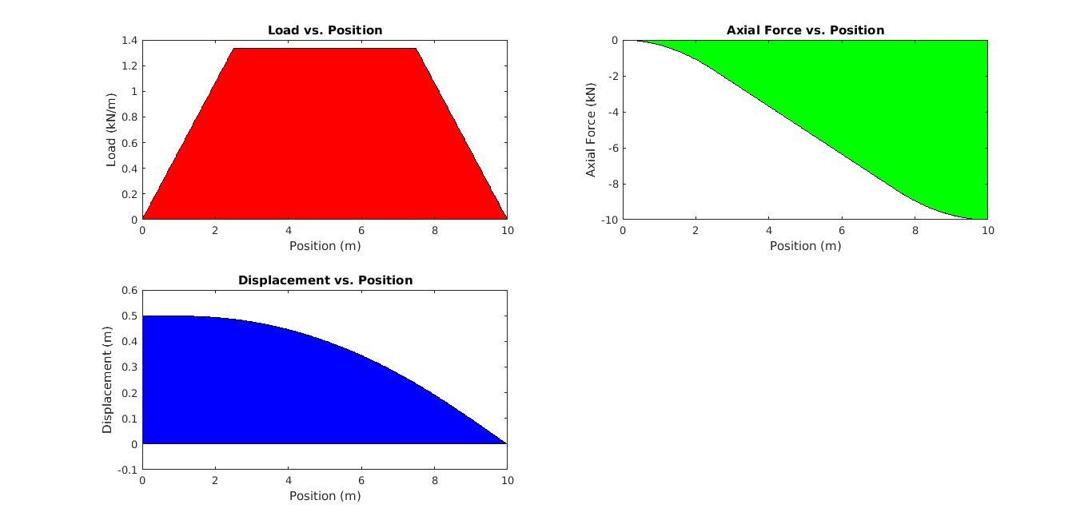

**Case 13 : Half Sinusoidal load, Fixed at both ends**

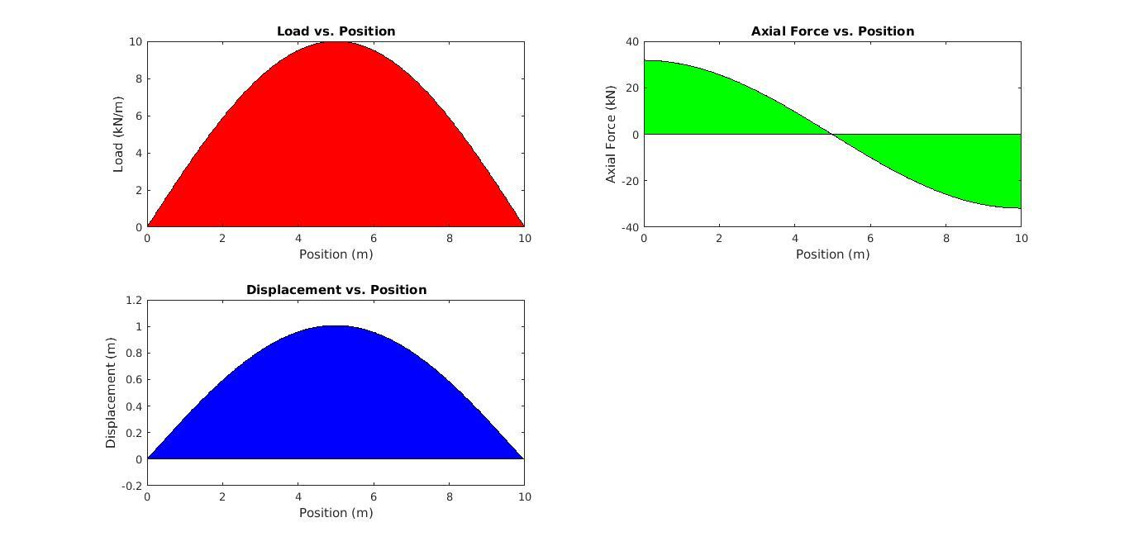

**Case 14 : Half Sinusoidal load, Fixed at left end only**

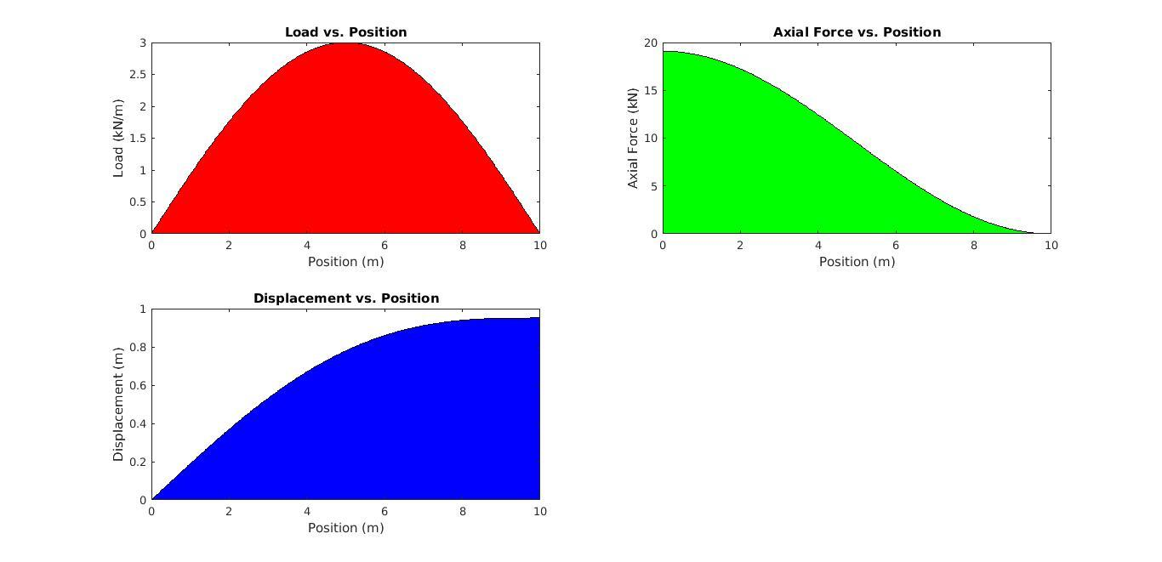

**Case 15 : Half Sinusoidal load, Fixed at right end only**

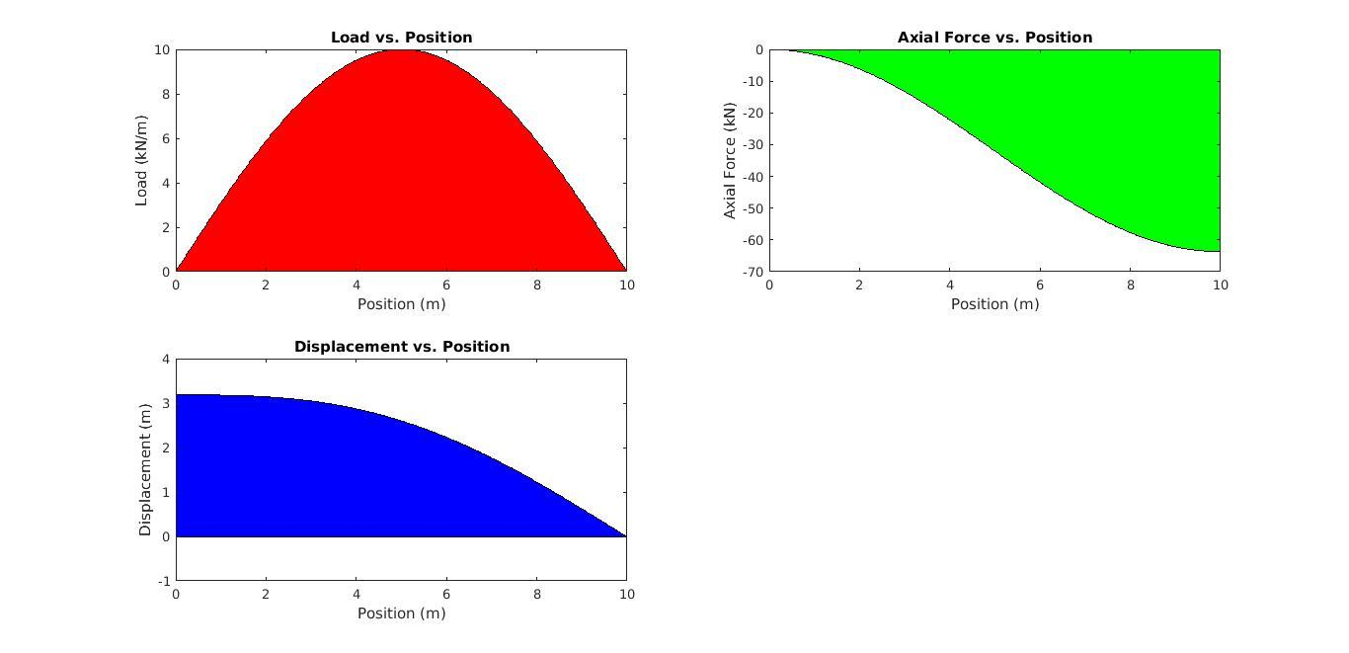

**Case 16 : Load on a patch, Fixed at both ends**

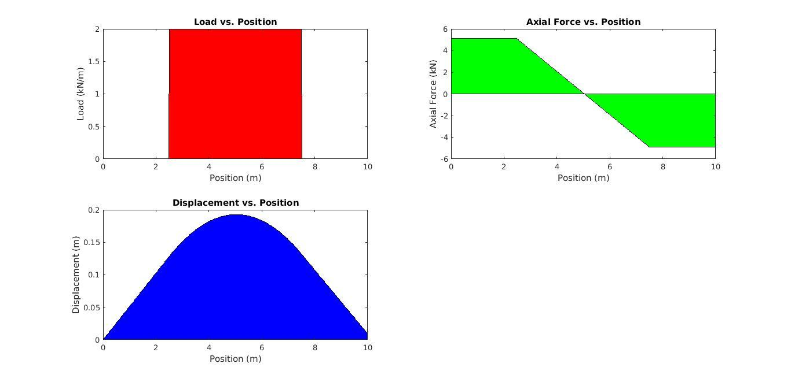

**Case 17 : Load on a patch, Fixed at left end only**

The numerical approximation error can be seen in this case; the axial force does not converge to zero at the right end. The error can be decreased by increasing the number of Simpson and GTR points. In the next section, it will be seen that smaller the patch, greater the number of points needed to obtain a good approximation.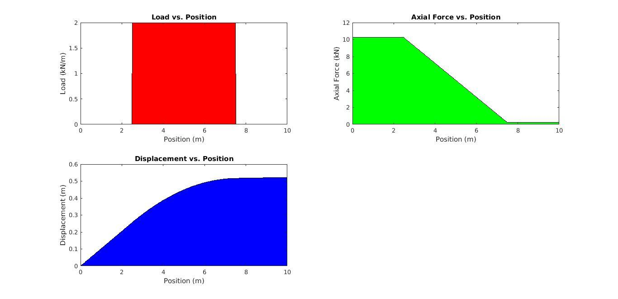

**Case 18 : Load on a patch, Fixed at right end only**

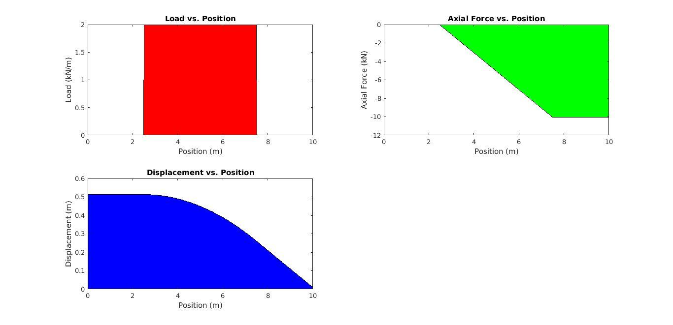

**5. Discussion and further exploration**

Next, we investigate if a distributed load in the limit does the same thing as a concentrated load. To do this, we apply the load over a very small patch, say from 0.45*L to 0.55*L with both ends fixed. The results are shown below.

The number of Simpson points used was 501 and no. of GTR points used was 1001 with a beta value of 0.5.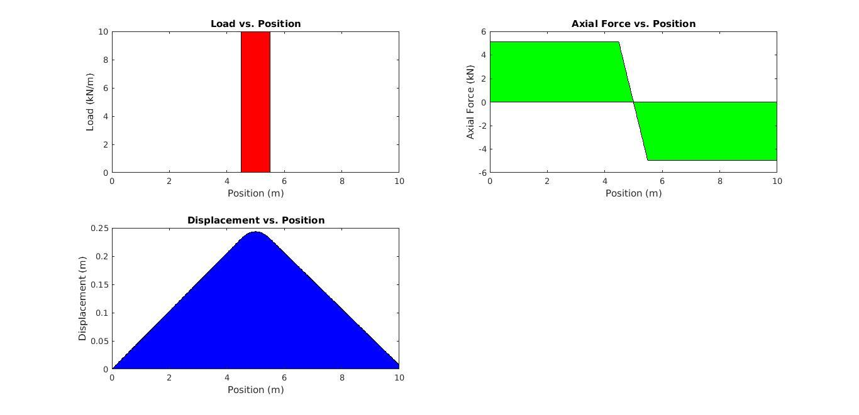

Reducing the patch further, let’s apply the load from 0.49*L to 0.51*L with both ends fixed. The results are shown below.

The number of Simpson points used was 1001 and no. of GTR points used was 2001 with a beta value of 0.5.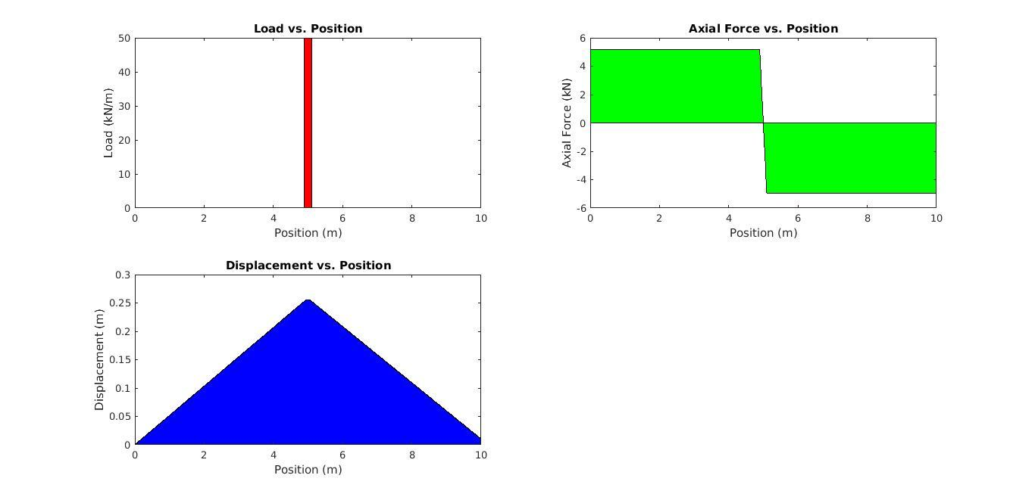

Greater no. of points are required to get a good approximation. Even with these many points, it can be xclearly seen that the displacement at the right end is not zero. This is due to the slow rate of convergence of the numerical methods used.

It can be seen that the displacement and axial force distribution approaches that of a concentrated load.

**6. Results for benchmark case**

Physical properties

L : 10

EA : 100

End conditions and load case

BC at x=0 : fixed

BC at x=L : fixed

Load case : Half sinusoid

po : 3.00

Numerical analysis parameters

Number of Simpson points : 21

Number of GTR points : 51

Beta (GTR parameter) : 0.5

Values of the state at x = 0 (exact)

u(0) 0.0000e+00

N(0) 9.5493e+00

Values of the state at x = L

|  |  |  |  |
| --- | --- | --- | --- |
|  | Exact | From GTR | Error |
| u(L) | 0.0000e+00 | -0.0359458 | 3.59% |
| N(L) | -9.5493e+00 | -9.50530 | 0.461% |

I0, I1 : 19.0986579, 0.95493289

