**Computing Project 3**

*Properties of Area*

**1. Introduction**

This project describes a MATLAB program that computes various properties of a cross-section. Three different cross-sections are implemented – rectangle, hollow rectangle and an L shape.

**2. Program Description**

The execution flow of the program is as follows:

1. Ask the user to input the type of cross-section. The program allows for 3 types of cross-sections, and each load is represented by a number that the user has to input.

1 = Rectangle, 2 = Hollow Rectangular Tube, 3 = Equal-Angle L shape

1. Depending upon the type of cross-section, the program calculates the area, centroid, the moment of inertia tensor, the principal values of the moment of inertia tensor and the polar moment of inertia.
2. The basic algorithm is as follows:

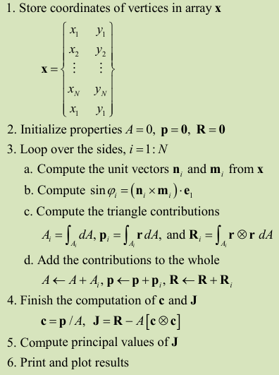

**3. File Structure**

The program consists of 2 files:

* CP3_Input
* AreaProp.m
* Simpson.m

The file “AreaProp.m” is the core script that runs and interacts with the other file that contains a helper routine that generates coordinates for the cross-section.

**4. Results**

**Case 1 : Rectangle of width 2 and height 5**

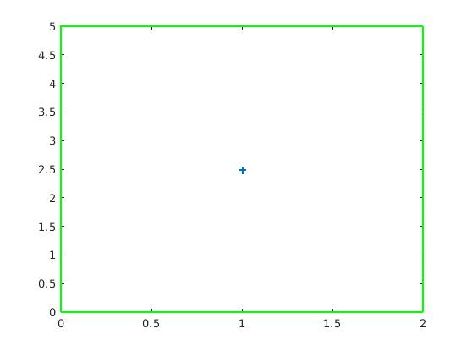**The ‘+’ represents the centroid.**

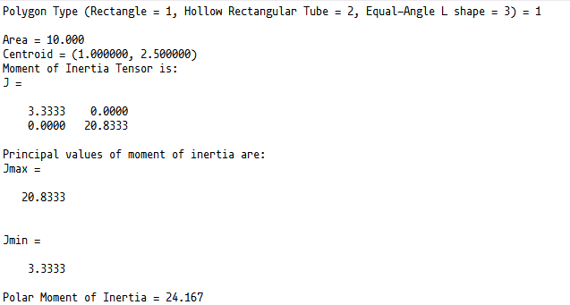

**Case 2 : Hollow Rectangular Tube of width 2 and height 5 and wall thickness 0.5**

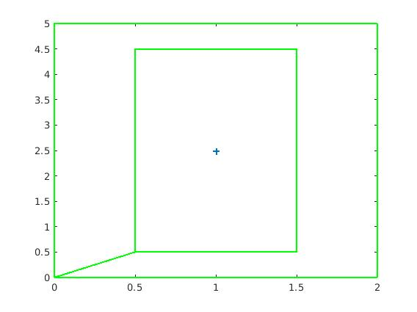**The ‘+’ represents the centroid.**

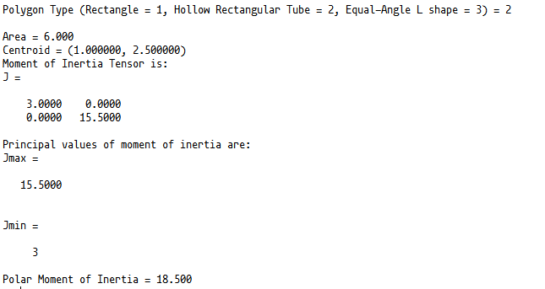

**Case 3 : Equal Angle L-shape with side length 200 and width 25**

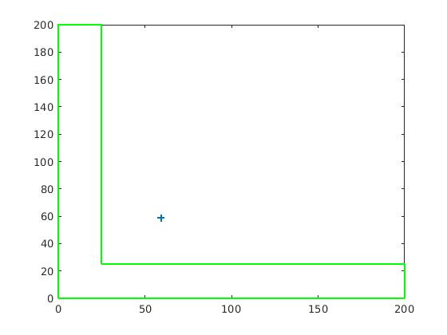

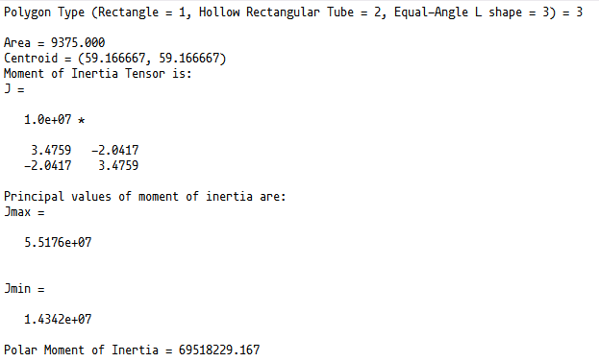

**5. Results for benchmark case**

Area = 9375

Centroid Location = (59.167, 59.167)

J(yy) = 3.4759e+07

J(xx) = 3.4759e+07

J(yz) = -2.0417e+07

J(max) = 5.5176e+07

J(min) = 1.4342e+07

J(polar) = 6.9518e+07