Computing Project 3
Properties of Area

1. Introduction
This project describes a MATLAB program that computes various properties of a cross-section. Three different cross-sections are implemented – rectangle, hollow rectangle and an L shape.

2. Program Description
The execution flow of the program is as follows:

- Ask the user to input the type of cross-section. The program allows for 3 types of cross-sections, and each load is represented by a number that the user has to input.

1 = Rectangle, 2 = Hollow Rectangular Tube, 3 = Equal-Angle L shape

- Depending upon the type of cross-section, the program calculates the area, centroid, the moment of inertia tensor, the principal values of the moment of inertia tensor and the polar moment of inertia.

- The basic algorithm is as follows:

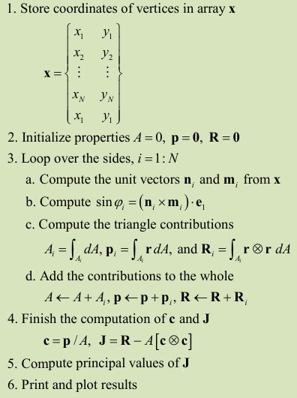
3. File Structure
The program consists of 2 files:
- CP3_Input
- AreaProp.m
- Simpson.m

The file “AreaProp.m” is the core script that runs and interacts with the other file that contains a helper routine that generates coordinates for the cross-section.

4. Results

Case 1 : Rectangle of width 2 and height 5

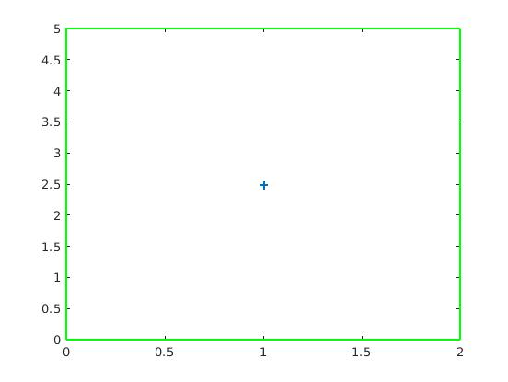
The ‘+’ represents the centroid.

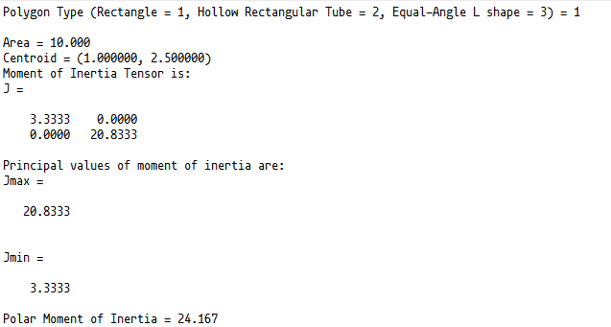
Case 2 : Hollow Rectangular Tube of width 2 and height 5 and wall thickness 0.5

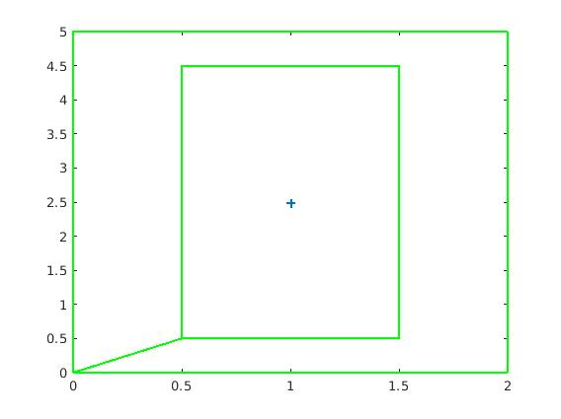
The ‘+’ represents the centroid.

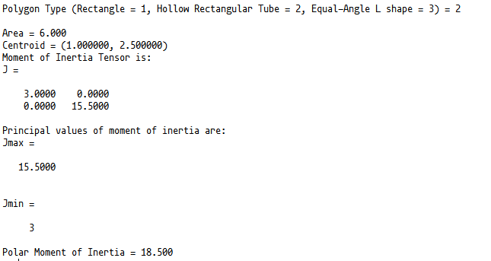
Case 3 : Equal Angle L-shape with side length 200 and width 25

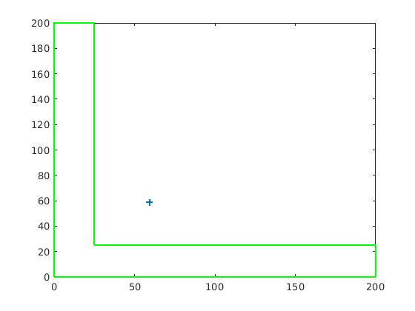
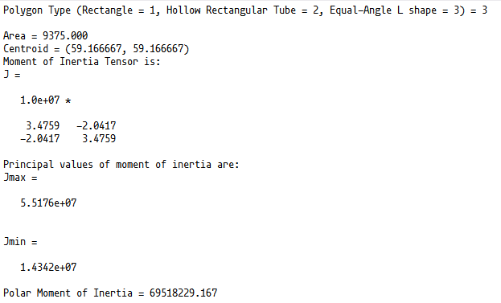

5. Results for benchmark case
Area = 9375
Centroid Location = (59.167, 59.167)
J(yy) = 3.4759e+07
J(xx) = 3.4759e+07
J(yz) = -2.0417e+07
J(max) = 5.5176e+07
J(min) = 1.4342e+07
J(polar) = 6.9518e+07

