Nikhil Raina

MATLAB Version: 9.8.0.1451342 (R2020a) Update 5

MATLAB License Number: 364896

3.

1. The photo I have decided to share is of when I had gone for trekking with a few friends of mine. The only thing I like about the photo is that I actually didn’t have to pose as it was literally taken in a fraction of a second when my friend called out my name and told me to smile. Usually my photos don’t look, even when I smile, but this one, fortunately turned out so much better than the rest.

Also, the hat I am wearing is a cargo hat that belongs to my friend, but I was able to pull it off better.



1. This is the inverted image of the profile photo I chose.

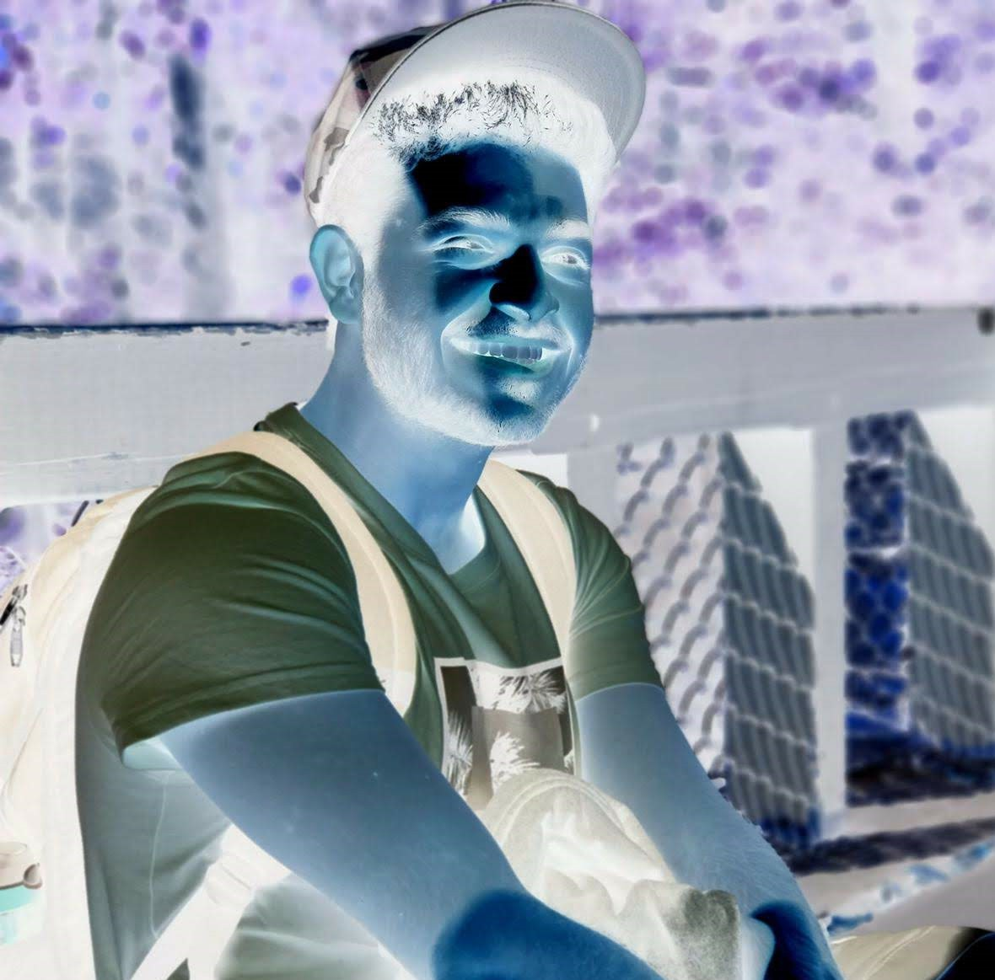

1. Quality is one of the parameters of HDF image transformation. By using this parameter, it applies a level of quality of the image within the range of 0 to 100. The only time this would work if the Compression is JPEG.

By setting the image quality to a lower number, the quality of the image becomes bad, that is the pixilation of the image drastically increases.

Below the image is of Quality 3:

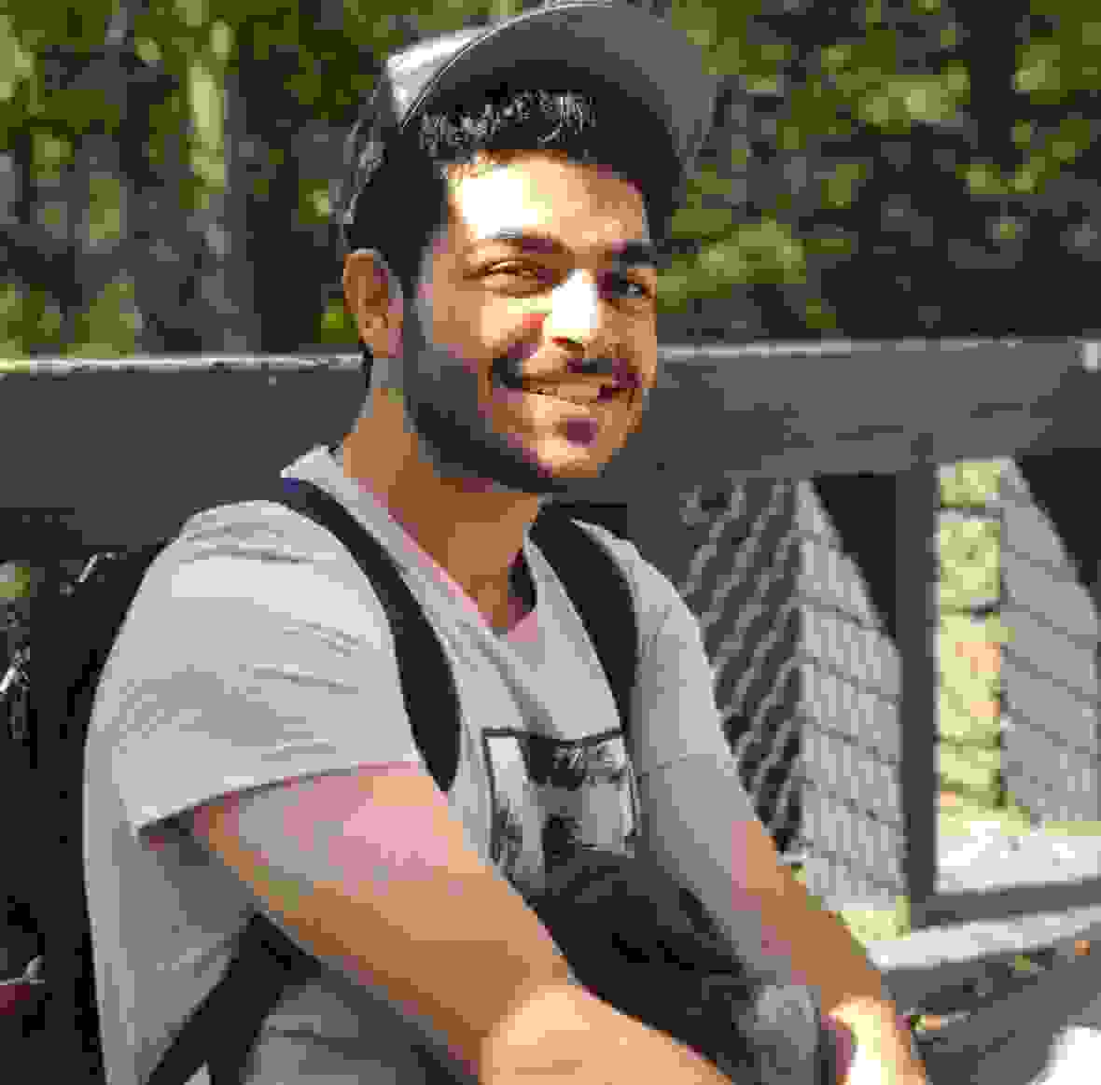

1. Here is the image flipped left or horizontally:



4. From this Assignment, by doing some experimentation with the images using the mentioned commands and few extra ones from the web, I realized that small and simple modifications in images, even if they are filters or changing simple features in the image itself, is an intricate process in the backend. The smallest changes can result in a complete different set of numbers that form the image. I found it especially interesting by doing simple mathematic calculations could result in a complete filter change of the image. In this case, from the normal image to a negative of the image.