

Functional Safety Concept Lane Assistance

**Document Version: 1.0**

**Template Version 1.0, Released on 2017-06-21**



# Document history

|  |  |  |  |
| --- | --- | --- | --- |
| Date | Version | Editor | Description |
| 21-Jun-18 | 1.0 | Nikhil Sinnarkar | Initial Draft |
|  |  |  |  |
|  |  |  |  |
|  |  |  |  |
|  |  |  |  |

# Table of Contents

Document history

Table of Contents

Purpose of the Functional Safety Concept

Inputs to the Functional Safety Analysis

Safety goals from the Hazard Analysis and Risk Assessment

Preliminary Architecture

Description of architecture elements

Functional Safety Concept

Functional Safety Analysis

Functional Safety Requirements

Refinement of the System Architecture

Allocation of Functional Safety Requirements to Architecture Elements

Warning and Degradation Concept

# Purpose of the Functional Safety Concept

The purpose of functional safety concept is to describe the implementation of the independent safety solutions for a defined item.

# Inputs to the Functional Safety Concept

## Safety goals from the Hazard Analysis and Risk Assessment

|  |  |
| --- | --- |
| **ID** | **Safety Goal** |
| Safety_Goal_01 | The oscillating steering torque from the Lane Departure Warning function shall be limited. |
| Safety_Goal_02 | The Lane Keeping Assistance function shall be time limited, and additional steering torque shall end after a given time interval so the driver cannot misuse the system for autonomous driving. |

## Preliminary Architecture

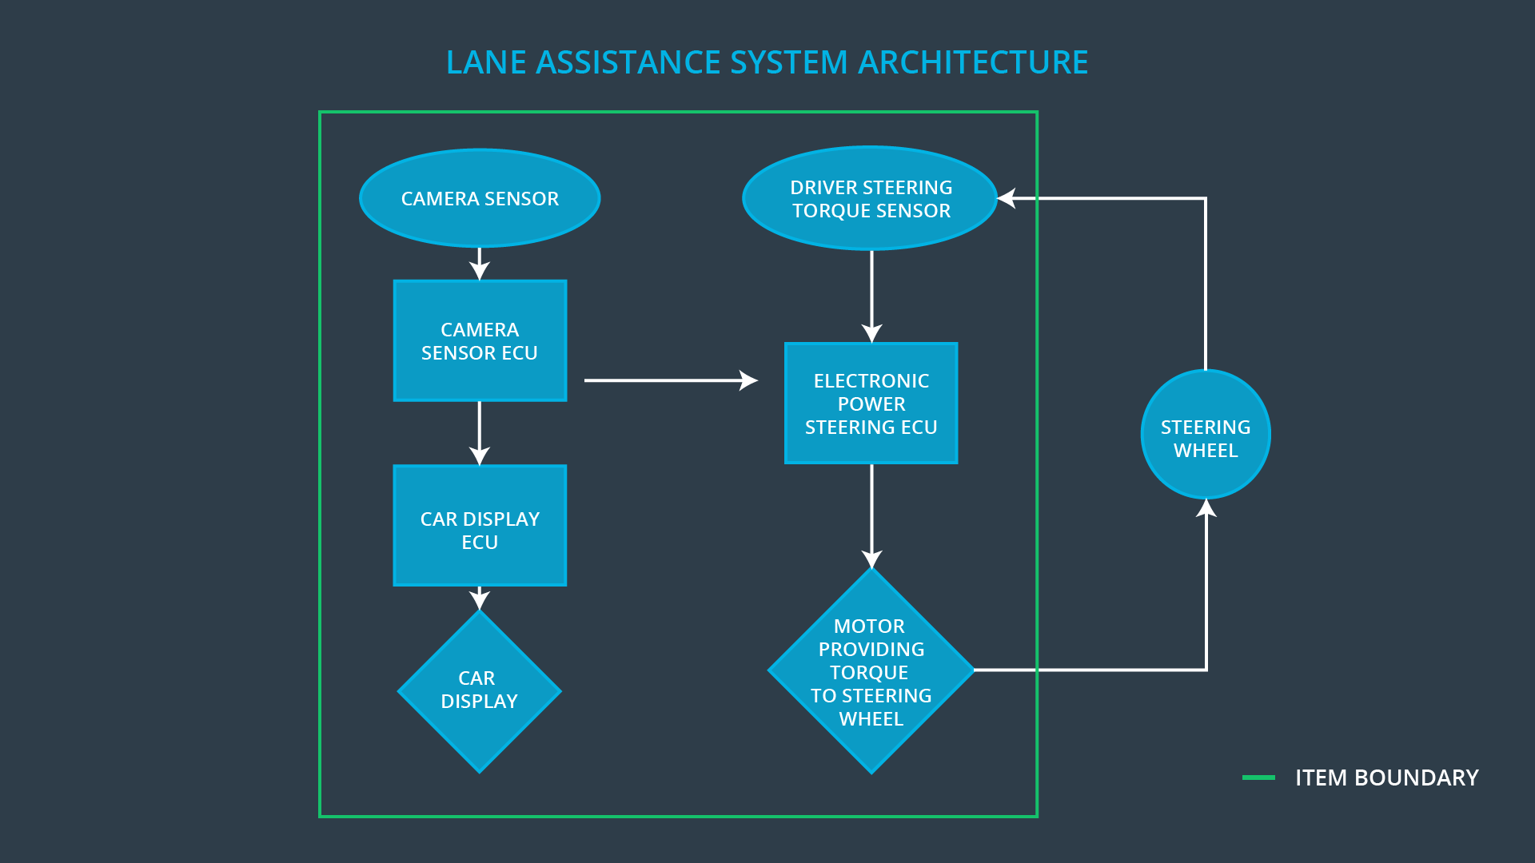

### Description of architecture elements

|  |  |
| --- | --- |
| **Element** | **Description** |
| Camera Sensor | Capture road images and provide them to the Camera Sensor ECU. |
| Camera Sensor ECU | Analyze provided images to determine if the car is leaving the lane and if so, send a vibrational torque request to the power steering ECU. |
| Car Display | Provide feedback to the driver displaying warnings and the Lane Departure Assistance status. |
| Car Display ECU | An Electronic Control Unit that drives the Car Display component to show the Lane Keeping Assistance warning and Lane Departure Assistance status. |
| Driver Steering Torque Sensor | Measure the torque applied to the steering wheel by the driver. |
| Electronic Power Steering ECU | ECU responsible for measuring the torque provided by the driver and adding appropriate amount of torque based on a lane assistance system torque request (LKA) and vibrates the steering wheel when the driver drifts away from the center (LDW). |
| Motor | Actuator responsible for applying requested torque to the steering column by Electronic Power Steering ECU for either the LKA or LDW functions. |

# Functional Safety Concept

The functional safety concept consists of:

* Functional safety analysis
* Functional safety requirements
* Functional safety architecture
* Warning and degradation concept

## Functional Safety Analysis

|  |  |  |  |
| --- | --- | --- | --- |
| **Malfunction ID** | **Main Function of the Item Related to Safety Goal Violations** | **Guidewords (NO, WRONG, EARLY, LATE, MORE, LESS)** | **Resulting Malfunction** |
| Malfunction_01 | Lane Departure Warning (LDW) function shall apply an oscillating steering torque to provide the driver a haptic feedback | MORE | The Lane Departure Warning function applies an oscillating torque with very high torque amplitude (above limit) |
| Malfunction_02 | Lane Departure Warning (LDW) function shall apply an oscillating steering torque to provide the driver a haptic feedback | MORE | The Lane Departure Warning function applies an oscillating torque with very high torque frequency (above limit) |
| Malfunction_03 | Lane Keeping Assistance (LKA) function shall apply the steering torque when active in order to stay in ego lane | NO | The Lane Keeping Assistance function is not limited in time duration which lead to misuse as an autonomous driving function. |

## Functional Safety Requirements

Lane Departure Warning (LDW) Requirements:

|  |  |  |  |  |
| --- | --- | --- | --- | --- |
| **ID** | **Functional Safety Requirement** | **ASIL** | **Fault Tolerant Time Interval** | **Safe State** |
| Functional  Safety  Requirement  01-01 | The lane keeping item shall ensure that the lane departure oscillating torque amplitude is below Max_Torque_Amplitude | C | 50 ms | Vibration torque amplitude below Max_Torque_Amplitude. |
| Functional  Safety  Requirement  01-02 | The Lane Departure Warning item shall ensure that the lane departure oscillating torque frequency is below Max_Torque_Frequency. | C | 50 ms | Vibration frequency is below Max_Torque_Frequency. |

Lane Departure Warning (LDW) Verification and Validation Acceptance Criteria:

|  |  |  |
| --- | --- | --- |
| **ID** | **Validation Acceptance**  **Criteria and Method** | **Verification Acceptance**  **Criteria and Method** |
| Functional  Safety  Requirement  01-01 | Validate Max_Torque_Amplitude chosen is high enough to be detected by a driver while low enough not to cause loss of steering | Verify the system does turn off if the Lane Departure Warning exceeded Max_Torque_Amplitude. |
| Functional  Safety  Requirement  01-02 | Validate Max_Torque_Frequency chosen is adequate to be detected by the driver and not cause the loss of steering. | Verify the system does turn off if the Lane Departure Warning exceeded Max_Torque_Frequency. |

Lane Keeping Assistance (LKA) Requirements:

|  |  |  |  |  |
| --- | --- | --- | --- | --- |
| **ID** | **Functional Safety Requirement** | **ASIL** | **Fault Tolerant Time Interval** | **Safe State** |
| Functional  Safety  Requirement  02-01 | The Lane keeping item shall ensure that the Lane Keeping Assistance torque is applied only Max_Duration. | B | 500 ms | Lane Keeping Assistance torque is zero. |

Lane Keeping Assistance (LKA) Verification and Validation Acceptance Criteria:

|  |  |  |
| --- | --- | --- |
| **ID** | **Validation Acceptance**  **Criteria and Method** | **Verification Acceptance**  **Criteria and Method** |
| Functional  Safety  Requirement  02-01 | Test and validate that the Max_duration chosen did dissuade drivers from using the car as self-driving car. | Verify that the system really does turn off if the lane keeping assistance ever exceeded Max_Duration. |

## Refinement of the System Architecture

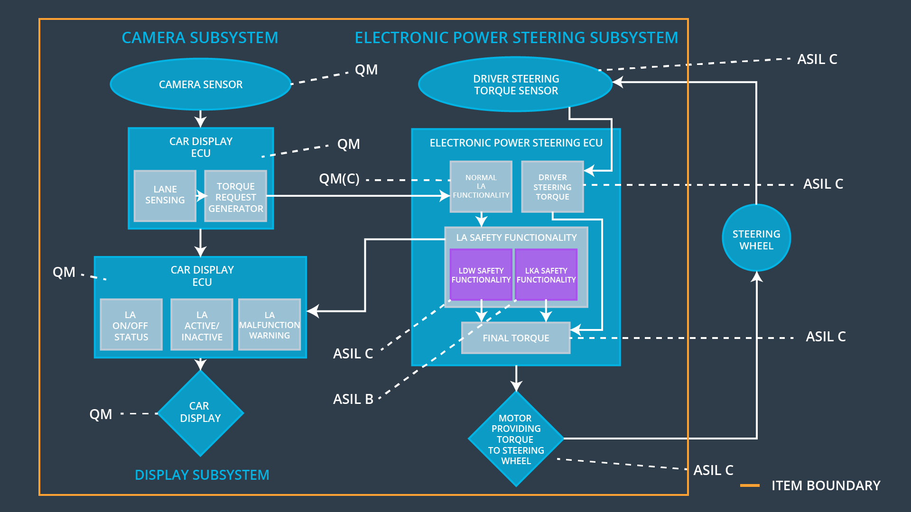

## Allocation of Functional Safety Requirements to Architecture Elements

|  |  |  |  |  |
| --- | --- | --- | --- | --- |
| **ID** | **Functional Safety Requirement** | **Electronic Power Steering ECU** | **Camera ECU** | **Car Display ECU** |
| Functional  Safety  Requirement  01-01 | The Lane Departure Warning item shall ensure that the lane departure oscillating torque amplitude is below Max_Torque_Amplitude. | **✓** |  |  |
| Functional  Safety  Requirement  01-02 | The Lane Departure Warning item shall ensure that the lane departure oscillating torque frequency is below Max_Torque_Frequency. | **✓** |  |  |
| Functional  Safety  Requirement  02-01 | The electronic power steering ECU shall ensure that the Lane Keeping Assistance torque is applied only Max_Duration. | **✓** |  |  |

## Warning and Degradation Concept

|  |  |  |  |  |
| --- | --- | --- | --- | --- |
| **ID** | **Degradation Mode** | **Trigger for Degradation Mode** | **Safe State invoked?** | **Driver Warning** |
| WDC-01 | Turn off Lane Departure Warning functionality | Malfunction_01,  Malfunction_02 | Yes | Lane Departure Warning Malfunction Warning on Car Display |
| WDC-02 | Turn off Lane Keeping Assistance functionality | Malfunction_03 | Yes | Lane Keeping Assistance Malfunction Warning on Car Display |