

Technical Safety Concept Lane Assistance

**Document Version: 1.0**

**Template Version 1.0, Released on 2017-06-21**



# Document history

|  |  |  |  |
| --- | --- | --- | --- |
| Date | Version | Editor | Description |
| 21-Jun-18 | 1.0 | Nikhil Sinnarkar | Initial Draft |
|  |  |  |  |
|  |  |  |  |
|  |  |  |  |
|  |  |  |  |

# Table of Contents

Document history

Table of Contents

Purpose of the Technical Safety Concept

Inputs to the Technical Safety Concept

Functional Safety Requirements

Refined System Architecture from Functional Safety Concept

Functional overview of architecture elements

Technical Safety Concept

Technical Safety Requirements

Refinement of the System Architecture

Allocation of Technical Safety Requirements to Architecture Elements

Warning and Degradation Concept

# Purpose of the Technical Safety Concept

The purpose of Technical Safety Concept is:

* Turning functional safety requirements into technical safety requirements.
* Allocating technical safety requirements to the system architecture.

These new requirements are more concrete and gets into details of the item’s technology as specified by ISO 26262.

# Inputs to the Technical Safety Concept

## Functional Safety Requirements

|  |  |  |  |  |
| --- | --- | --- | --- | --- |
| **ID** | **Functional Safety Requirement** | **ASIL** | **Fault Tolerant Time Interval** | **Safe State** |
| Functional  Safety  Requirement  01-01 | The Lane Departure Warning item shall ensure that the lane departure oscillating torque amplitude is below Max_Torque_Amplitude. | C | 50 ms | Vibration torque amplitude below Max_Torque_Amplitude. |
| Functional  Safety  Requirement  01-02 | The Lane Departure Warning item shall ensure that the lane departure oscillating torque frequency is below Max_Torque_Frequency. | C | 50 ms | Vibration frequency is below Max_Torque_Frequency. |
| Functional  Safety  Requirement  02-01 | The electronic power steering ECU shall ensure that the Lane Keeping Assistance torque is applied only Max_Duration. | B | 500 ms | Lane Keeping Assistance torque is zero. |

## Refined System Architecture from Functional Safety Concept

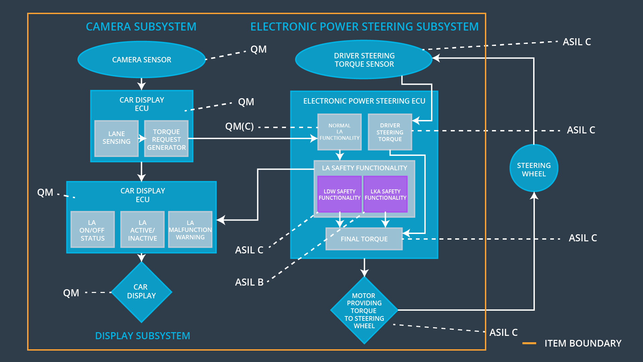

### Functional overview of architecture elements

|  |  |
| --- | --- |
| **Element** | **Description** |
| Camera Sensor | Capture road images and provide them to the Camera Sensor ECU. |
| Camera Sensor ECU - Lane Sensing | Software module detecting the lane line positions from the Camera Sensor images. |
| Camera Sensor ECU - Torque request generator | Software module calculating the necessary torque to be requested to the Electronic Power Steering ECU. |
| Car Display | Display warning for the driver. |
| Car Display ECU - Lane Assistance On/Off Status | Indicate the status of the Lane Assistance functionality (On/Off.) |
| Car Display ECU - Lane Assistant Active/Inactive | Indicate if the Lane Assistance functionality is properly functioning (Active/Inactive.) |
| Car Display ECU - Lane Assistance malfunction warning | Indicate a malfunction on the Lane Assistance functionality. |
| Driver Steering Torque Sensor | Measure the torque applied to the steering wheel by the driver. |
| Electronic Power Steering (EPS) ECU - Driver Steering Torque | Software module receiving the driver’s torque request from the steering wheel. |
| EPS ECU - Normal Lane Assistance Functionality | Software module receiving the Camera Sensor ECU torque request. |
| EPS ECU - Lane Departure Warning Safety Functionality | Software module ensuring the torque amplitude is below Max_Torque_Amplitude and torque frequency is below Max_Torque_Frequency. |
| EPS ECU - Lane Keeping Assistant Safety Functionality | Software module ensuring the Lane Keeping Assistance functionality application is not activate more than Max_duration time. |
| EPS ECU - Final Torque | Combine the torque request from the Lane Keeping and Lane Departure Warning functionalities and sends them to the Motor. |
| Motor | Applies the required torque to the steering wheels. |

# Technical Safety Concept

## Technical Safety Requirements

**Lane Departure Warning (LDW) Requirements:**

Functional Safety Requirement 01-01 with its associated system elements

(derived in the functional safety concept)

|  |  |  |  |  |
| --- | --- | --- | --- | --- |
| **ID** | **Functional Safety Requirement** | **Electronic Power Steering ECU** | **Camera ECU** | **Car Display ECU** |
| Functional  Safety  Requirement  01-01 | The lane keeping item shall ensure that the lane departure oscillating torque amplitude is below Max_Torque_Amplitude | X |  |  |

Technical Safety Requirements related to Functional Safety Requirement 01-01 are:

|  |  |  |  |  |  |
| --- | --- | --- | --- | --- | --- |
| **ID** | **Technical Safety Requirement** | **ASIL** | **Fault Tolerant Time Interval** | **Architecture Allocation** | **Safe State** |
| Technical  Safety  Requirement  01 | The Lane Departure Warning safety component shall ensure that the amplitude of the ‘LDW_Torque_Request’ sent to the ‘Final electronic power steering Torque’ component is below ‘Max_Torque_Amplitude.’ | C | 50 ms | LDW Safety | Lane Departure Warning torque to zero. |
| Technical  Safety  Requirement  02 | When the Lane Departure Warning is deactivated, the ‘LDW Safety’ software module shall send a signal to the Car Display ECU to turn on a warning signal. | C | 50 ms | LDW Safety | Lane Departure Warning torque to zero. |
| Technical  Safety  Requirement  03 | When a failure is detected by the Lane Departure Warning functionality, it shall deactivate the Lane Departure Warning feature and set ‘LDW_Torque_Request’ to zero. | C | 50 ms | LDW Safety | Lane Departure Warning torque to zero. |
| Technical  Safety  Requirement  04 | The validity and integrity of the data transmission for ‘LDW_Torque_Request’ signal shall be ensured. | C | 50 ms | LDW Safety | Lane Departure Warning torque to zero. |
| Technical  Safety  Requirement  05 | Memory test shall be conducted at startup of the EPS ECU to check for any memory problems | A | Ignition cycle | Data Transmission Integrity Check | Lane Departure Warning torque to zero. |

Functional Safety Requirement 01-2 with its associated system elements

(derived in the functional safety concept)

|  |  |  |  |  |
| --- | --- | --- | --- | --- |
| **ID** | **Functional Safety Requirement** | **Electronic Power Steering ECU** | **Camera ECU** | **Car Display ECU** |
| Functional  Safety  Requirement  01-02 | The lane keeping item shall ensure that the lane departure oscillating torque frequency is below Max_Torque_Frequency | X |  |  |

Technical Safety Requirements related to Functional Safety Requirement 01-02 are:

|  |  |  |  |  |  |
| --- | --- | --- | --- | --- | --- |
| **ID** | **Technical Safety Requirement** | **ASIL** | **Fault Tolerant Time Interval** | **Architecture Allocation** | **Safe State** |
| Technical  Safety  Requirement  01 | The LDW safety component shall ensure that the frequency of ‘LDW_Frequency_Request’ sent to ‘Final electronic power steering torque’ component is below Max_Trorque_Frequency | C | 50 ms | LDW Safety | Lane Departure Warning torque to zero. |
| Technical  Safety  Requirement  02 | As soon as the LDW function deactivates the LDW feature, the ‘LDW safety’ software block shall send a signal to the car display ECU to turn on a warning light. | C | 50 ms | LDW safety functionality | Deactivate functionality (reset frequency to 0) |
| Technical  Safety  Requirement  03 | As soon as the failure is detected by the LDW function, it shall deactivate the LDW feature and ‘LDW_Frequency_Request’ shall be set to zero. | C | 50 ms | LDW safety functionality | Deactivate functionality (reset frequency to 0) |
| Technical  Safety  Requirement  04 | The validity and integrity of data transmission for ‘LDW_Frequency_Request’ signal shall be ensured | C | 50 ms | Data transmission integrity check | Deactivate functionality (reset frequency to 0) |
| Technical  Safety  Requirement  05 | Memory test shall be conducted at startup of the EPS ECU to check for any faults in memory | A | Ignition cycle | SAFETY STARTUP | Max_Torque_Frequency is correct & Deactivate functionality will reset Frequency to 0 |

**Lane Departure Warning (LDW) Verification and Validation Acceptance Criteria:**

|  |  |  |
| --- | --- | --- |
| **ID** | **Validation Acceptance Criteria and Method** | **Verification Acceptance Criteria and Method** |
| Technical  Safety  Requirement  01 | Validate the Max_Torque_Amplitude is the chosen from the Lane Departure Warning Validation | Verify the Lane Departure Warning functionality is turned off. |
| Technical  Safety  Requirement  02 | Validate the ‘TORQUE_LIMITER’ sends the error_status_torque_limiter signal to the LDW_SAFETY_ACTIVATION. | Verify the Car Display ECU displays the Lane Departure Warning malfunction warning signal. |
| Technical Safety Requirement  03 | Validate the ‘TORQUE_LIMITER’ sends ‘LDW_Torque_Request’ with zero. | Verify the Final EPS Torque generator receives a LDW_Torque_Request of zero. |
| Technical Safety Requirement 04 | Validate the ‘TORQUE_LIMITER’ calculate and sends the correct cyclic redundancy check (CRC) and Alive counter for data transmission validity and integrity. | Verify the functionality is turn off if there is a CRC or Alive counter discrepancy. |
| Technical Safety Requirement  05 | Validate the Safety Startup Memory test to check memory faults catch memory faults. | Verify the Lane Departure Warning is turned off when the Safety Startup Memory fails. |

**Lane Keeping Assistance (LKA) Requirements:**

Functional Safety Requirement 02-1 with its associated system elements

(derived in the functional safety concept)

|  |  |  |  |  |
| --- | --- | --- | --- | --- |
| **ID** | **Functional Safety Requirement** | **Electronic Power Steering ECU** | **Camera ECU** | **Car Display ECU** |
| Functional  Safety  Requirement  02-01 | The lane keeping item shall ensure that the lane keeping assistance torque is applied for only Max_Duration | X |  |  |

Technical Safety Requirements related to Functional Safety Requirement 02-01 are:

|  |  |  |  |  |  |
| --- | --- | --- | --- | --- | --- |
| **ID** | **Technical Safety Requirement** | **ASIL** | **Fault Tolerant Time Interval** | **Allocation to Architecture** | **Safe State** |
| Technical  Safety  Requirement  01 | The Lane Keeping Assistance safety component shall ensure the lane keeping assistance torque is applied for less than Max_Duration | C | 50 ms | LKA Safety | Lane Keeping Assistance torque to zero. |
| Technical  Safety  Requirement  02 | When the Lane Keeping Assistance function deactivates, the ‘LKA Safety’ shall send a signal to the Car Display ECU to turn on a warning light. | C | 50 ms | LKA Safety | Lane Keeping Assistance torque to zero. |
| Technical  Safety  Requirement  03 | When a failure is detected, the Lane Keeping Assistance function shall deactivate and the ‘LKA_Torque_Request’ shall be zero. | C | 50 ms | LKA Safety | Lane Keeping Assistance torque to zero. |
| Technical  Safety  Requirement  04 | The validity and integrity of the data transmission for ‘LKA_Torque_Request’ signal shall be ensured. | C | 50 ms | Data transmission integrity check | Lane Keeping Assistance torque to zero. |
| Technical  Safety  Requirement  05 | Memory test shall be conducted at startup of the EPS ECU to check for any memory problems | A | Ignition cycle | SAFETY STARTUP | Lane Departure Warning torque to zero. |

**Lane Keeping Assistance (LKA) Verification and Validation Acceptance Criteria:**

|  |  |  |
| --- | --- | --- |
| **ID** | **Validation Acceptance Criteria and Method** | **Verification Acceptance Criteria and Method** |
| Technical  Safety  Requirement  01 | Validate the Max_Duration is set to the chosen value from LKA Validation Assistance Criteria | Verify the functionality is turned off after it is applied for Max_Duration. |
| Technical  Safety  Requirement  02 | Validate the ‘TORQUE_LIMITER’ sends the error_status_torque_limiter signal to the LKA_SAFETY_ACTIVATION. | Verify the Car Display ECU displays the Lane Keeping Assistance malfunction warning signal. |
| Technical Safety Requirement  03 | Validate the ‘TORQUE_LIMITER’ sends ‘LKA_Torque_Request’ with zero. | Verify the Final EPS Torque generator receives a LKA_Torque_Request of zero. |
| Technical Safety Requirement 04 | Validate the ‘TORQUE_LIMITER’ calculate and sends the correct cyclic redundancy check (CRC) and Alive counter for data transmission validity and integrity. | Verify the functionality is turn off if there is a CRC or Alive counter discrepancy. |
| Technical Safety Requirement  05 | Validate the Safety Startup Memory test to check memory faults catch memory faults. | Verify the Lane Keeping Assistance is turned off when the Safety Startup Memory fails. |

## Refinement of the System Architecture

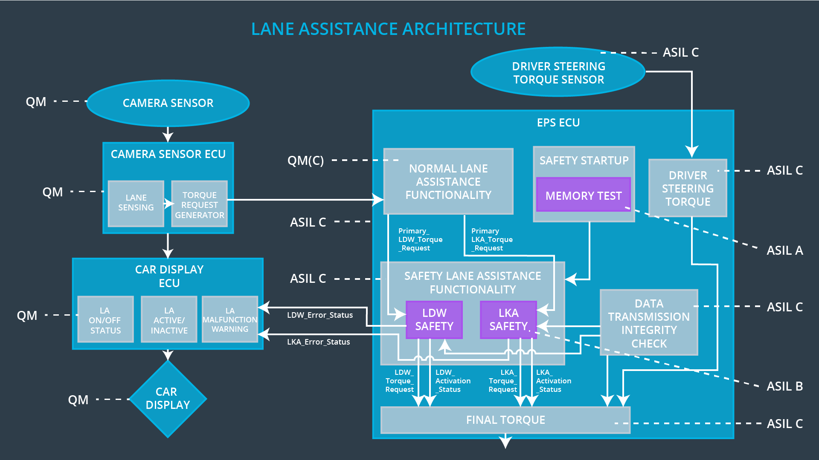

## Allocation of Technical Safety Requirements to Architecture Elements

|  |  |  |  |  |
| --- | --- | --- | --- | --- |
| **ID** | **Technical Safety Requirement** | **Electronic Power Steering ECU** | **Camera ECU** | **Car Display ECU** |
| Technical  Safety  Requirement  01-01-01 | The Lane Departure Warning safety component shall ensure that the amplitude of the ‘LDW_Torque_Request’ sent to the ‘Final electronic power steering Torque’ component is below ‘Max_Torque_Amplitude.’ | **X** |  |  |
| Technical  Safety  Requirement  01-01-02 | When the Lane Departure Warning is deactivated, the ‘LDW Safety’ software module shall send a signal to the Car Display ECU to turn on a warning signal. | **X** |  |  |
| Technical  Safety  Requirement  01-01-03 | When a failure is detected by the Lane Departure Warning functionality, it shall deactivate the Lane Departure Warning feature and set ‘LDW_Torque_Request’ to zero. | **X** |  |  |
| Technical  Safety  Requirement  01-01-04 | The validity and integrity of the data transmission for ‘LDW_Torque_Request’ signal shall be ensured. | **X** |  |  |
| Technical  Safety  Requirement  01-01-05 | Memory test shall be conducted at startup of the EPS ECU to check for any memory problems | **X** |  |  |
| Technical  Safety  Requirement  01-02-01 | The Lane Departure Warning safety component shall ensure the frequency of the ‘LDW_Torque_Request’ sent to the ‘Final electronic power steering Torque’ component is below ‘Max_Torque_Frequency.’ | **X** |  |  |
| Technical  Safety  Requirement  02-01-01 | The Lane Keeping Assistance safety component shall ensure the duration of the lane keeping assistance torque is applied for less than Max_Duration | **X** |  |  |
| Technical  Safety  Requirement  02-01-02 | When the Lane Keeping Assistance function deactivates, the ‘LKA Safety’ shall send a signal to the Car Display ECU to turn on a warning light. | **X** |  |  |
| Technical  Safety  Requirement  02-01-03 | When a failure is detected, the Lane Keeping Assistance function shall deactivate and the ‘LKA_Torque_Request’ shall be zero. | **X** |  |  |
| Technical  Safety  Requirement  02-01-04 | The validity and integrity of the data transmission for ‘LKA_Torque_Request’ signal shall be ensured. | **X** |  |  |
| Technical  Safety  Requirement  02-01-05 | Memory test shall be conducted at startup of the EPS ECU to check for any memory problems |  |  |  |

## Warning and Degradation Concept

|  |  |  |  |  |
| --- | --- | --- | --- | --- |
| WDC-01 | Turn off Lane Departure Warning functionality | Malfunction_01,  Malfunction_02 | Yes | Lane Departure Warning Malfunction Warning on Car Display |
| WDC-02 | Turn off Lane Keeping Assistance functionality | Malfunction_03 | Yes | Lane Keeping Assistance Malfunction Warning on Car Display |