

Safety Plan Lane Assistance

**Document Version: 1.0**

**Template Version 1.0, Released on 2017-06-21**



# Document history

|  |  |  |  |
| --- | --- | --- | --- |
| Date | Version | Editor | Description |
| 20-Jun-18 | 1.0 | Nikhil Sinnarkar | First Draft of Safety plan |
|  |  |  |  |
|  |  |  |  |
|  |  |  |  |
|  |  |  |  |

# Table of Contents

Document history

Table of Contents

Introduction

Purpose of the Safety Plan

Scope of the Project

Deliverables of the Project

Item Definition

Goals and Measures

Goals

Measures

Safety Culture

Safety Lifecycle Tailoring

Roles

Development Interface Agreement

Confirmation Measures

# Introduction

## Purpose of the Safety Plan

The Safety plan gives an overview of how to achieve a safe system. Among others this includes the system under consideration and to set up a goal for the project. It also includes the assignment of roles and responsibilities for the item’s functional safety.

## Scope of the Project

For the lane assistance project, the following safety lifecycle phases are in scope:

Concept phase

Product Development at the System Level

Product Development at the Software Level

The following phases are out of scope:

Product Development at the Hardware Level

Production and Operation

## Deliverables of the Project

The deliverables of the project are:

Safety Plan

Hazard Analysis and Risk Assessment

Functional Safety Concept

Technical Safety Concept

Software Safety Requirements and Architecture

# Item Definition

This safety plan covers the Lane Assistance System which is an Advanced Driver Assistance system (ADAS). The Lane Assistance System alert the driver to potentially dangerous situations and take control over the vehicle to prevent accidents from occurring.

The two main function of this item are:

* **Lane departure warning function**: The Lane departure warning function vibrates the steering wheel in case the car drifts towards the edge of the lane.
* **Lane Keeping assistance function**: The Lane keeping assistance function moves the car turns back towards the center of the lane.

The item consists of three subsystems with their own components:

* Camera subsystem consisting of 2 components:
  + Camera sensor
  + Camera sensor with Electronic Control Unit (ECU)
* Electronic power steering subsystem consisting of 3 components:
  + Driver Steering Torque sensor
  + Electronic Power Steering
  + Motor providing torque to steering wheel
* Car Display subsystem consisting of 2 components:
  + Car Display ECU
  + Car Display

The following diagram shows the interaction between the 3 subsystems:

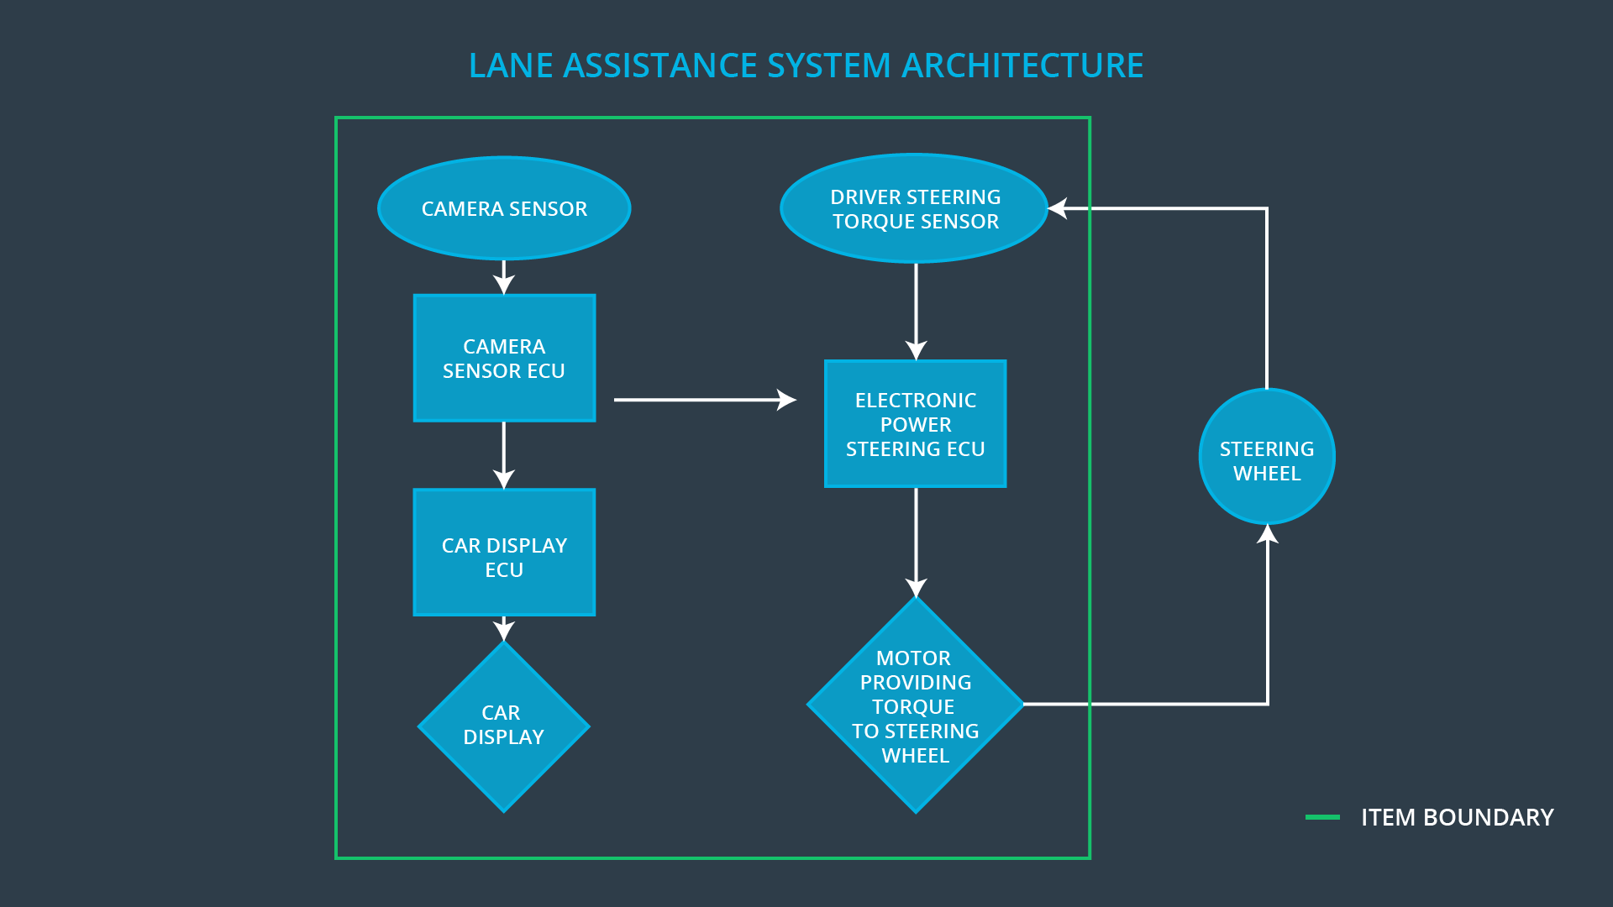

The camera subsystem is responsible for detecting and monitoring the position of the car in the ego lane and informing the car display and Electronic Power Steering subsystem if the car drifts towards the edge.

The Electronic Power Steering subsystem detects how much the driver is already turning the vehicle and add an extra torque to get the vehicle back towards the center.

The Car Display subsystem is only responsible for displaying the warning if necessary.

The Lane assistance system deactivates itself if the driver uses a turn signal or uses a button on the dashboard to turn off the system.

Other car subsystem like the steering wheel lie outside of this item.

# Goals and Measures

## Goals

This project goals are:

* Identify risk and hazardous situations in the Lane Assistance System components malfunction causing injuries to a person.
* Evaluate the risks of the hazardous situations.
* Lower the risk of the malfunctions to a reasonable levels acceptable by current society.

## Measures

|  |  |  |
| --- | --- | --- |
| Measures and Activities | Responsibility | Timeline |
| Follow safety processes | All Team Members | Constantly |
| Create and sustain a safety culture | All Team Members | Constantly |
| Coordinate and document the planned safety activities | Safety Manager | Constantly |
| Allocate resources with adequate functional safety competency | Project Manager | Within 2 weeks of start of project |
| Tailor the safety lifecycle | Safety Manager | Within 4 weeks of start of project |
| Plan the safety activities of the safety lifecycle | Safety Manager | Within 4 weeks of start of project |
| Perform regular functional safety audits | Safety Auditor | Once every 2 months |
| Perform functional safety pre-assessment prior to audit by external functional safety assessor | Safety Manager | 3 months prior to main assessment |
| Perform functional safety assessment | Safety Assessor | Conclusion of functional safety activities |

# Safety Culture

To increase functional safety our organization provides a safety culture. This includes the following characteristics:

* **High priority**: safety has the highest priority among competing constraints like cost and productivity.
* **Accountability**: processes ensure accountability such that design decisions are traceable back to the people and teams who made the decisions.
* **Rewards**: the organization motivates and supports the achievement of functional safety.
* **Penalties**: the organization penalizes shortcuts that jeopardize safety or quality.
* **Independence**: teams who design and develop a product should be independent from the teams who audit the work.
* **Well defined processes**: company design and management processes should be clearly defined.
* **Resources**: projects have necessary resources including people with appropriate skills.
* **Diversity**: intellectual diversity is sought after, valued and integrated into processes.
* **Communication**: communication channels encourage disclosure of problems.

# Safety Lifecycle Tailoring

For this project the safety plan is tailored. The following lifecycle phases are in scope:

* Concept phase
* Product Development at the System Level
* Product Development at the Software Level

The following phases are out of scope:

* Product Development at the Hardware Level
* Production and Operation

# Roles

|  |  |
| --- | --- |
| Role | Org |
| Functional Safety Manager- Item Level | OEM |
| Functional Safety Engineer- Item Level | OEM |
| Project Manager - Item Level | OEM |
| Functional Safety Manager- Component Level | Tier-1 |
| Functional Safety Engineer- Component Level | Tier-1 |
| Functional Safety Auditor | OEM or external |
| Functional Safety Assessor | OEM or external |

# Development Interface Agreement

The Development Interface Agreement (DIA) helps to avoid disputes during planning and development of the lane assistance system as it defines the above roles and responsibilities between the involved companies.

The OEM will be responsible for the overall vehicle safety and all ISO 26262 required functional safety actions. The companies agreed that the above tailored safety lifecycle is enough to fulfill the ISO 26262 norms for the Lane Assistance System.

Furthermore, all useful information which helps to achieve functional safety and concerns the Lane Assistance component will be shared through the appointed Functional Safety Managers. The Tier-1 Supplier is accountable for the lane assistance component and not the other parts of the vehicle. Therefore, the Tier-1 Supplier will analyze various sub-systems of the Lane assistance component from a functional safety viewpoint.

The Tier-1 company will act and fix all the bugs which apply to the Lane Assistance System. All other issues have to investigated by the OEM.

# Confirmation Measures

**[Instructions:**

**Please answer the following questions:**

1. **What is the main purpose of confirmation measures?**

The Confirmation measures ensures that the applied processes comply with functional safety standards provided by ISO 26262 and that project execution is following the safety plan, therefore verifying if the design really does improve safety.

In particular, by providing confirmation review, during design and development of the product, compliance with ISO 26262 is assured by an independent person.

A *Functional Safety Audit*

1. **What is a confirmation review?**
2. **What is a functional safety audit?**
3. **What is a functional safety assessment?**

**]**

A safety plan could have other sections that we are not including here. For example, a safety plan would probably contain a complete project schedule.

There might also be a "Supporting Process Management" section that would cover "Part 8: Supporting Processes" of the ISO 26262 functional safety standard. This would include descriptions of how the company handles requirements management, change management, configuration management, documentation management, and software tool usage and confidence.

Similarly, a confirmation measures section would go into more detail about how each confirmation will be carried out.