WEEK 3 INTERNSHIP REPORT

Statistical Analysis and
Predictive Modeling using R
Hotel Booking Demand Dataset
Task: Week 3 – Statistical Analysis and Predictive Modeling
Analysis Type: Hypothesis Testing + Binary Logistic Regression
Evaluation: Cross-Validation + Confusion Matrix + ROC/AUC + Diagnostics
Software: R / R Console
Prepared by: Nikhil Wadkar
Submitted as part of the 4-Week R Data Analyst Internship

Table of Contents
- 1. Executive Summary
- 2. Task Objective and Research Question
- 3. Dataset and Analytical Setup
- 4. Analytical Workflow
- 5. Exploratory Statistical Analysis
- 6. Hypothesis Testing
- 7. Predictive Model Development
- 8. Model Coefficient Interpretation
- 9. Cross-Validation
- 10. Confusion Matrix and Classification Metrics
- 11. ROC Curve and AUC Analysis
- 12. Model Diagnostics
- 13. Model Comparison Using AIC
- 14. Integrated Findings and Original Data-Based Insights
- 15. Strengths, Limitations and Potential Improvements
- 16. Conclusion
- Appendix A – Key R Code
- Appendix B – Figure List
- Appendix C – Submission Checklist

1. Executive Summary
This report presents a statistical and predictive analysis of hotel booking cancellations using R. The analysis treats is_canceled as a binary outcome with two classes, No and Yes, and combines statistical inference with logistic-regression classification. The workflow includes exploratory distribution analysis, a Pearson chi-square test, two logistic regression specifications, 10-fold cross-validation, confusion-matrix evaluation, ROC/AUC analysis, residual diagnostics, and AIC-based model comparison.
The hypothesis test examined whether lead-time category is associated with cancellation status. The observed contingency table contained 69,589 training observations. Cancellation rates increased from 16.37% for bookings made 0–30 days ahead to 39.57% for bookings made 181 or more days ahead. The Pearson chi-square statistic was 2,991 with 3 degrees of freedom and p < 2.2e-16, providing strong statistical evidence of an association in the analyzed training data.
The predictive analysis produced two logistic-regression models. Model 1 had an AUC of 0.799 and AIC of 65,255.29. Model 2 had an AUC of 0.758 and AIC of 69,510.07. The supplied 10-fold cross-validation output reported accuracy of 0.7849515 and Kappa of 0.373929. For Model 2, the confusion matrix reported accuracy of 0.7719, sensitivity of 0.31076, specificity of 0.94687, and balanced accuracy of 0.62882.
The key interpretation is that raw accuracy should not be viewed alone. The Model 2 classification rule identified non-canceled bookings much more often than canceled bookings: specificity was 94.69%, whereas sensitivity was 31.08%. This class-level difference is an important limitation and motivates threshold tuning, class-balancing strategies, calibration analysis, and alternative model specifications as future improvements.

2. Task Objective and Research Question
The Week 3 task requires in-depth statistical analysis and development of a predictive model using R. The analysis includes hypothesis testing, distribution and assumption analysis, model development, cross-validation, performance evaluation, diagnostics, and discussion of possible improvements.

2.1 Research Question
Can booking-related characteristics such as lead time, previous cancellations, booking changes, deposit type, market segment, repeated-guest status, average daily rate, and special requests help explain and predict whether a hotel booking is canceled?

2.2 Hypothesis Tested
H₀ (null hypothesis): Lead-time category and booking cancellation status are independent.
H₁ (alternative hypothesis): Lead-time category and booking cancellation status are associated.

3. Dataset and Analytical Setup
The analysis continues with the Hotel Booking Demand dataset used in the earlier internship tasks. The modeling target is is_canceled, represented by the classes No and Yes. The training outputs used for the statistical test contain 69,589 observations, and the cross-validation output also reports 69,589 samples.

3.1 Target Variable and Main Predictors
Variable | Role | Classes / Meaning
is_canceled | Target | No = booking not canceled; Yes = booking canceled
lead_time | Predictor | Number of days between booking and arrival
previous_cancellations | Predictor | Previous canceled bookings
booking_changes | Predictor | Number of booking changes
deposit_type | Categorical predictor | Deposit category
market_segment | Categorical predictor | Market segment
is_repeated_guest | Predictor | Repeated-guest indicator
adr | Predictor | Average Daily Rate
total_of_special_requests | Predictor | Number of special requests

3.2 Modeling Strategy
Because the target variable has two classes, binary logistic regression was selected. Logistic regression estimates the probability of cancellation from the supplied predictors. Two model specifications were evaluated so that predictive discrimination and information-criterion results could be compared.

4. Analytical Workflow
- Inspect distributions of key numerical variables.
- Create lead-time categories and examine their relationship with cancellation status.
- Perform a Pearson chi-square test for the categorical association.
- Fit binary logistic-regression models using booking-related predictors.
- Evaluate the models using 10-fold cross-validation.
- Evaluate a classification rule with a confusion matrix and class-specific metrics.
- Assess discrimination using ROC curves and AUC.
- Inspect residual and leverage diagnostics.
- Compare model specifications using AIC.
- Translate the numerical outputs into data-based findings, limitations, and improvement actions.

5. Exploratory Statistical Analysis

5.1 Distribution of Lead Time
The lead-time histogram is strongly right-skewed. A large concentration of observations occurs at relatively low lead-time values, while the distribution extends toward much larger values. The long right tail indicates that a smaller group of bookings was created far in advance of arrival.
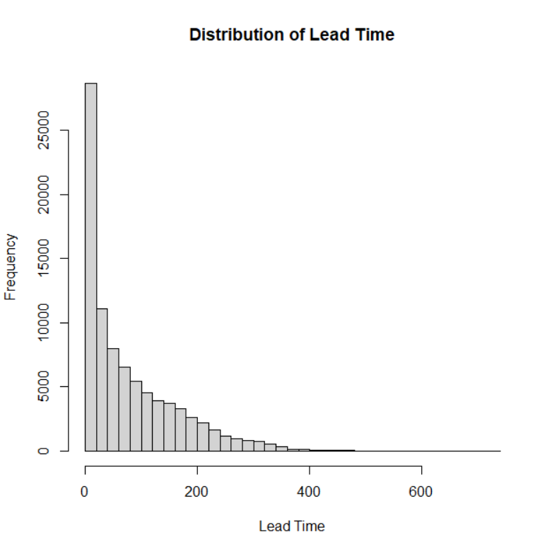
Figure 5.1. Distribution of Lead Time.
This pattern is relevant to cancellation analysis because the later hypothesis test divides lead time into four groups. The group-level cancellation rates show that the relationship is not simply a consequence of one or two extreme observations.

5.2 Distribution of Average Daily Rate (ADR)
The ADR histogram is also strongly right-skewed. Most observations are concentrated at comparatively lower ADR values, while a smaller number extend far into the upper tail.
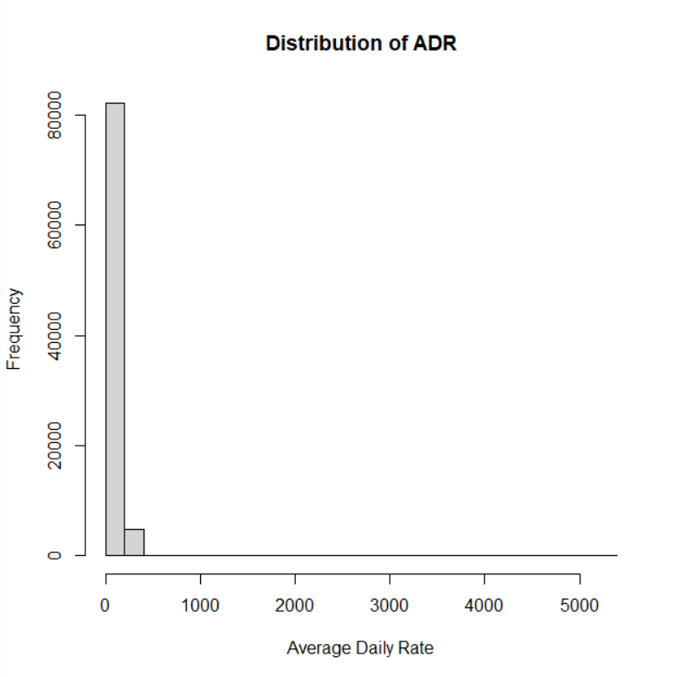
Figure 5.2. Distribution of Average Daily Rate.
Because both lead time and ADR are skewed, the analysis does not rely on normality of these predictors as a prerequisite for the logistic-regression classification task. Instead, the fitted model is evaluated through observed classification and discrimination metrics together with diagnostics.

6. Hypothesis Testing

6.1 Contingency Table
Lead time was grouped into four categories. The following table reproduces the counts shown in the R output. Cancellation percentages are calculated as Yes / (No + Yes) × 100.
Lead-Time Group | Not Canceled (No) | Canceled (Yes) | Total | Cancellation Rate
0–30 Days | 22,955 | 4,494 | 27,449 | 16.37%
31–90 Days | 12,340 | 5,841 | 18,181 | 32.13%
91–180 Days | 9,476 | 5,090 | 14,566 | 34.94%
181+ Days | 5,676 | 3,717 | 9,393 | 39.57%
Total | 50,447 | 19,142 | 69,589 | 27.51%

The calculated cancellation rate rises from 16.37% in the 0–30 day group to 39.57% in the 181+ day group. That is an absolute increase of about 23.20 percentage points across the displayed categories. The pattern provides a concrete data example of why lead-time category was selected for formal hypothesis testing.

6.2 Pearson Chi-Square Test
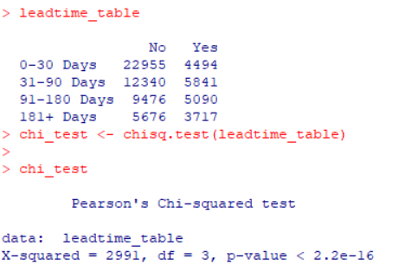
Figure 6.1. R output for the Pearson chi-square test.
Statistic | Observed Result | Interpretation
Chi-square (X²) | 2,991 | Large test statistic relative to the null-independence expectation
Degrees of freedom | 3 | Four lead-time categories produce 3 df for the 2-way table
p-value | < 2.2e-16 | Extremely small p-value under the null hypothesis
Training observations | 69,589 | Total of the four displayed lead-time rows

The Pearson chi-square test produced X² = 2,991, df = 3, and p < 2.2e-16. Therefore, the observed data provide strong statistical evidence against the null hypothesis that lead-time category and cancellation status are independent. This result establishes an association in the analyzed training data; it does not by itself establish causation.

6.3 R Code Used
leadtime_table <- table(train_data$lead_time_group,
train_data$is_canceled)
chi_test <- chisq.test(leadtime_table)
chi_test

7. Predictive Model Development
The target variable is binary, so logistic regression was used. The model estimates the probability that is_canceled belongs to the Yes class from the supplied numerical and categorical predictors.

7.1 Model 2 Specification
model_2 <- glm(
is_canceled ~ lead_time + previous_cancellations +
booking_changes + deposit_type + market_segment +
is_repeated_guest + adr + total_of_special_requests,
data = train_data,
family = binomial
)
The displayed Model 2 output contains 16 model degrees of freedom and 69,589 training observations. The null deviance is 81,870 on 65,988 degrees of freedom, while the residual deviance is 69,478 on 65,973 degrees of freedom. The AIC is 69,510 and the model required 8 Fisher Scoring iterations.
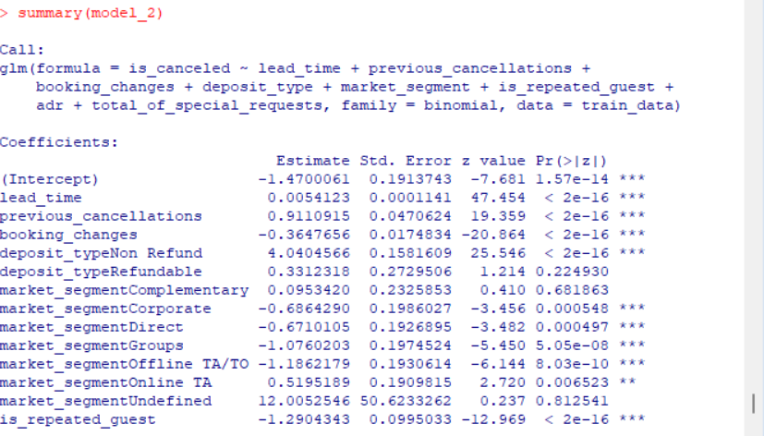
Figure 7.1. Model 2 logistic-regression coefficient output.
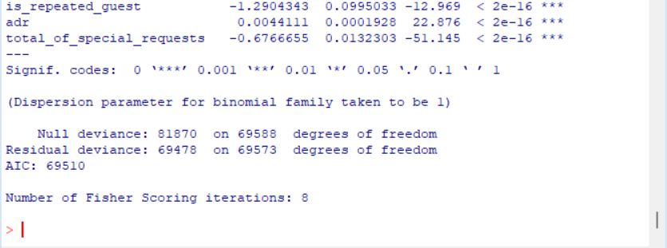
Figure 7.2. Continuation of the Model 2 logistic-regression output.

8. Model Coefficient Interpretation
Logistic-regression coefficients are expressed in log-odds. Exponentiating a coefficient converts it to an odds multiplier. The following selected interpretations are calculated directly from the coefficient estimates shown in the supplied R output. For numerical predictors, the odds multiplier applies to a one-unit increase while holding the other included predictors constant. For categorical predictors, the multiplier is relative to the omitted reference category.
Predictor | Coefficient | exp(Coefficient) | Data-based interpretation
lead_time | 0.0054123 | 1.0054 | A one-day increase corresponds to about 0.54% higher modeled odds of cancellation, holding other variables constant.
previous_cancellations | 0.9110915 | 2.4870 | Each additional previous cancellation is associated with about 2.49× the modeled odds of cancellation.
booking_changes | -0.3647656 | 0.6944 | Each additional booking change corresponds to a modeled odds multiplier of about 0.69.
deposit_type = Non Refund | 4.0404566 | 56.85 | Relative to the reference deposit category, the modeled odds multiplier is about 56.85.
is_repeated_guest | -1.2904343 | 0.2752 | A repeated-guest indicator of 1 corresponds to a modeled odds multiplier of about 0.28 relative to 0.
adr | 0.0044111 | 1.0044 | A one-unit increase in ADR corresponds to about 0.44% higher modeled odds, holding other variables constant.
total_of_special_requests | -0.6766655 | 0.5083 | Each additional special request corresponds to a modeled odds multiplier of about 0.51.

These coefficient interpretations describe associations estimated by the fitted model. They should not be interpreted as proof that changing a predictor would causally change cancellation behavior.

9. Cross-Validation
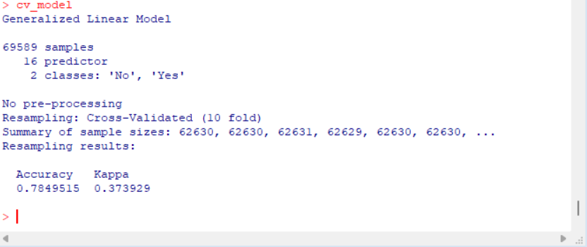
Figure 9.1. 10-fold cross-validation output from R.
Cross-Validation Result | Value
Resampling method | 10-fold cross-validation
Samples | 69,589
Predictors | 16
Classes | No, Yes
Accuracy | 0.7849515 (78.50%)
Kappa | 0.373929

The 10-fold cross-validation output reports accuracy of approximately 78.50%. This means that, averaged over the displayed resampling procedure, about 78.5% of evaluated classifications were correct. Kappa is approximately 0.374 and provides agreement information beyond class proportions alone.

10. Confusion Matrix and Classification Metrics
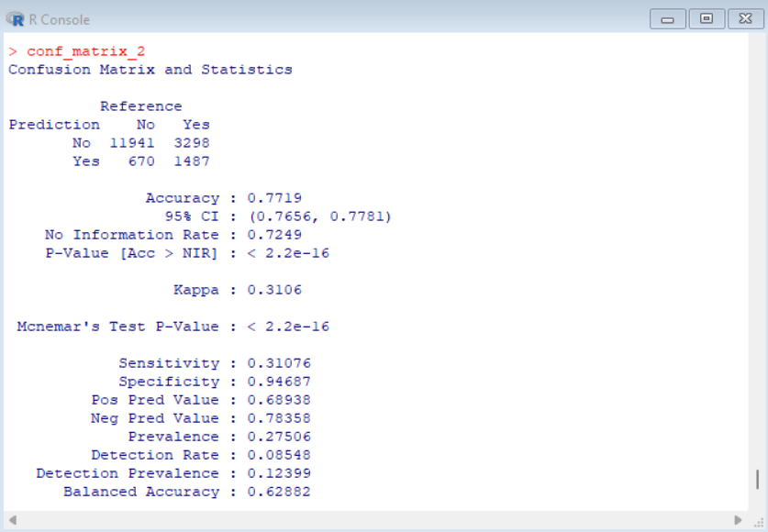
Figure 10.1. Model 2 confusion matrix and classification statistics.
The displayed confusion matrix is:
Prediction \ Reference | No | Yes
No | 11,941 | 3,298
Yes | 670 | 1,487

The matrix contains 17,396 evaluated cases: 11,941 true negatives, 1,487 true positives, 670 false positives, and 3,298 false negatives.
Metric | Value | Interpretation
Accuracy | 0.7719 (77.19%) | Overall proportion of correct classifications.
Sensitivity | 0.31076 (31.08%) | Share of actual Yes cases correctly detected.
Specificity | 0.94687 (94.69%) | Share of actual No cases correctly detected.
Positive Predictive Value | 0.68938 (68.94%) | Among predicted Yes cases, proportion that were actually Yes.
Negative Predictive Value | 0.78358 (78.36%) | Among predicted No cases, proportion that were actually No.
Balanced Accuracy | 0.62882 (62.88%) | Average of sensitivity and specificity.
Kappa | 0.3106 | Agreement beyond chance reported by the evaluation.

The most important performance observation is the difference between sensitivity and specificity. The classification rule correctly detects only 31.08% of actual cancellations but correctly identifies 94.69% of non-cancellations. Thus, the 77.19% accuracy should not be interpreted as equally strong performance for both classes. Balanced accuracy of 62.88% makes this class-level difference more visible.

11. ROC Curve and AUC Analysis

11.1 Model 1
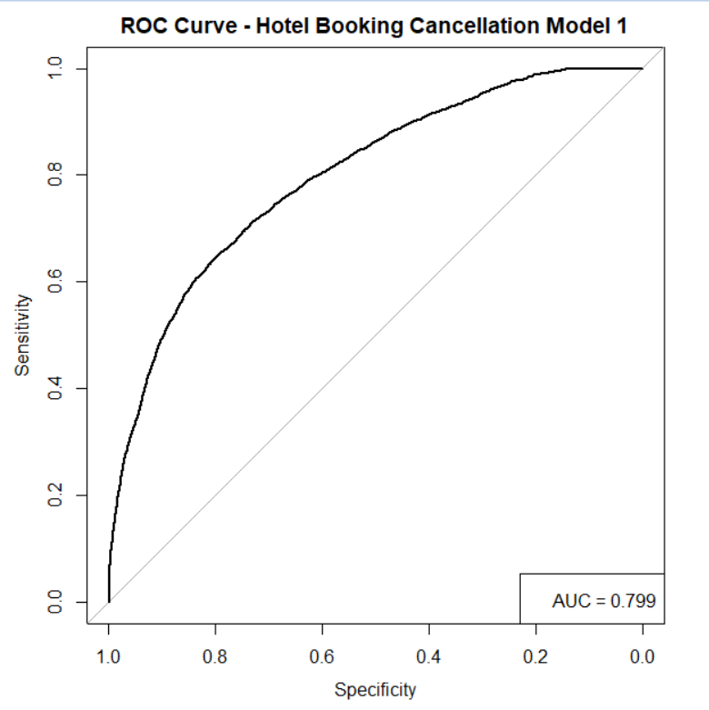
Figure 11.1. ROC curve for Hotel Booking Cancellation Model 1. AUC = 0.799.
Model 1 reports an AUC of 0.799. The ROC curve is above the diagonal reference line, showing that its predicted scores contain useful information for ranking the two cancellation classes across thresholds.

11.2 Model 2
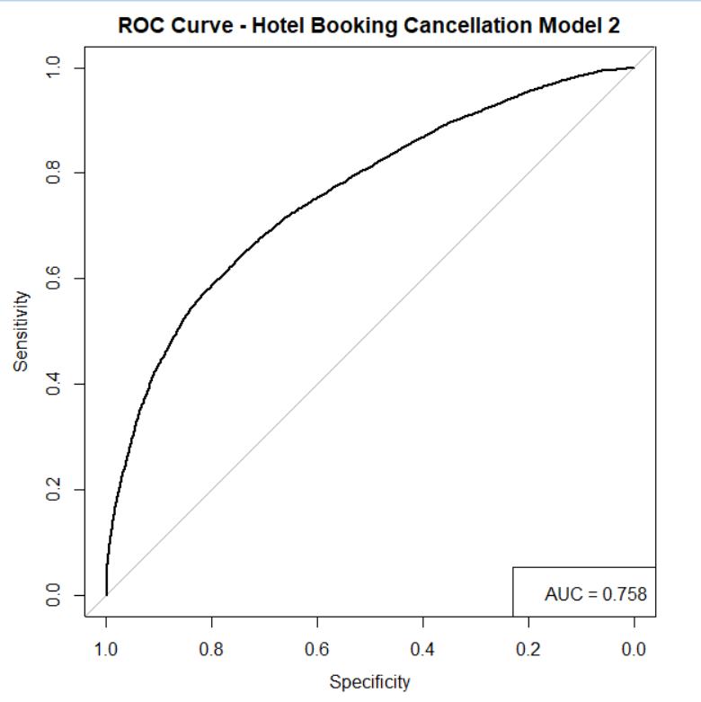
Figure 11.2. ROC curve for Hotel Booking Cancellation Model 2. AUC = 0.758.
Model 2 reports an AUC of 0.758. Its curve is also above the diagonal reference line, indicating useful class-discrimination information.

11.3 AUC Comparison
Model | AUC | AIC | Degrees of Freedom
Model 1 | 0.799 | 65,255.29 | 26
Model 2 | 0.758 | 69,510.07 | 16

The supplied ROC outputs show a higher AUC for Model 1 than Model 2, a difference of 0.041 AUC points. AUC evaluates ranking performance across thresholds; it does not replace the confusion matrix because the confusion matrix evaluates a specific classification rule.

12. Model Diagnostics
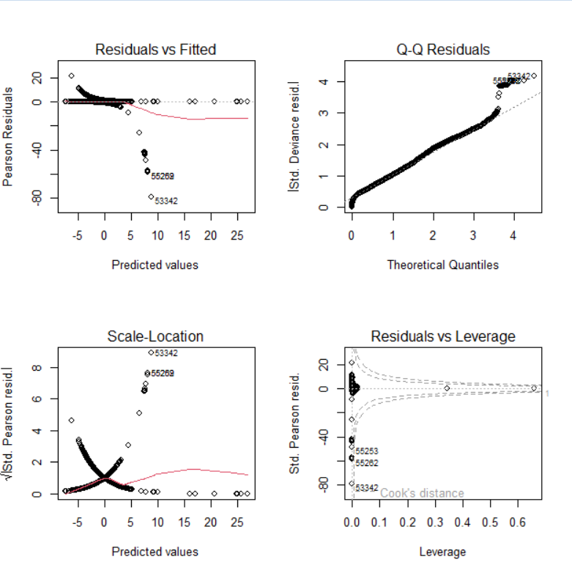
Figure 12.1. Diagnostic plots for the fitted logistic-regression model.

12.1 Residuals vs Fitted
The Residuals vs Fitted panel is not perfectly flat around zero and contains several observations with large negative residuals. This indicates that some observations are not represented equally well by the fitted relationship.

12.2 Q-Q Residuals
The Q-Q residual plot departs from the reference pattern in the upper tail. Several observations have relatively large residual magnitudes and should be investigated as potential unusual or influential observations.

12.3 Scale-Location
The Scale-Location panel shows changing spread across fitted values and several comparatively large standardized residual magnitudes. Model behavior is therefore not perfectly uniform across fitted values.

12.4 Residuals vs Leverage
The Residuals vs Leverage panel highlights observations that deserve additional review because they combine residual size and leverage information. The appropriate next step is record-level investigation and sensitivity analysis rather than automatic deletion.

13. Model Comparison Using AIC
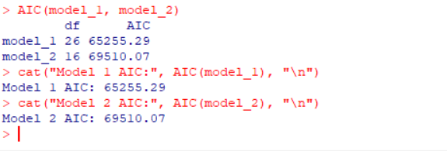
Figure 13.1. R output comparing AIC values for Model 1 and Model 2.
The AIC comparison reports 65,255.29 for Model 1 and 69,510.07 for Model 2. The numerical difference is 4,254.78 AIC points. For models fitted to the same data under the same likelihood framework, lower AIC represents the preferred fit-complexity trade-off under the AIC criterion.
The AIC result and the AUC result point in the same direction in the supplied outputs: Model 1 has both the lower AIC and the higher AUC. However, model selection should also consider interpretability, resampling stability, class-specific performance, and intended use.

14. Integrated Findings and Original Data-Based Insights
This section translates the statistical outputs into concrete findings rather than only repeating the R console results.
Lead-time gradient: The cancellation rate increases from 16.37% for 0–30 day bookings to 39.57% for 181+ day bookings. This is a 23.20 percentage-point increase across the displayed categories and is consistent with the highly significant chi-square result.
Statistical association: The chi-square result (X² = 2,991, df = 3, p < 2.2e-16) indicates that the observed distribution of cancellations differs across lead-time groups in the training data.
Class imbalance: The confusion-matrix output reports prevalence of 27.506% for the Yes class. The model therefore faces fewer cancellation cases than non-cancellation cases.
Accuracy versus sensitivity: Model 2 accuracy is 77.19%, but sensitivity is only 31.08%. This means that a substantial share of actual cancellations are classified as No at the evaluated threshold.
High specificity: Specificity of 94.69% shows that the same classification rule is much more successful at identifying non-canceled bookings.
Cross-validation consistency: The 10-fold cross-validation accuracy is 78.50%, close to the 77.19% confusion-matrix accuracy. The two figures come from different evaluation procedures, so they should not be treated as identical estimates.
Model discrimination: Model 1 AUC is 0.799 versus 0.758 for Model 2. The difference of 0.041 indicates that Model 1 ranked the two classes more effectively in the supplied ROC evaluation.
Model complexity and fit: Model 1 has 26 degrees of freedom and AIC 65,255.29, whereas Model 2 has 16 degrees of freedom and AIC 69,510.07. The AIC criterion therefore favors Model 1 among these two specifications.
Predictor associations: In Model 2, previous cancellations has a positive coefficient (0.9111), while repeated-guest status and special requests have negative coefficients (-1.2904 and -0.6767). These are conditional model associations, not causal effects.
Diagnostic evidence: The residual and leverage plots show several unusual observations and departures from ideal reference patterns. This supports further investigation of influential observations and alternative model specifications.

14.1 Additional Derived Calculations
Calculation | Result | Meaning
181+ day rate − 0–30 day rate | 39.57% − 16.37% = 23.20 pp | Absolute increase across displayed lead-time groups.
Model 2 specificity − sensitivity | 94.69% − 31.08% = 63.61 pp | Specificity exceeds sensitivity by about 63.61 percentage points.
Model 1 AUC − Model 2 AUC | 0.799 − 0.758 = 0.041 | Difference in ROC discrimination.
Model 2 AIC − Model 1 AIC | 69,510.07 − 65,255.29 = 4,254.78 | AIC difference; lower is preferred under the AIC criterion for comparable models.
Cross-validation vs confusion-matrix accuracy | 78.50% vs 77.19% | Difference of about 1.31 percentage points between the two reported accuracy measures.

15. Strengths, Limitations and Potential Improvements

15.1 Strengths
- Combines statistical inference and predictive modeling rather than relying on one analytical method.
- Uses an explicit hypothesis and a reproducible Pearson chi-square test.
- Uses binary logistic regression appropriate to the two-class cancellation target.
- Includes 10-fold cross-validation, confusion-matrix statistics, ROC/AUC evaluation, residual diagnostics, and AIC comparison.
- Uses actual numerical results and derived calculations to explain model behavior.

15.2 Limitations
- Sensitivity for the Yes cancellation class is substantially lower than specificity at the evaluated classification threshold.
- The lead-time and ADR distributions are strongly right-skewed.
- Diagnostic plots contain unusual residuals and possible influential observations.
- The supplied evidence does not include calibration curves, threshold optimization, or external validation.
- The chi-square test demonstrates association, not causation.
- Model coefficients are conditional associations and should not be interpreted as causal effects.

15.3 Potential Improvements
- Tune the classification threshold according to the business cost of missed cancellations versus false alarms.
- Evaluate class-imbalance strategies if the objective is to improve cancellation detection.
- Examine nonlinear effects for strongly skewed predictors such as lead time and ADR.
- Test theoretically justified interaction terms.
- Investigate observations with large residuals or leverage values and verify their data quality.
- Add calibration analysis so predicted probabilities can be assessed, not only class labels.
- Compare logistic regression with alternative classifiers such as decision trees, random forests, or gradient boosting.
- Use a clearly separated holdout set or external validation data for a stronger estimate of generalization.

16. Conclusion
The Week 3 analysis completed the requested statistical and predictive workflow for hotel booking cancellations using R. The hypothesis test found a statistically significant association between lead-time category and cancellation status, with cancellation rates rising from 16.37% in the 0–30 day group to 39.57% in the 181+ day group. The Pearson chi-square test returned X² = 2,991, df = 3, and p < 2.2e-16.
The predictive analysis evaluated two logistic-regression models. Model 1 produced AUC = 0.799 and AIC = 65,255.29, while Model 2 produced AUC = 0.758 and AIC = 69,510.07. The 10-fold cross-validation output reported 78.50% accuracy and Kappa = 0.374. The Model 2 confusion matrix reported 77.19% accuracy, 31.08% sensitivity, 94.69% specificity, and 62.88% balanced accuracy.
The combined evidence shows why multiple evaluation metrics are necessary. The model can identify non-canceled bookings with high specificity, but it misses a substantial portion of actual cancellations at the evaluated threshold. The diagnostic plots also identify areas for further investigation. Future work should focus on threshold optimization, class-imbalance handling, nonlinear and interaction effects, calibration, and validation on held-out data.

Appendix A – Key R Code
# Hypothesis test
leadtime_table <- table(train_data$lead_time_group,
train_data$is_canceled)
chi_test <- chisq.test(leadtime_table)
chi_test
# Model 2
model_2 <- glm(
is_canceled ~ lead_time + previous_cancellations +
booking_changes + deposit_type + market_segment +
is_repeated_guest + adr + total_of_special_requests,
data = train_data,
family = binomial
)
summary(model_2)
# 10-fold cross-validation
cv_model
# Confusion matrix
conf_matrix_2
# AIC comparison
AIC(model_1, model_2)

Appendix B – Figure List
- Figure 5.1 – Distribution of Lead Time
- Figure 5.2 – Distribution of Average Daily Rate
- Figure 6.1 – Pearson Chi-Square Test Output
- Figure 7.1 – Model 2 Logistic-Regression Coefficient Output
- Figure 7.2 – Continuation of Model 2 Logistic-Regression Output
- Figure 9.1 – 10-Fold Cross-Validation Output
- Figure 10.1 – Model 2 Confusion Matrix and Classification Statistics
- Figure 11.1 – Model 1 ROC Curve
- Figure 11.2 – Model 2 ROC Curve
- Figure 12.1 – Logistic-Regression Diagnostic Plots
- Figure 13.1 – AIC Model Comparison

Appendix C – Submission Checklist
- DOC/DOCX report completed and updated.
- Dataset and target variable documented.
- Research question and hypotheses clearly stated.
- Actual contingency-table values included.
- Chi-square result and interpretation included.
- Logistic regression model specification included.
- Selected coefficient estimates converted to odds multipliers.
- 10-fold cross-validation documented.
- Confusion matrix and class-specific metrics documented.
- Model 1 and Model 2 ROC/AUC results documented.
- Residual and leverage diagnostics documented.
- AIC comparison documented.
- Specific numerical insights and derived calculations included.
- Strengths, limitations, and future improvements included.
- R code excerpts included.
- All major R output figures included.

