WEEK 1 – DATA CLEANING AND PRELIMINARY ANALYSIS

Dataset: Hotel Booking Demand
Tool: R / RGui
Programming Language: R
Task: Data Cleaning and Preliminary Analysis
Prepared By: Nikhil Wadkar
Submission: Week 1 Internship Task

1. Introduction
The objective of this project is to perform data cleaning, preprocessing, and preliminary exploratory analysis using R. The Hotel Booking Demand dataset was selected because it contains a combination of numerical and categorical variables along with missing values, duplicate records, invalid values, and potential outliers.
The analysis focuses on understanding the structure of the dataset, identifying and handling data quality issues, detecting outliers, normalizing numerical variables, encoding categorical variables, generating descriptive statistics, performing correlation analysis, and creating exploratory visualizations.
The cleaned dataset is then exported for further analysis and reporting.

2. Dataset Overview

The selected dataset is the Hotel Booking Demand dataset. It contains hotel reservation information such as hotel type, cancellation status, lead time, arrival date, number of guests, length of stay, market segment, room type, booking changes, deposit type, customer type, average daily rate (ADR), and reservation status.
The dataset contains both numerical and categorical variables, making it suitable for demonstrating data cleaning and preliminary analysis techniques in R.

Property | Value
Dataset | Hotel Booking Demand
Initial Rows | 119,390
Initial Columns | 32
Cleaned Rows | 86,985
Cleaned Columns | 36
Tool | R / RGui

3. Dataset Selection

The Hotel Booking Demand dataset was selected because it satisfies the requirements of the task. It contains numerical variables such as lead time, adults, children, babies, ADR, and number of nights, as well as categorical variables such as hotel, meal, country, market segment, distribution channel, room type, deposit type, and customer type.
The dataset also contains missing values, duplicate records, invalid values, and potential outliers, making it appropriate for demonstrating a complete data-cleaning workflow.
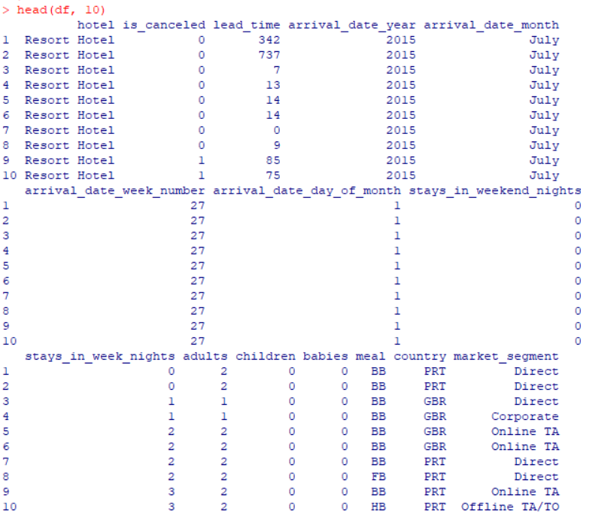

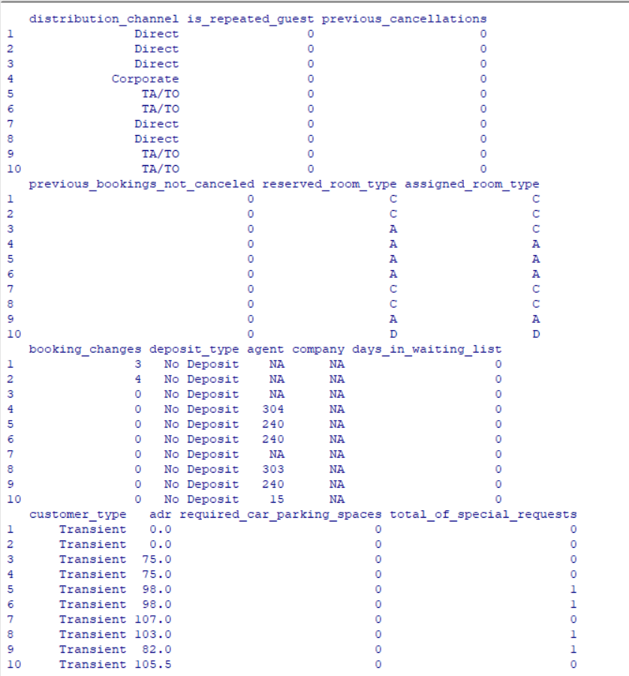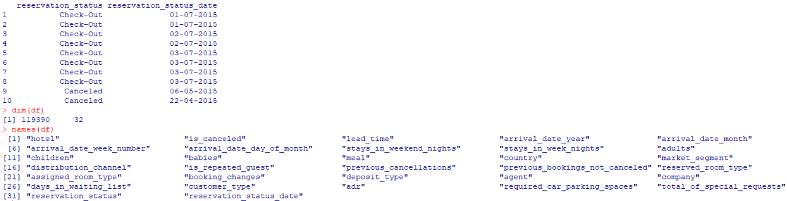

4. Loading the Dataset
R code:
df <- read.csv (
"data/raw/hotel_bookings.csv",
stringsAsFactors = FALSE,
na. strings = c ("", "NA", "NULL")
)

The dataset was imported into R using read.csv (). Empty strings and common missing-value representations were converted to NA so that missing values could be identified and handled consistently.

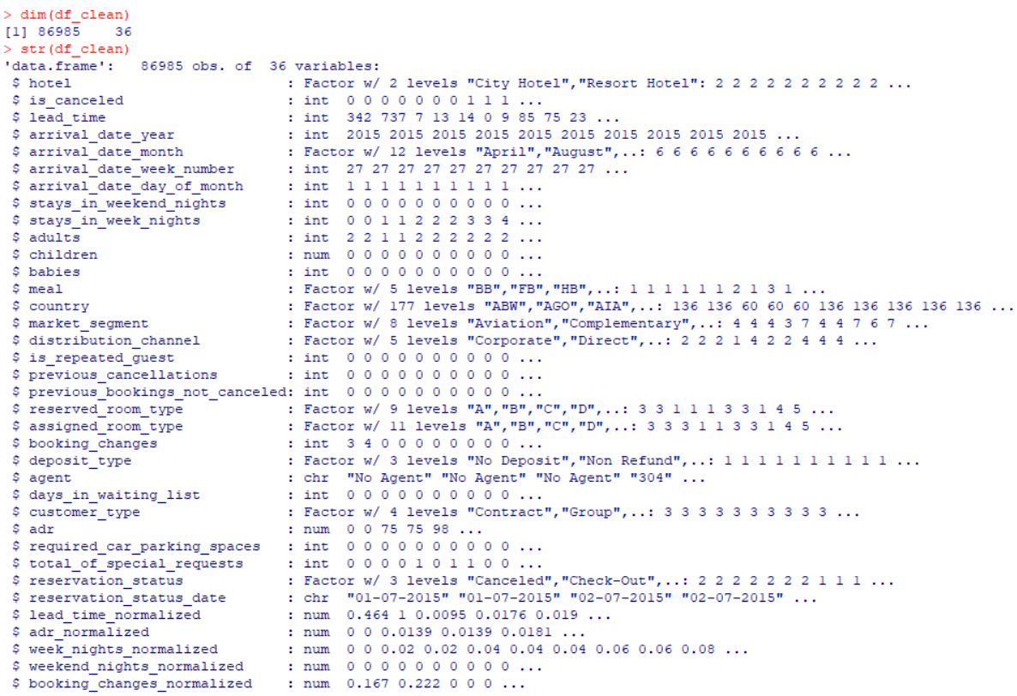

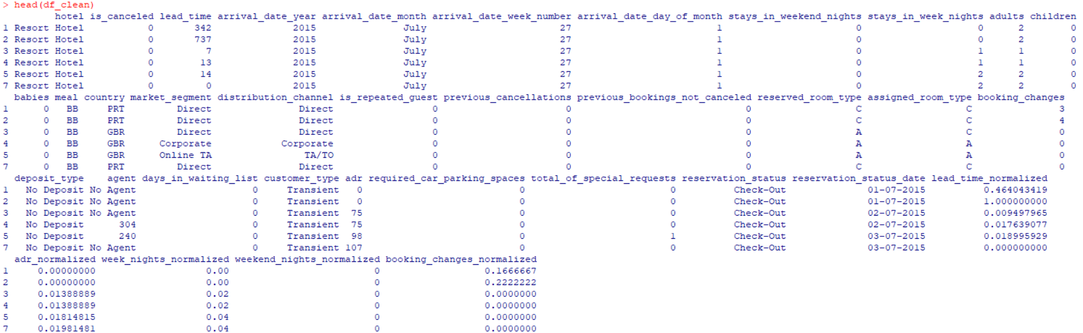

5. Initial Data Inspection
R code:
dim(df)
names(df)
str(df)
summary(df)
head(df)
TABLE:
Inspection Function | Purpose
dim () | Determines number of rows and columns
names () | Displays variable names
str () | Shows variable structure and data types
summary () | Provides descriptive statistics
head () | Displays the first observations

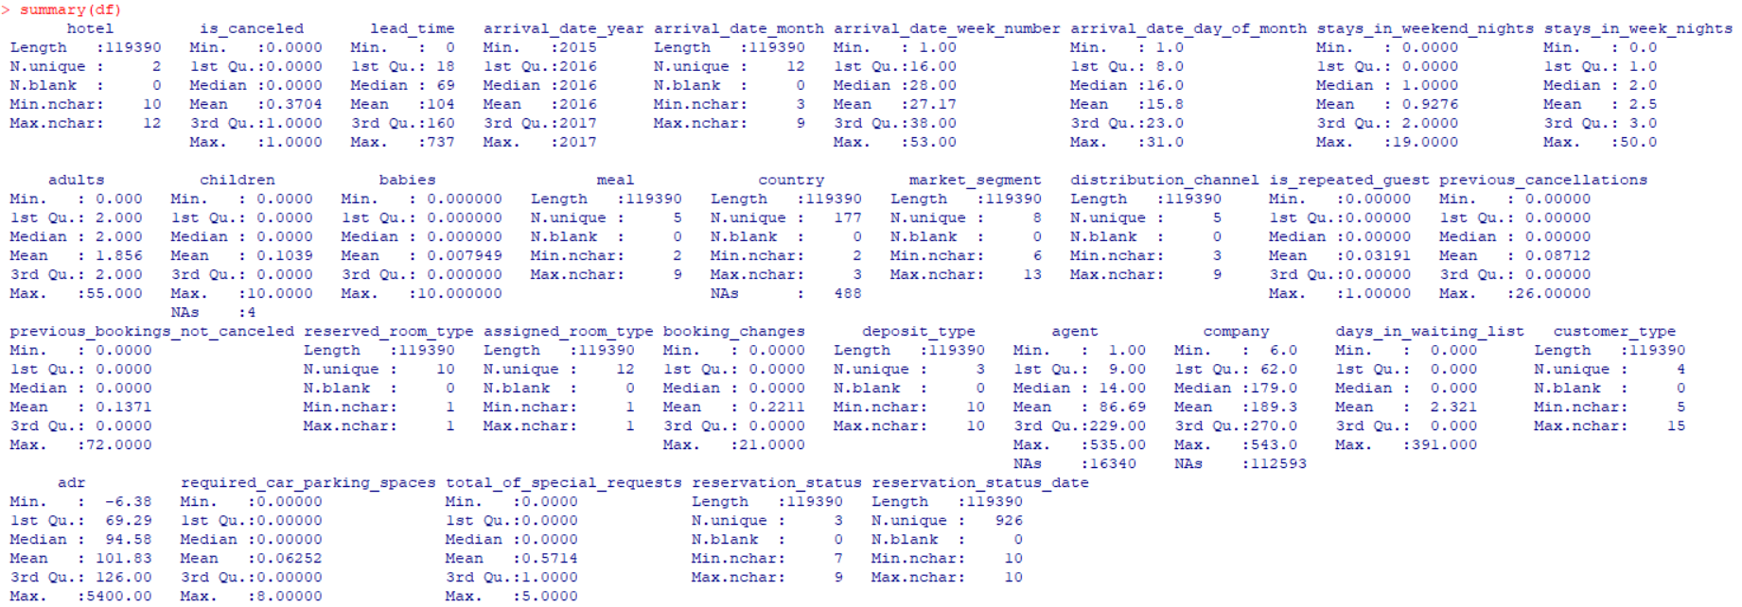
6. Missing Value Analysis
R code:
missing_summary <- data. frame (
Variable = names(df),
Missing_Count = sapply (df, function(x) sum(is.na(x))),
Missing_Percentage = sapply (
df,
function(x) mean(is.na(x)) * 100
)
)

missing_summary <- missing_summary [
order(-missing_summary$Missing_Count),
]

print(missing_summary)

The missing-value analysis identified four variables containing missing observations. The company variable had the highest proportion of missing values, followed by agent. The country and children variables contained comparatively few missing observations.

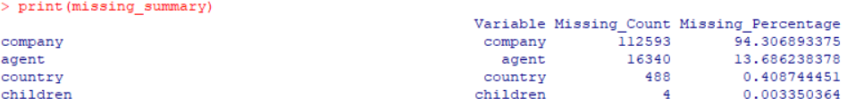

7. Duplicate Detection
R code:

Duplicate_count <- sum(duplicated(df))
Duplicate_percentage <-
(duplicate_count / nrow(df)) * 100
cat (
"Number of duplicate rows:",
duplicate_count,
"\n"
)
cat (
"Percentage of duplicate rows:",
round (duplicate_percentage, 2),
"%\n"
)
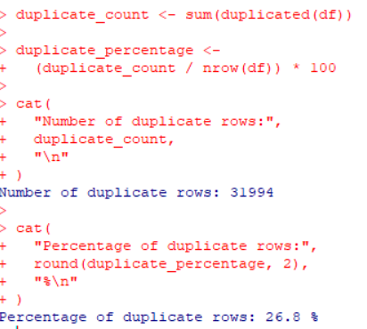

A total of 31,994 duplicate records were identified, representing approximately 26.8% of the original dataset. These duplicate records were removed during the cleaning process.
8. Duplicate Removal
R code:

df_clean <- df[!duplicated(df), ]

dim(df_clean)

OUTPUT:-

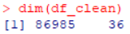

9. Missing Value Treatment
Table:-

Variable | Treatment
company | Removed
agent | Replaced with 0
country | Replaced with mode PRT
children | Replaced with median

Different missing-value treatment methods were selected according to the nature of each variable. The company variable contained an extremely high proportion of missing values and was therefore removed. Missing values in agent were replaced with 0 to represent the absence of an assigned agent. Missing country values were replaced using the mode, which was PRT. Missing children values were replaced using the median.

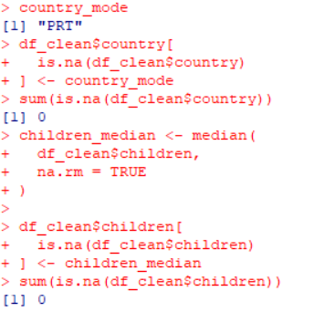
10. Invalid Value Detection

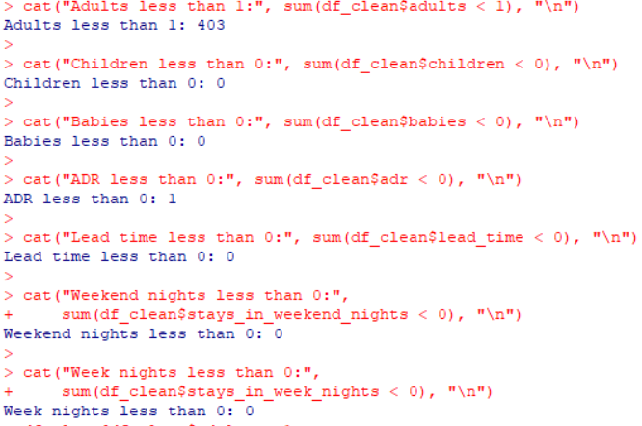

11. Invalid Value Detection and Review

Invalid values were checked in the cleaned dataset to identify logically incorrect records. The analysis examined records with fewer than one adult, negative ADR values, and related guest-count fields. The results showed 403 records with fewer than one adult and one record with a negative ADR. These records were reviewed before applying the data-cleaning rules.
After duplicate removal, additional records containing logically invalid values were handled according to the defined data-cleaning rules, resulting in the final cleaned dataset used for analysis.

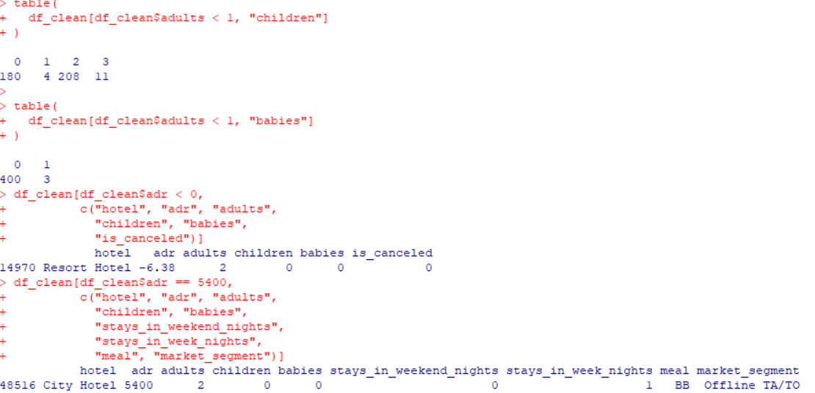
Figure 11: Verification of invalid values in the cleaned dataset
12. Outlier Detection

Outliers were identified using the Interquartile Range (IQR) method. The IQR method identifies observations below Q1 − 1.5 × IQR or above Q3 + 1.5 × IQR as potential outliers.

OUTPUT :-

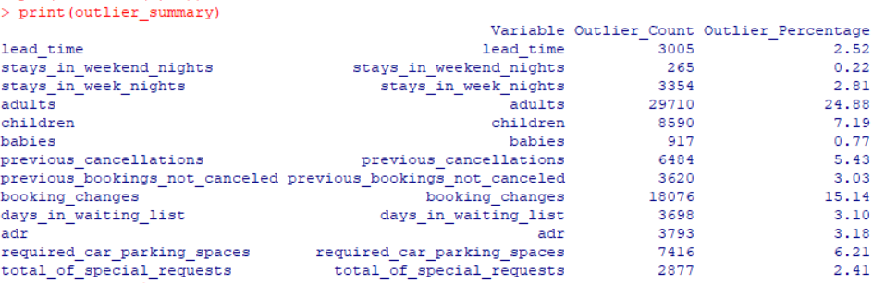

13. Outlier Visualization

Boxplots were generated for selected numerical variables to visually identify potential outliers. The visualization includes Lead Time, Average Daily Rate, Week Night Stays, Weekend Night Stays, Booking Changes, and Total Special Requests. Values appearing beyond the whiskers represent potential extreme observations according to the boxplot method.

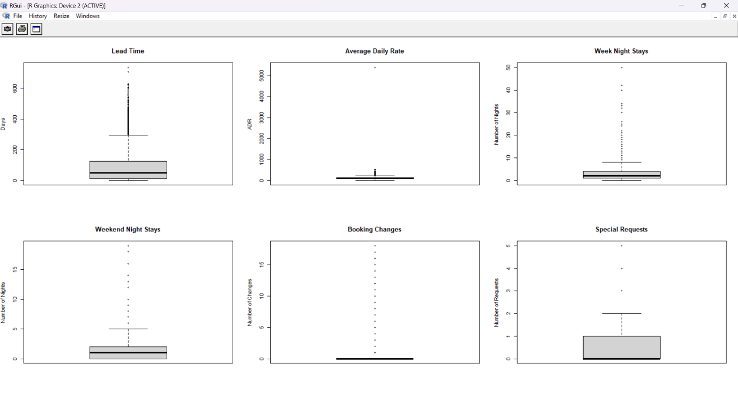

14. Data Normalization

Min-Max normalization was applied to selected numerical variables to transform their values to a common scale between 0 and 1. This transformation is useful when variables have substantially different ranges.

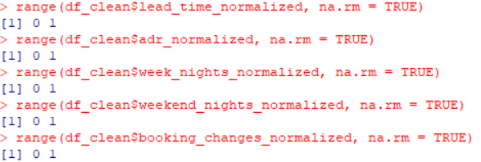

15. Categorical Encoding

Categorical variables were converted into factor variables and encoded to make them suitable for statistical analysis and subsequent analytical workflows.

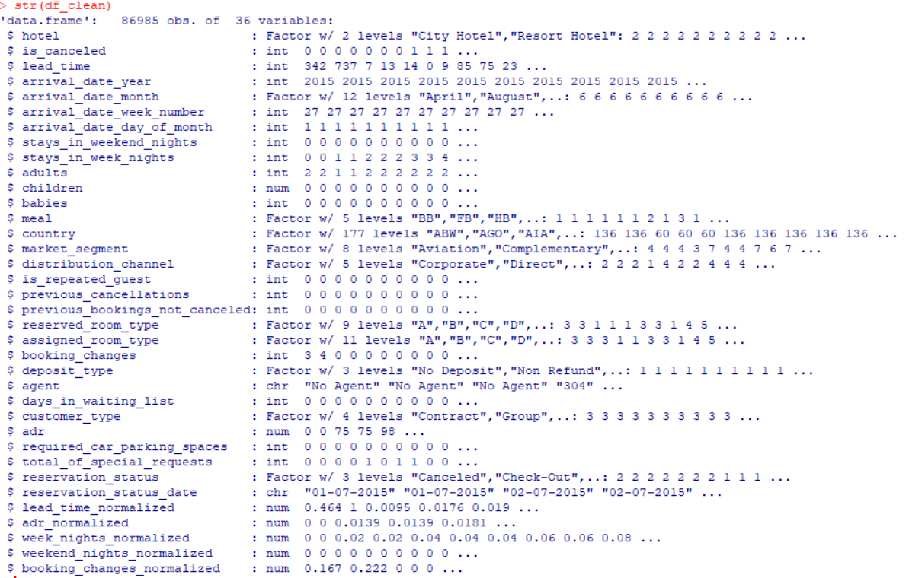

16. Descriptive Statistics
Descriptive statistics were generated to understand the central tendency, spread, and range of numerical variables. Variables such as lead time, ADR, number of adults, children, and length of stay were examined using minimum, first quartile, median, mean, third quartile, and maximum values.

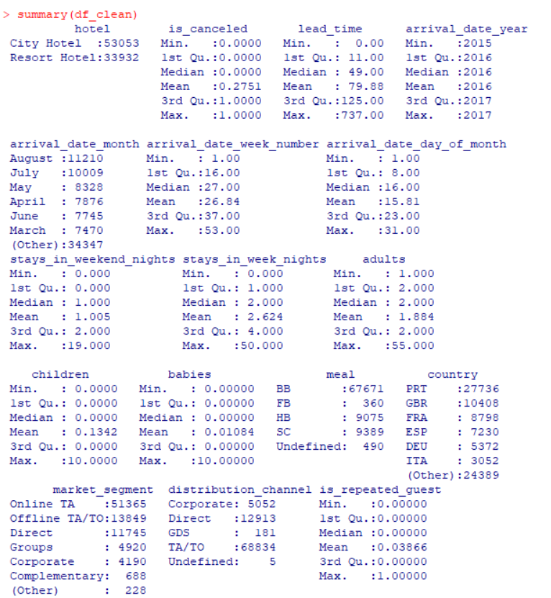

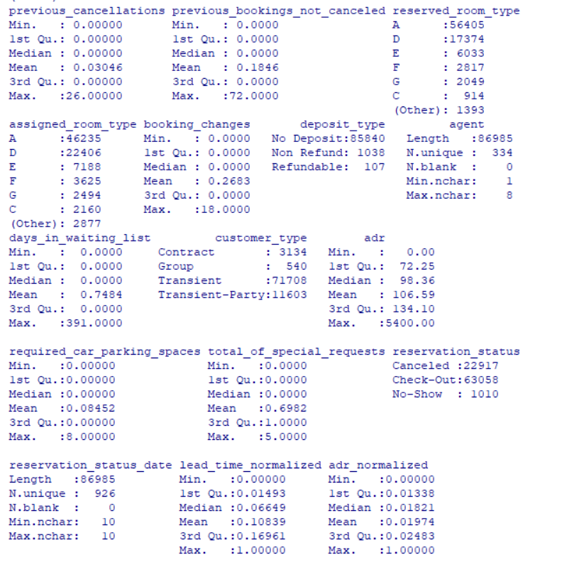

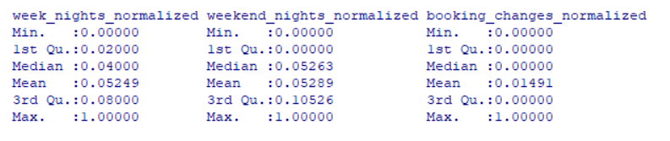

17. Correlation Analysis
Correlation analysis was performed to examine the relationships among selected numerical variables. Pearson correlation coefficients were calculated using pairwise complete observations.

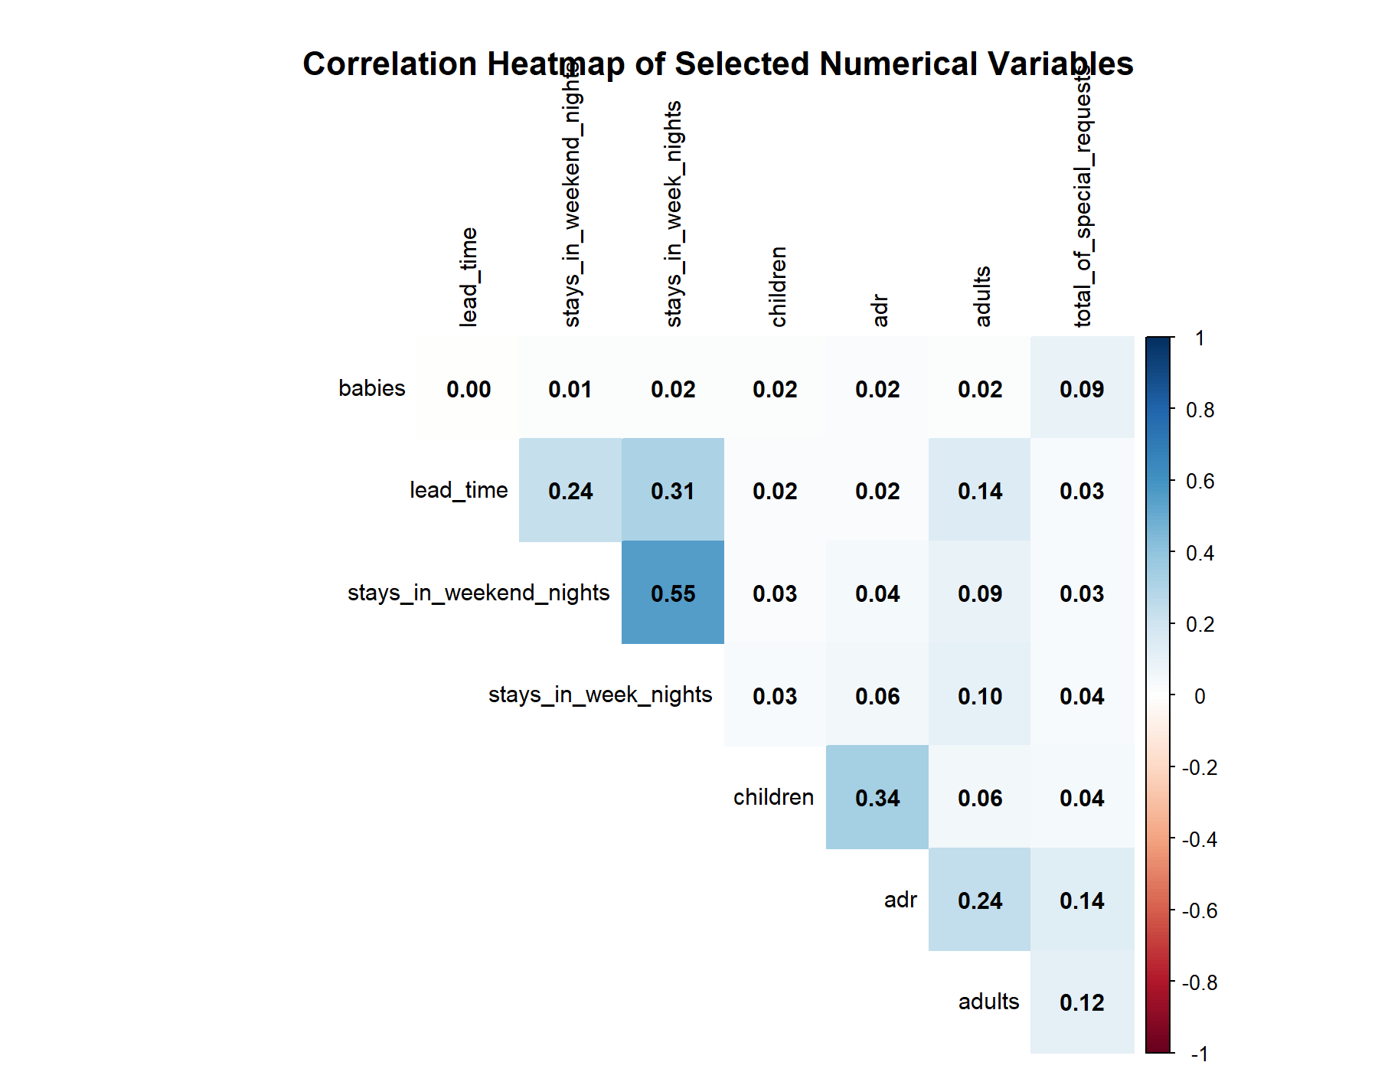

The heatmap indicates that most numerical variables have weak correlations. A relatively stronger positive correlation is observed between weekend-night stays and week-night stays (r = 0.55). A moderate positive correlation is also observed between children and ADR (r = 0.34). The remaining relationships are generally weak.

18. Exploratory Data Visualization

Exploratory visualizations were created to understand the distribution and patterns present in the cleaned Hotel Booking Demand dataset. Bar charts were used for categorical variables such as cancellation status, hotel type, arrival month, and market segment, while histograms were used to examine numerical variables such as lead time and average daily rate (ADR). These visualizations provide an initial understanding of booking patterns, variable distributions, and potential differences across categories.

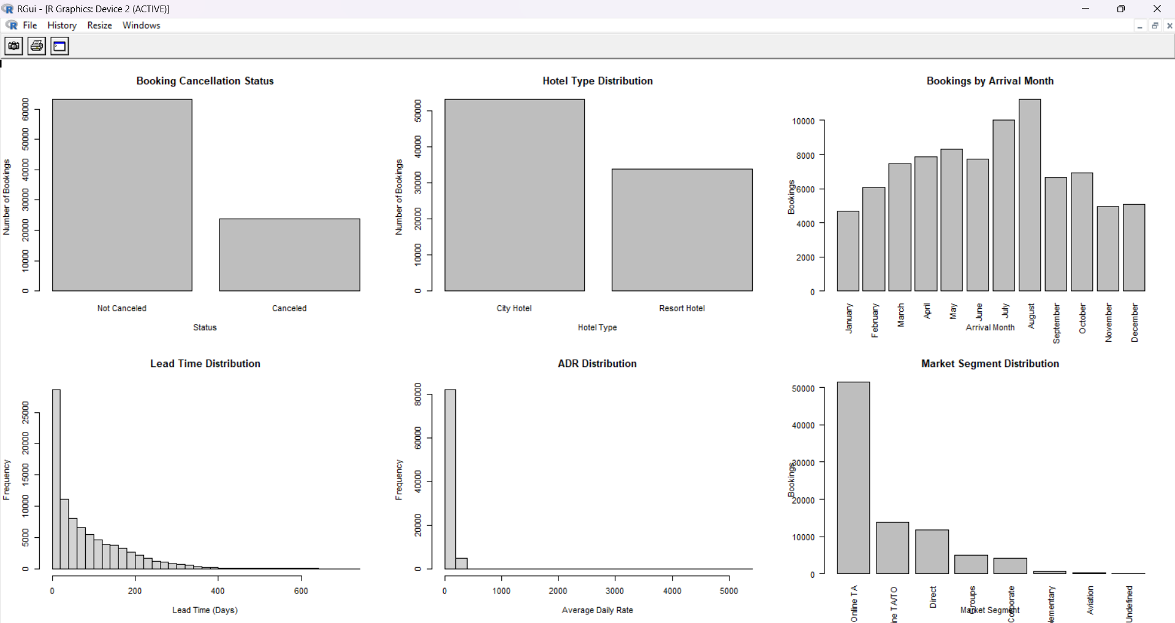
19. Initial Insights

The initial analysis of the cleaned dataset showed that there were 86,985 hotel bookings. The overall booking cancellation rate was 27.51%. The average lead time was 79.88 days, indicating that bookings were generally made several weeks before arrival. The average daily rate (ADR) was 106.59, while the average length of stay was 3.63 nights. Customers made an average of 0.70 special requests per booking.

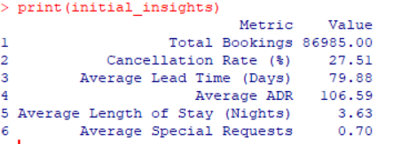

Figure: Initial insights summary generated from the cleaned dataset

20. Export of Clean Dataset
R CODE:-

write.csv(
df_clean,
"data/processed/hotel_bookings_clean.csv",
row.names = FALSE
)

After completing the cleaning and preprocessing operations, the cleaned dataset was exported as a CSV file for future analysis and reuse.

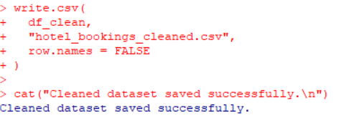

21. Conclusion

The Week 1 analysis successfully demonstrated a complete data-cleaning and preliminary-analysis workflow using R. The Hotel Booking Demand dataset was inspected, missing values and duplicate records were identified, invalid values were investigated, outliers were detected using the IQR method, numerical variables were normalized, and categorical variables were prepared for analysis.
Exploratory analysis and descriptive statistics provided an initial understanding of booking patterns and variable distributions. The final cleaned dataset was exported for further analytical work.
This process provides a reliable foundation for more advanced exploratory analysis and visualization in subsequent stages.

