WEEK 4 FINAL REPORT
Comprehensive Data Analysis Reporting and Presentation
Hotel Booking Demand Dataset
Integrated Data Cleaning • Visualization • Statistical Analysis • Predictive Modeling

Prepared by: Nikhil Wadkar
B.Sc. IT Graduate | Data Analytics
R Data Analyst Internship

Table of Contents
- Executive Summary
- Objectives and Analytical Questions
- Dataset Overview
- End-to-End Methodology
- Week 1 – Data Cleaning and Preliminary Analysis
- Week 2 – Data Visualization and Insight Communication
- Week 3 – Statistical Analysis and Predictive Modeling
- Integrated Findings and Discussion
- Business and Analytical Implications
- Challenges Encountered
- Lessons Learned
- Limitations
- Future Scope and Recommendations
- Conclusion
- Key R Code Excerpts

1. Executive Summary
This final report integrates the three completed analytical stages of the R Data Analyst internship using the Hotel Booking Demand dataset. Week 1 established the data-quality foundation, Week 2 communicated descriptive patterns through visualizations, and Week 3 applied statistical testing and predictive modeling. Week 4 consolidates these outputs into one coherent report.
The Week 1 report documented an original dataset of 119,390 observations and 32 variables, with a documented cleaned dataset of 86,985 bookings and 36 columns. The cleaning workflow covered missing values, duplicate detection and removal, invalid-value checks, outlier analysis, normalization, categorical preparation, descriptive statistics, and correlation analysis.
Week 2 produced ten visualizations examining booking status, hotel type, cancellation rates, ADR, lead time, market segment, and time trends. Week 3 reported a statistically significant association between lead-time group and cancellation status (X² = 2991, df = 3, p < 2.2e-16). The documented cross-validation accuracy was 0.7849515 with Kappa 0.373929; Model 1 AUC was 0.799 and Model 2 AUC was 0.758. Model 2 reported 77.19% accuracy, 31.08% sensitivity, 94.69% specificity, and 62.88% balanced accuracy.

2. Objectives and Analytical Questions

2.1 Objectives
- Clean and prepare the Hotel Booking Demand dataset in R.
- Identify missing values, duplicate records, invalid values, and potential outliers.
- Perform descriptive and exploratory statistical analysis.
- Create clear visualizations for technical and non-technical audiences.
- Test whether lead-time groups are associated with booking cancellation.
- Build and evaluate logistic-regression classification models.
- Integrate findings, limitations, lessons learned, and future directions.

2.2 Analytical Question
How do booking characteristics relate to cancellation status, and how effectively can selected booking variables support prediction of whether a reservation is canceled?

2.3 Hypotheses
Hypothesis | Statement
H₀ | Lead-time group and booking cancellation status are independent.
H₁ | Lead-time group and booking cancellation status are associated.

3. Dataset Overview
The Hotel Booking Demand dataset was selected because it contains mixed numerical and categorical reservation variables and supports a complete workflow from cleaning and visualization through statistical analysis and predictive modeling.
Item | Documented value
Original observations | 119,390
Original variables | 32
Documented cleaned observations | 86,985
Documented cleaned variables | 36
Target variable | is_canceled
Software | R

3.1 Key Variables
Variable | Role
hotel | Hotel type
is_canceled | Binary cancellation outcome
lead_time | Days between booking and arrival
arrival_date_month | Arrival month
adults | Number of adults
children | Number of children
adr | Average Daily Rate
market_segment | Booking market segment
deposit_type | Deposit category
previous_cancellations | Previous cancellation count
booking_changes | Number of booking changes
total_of_special_requests | Number of special requests

4. End-to-End Methodology
Stage | Main activities | Output
Week 1 | Inspection, missing values, duplicates, invalid values, outliers, normalization, categorical preparation | Clean dataset and preliminary findings
Week 2 | Bar charts, histograms, scatter plot, monthly/yearly trends | Ten explanatory visualizations
Week 3 | Contingency analysis, chi-square test, logistic regression | Statistical and predictive results
Evaluation | 10-fold cross-validation, confusion matrix, ROC/AUC, diagnostics, AIC | Model-performance evidence
Week 4 | Integration, discussion, limitations, future scope | Comprehensive final report

5. Week 1 – Data Cleaning and Preliminary Analysis

5.1 Data Inspection
The dataset was inspected using dimension, names, structure, summary, and missing-value checks to understand its size, variable types, and data-quality issues.

5.2 Missing-Value Treatment
Variable | Treatment
company | Removed due to extensive missingness
agent | Replaced with 0
country | Replaced with PRT
children | Replaced with median

5.3 Duplicate and Invalid Records
The Week 1 report identified 31,994 duplicate rows, approximately 26.8% of the original dataset, and removed duplicate records. Invalid-value checks identified 403 records with adults < 1 and one record with negative ADR.

5.4 Outliers, Normalization and Encoding
Visual evidence from the Week 1 analysis is included below to document the actual analytical outputs used in the internship workflow.

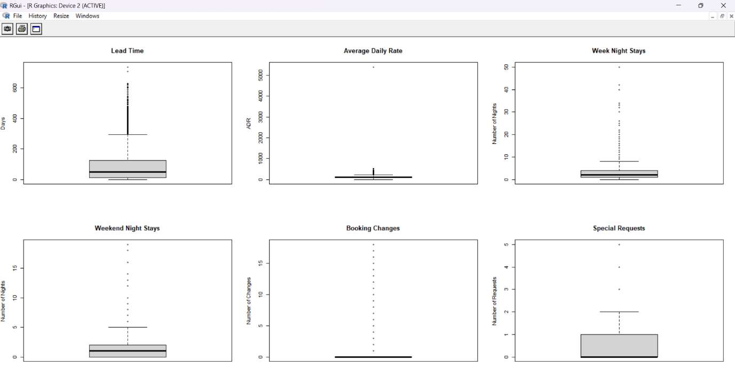
Figure 5.1: IQR-based outlier boxplots for selected numerical variables.

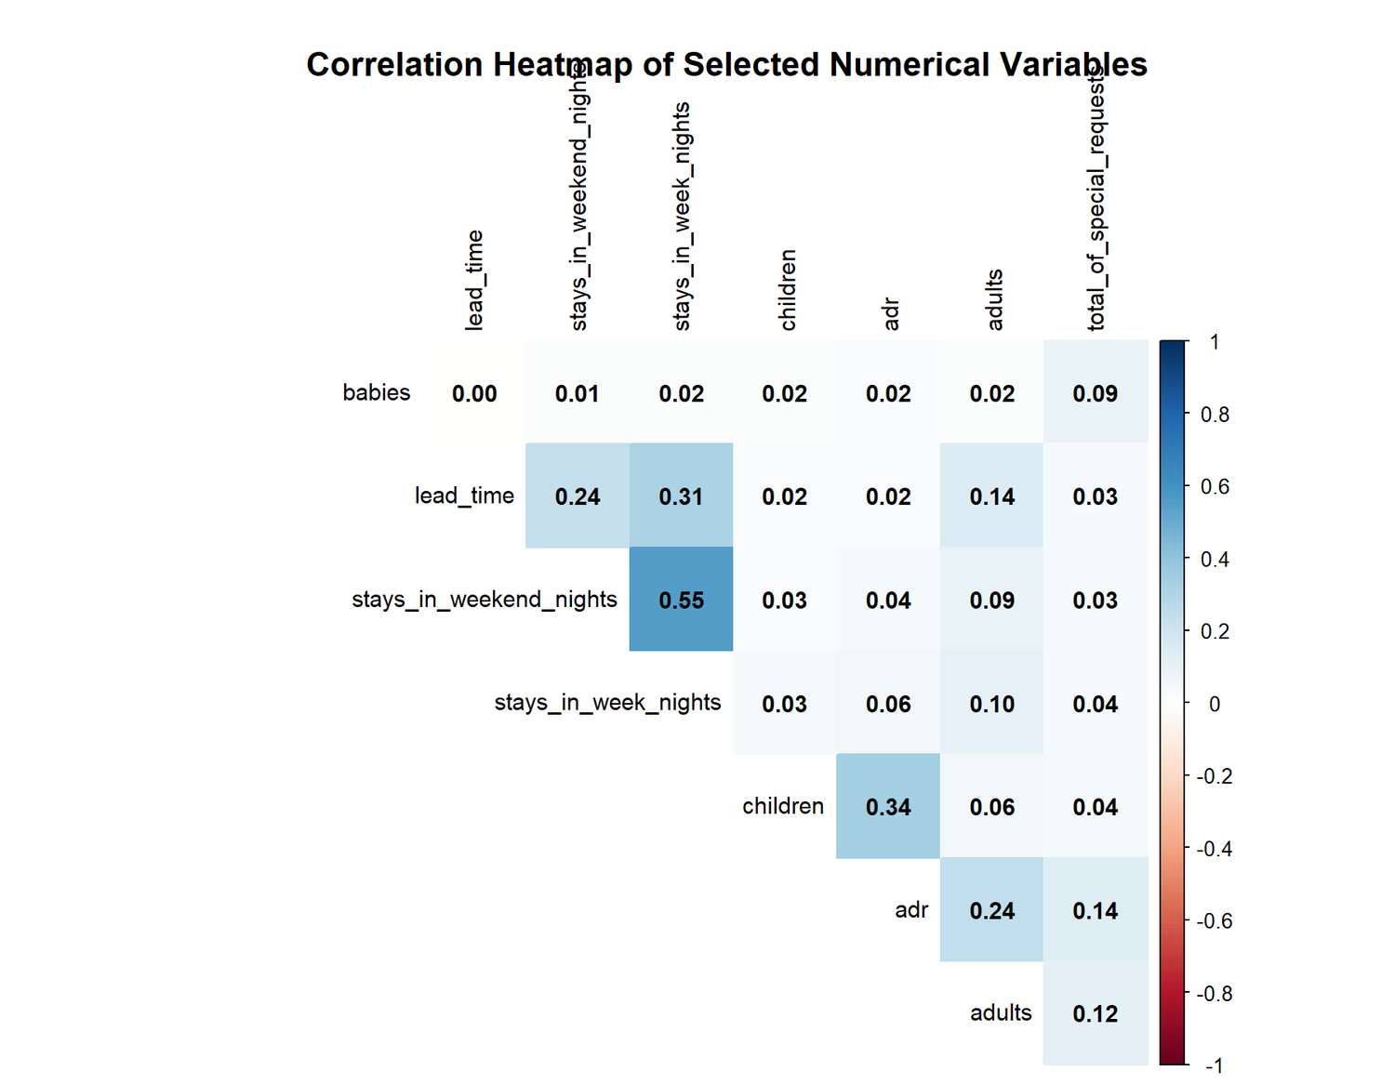
Figure 5.2: Correlation heatmap of selected numerical variables.

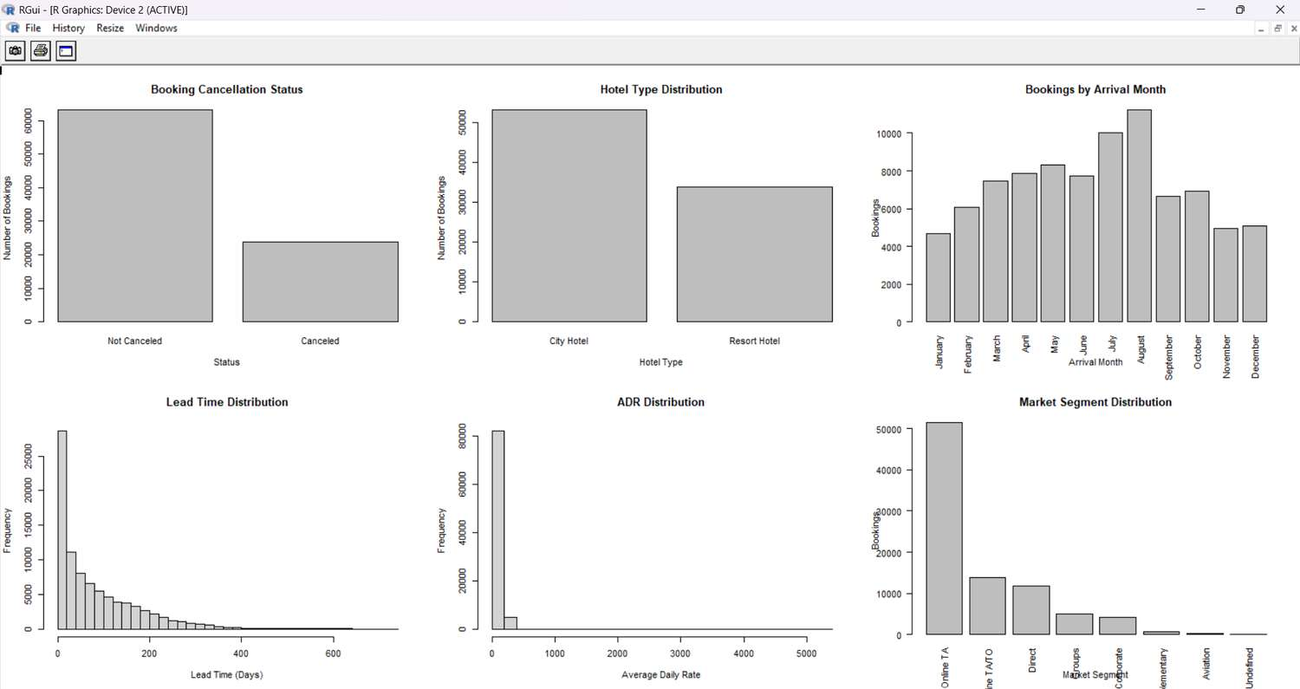
Figure 5.3: Exploratory visualizations from the cleaned dataset.

- IQR-based rules were used for potential outlier detection.
- Boxplots were generated for lead time, ADR, week-night stays, weekend-night stays, booking changes, and special requests.
- Selected numerical variables were normalized using Min-Max scaling to 0–1.
- Categorical variables were prepared as factors for analysis.

5.5 Preliminary Results
Measure | Documented result
Cleaned bookings | 86,985
Cancellation rate | 27.51%
Average lead time | 79.88 days
Average ADR | 106.59
Average length of stay | 3.63 nights
Average special requests | 0.70

The correlation analysis reported generally weak relationships. A relatively stronger positive correlation was observed between weekend-night and week-night stays (r = 0.55), while children and ADR showed a moderate positive relationship (r = 0.34).

6. Week 2 – Data Visualization and Insight Communication
Selected visualization outputs from the Week 2 report are embedded below. They provide direct visual evidence for the descriptive findings discussed in this final report.

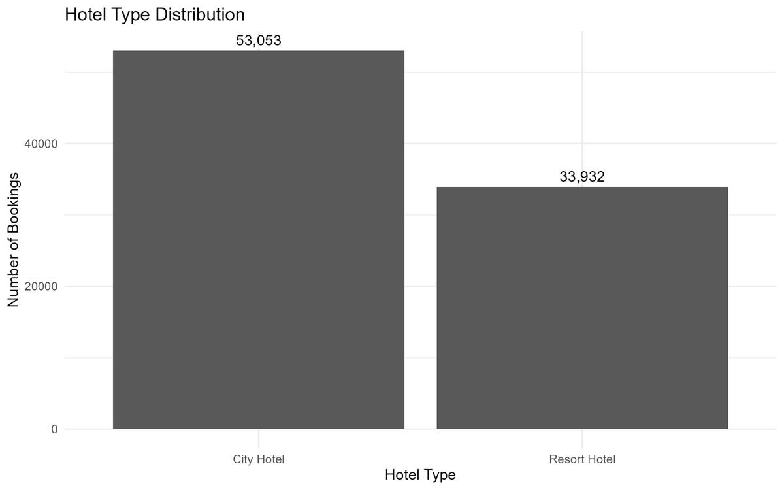
Figure 6.1: Hotel type distribution.

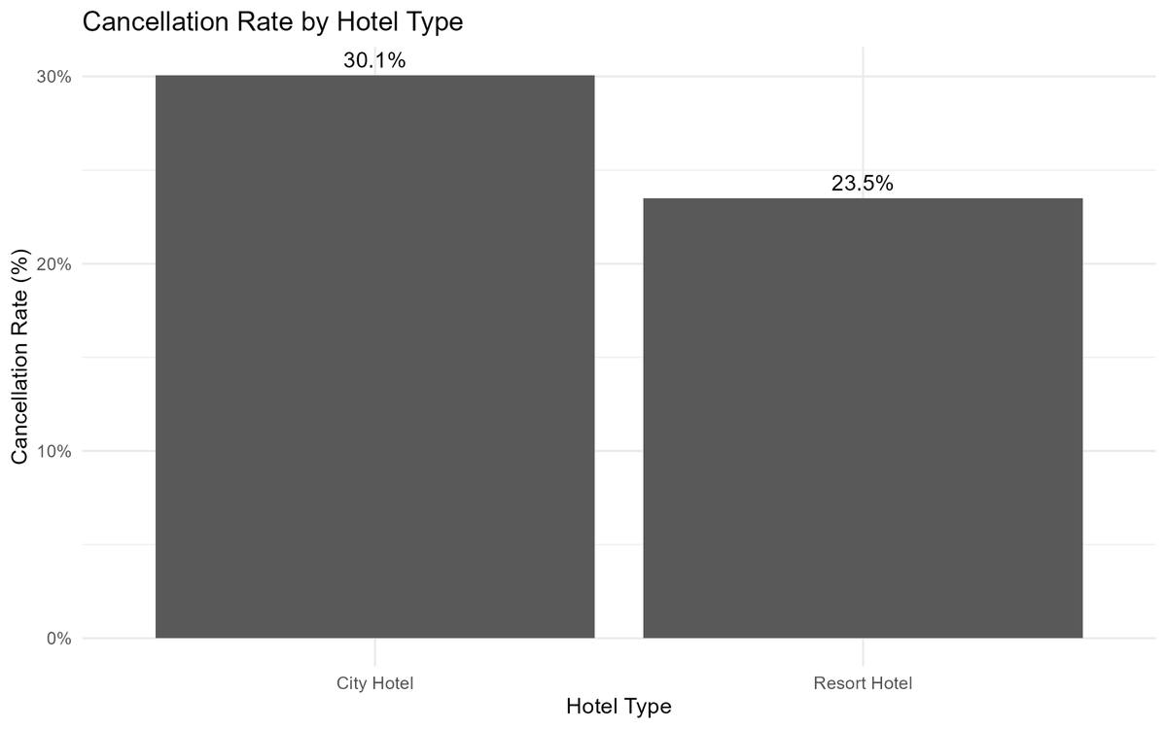
Figure 6.2: Cancellation rate by hotel type.

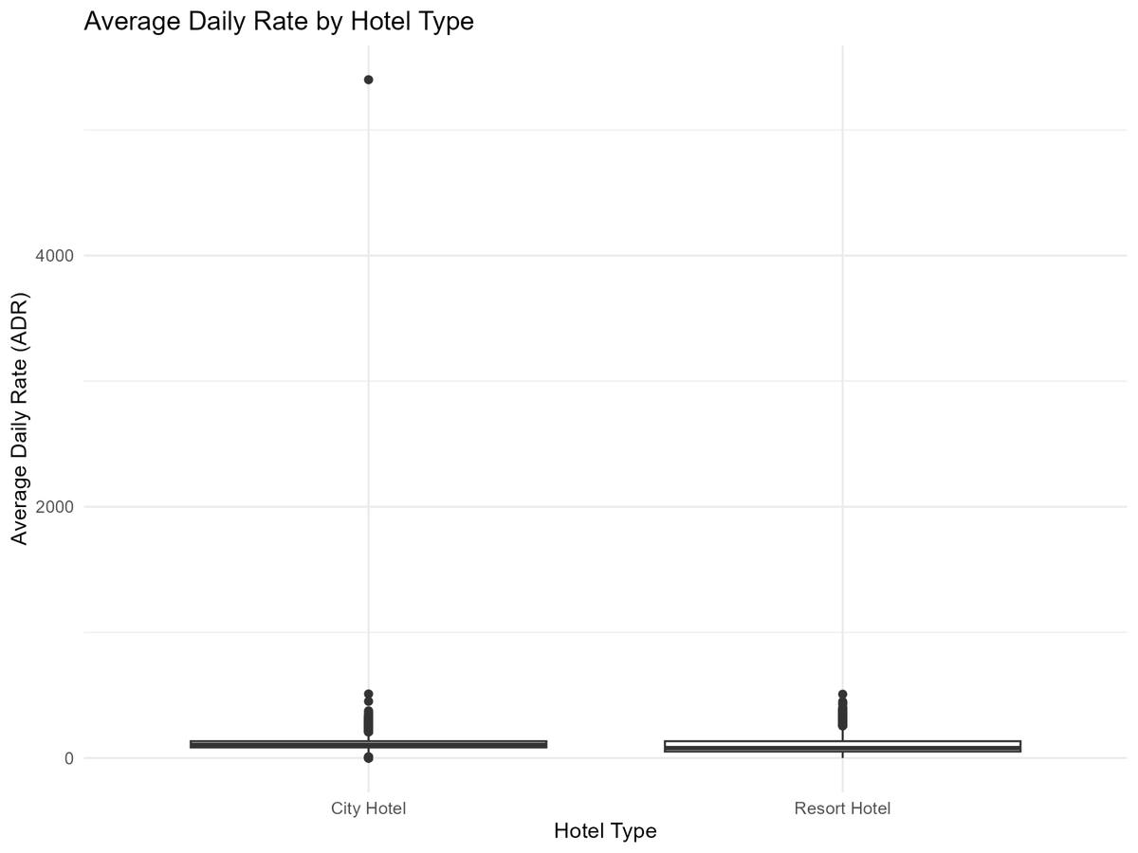
Figure 6.3: Average Daily Rate distribution by hotel type.

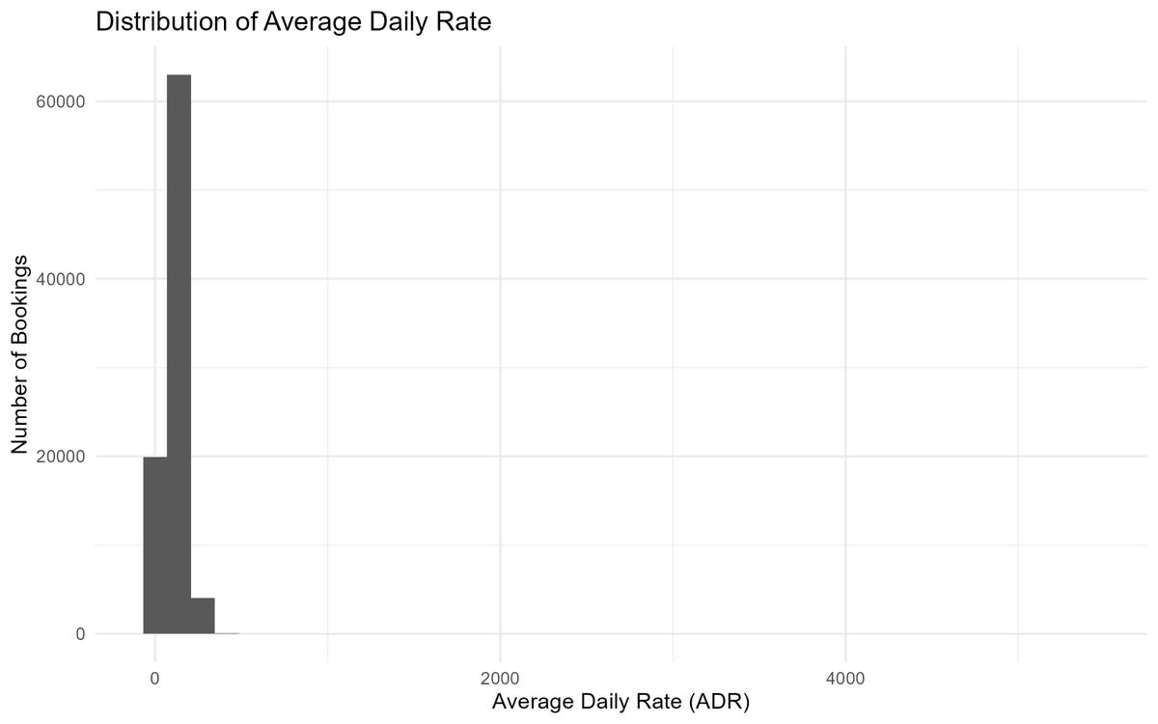
Figure 6.4: Distribution of Average Daily Rate (ADR).

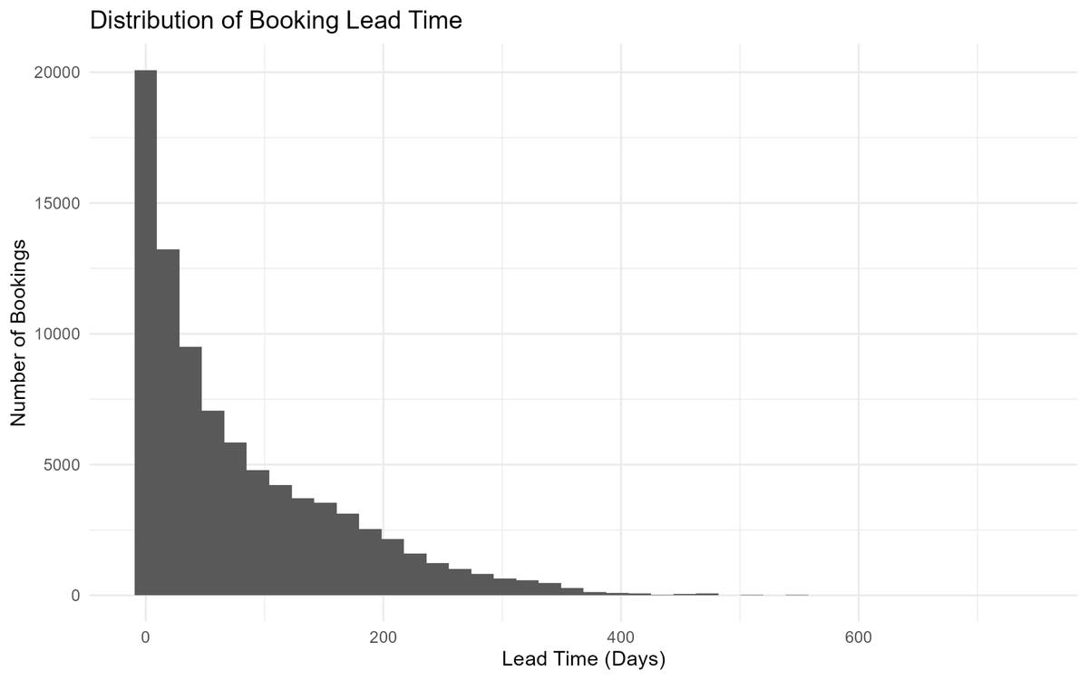
Figure 6.5: Distribution of booking lead time.

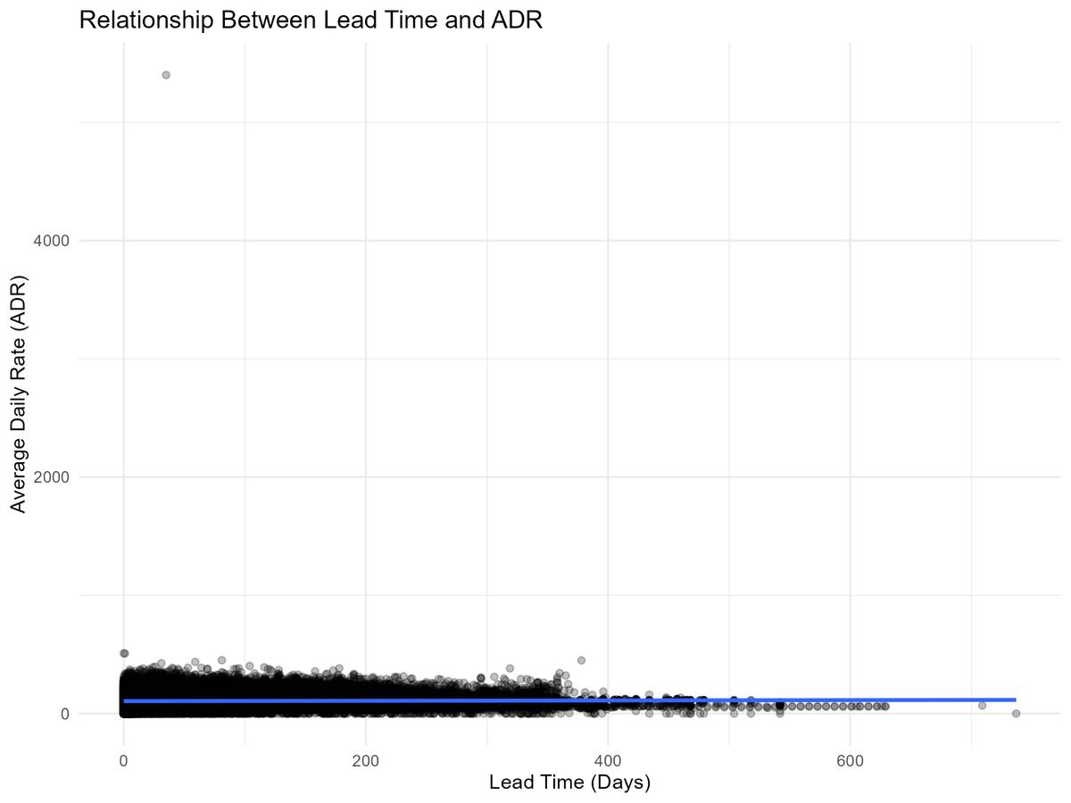
Figure 6.6: Relationship between booking lead time and ADR.

The second week translated the cleaned data into ten visualizations designed to communicate booking composition, cancellation behavior, pricing, lead time, market segment, and temporal patterns.
Visualization | Documented finding
Booking Cancellation Status | 23,927 canceled and 63,058 not-canceled bookings were shown.
Hotel Type Distribution | 53,053 City Hotel and 33,932 Resort Hotel bookings were shown.
Cancellation Rate by Hotel | 30.1% for City Hotel and 23.5% for Resort Hotel.
ADR by Hotel | ADR distributions differed across hotel types and contained high-value observations.
ADR Distribution | Strong right-skew and a long upper tail were observed.
Lead Time Distribution | Strong right-skew with many lower lead-time observations.
Lead Time vs ADR | A slight downward fitted trend with substantial dispersion was observed.
Market Segment Distribution | Online TA was the largest displayed segment.
Monthly Booking Trend | August had the highest displayed monthly count and January the lowest.
Year-wise Booking Trend | 2016 had the highest displayed yearly count.

These descriptive patterns provided context for the formal lead-time/cancellation analysis performed in Week 3.
Note: The Week 2 source report documented ten visualizations; the figures embedded here are the six visual outputs available directly in that report for integration into this final document.

7. Week 3 – Statistical Analysis and Predictive Modeling

7.1 Lead-Time Group Analysis
Lead-time group | Not canceled | Canceled | Total | Cancellation rate
0–30 Days | 22,955 | 4,494 | 27,449 | 16.37%
31–90 Days | 12,340 | 5,841 | 18,181 | 32.13%
91–180 Days | 9,476 | 5,090 | 14,566 | 34.94%
181+ Days | 5,676 | 3,717 | 9,393 | 39.57%
Total | 50,447 | 19,142 | 69,589 | 27.51%

Across the displayed groups, cancellation rate increased from 16.37% for 0–30 day bookings to 39.57% for bookings with lead time of 181 days or more.

7.2 Pearson Chi-Square Test
The following figures document the supplied Week 3 R outputs used for statistical testing, classification evaluation, ROC/AUC analysis, and diagnostics.

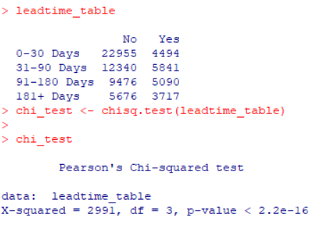
Figure 7.1: Pearson chi-square test output for lead-time group and cancellation status.

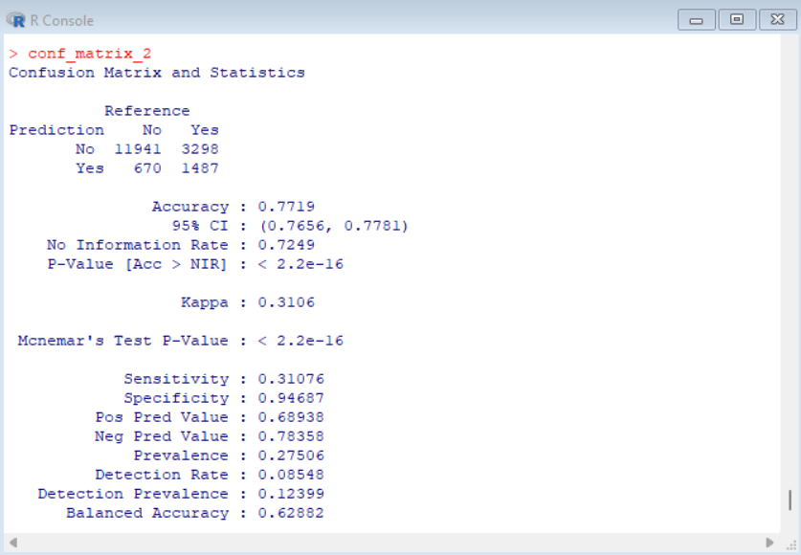
Figure 7.2: Confusion-matrix and classification metrics output for Model 2.

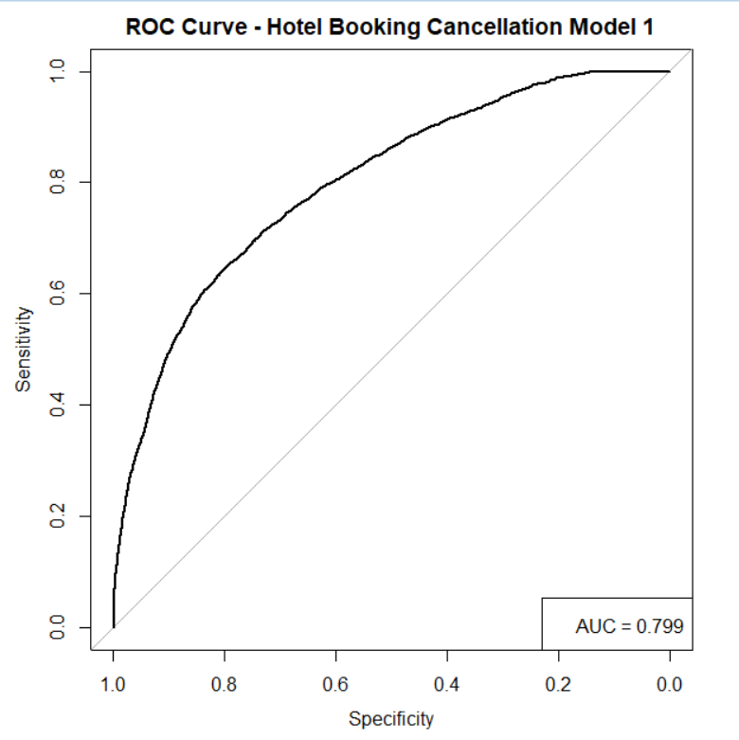
Figure 7.3: ROC curve for Model 1 (AUC = 0.799).

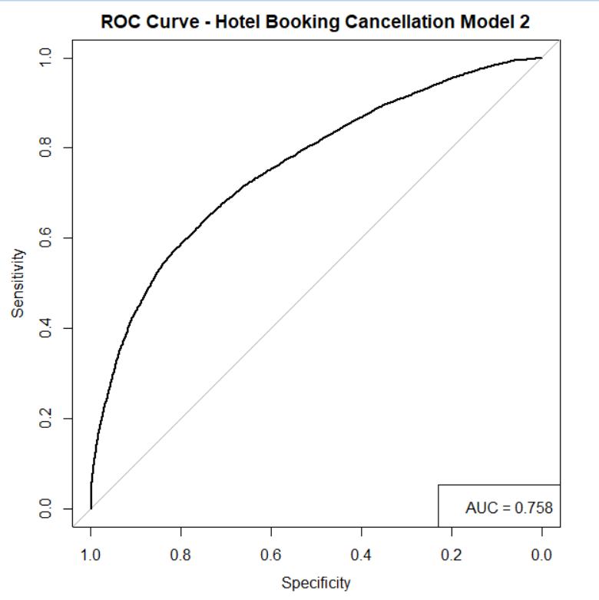
Figure 7.4: ROC curve for Model 2 (AUC = 0.758).

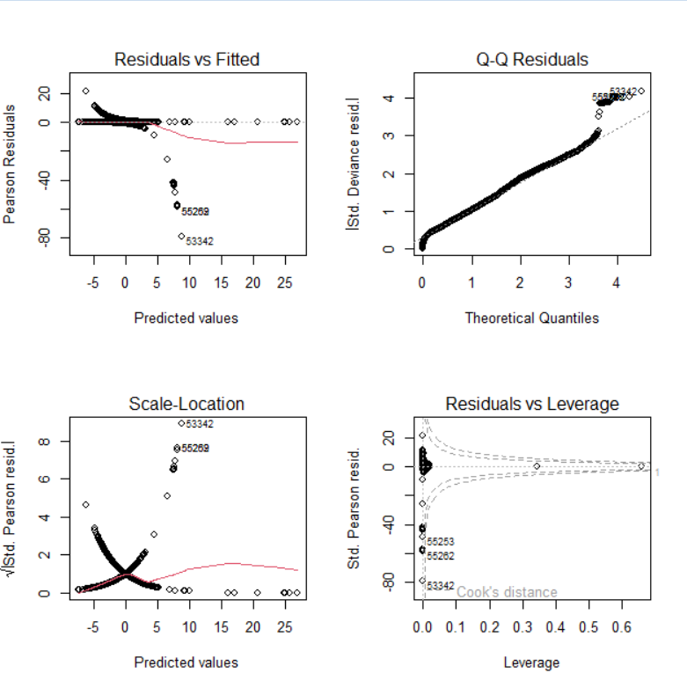
Figure 7.5: Model diagnostic plots from the supplied R output.

Statistic | Result
Chi-square | 2991
Degrees of freedom | 3
p-value | < 2.2e-16
Interpretation | Evidence of an association between lead-time group and cancellation status in the analyzed data.

The result provides strong statistical evidence against the null hypothesis of independence. It demonstrates association in the analyzed data, not a causal effect of lead time.

7.3 Logistic Regression Models
Model | AUC | AIC | df
Model 1 | 0.799 | 65,255.29 | 26
Model 2 | 0.758 | 69,510.07 | 16

Model 2 used Lead Time, Previous Cancellations, Booking Changes, Deposit Type, Market Segment, Repeated Guest Status, ADR, and Total Special Requests.

7.4 Cross-Validation
Metric | Result
Method | 10-fold cross-validation
Observations | 69,589
Accuracy | 0.7849515 (78.50%)
Kappa | 0.373929

7.5 Model 2 Confusion Matrix
 | Actual No | Actual Yes
Predicted No | 11,941 | 3,298
Predicted Yes | 670 | 1,487

Metric | Value
Accuracy | 77.19%
Kappa | 0.3106
Sensitivity | 31.08%
Specificity | 94.69%
PPV | 68.94%
NPV | 78.36%
Balanced Accuracy | 62.88%

The reported Model 2 results show substantially higher specificity than sensitivity. Therefore, overall accuracy should be interpreted together with class-specific metrics.

7.6 Selected Model Coefficients
Predictor | Coefficient | exp(coefficient)
lead_time | 0.0054123 | 1.0054
previous_cancellations | 0.9110915 | 2.4870
booking_changes | -0.3647656 | 0.6944
deposit_type = Non Refund | 4.0404566 | 56.85
is_repeated_guest | -1.2904343 | 0.2752
adr | 0.0044111 | 1.0044
total_of_special_requests | -0.6766655 | 0.5083

8. Integrated Findings and Discussion
Theme | Integrated evidence
Data quality | Substantial cleaning was required, including 31,994 duplicate records and multiple missing/invalid-value treatments.
Booking composition | City Hotel had the larger displayed booking volume.
Cancellation | The documented overall cancellation rate was 27.51%, with differences by hotel and lead-time group.
Lead time | Cancellation rate increased across the four displayed lead-time categories.
Statistical evidence | The chi-square test indicated an association between lead-time group and cancellation status.
Prediction | Logistic models produced measurable discrimination, with AUC 0.799 for Model 1 and 0.758 for Model 2.
Class-level behavior | Model 2 showed 31.08% sensitivity and 94.69% specificity at the evaluated threshold.

Taken together, the three weeks form a consistent analytical progression: data quality enabled exploration, visualization revealed patterns, statistical testing formalized a key relationship, and predictive modeling quantified classification performance.

9. Business and Analytical Implications
- Lead-time groups can be used as descriptive segments when monitoring cancellation patterns.
- Cancellation behavior can be reviewed separately by hotel type rather than assuming one common rate.
- Market-segment and time-based differences can guide further operational investigation.
- Predictive outputs should be evaluated with sensitivity, specificity, balanced accuracy, and AUC rather than accuracy alone.
- The low sensitivity reported for Model 2 indicates that threshold tuning or alternative modeling strategies would be important before operational use.

10. Challenges Encountered
- Handling missing values with variable-specific treatments.
- Detecting and removing a substantial number of duplicate records.
- Checking invalid values and potential outliers in a large dataset.
- Communicating strongly skewed distributions clearly.
- Connecting exploratory findings to a formal statistical hypothesis.
- Evaluating classification models with several complementary metrics.
- Interpreting diagnostic outputs and recognizing the need for additional validation.

11. Lessons Learned
- Data quality is the foundation of reliable analysis.
- Visualization can reveal patterns that motivate formal statistical tests.
- Statistical significance should be distinguished from causal interpretation.
- Accuracy alone can hide weak performance on an important class.
- ROC/AUC, confusion matrices, Kappa, and class-specific metrics provide complementary evidence.
- Model diagnostics and limitations are essential parts of responsible reporting.

12. Limitations
- The analysis uses one hotel-booking dataset and should not automatically be generalized to other populations.
- The results identify associations and predictive patterns rather than causal effects.
- Lead time and ADR were strongly right-skewed.
- Model 2 showed much lower sensitivity than specificity.
- Diagnostic plots indicated observations that warrant further investigation.
- External validation and probability calibration were not part of the supplied analysis.
- Alternative classification algorithms and threshold strategies were not fully explored.

13. Future Scope and Recommendations
- Investigate class-imbalance strategies and compare their effect on cancellation sensitivity.
- Tune the probability threshold according to the intended business objective.
- Examine nonlinear effects for highly skewed variables such as lead time and ADR.
- Test theoretically justified interaction terms.
- Review observations with large residuals or leverage values.
- Add probability-calibration analysis.
- Compare logistic regression with tree-based and other classification approaches.
- Use explicit holdout or external validation data to assess generalization.
- Extend the analysis into an interactive dashboard for ongoing booking and cancellation monitoring.

14. Conclusion
This final report demonstrates an end-to-end R data-analysis workflow using the Hotel Booking Demand dataset. Week 1 created the analytical foundation through cleaning, missing-value treatment, duplicate removal, invalid-value checks, outlier analysis, normalization, categorical preparation, descriptive statistics, and correlation analysis.
Week 2 communicated booking and cancellation patterns through ten visualizations. Week 3 then connected those patterns to formal statistical testing and logistic-regression modeling.
The Pearson chi-square test reported X² = 2991, df = 3, and p < 2.2e-16 for the lead-time/cancellation association. Predictive evaluation reported cross-validation accuracy of 78.50% with Kappa 0.374, Model 1 AUC 0.799, and Model 2 AUC 0.758. Model 2's reported sensitivity of 31.08% and specificity of 94.69% show why multiple performance measures are necessary.
The project demonstrates how R can support a complete analytical process from raw data preparation to statistical inference, visualization, model evaluation, and professional communication. Further work should focus on stronger validation, threshold selection, calibration, alternative models, and deeper diagnostic analysis.

15. Key R Code Excerpts

15.1 Data Import
df <- read.csv(
file.choose(),
stringsAsFactors = FALSE,
na.strings = c("", "NA", "NULL")
)

15.2 Correlation Analysis
numeric_data <- df_clean[, c(
"lead_time", "adults", "children", "babies",
"stays_in_weekend_nights", "stays_in_week_nights",
"adr", "total_of_special_requests"
)]
cor_matrix <- cor(numeric_data, use = "pairwise.complete.obs")

15.3 Chi-Square Test
leadtime_table <- table(
train_data$lead_time_group,
train_data$is_canceled
)
chi_test <- chisq.test(leadtime_table)
chi_test

15.4 Logistic Regression
model_2 <- glm(
is_canceled ~ lead_time + previous_cancellations +
booking_changes + deposit_type + market_segment +
is_repeated_guest + adr + total_of_special_requests,
data = train_data,
family = binomial
)

