TASK 2
Hotel Booking Demand
Data Visualization & Exploratory Analysis
R Programming Internship Project
Prepared by
Nikhil Wadkar
B.Sc. IT Graduate | Data Analytics
Tools: R, ggplot2, dplyr, RStudio/RGui
Dataset: Hotel Booking Demand

1. Introduction
This report presents Task 2 of the R programming internship, focused on data visualization and exploratory analysis of the Hotel Booking Demand dataset. The objective is to convert cleaned booking data into clear visual summaries and identify patterns in booking behavior, cancellations, hotel type, pricing, market segments, lead time, and booking trends.

2. Objectives
- Create meaningful visualizations for categorical and numerical variables.
- Compare booking behavior and cancellation rates across hotel types.
- Examine the distributions of Average Daily Rate (ADR) and booking lead time.
- Explore the relationship between lead time and ADR.
- Analyze booking volume by market segment, month, and year.
- Interpret the visual results and document initial observations.

3. Dataset and Analysis Approach
The Hotel Booking Demand dataset contains hotel reservation records with categorical and numerical attributes. The visual analysis in this report uses the cleaned dataset prepared during the internship workflow. R was used to prepare and visualize the data using descriptive charts.

4. Visualization Methodology
Analysis Area | Visualization | Purpose
Booking status | Bar chart | Compare canceled and non-canceled bookings
Hotel type | Bar chart | Compare City and Resort Hotel booking volume
Cancellation by hotel | Bar chart | Compare cancellation rates
ADR by hotel | Boxplot | Compare ADR distributions and outliers
ADR distribution | Histogram | Examine price distribution and skewness
Lead time | Histogram | Examine booking lead-time distribution
Lead time vs ADR | Scatter plot + trend line | Explore relationship between variables
Market segment | Horizontal bar chart | Compare booking volume by segment
Monthly trend | Line chart | Examine monthly booking variation
Yearly trend | Line chart | Compare booking volume across years

5. Exploratory Visualizations and Findings
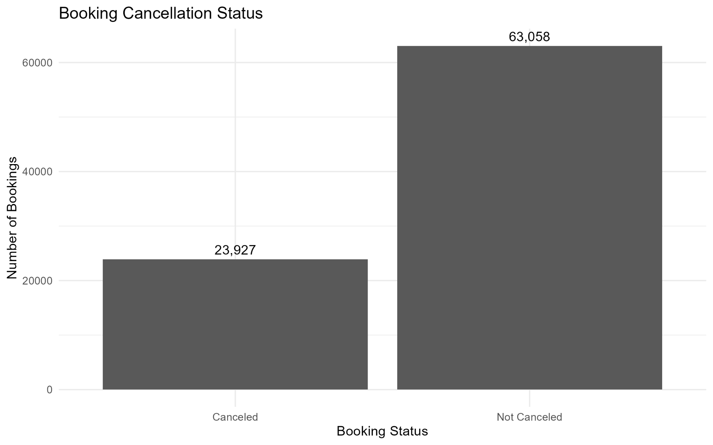
Figure 1. Booking Cancellation Status
The chart shows 23,927 canceled bookings and 63,058 bookings that were not canceled.

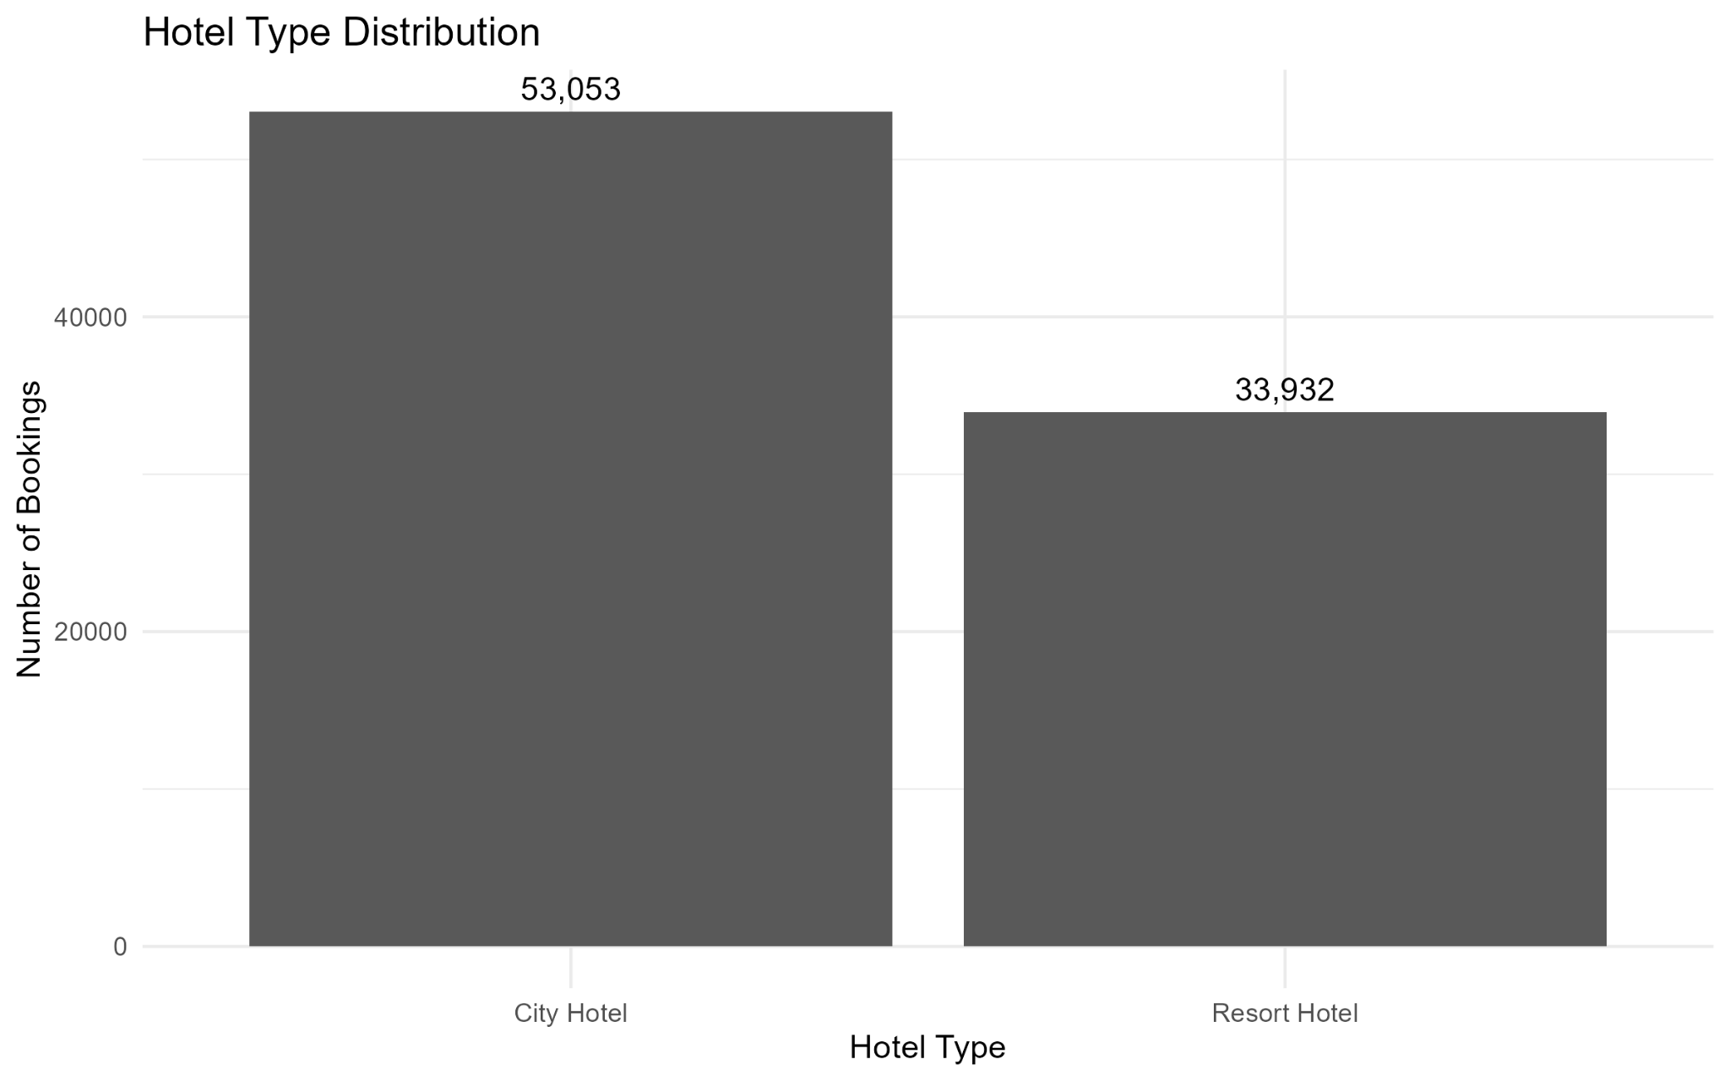
Figure 2. Hotel Type Distribution
The dataset contains 53,053 City Hotel bookings and 33,932 Resort Hotel bookings.

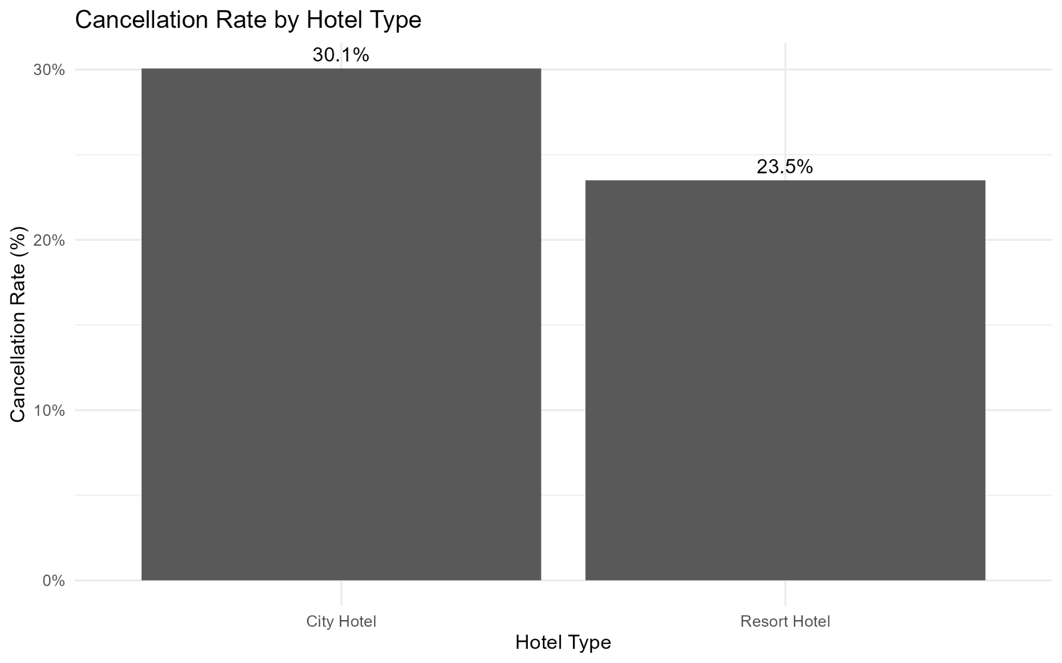
Figure 3. Cancellation Rate by Hotel Type
The cancellation rate is 30.1% for City Hotel and 23.5% for Resort Hotel.

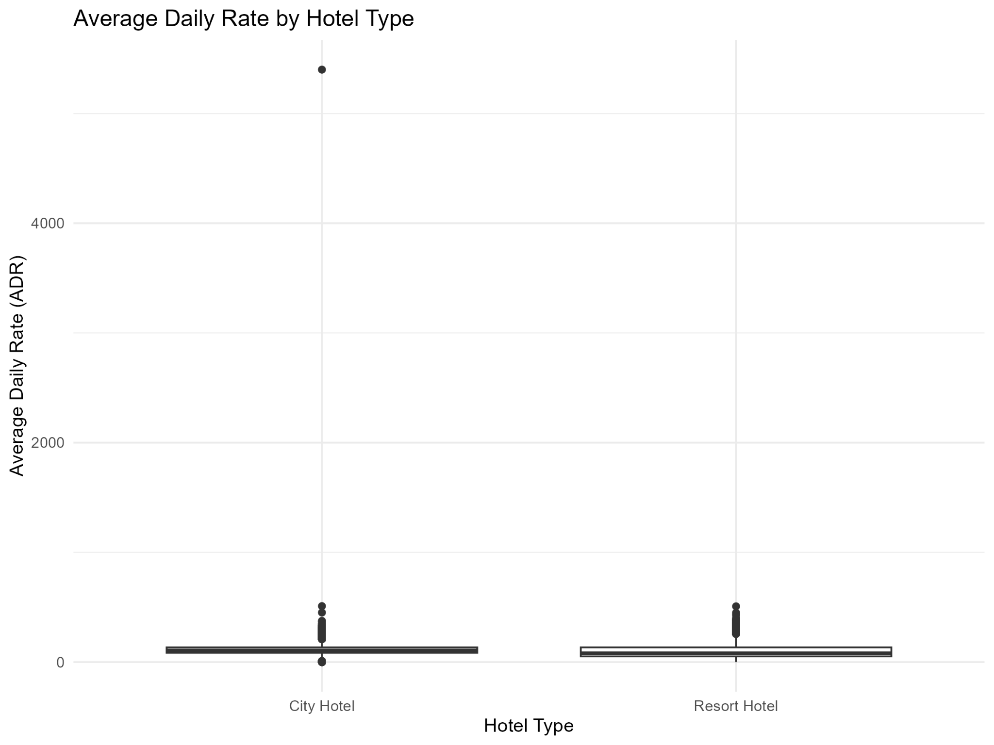
Figure 4. Average Daily Rate by Hotel Type
The boxplot compares the ADR distributions for City and Resort Hotels and shows several high-value observations.

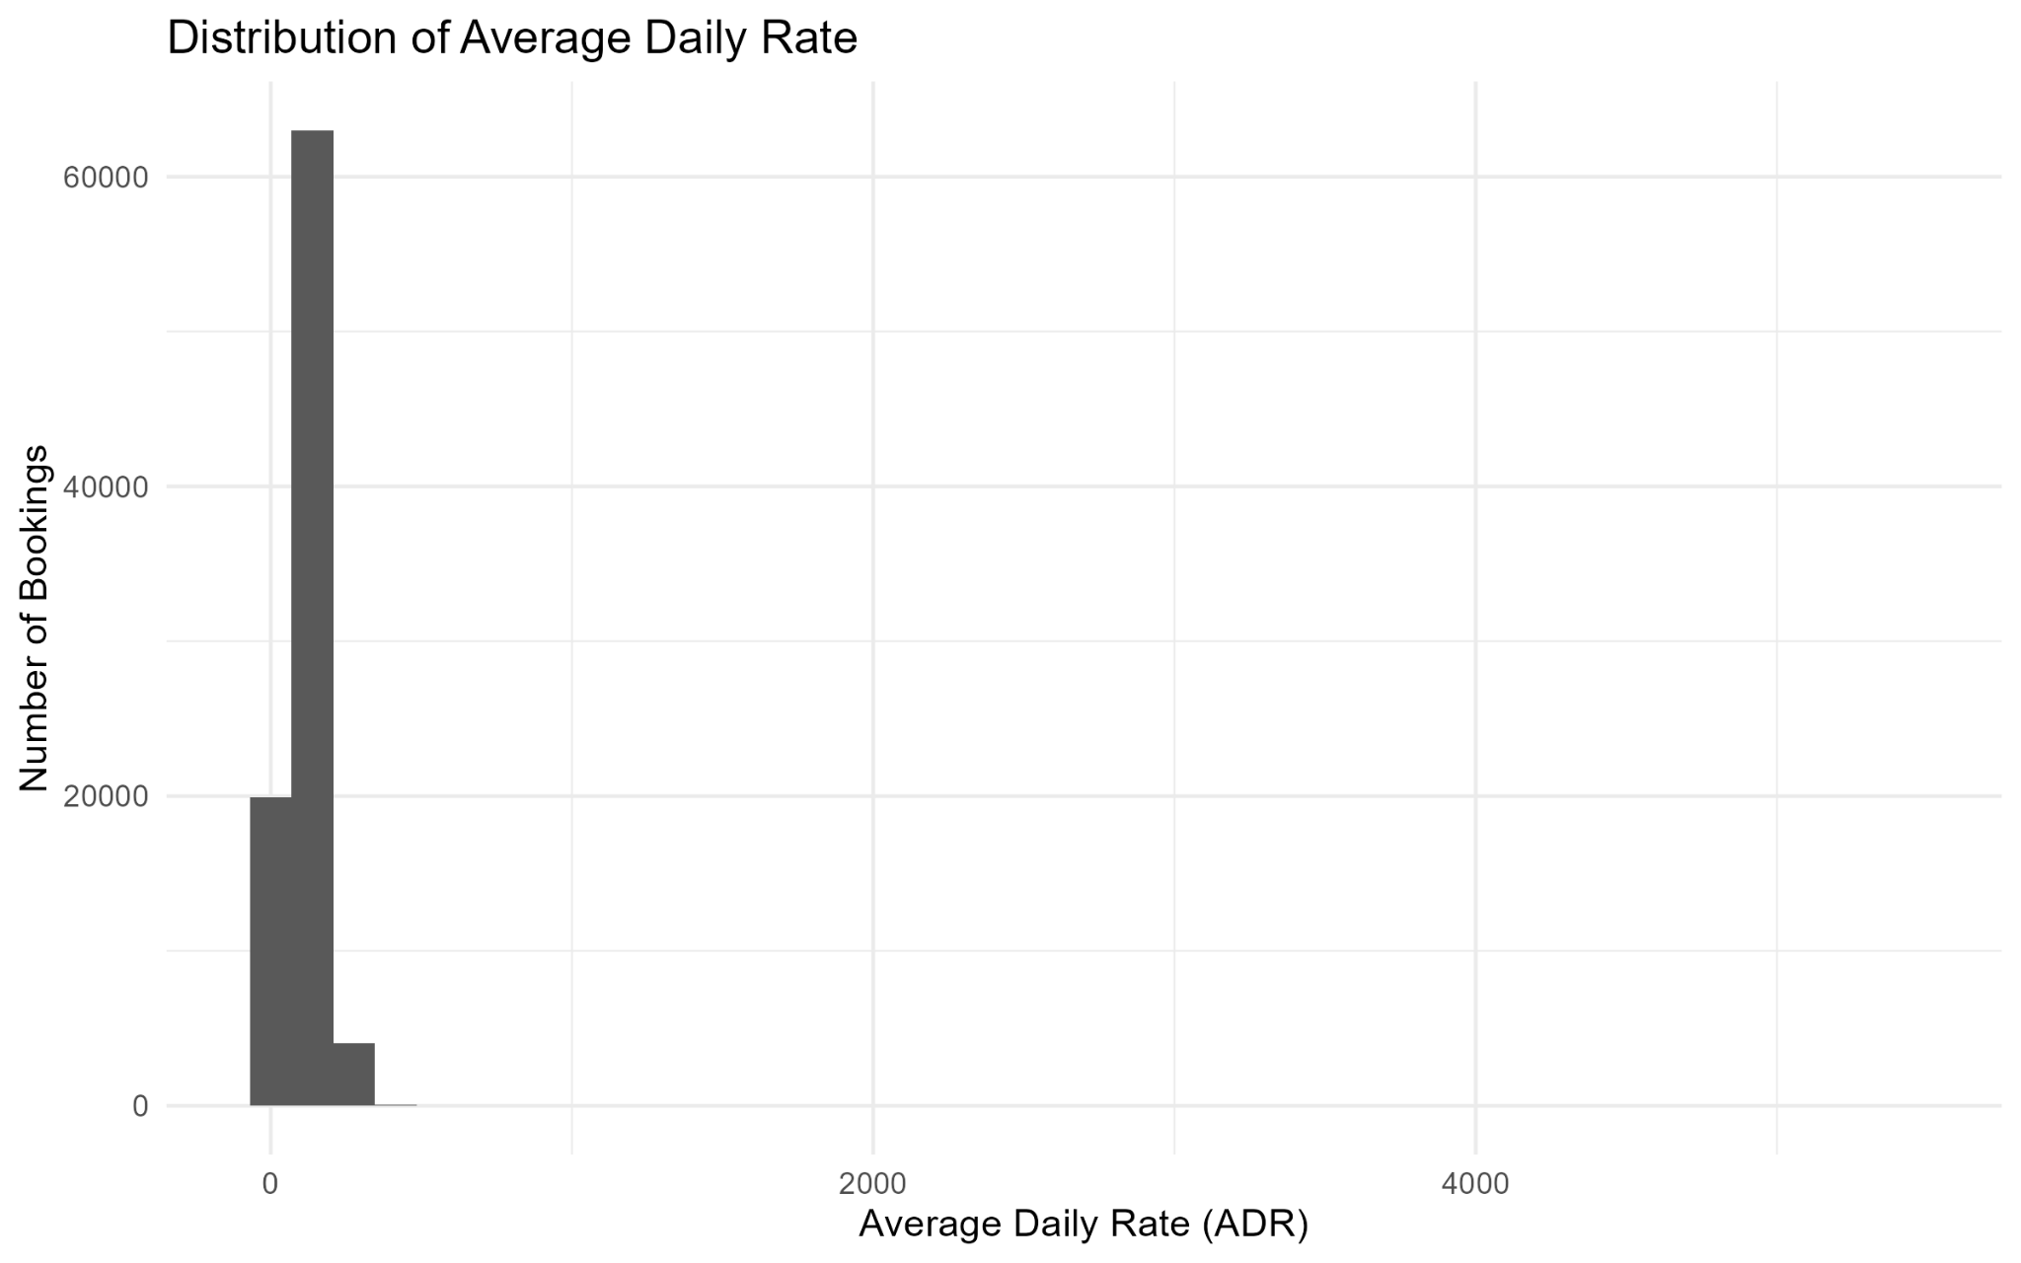
Figure 5. Distribution of Average Daily Rate
The ADR distribution is concentrated at lower values with a long right tail, indicating positive skewness and high-value observations.

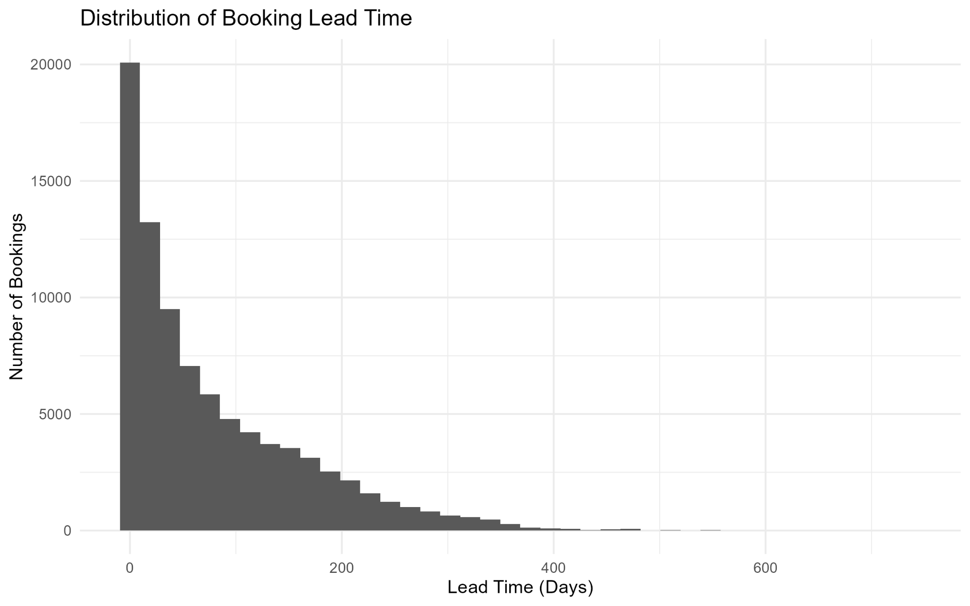
Figure 6. Distribution of Booking Lead Time
Lead time is concentrated at lower values and decreases as the number of days before arrival increases, producing a right-skewed distribution.

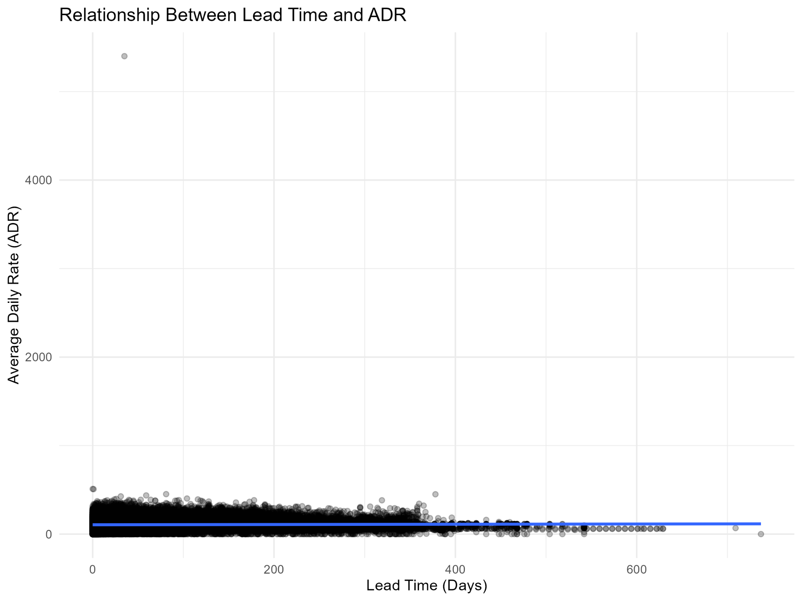
Figure 7. Relationship Between Lead Time and ADR
The scatter plot shows a slightly downward fitted trend, while most observations are concentrated in the lower ADR range.

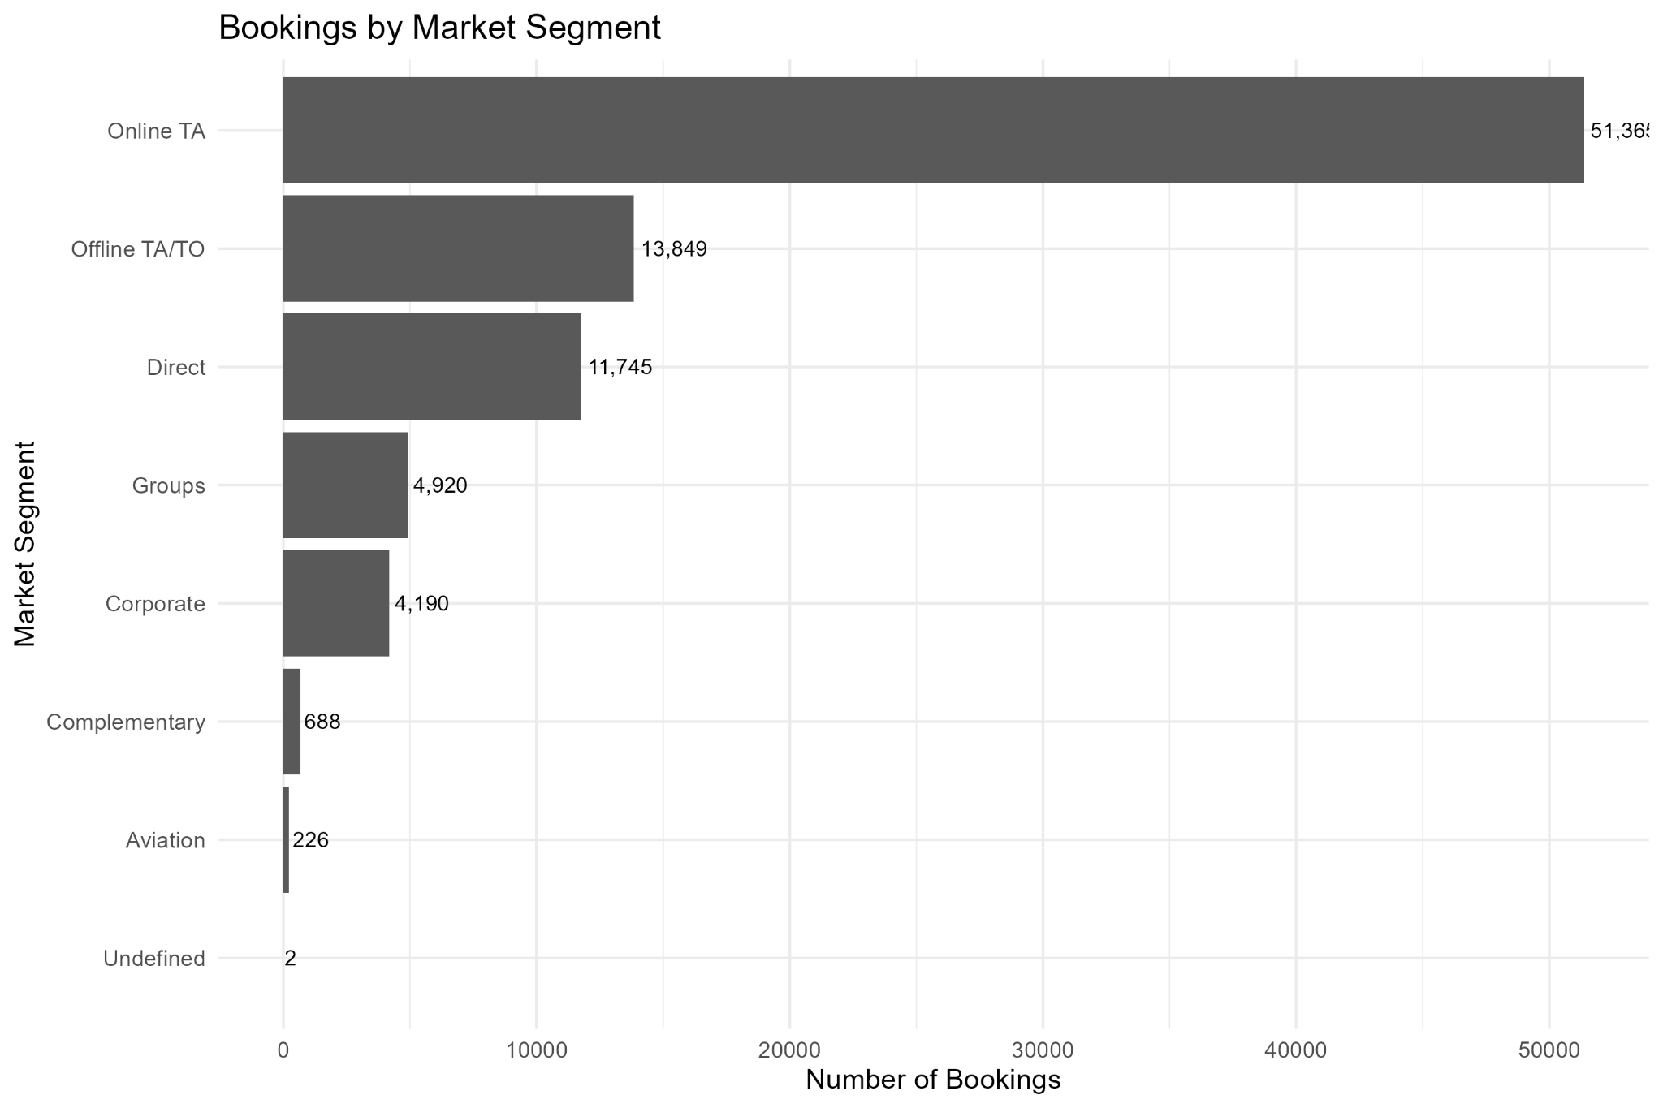
Figure 8. Bookings by Market Segment
Online TA is the largest market segment shown, followed by Offline TA/TO and Direct.

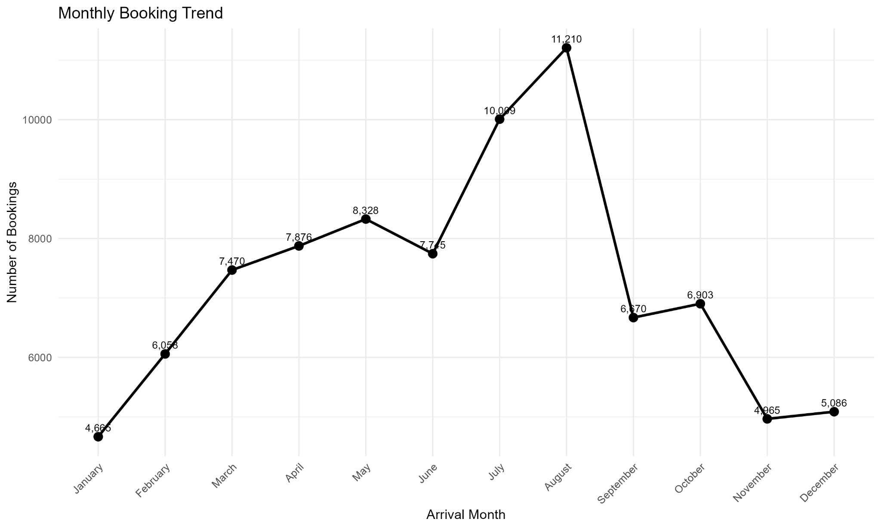
Figure 9. Monthly Booking Trend
Booking volume varies across arrival months. August has the highest monthly count shown, while January has the lowest.

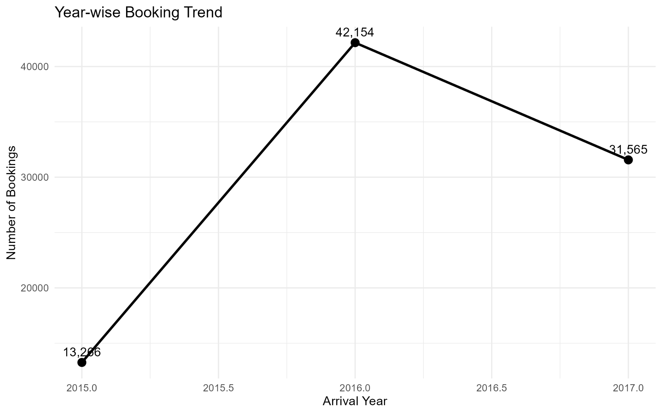
Figure 10. Year-wise Booking Trend
The chart shows booking counts for 2015, 2016, and 2017, with the highest count occurring in 2016.

6. Key Observations
- The booking-status chart shows 23,927 canceled bookings and 63,058 bookings that were not canceled.
- City Hotel has a larger booking volume than Resort Hotel, with 53,053 and 33,932 bookings respectively.
- The cancellation-rate comparison shows 30.1% for City Hotel and 23.5% for Resort Hotel.
- ADR is strongly right-skewed, with most observations concentrated at lower values and a long upper tail.
- The ADR boxplot contains several high-value observations, indicating extreme values in the pricing variable.
- Booking lead time is also right-skewed, with many reservations made relatively close to arrival and fewer very long-lead reservations.
- The lead-time versus ADR chart has a slightly downward fitted trend, but the observations are widely dispersed.
- Online TA is the largest market segment shown, followed by Offline TA/TO and Direct.
- Monthly booking volume varies considerably; August has the highest count shown and January the lowest.
- The year-wise chart shows 2016 with the highest booking count among the years displayed.

7. Interpretation of Visual Patterns
The visual analysis shows that booking activity is not evenly distributed across hotel types, market segments, months, or years. The concentration of ADR and lead-time observations at lower values, together with long right tails, indicates that distributions should be interpreted alongside their visual shape. The hotel-level cancellation comparison also shows differences between City and Resort Hotels. These observations provide a foundation for deeper statistical analysis in subsequent tasks.

8. Limitations
- The visualizations are descriptive and do not establish causal relationships.
- Extreme observations visible in ADR-related charts may influence averages and fitted trends.
- The lead-time versus ADR plot contains many observations, so points overlap in dense regions.
- The year-wise chart reflects only the years represented in the analyzed dataset and should not be treated as a general industry trend.

9. Conclusion
Task 2 applies data visualization techniques in R to the Hotel Booking Demand dataset. Ten visualizations were created to examine booking status, hotel distribution, cancellation rates, ADR, lead time, market segments, and temporal booking patterns. The charts reveal differences in booking volume and cancellation rates, right-skewed distributions for ADR and lead time, and variation across months and years. The results provide a visual foundation for further statistical analysis and predictive modeling.

10. Tools and Technologies
- R
- ggplot2
- dplyr
- RStudio / RGui
- Hotel Booking Demand dataset

11. Project Deliverables
- R visualization/analysis script
- Ten visualization output images
- Task 2 report in DOCX format
- GitHub repository containing the project files

