Executive Summary
This assessment comprehensively analyzes the existing ETL Assets (Informatica PowerCenter workflows and mappings) Autosys Jobs (File Watcher, Event Driven Jobs) span across multiple layers (file-preland-today-delta-publish around CDM and SFDC. Our detailed analysis highlights significant opportunities to streamline operations, enhance system efficiency, and reduce technical debt.
The recommended approach is a hybrid migration strategy, leveraging PySpark, AWS Glue, and AWS Managed Workflows for Apache Airflow (MWAA). This strategy prioritizes high-frequency and high-impact jobs, ensuring rapid performance improvements, better scalability, and easier maintainability.
Scope & Objective
- Scope: The assessment encompasses the entire ETL integration landscape involving Salesforce (SFDC) and Customer Data Management (CDM), specifically targeting workflows and mappings currently executed in the on-premises Informatica PowerCenter Production environment.
- Objective:
  - Perform an in-depth inventory analysis of Informatica PowerCenter ETL components to identify optimal migration candidates to AWS.
  - Document existing operational and performance challenges, recommending actionable mitigation plans.
  - Propose a robust and scalable cloud-based architecture using PySpark, AWS Glue, and AWS Airflow (MWAA), integrating Master Data Management (MDM) services delivered as SaaS solutions

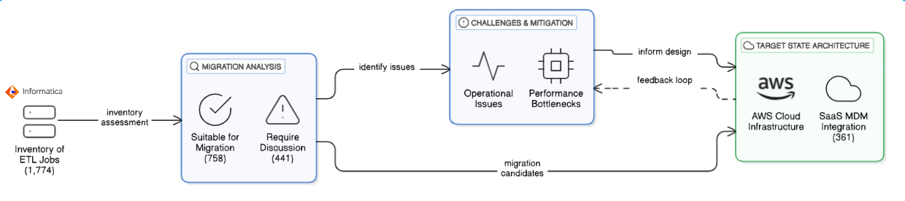
Assessment Methodology
- Data Collection: Data was collected through interviews with key ETL Teams, CG SMEs, document reviews and analysis of Autosys Jobs and PowerCenter logs and reports.
- Analysis Techniques: The analysis involved reviewing the workflows and mappings, identifying dependencies, and evaluating performance metrics

Areas of Assessment
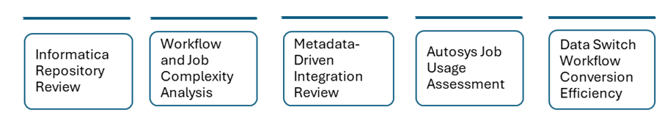
Informatica and Autosys Job Landscape

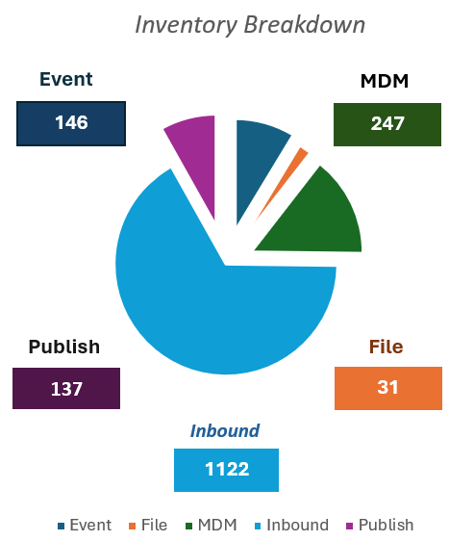 | Prioritizing "Other Jobs" for Maximum Impact  - Reason: Largest portion (71.6%) of job distribution.  - Impact: Significant progress and resource optimization.  Handle MDM Jobs Separately  - Reason: Crucial for data integrity and synchronization.  - Impact: Vital for seamless master data processes.  Special Handling for Event Watchers and File Watchers  - Reason: Key role in event-driven triggers and file monitoring.  - Impact: Ensures real-time responsiveness and data flow integrity.

Inventory of ETL Assessment (In Scope/Out of Scope)
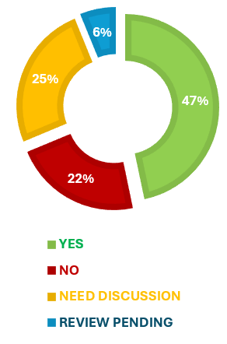 | - Migration Scope Analysis (1837 Jobs)  - Review Pending: 837  - Reviewed till date: 1000  - Not Recommended for Migration after Review: 250 (ex: MOCA, MDM Jobs etc.)  - Assessed: 500  - Assessed and recommended for Migration: 350  - Assessed and not recommended for Migration: 100  - Assessed and needs further discussion: 50  - Possible Migration (Yes): 856 jobs (46.6%)  Ideal for automated transformation using Dataswitch or a custom framework due to standardized patterns and low migration risk.  Not Recommended (No): 461 jobs (25.1%)  Legacy status with low business relevance, scheduled retirement, dependencies on obsolete systems, or infrequent execution (less than yearly).  Needs Discussion: 406 jobs (22.1%)  Uncertain business relevance, unclear documentation, mixed migration suitability patterns, potential duplication, or need to weigh business value against migration complexity.  Review Pending: 113 jobs (6.15%)

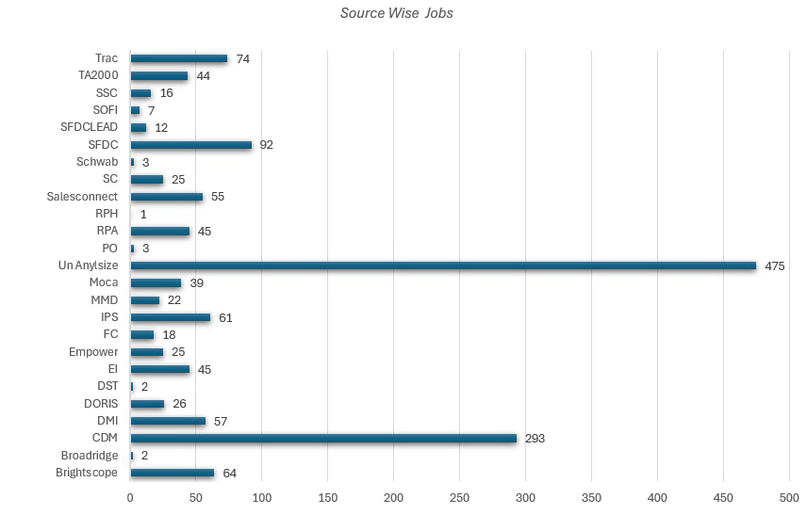

For more information on the assessed jobs, please refer to the Confluence page.
Click here

Layer-wise Categorized Job Analysis:

Source System Distribution
- MDM (15.2%) being the largest source aligns with our finding of 361 MDM jobs (19.65%) in our analysis
- SALESFORCE's position as the second-largest source (6.1%) corresponds with our SFDC count of 216 jobs (11.76%) - the discrepancy may be due to naming conventions
- The presence of TRAC (5.5%) and DST (5.2%) as major sources matches our detailed source system scope analysis
Operational Categorization
- LANDING jobs (18.7%) involve data ingestion, matching our inbound job analysis (77.55%)
- MERGE operations (9.0%) represent complex data consolidation logic that may require custom development
- Equal representation of DATA_LOADING and PUBLISHING (8.6% each) indicates balanced ingestion/distribution patterns

Job Execution Patterns
- The difference between 1-month and 3-month metrics (142 additional jobs) suggests these are likely quarterly batch processes
- Minimal increases between 3-6 months (62 jobs) and 6-12 months (14 jobs) indicate most jobs run either monthly or quarterly
- The 291 jobs (12.7%) that have never run represent potential technical debt or contingency processes that should be reviewed for decommissioning prior to migration

Average Job Execution Frequency Analysis  1 Month: 150 jobs  3 Months: 400 jobs  6 Months: 600 jobs  1 Year: 800 jobs  Jobs Execution Over Time  - ✓ Last 1 month: 1,200 jobs  - ✓ Last 3 months: 1,342 jobs  - ✓ Last 6 months: 1,404 jobs  ✓ Last 1 year: 1,418 jobs | 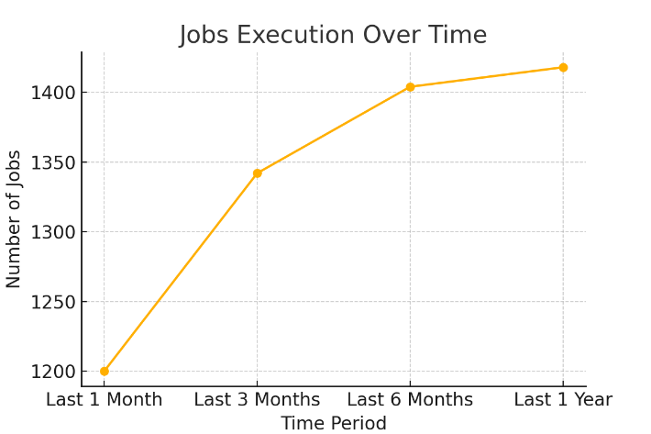

Jobs Never Run: Total jobs that have never run: 291 (12.7% of all jobs)
Key Findings & Recommendations from Current Architecture
- Excess Storage: Multiple data hops result in duplicate data storage.
- Maintainability: Too many jobs for each entity per source.
- Performance: Lack of parallel ingestion for Investor and Advisor.
- Extensibility: Data ingestion framework is not extensible.
- Best Practice: Unnecessary full publish.
- Performance Improvement: Potential redesign of DB schema for better performance.
- Optimization: Provision to fine-tune SQL queries.
- Logging & Auditing: Not implemented.
Workflow Consolidation
Observations
- Total Workflows Analyzed: 148
- Largest Workflow: 'cdm_ips_update_source_system_for_salesconnect' with 149 child jobs.
- Other Workflows: 'cdm_preland_dst_ta_customer_gap_od' with 71 jobs, and several others with 35+ jobs.
Recommendations
- Consolidation: Use reusable frameworks and parameterization to consolidate workflows.
Cross-Source Integration
- Unique Source Systems: 21 identified.
- PARTY_MANAGEMENT Jobs: Span multiple sources, comprising 31.2% of total jobs.
- DATA_LOADING: Spans 9 sources with 93 jobs.
- MATCHING: Spans 4 sources with 25 jobs.
- Unification: Unify similar logic into shared modules for improved reusability and monitoring.
Execution Frequency Optimization
- Daily Jobs: 48 jobs (2.1%).
- Weekly Jobs: 100 jobs (4.4%).
- Optimization: Consolidate and batch jobs where logic and timing allow. Run short-duration jobs (average 18.7s) in parallel to reduce total workflow execution time.
Architectural Improvements
- Job Chains: Replace static job chains with parameterized job templates.
- Framework: Create a centralized data loading and matching framework to serve multiple sources.
- Modularity: Simplify large workflows and improve maintainability with a modular code structure.
Technical Debt Reduction
- Unused Jobs: 291 jobs (12.7%) have never been executed and can be removed or archived.
- Source Tagging: 36.4% of jobs are categorized under 'OTHER_SOURCE' with unclear ownership.
- Cleanup: Clean up unused jobs, fix source tagging, and apply consistent naming conventions.
Next Modernization Opportunities
- ETL to Streaming: Move from file-based ETL to streaming pipelines for real-time ingestion.
- Microservices: Introduce microservices and event-driven Lambda triggers for small, frequent tasks.
- System Responsiveness: Improve system responsiveness and reduce maintenance costs.

Migration Recommendations
Data switch Approach | Custom Framework Approach
Pros:  - Pre-built tool for converting Informatica XML to PySpark  - Faster initial migration  - Less development effort  - Standardized conversion process  Cons:  - Less flexibility for customization  - Potential limitations in handling complex transformations  - Will require additional post-migration adjustments | Pros:  - Tailored solution specific to Capital Group's needs  - Full control over the migration process  - Better optimization opportunities  - No vendor dependencies  Cons:  - Longer development time  - Requires specialized AWS and PySpark expertise  - Higher initial development cost  - May require more extensive testing

Recommended Migration Strategy
Based on the mixed job types of present, a hybrid approach is recommended:
- Use Data switch for simpler, standard jobs (especially file watchers and notifications)
- Develop custom frameworks for complex MDM jobs with critical business logic
- Consider container-based solutions for jobs with external dependencies

Target State Architecture and Recommendations
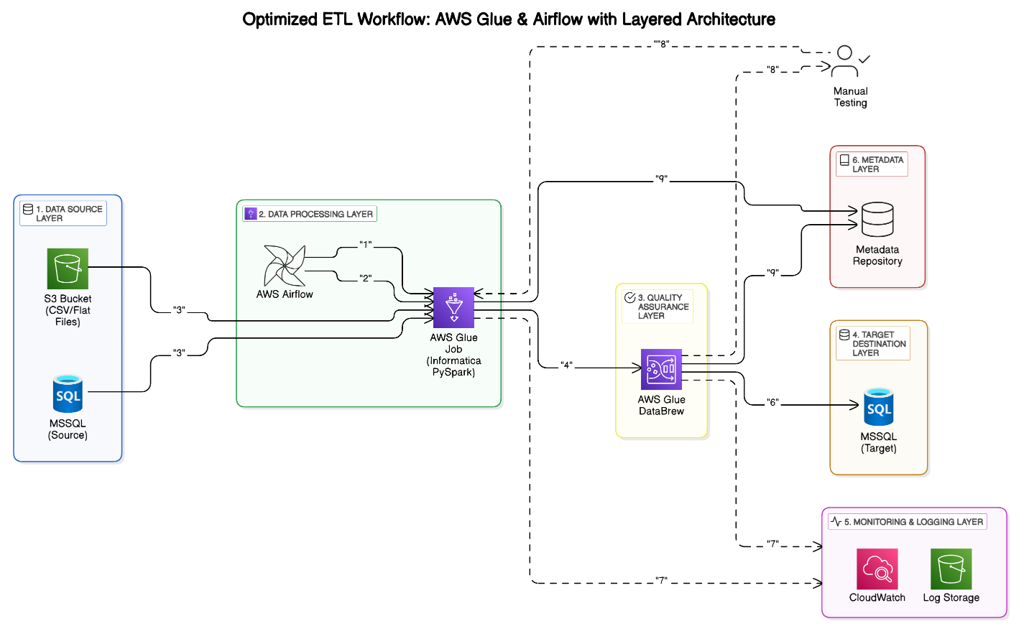
Layered ETL Architecture Overview
1. Data Source Layer
- Sources: Collects raw data from various sources, including S3 (flat files) and MSSQL (source database).
- Purpose: Acts as the initial point of data entry into the ETL pipeline.
2. Data Processing Layer
- Tools: Utilizes AWS Airflow for orchestration and AWS Glue (PySpark jobs) for data transformation.
- Functions: Manages the scheduling, execution, and transformation of data to ensure it is in the correct format for downstream processes.
3. Quality Assurance Layer
- Tools: Employs AWS Glue DataBrew for data quality assurance.
- Functions: Validates the processed data to ensure accuracy, consistency, and reliability before it moves to the target destination.

4. Target Destination Layer
- Storage: Stores the transformed data into MSSQL (target database).
- Purpose: Makes the data available for downstream consumption, such as reporting, analytics, and business intelligence.
5. Monitoring & Logging Layer
- Tools: Uses AWS CloudWatch and S3 log storage.
- Functions: Tracks job executions, monitors errors, and captures system metrics to ensure the ETL processes are running smoothly and efficiently.
6. Metadata Layer
- Functions: Captures job metadata and transformation details.
- Support: Facilitates manual data validation workflows and provides insights into the ETL process for better management and troubleshooting.
Additional Considerations
- Scalability: The architecture is designed to scale with increasing data volumes and complexity, ensuring robust performance.
- Security: Implements security best practices, including data encryption, access controls, and regular audits to protect sensitive information.
- Extensibility: The modular design allows for easy integration of new data sources and processing tools as requirements evolve.
- Automation: Emphasizes automation to reduce manual intervention, improve efficiency, and minimize the risk of errors.

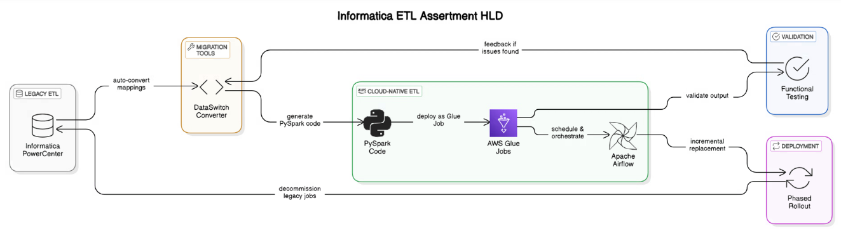

Cloud Modernization Migration Strategy

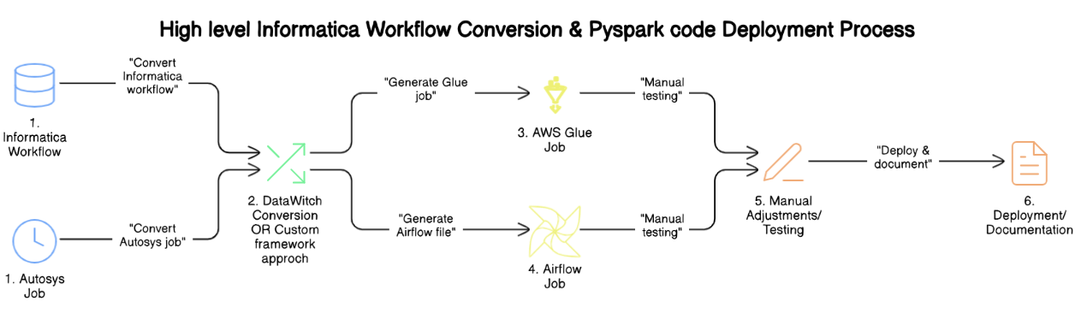

The image is a flowchart titled "High-Level Informatica Workflow Conversion & PySpark Code Deployment Process." It outlines the steps involved in converting and deploying workflows from Informatica and Autosys to AWS Glue and Airflow jobs, followed by manual testing, adjustments, documentation, and deployment.
Flowchart Steps:
- Informatica Workflow: Convert Informatica workflow
- Autosys Job: Convert Autosys job
- Data switch Conversion OR Custom Framework Approach (Generate Glue job, AWS Glue Job)
- Generate Airflow File(s) Airflow Job
- Manual Adjustments/Testing
- Deployment/Documentation
Additional Notes
- Data Quality Check: Although not explicitly mentioned in the flowchart, data quality checks are an integral part of the process to ensure the accuracy and integrity of the data.
- Process Health Check: Similarly, process health checks are conducted to monitor and maintain the overall health and performance of the workflows, ensuring they run smoothly and efficiently.

Migrating Informatica Jobs to AWS Glue
AWS Glue is a fully managed serverless ETL (Extract, Transform, Load) service that enables easy migration and modernization of traditional Informatica PowerCenter jobs.
Migrating Autosys Workflows to AWS Airflow (MWAA)
AWS Managed Workflows for Apache Airflow (MWAA) provides a scalable and cost-effective way to orchestrate complex workflows. It serves as a modern replacement for Autosys job scheduling.

Business Impact/Benefits
- Faster Performance: Modern serverless processing.
- Cost Optimization: Pay-as-you-go resource utilization.
- Scalability: Elastic architecture.
- Operational Excellence: Automated monitoring, alerting, and audit trails.
- Future Ready: Easy integration with real-time, streaming, and AI/ML pipelines.

- Overall Timeline
- Cost Analysis

