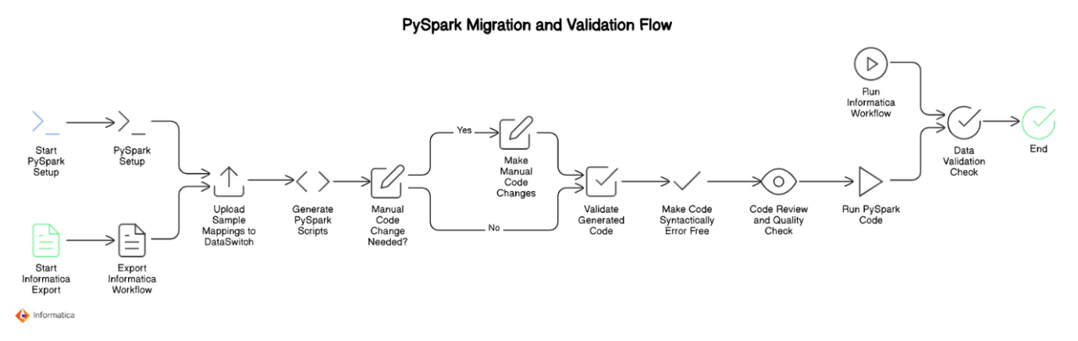

Apporch 1 : Nikhil recommend

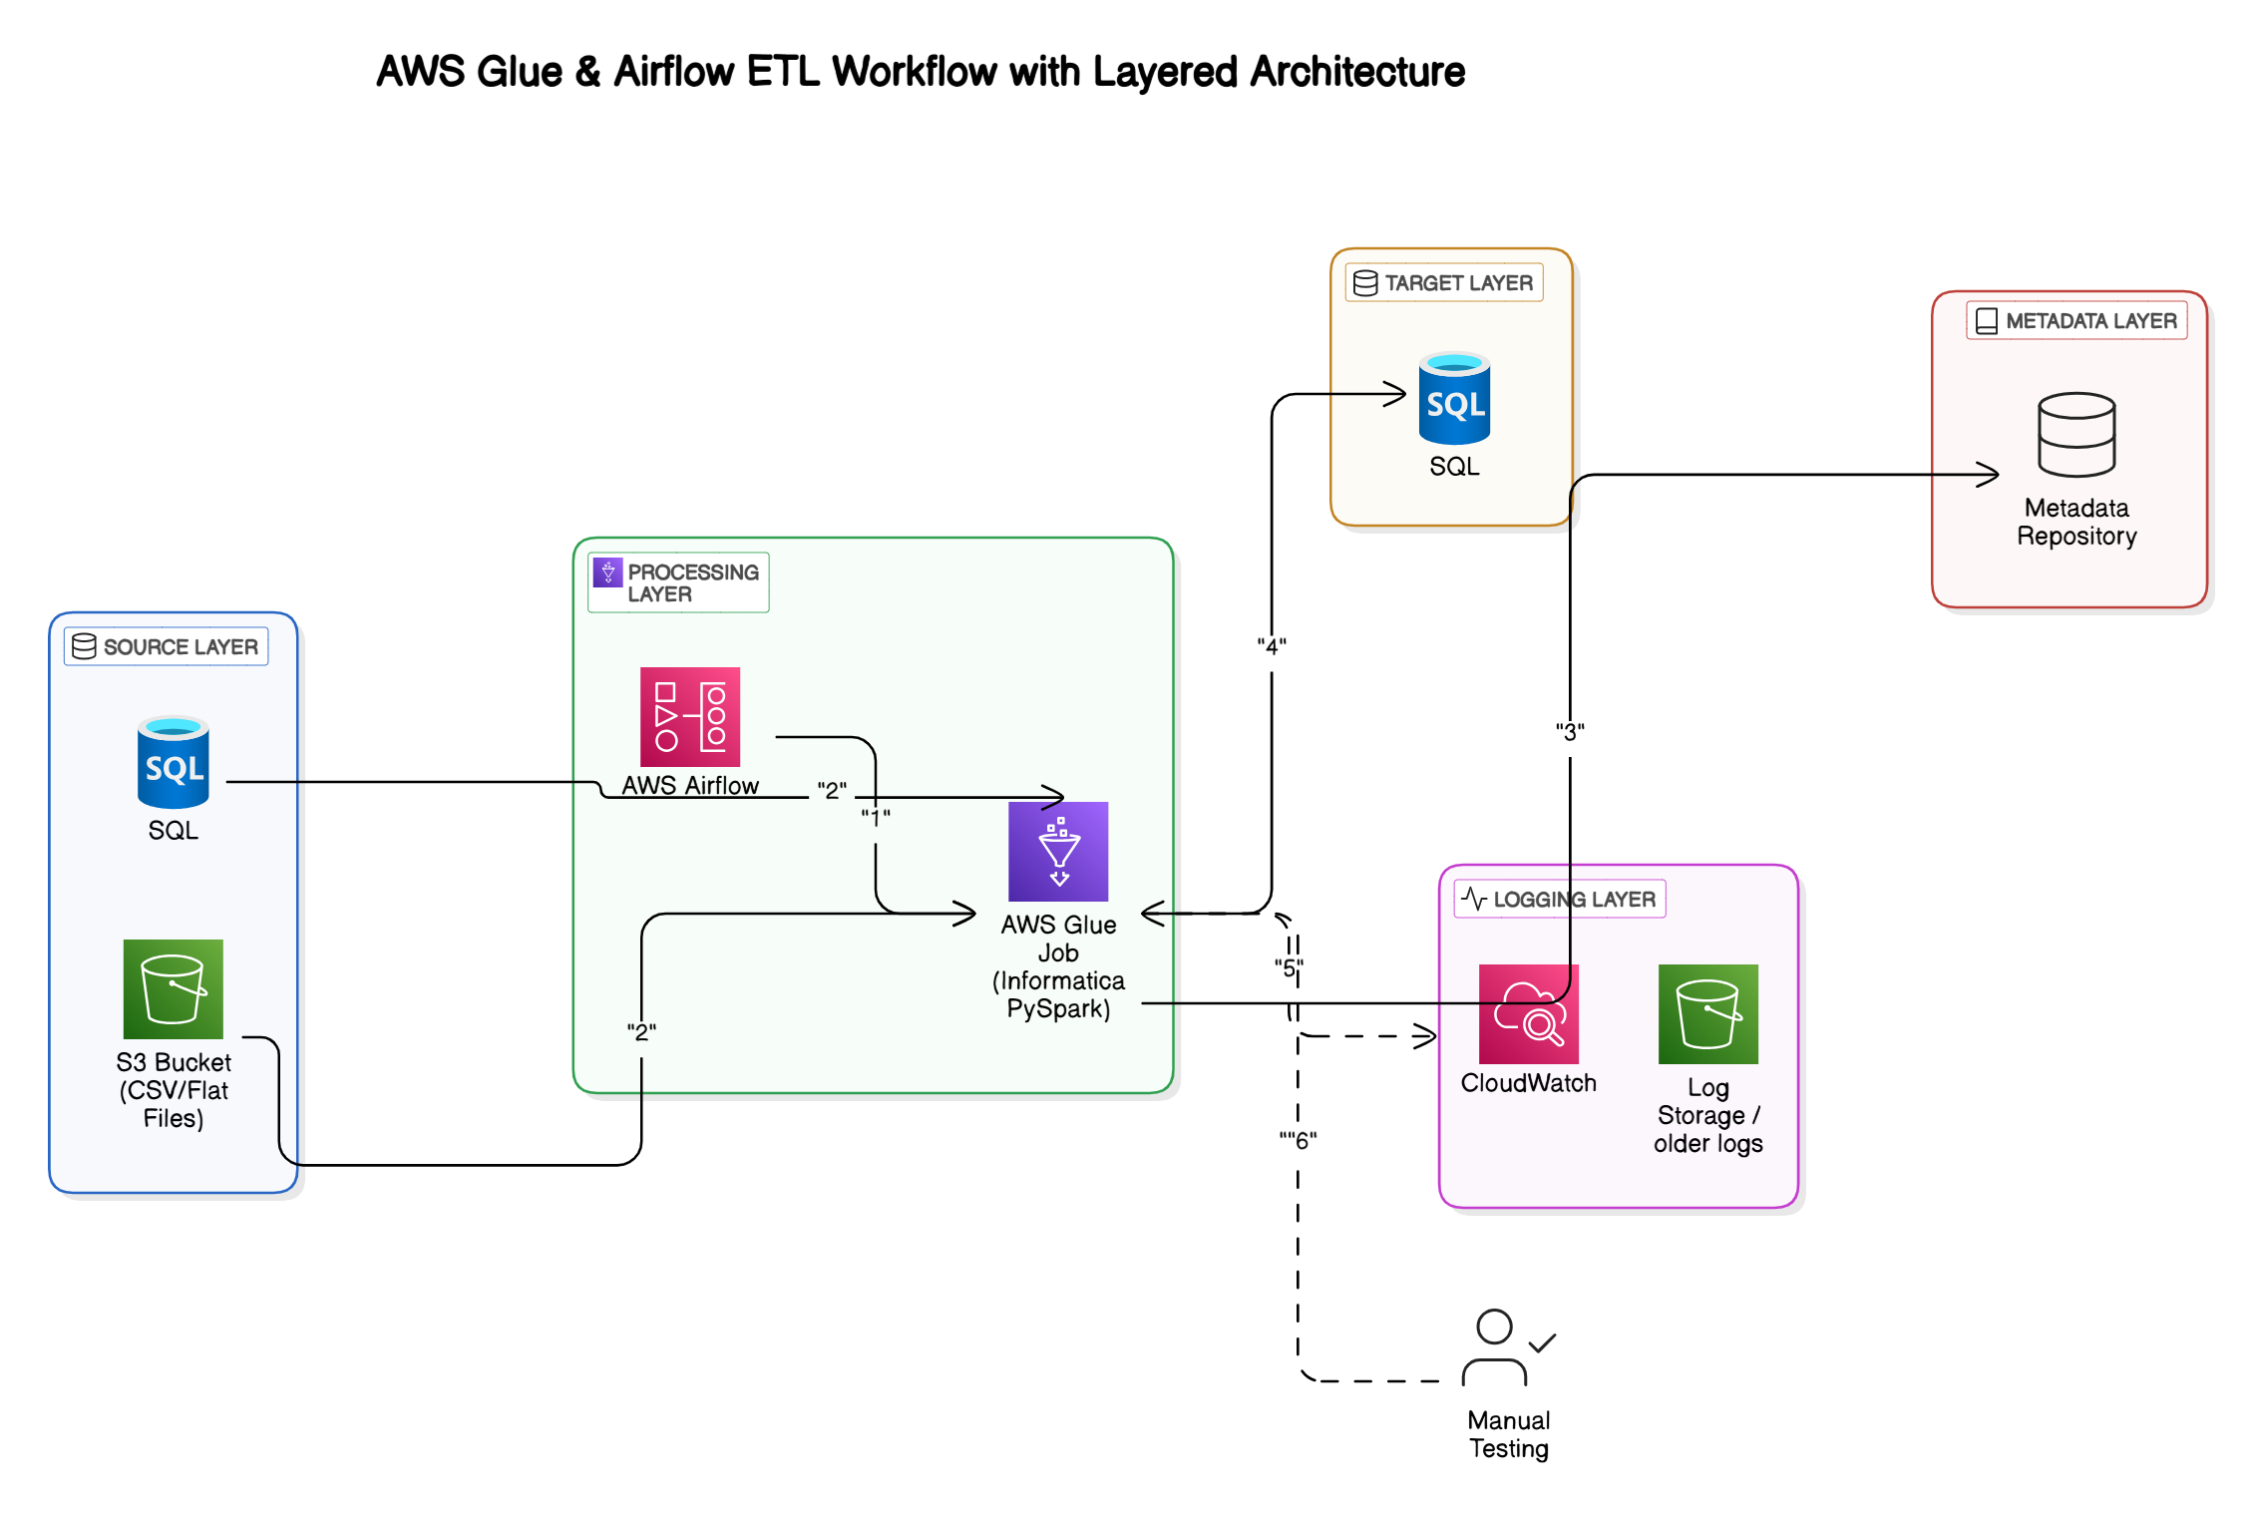

Apporch 2 : Nagesh recommend:

