TUTORIAL – 12
AI-Powered Software Testing
Name: Nikhil M Chavda

Aim
To analyze AI-powered software testing tools and apply Generative AI techniques for requirement analysis, test-case generation, test-data creation, defect prediction, and Selenium-based automated testing of a login module.

Software / Tools Required
- PyCharm IDE
- Python 3.x
- Google Chrome browser
- Selenium WebDriver package
- Generative AI assistant
- Internet connection

Requirement / Problem Statement
A registered user should be able to log in using a valid username and password. Invalid credentials should be rejected and an appropriate error message should be displayed.

Test Cases and Test Data
Test Case ID | Scenario | Test Data | Expected Result
TC-12-01 | Valid login | standard_user / secret_sauce | Products page opens
TC-12-02 | Invalid password | standard_user / wrong123 | Error message is displayed
TC-12-03 | Invalid username | wrong_user / secret_sauce | Error message is displayed
TC-12-04 | Empty username | Blank / secret_sauce | Validation message is displayed
TC-12-05 | Empty password | standard_user / Blank | Validation message is displayed

Script / Source Code
Create a Python file named ai_login_test.py in PyCharm and paste the reviewed code below.
from selenium import webdriver
from selenium.webdriver.common.by import By
from selenium.webdriver.support.ui import WebDriverWait
from selenium.webdriver.support import expected_conditions as EC

driver = webdriver.Chrome()
driver.maximize_window()

try:
driver.get("https://www.saucedemo.com/")
wait = WebDriverWait(driver, 10)

username = wait.until(
EC.visibility_of_element_located((By.ID, "user-name"))
)
password = driver.find_element(By.ID, "password")
login_button = driver.find_element(By.ID, "login-button")

username.send_keys("standard_user")
password.send_keys("secret_sauce")
login_button.click()

wait.until(EC.url_contains("inventory"))
assert "inventory" in driver.current_url

print("AI-Assisted Selenium Test: PASS")
print("Requirement Validation: PASS")

except Exception as error:
print("AI-Assisted Selenium Test: FAIL")
print("Reason:", error)

finally:
driver.quit()

Procedure (PyCharm)
- Install Python 3.x if it is not already installed. During installation, enable "Add Python to PATH" if using the Windows installer.
- Install and open PyCharm. Create a new Python project named AI_Software_Testing and select a valid Python 3.x interpreter.
- Open the project and create a Python file named ai_login_test.py.
- Open PyCharm's Terminal tool window and install Selenium using: python -m pip install selenium. If needed on Windows, use: py -m pip install selenium.
- Paste the source code from this report into ai_login_test.py and save the file.
- Ensure Google Chrome is installed and internet access is available. Selenium Manager normally obtains the compatible Chrome driver automatically.
- Right-click ai_login_test.py and select Run 'ai_login_test', or use the green Run button.
- Observe Chrome opening SauceDemo, submitting the demo credentials, and navigating to the Products page. Check the Run/Console window for PASS messages.
- If the script fails, review the error message, check Python/Selenium/Chrome setup, correct the issue, and run the file again.

Output Screenshot
Screenshot 1 – Source Code in PyCharm
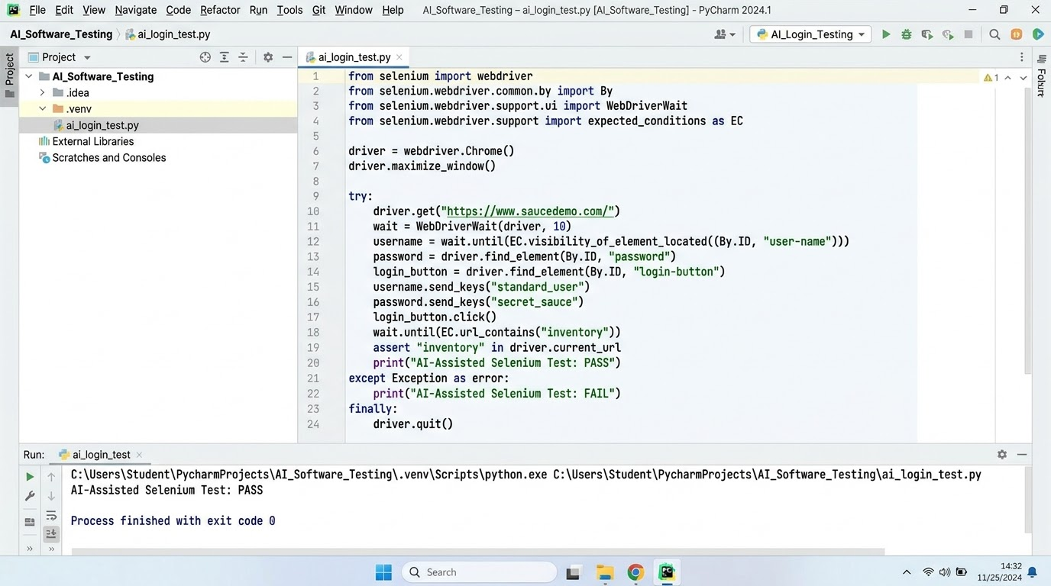
Screenshot 2 – SauceDemo Browser Output
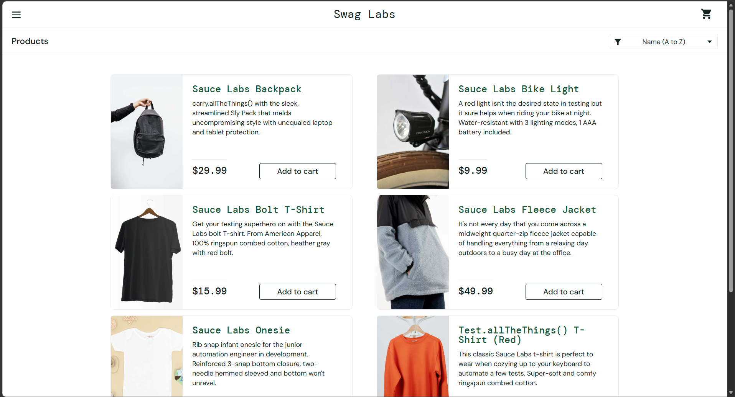
Screenshot 3 – PyCharm Run / Console Output
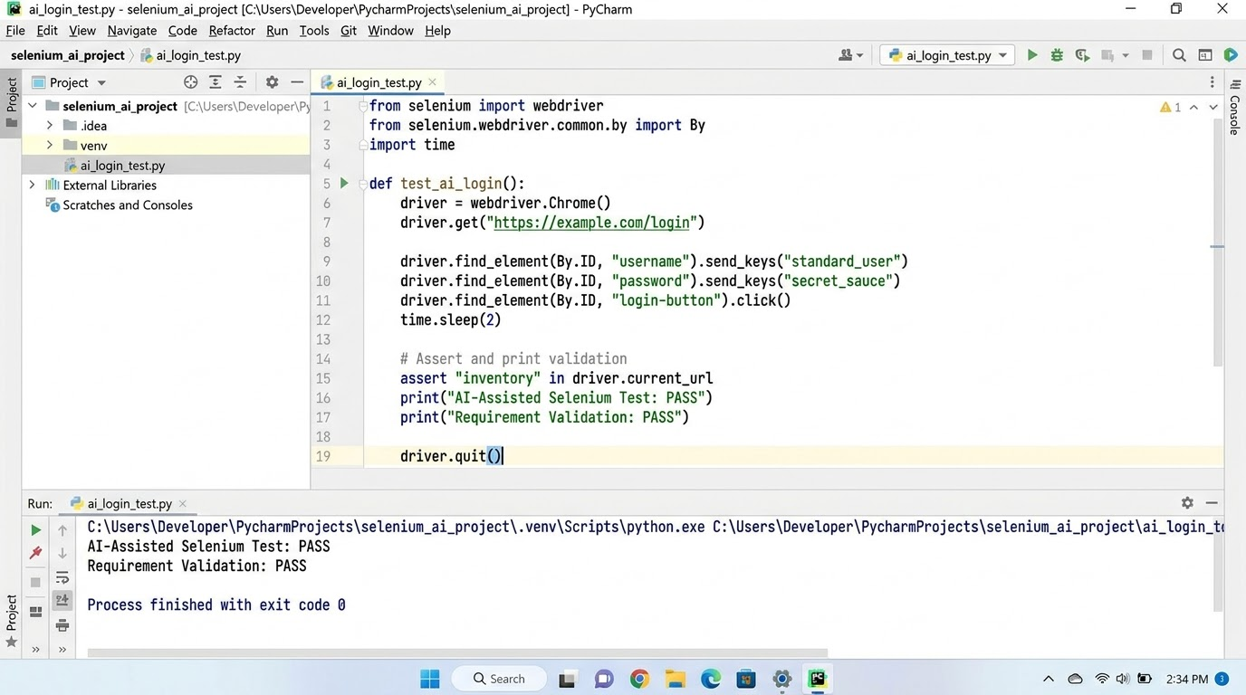

Conclusion
This practical demonstrates how Generative AI can assist with requirement analysis, test-case and test-data preparation, defect prediction, and Selenium automation. AI-generated output should be reviewed and executed to verify its behavior. The provided script automates the valid-login scenario; negative and empty-field scenarios should also be tested separately.

