LibraryMS – Software Testing Practical
Test Scenarios (Part 1)

Login
Scenario ID: 3a
Scenario: Login with valid username and password
Test Steps:
- Navigate to the Login page
- Enter Username: 'admin'
- Enter Password: 'admin123'
- Click the 'Login' button
- Verify redirect to respective dashboard (Admin/Member)
- Verify success message: 'Login Successful' is displayed
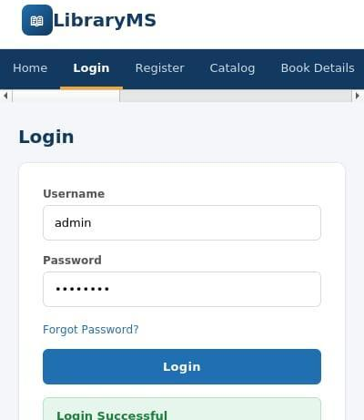
Scenario ID: 3b
Scenario: Login with wrong password
Test Steps:
- Navigate to the Login page
- Enter Username: 'admin'
- Enter Password: 'wrongpass'
- Click the 'Login' button
- Verify error message: 'Invalid username or password. Please try again.'
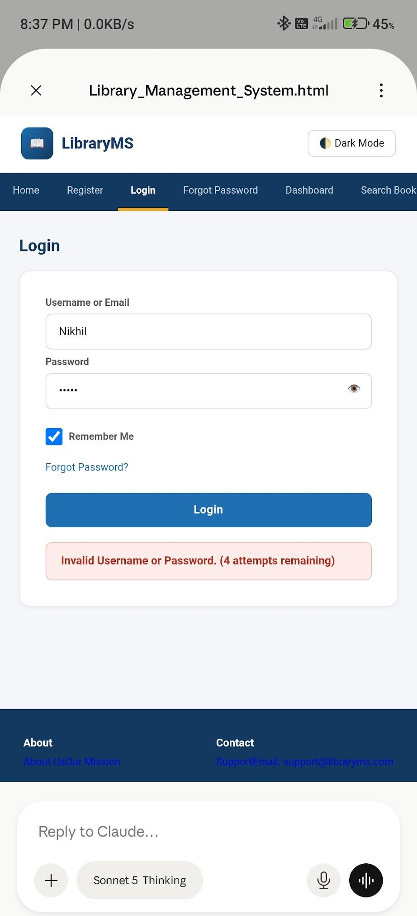
Scenario ID: 3c
Scenario: Try login with empty fields
Test Steps:
- Navigate to the Login page
- Leave both Username and Password fields empty
- Click the 'Login' button
- Verify validation errors for both fields
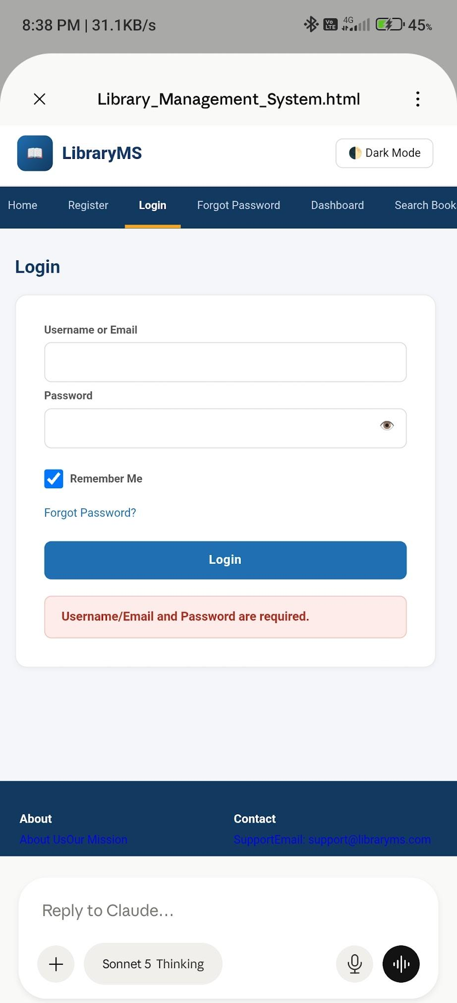
Scenario ID: 3d
Scenario: Forgot password flow
Test Steps:
- Navigate to the Login page
- Click on 'Forgot Password?' link
- Enter registered email: 'nikhil@example.com'
- Click 'Submit'
- Verify password reset email sent confirmation
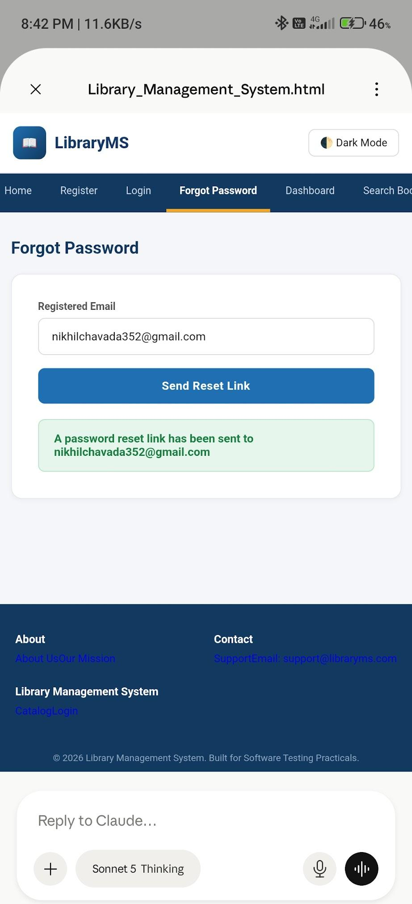
Scenario ID: 3f
Scenario: Login rate limit / attempt limit test
Test Steps:
- Navigate to the Login page
- Enter wrong password 5 consecutive times
- Attempt login with correct credentials on the 6th try
- Verify account is temporarily locked with rate limit message
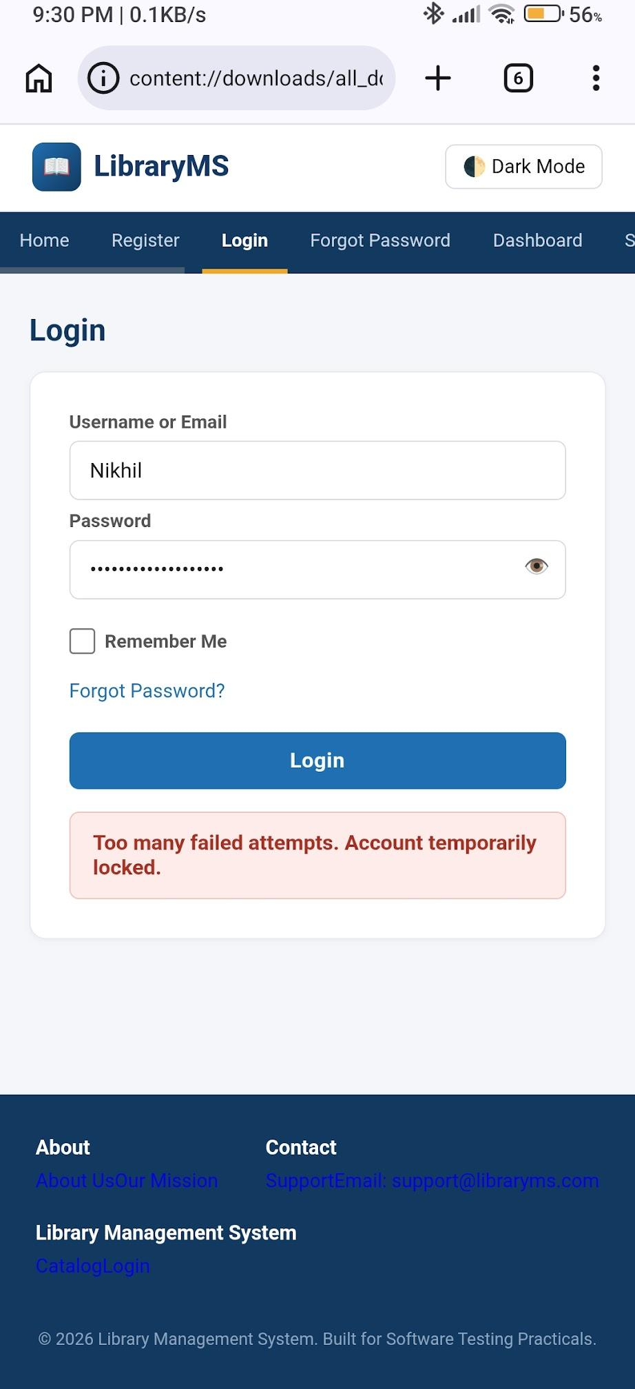

Book Management
Scenario ID: 4a
Scenario: View book catalog and search by title
Test Steps:
- Navigate to Catalog / Search Books page
- Verify catalog table displays all books with Title, Author, ISBN, Category, Status, and Action columns
- Enter 'Data Structures' in the 'Search by Title' field
- Press Enter or click Search
- Verify catalog filters to show only matching book
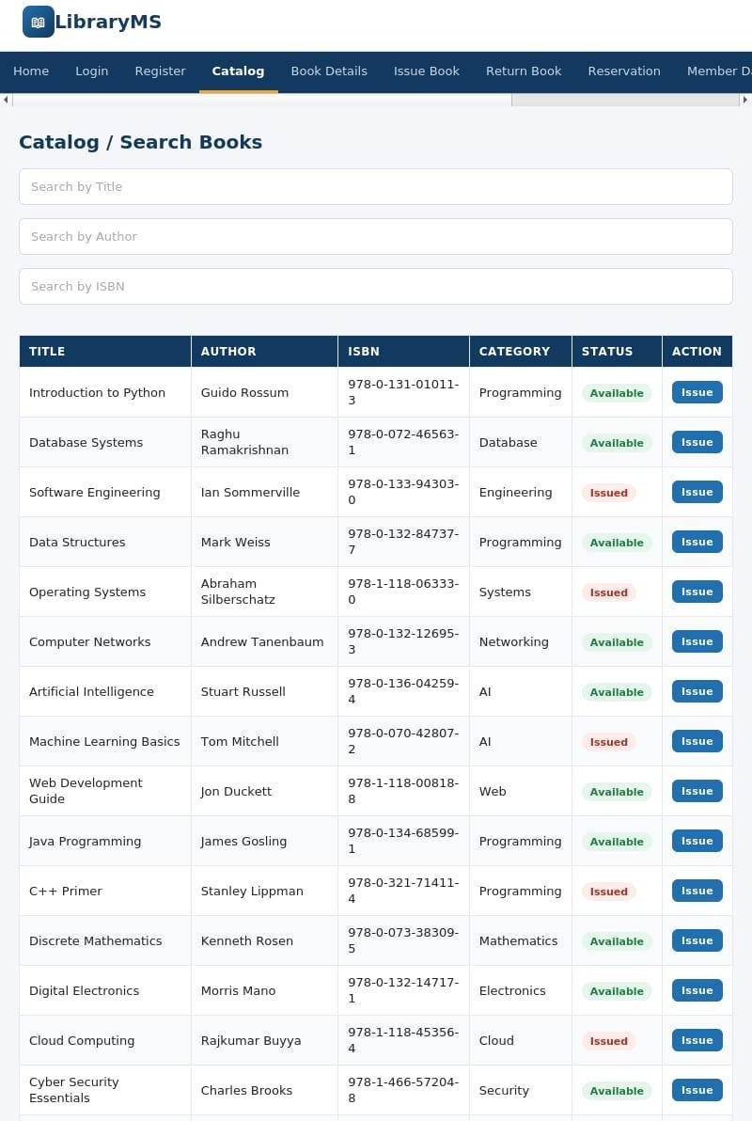
Scenario ID: 4e
Scenario: View detailed book information
Test Steps:
- Navigate to Catalog page
- Click on 'Introduction to Python'
- Verify Book Details page shows: Title, Author, ISBN, Category, Publisher, Status
- Verify 'Issue This Book' button is visible and clickable
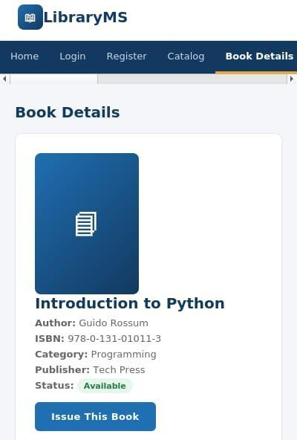
Scenario ID: 4f
Scenario: Add new book to catalog
Test Steps:
- Log in as Admin
- Navigate to Admin Dashboard > Add / Edit Book
- Enter Title: 'java oop'
- Enter Author: 'nikhil'
- Enter ISBN: '978-0-132-35088-10'
- Enter Category: 'Programming'
- Click 'Add Book'
- Verify success message and book appears in catalog
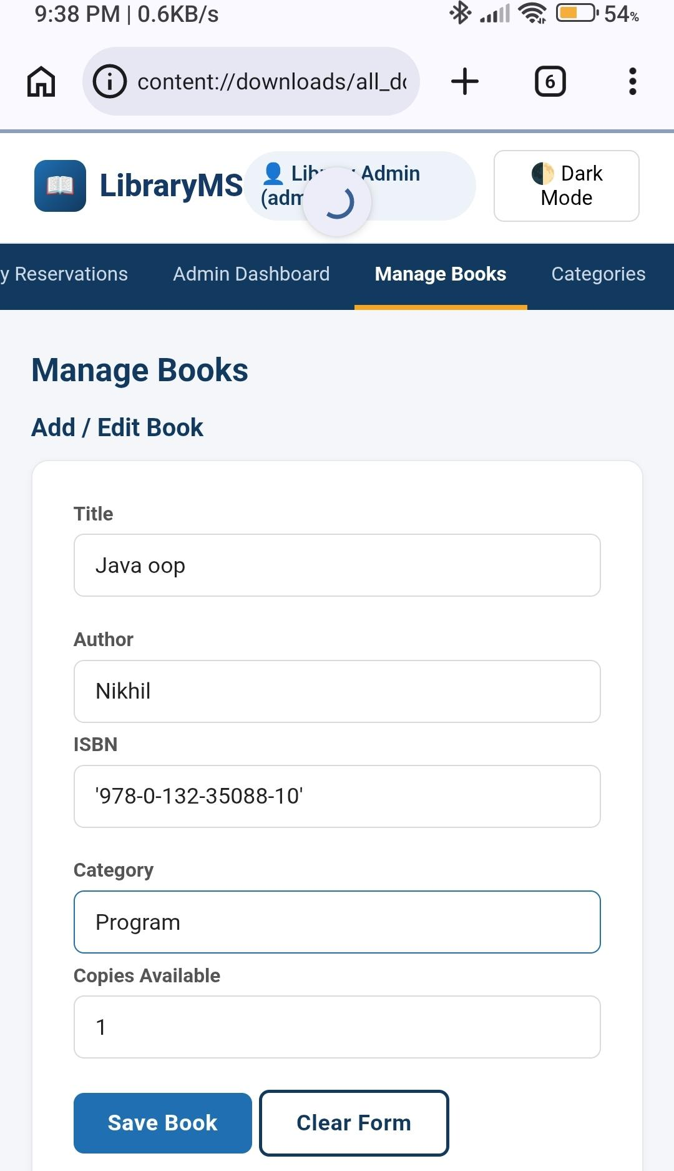
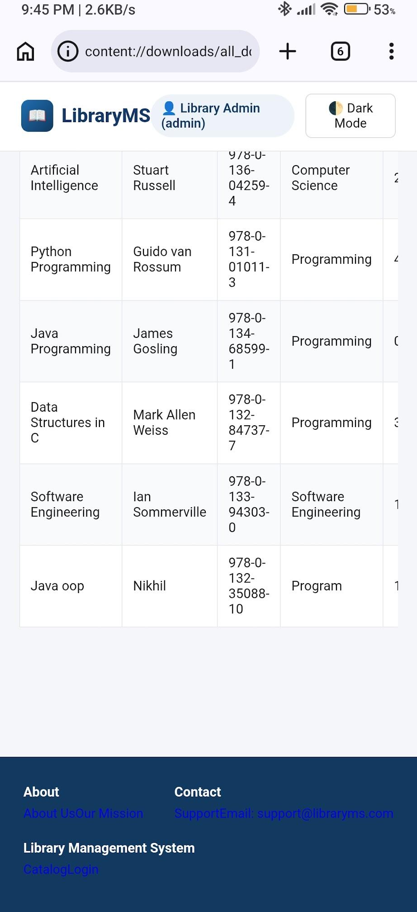
Scenario ID: 4g
Scenario: Edit existing book details
Test Steps:
- Navigate to Admin Dashboard > Add / Edit Book
- Search for book 'Introduction to Python'
- Change the Author to 'Guido van Rossum'
- Click 'Edit Book'
- Verify updated details reflect in the catalog
