LibraryMS – Software Testing Practical
Test Scenarios, Results and Bug Reports (Part 2)

Book Management (continued)
Scenario ID: 4h
Scenario: Delete book from catalog
Test Steps:
- Navigate to Admin Dashboard > Add / Edit Book
- Search for book 'Digital Electronics'
- Click 'Delete Book'
- Confirm deletion in the popup
- Verify book is removed from catalog

Issue & Return Books
Scenario ID: 5a
Scenario: Issue an available book
Test Steps:
- Log in as Admin
- Navigate to Issue Book page
- Enter Book ID: 'B101' (Introduction to Python)
- Enter Student / Member ID: 'S001'
- Click 'Issue Book'
- Verify success message: 'Book Issued Successfully'
- Verify book status changes to 'Issued' in catalog
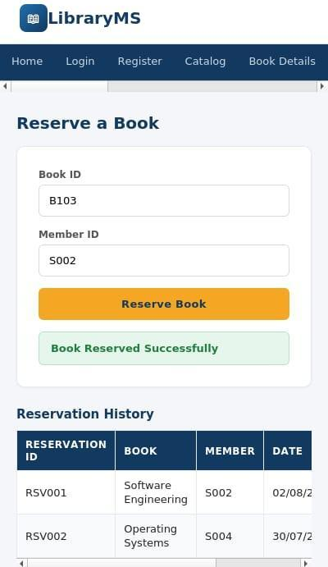
Scenario ID: 5b
Scenario: Issue an already issued/unavailable book
Test Steps:
- Navigate to Issue Book page
- Enter Book ID: 'B103' (Software Engineering - already issued)
- Enter Student / Member ID: 'S002'
- Click 'Issue Book'
- Verify error: 'Book is currently unavailable. It has already been issued.'
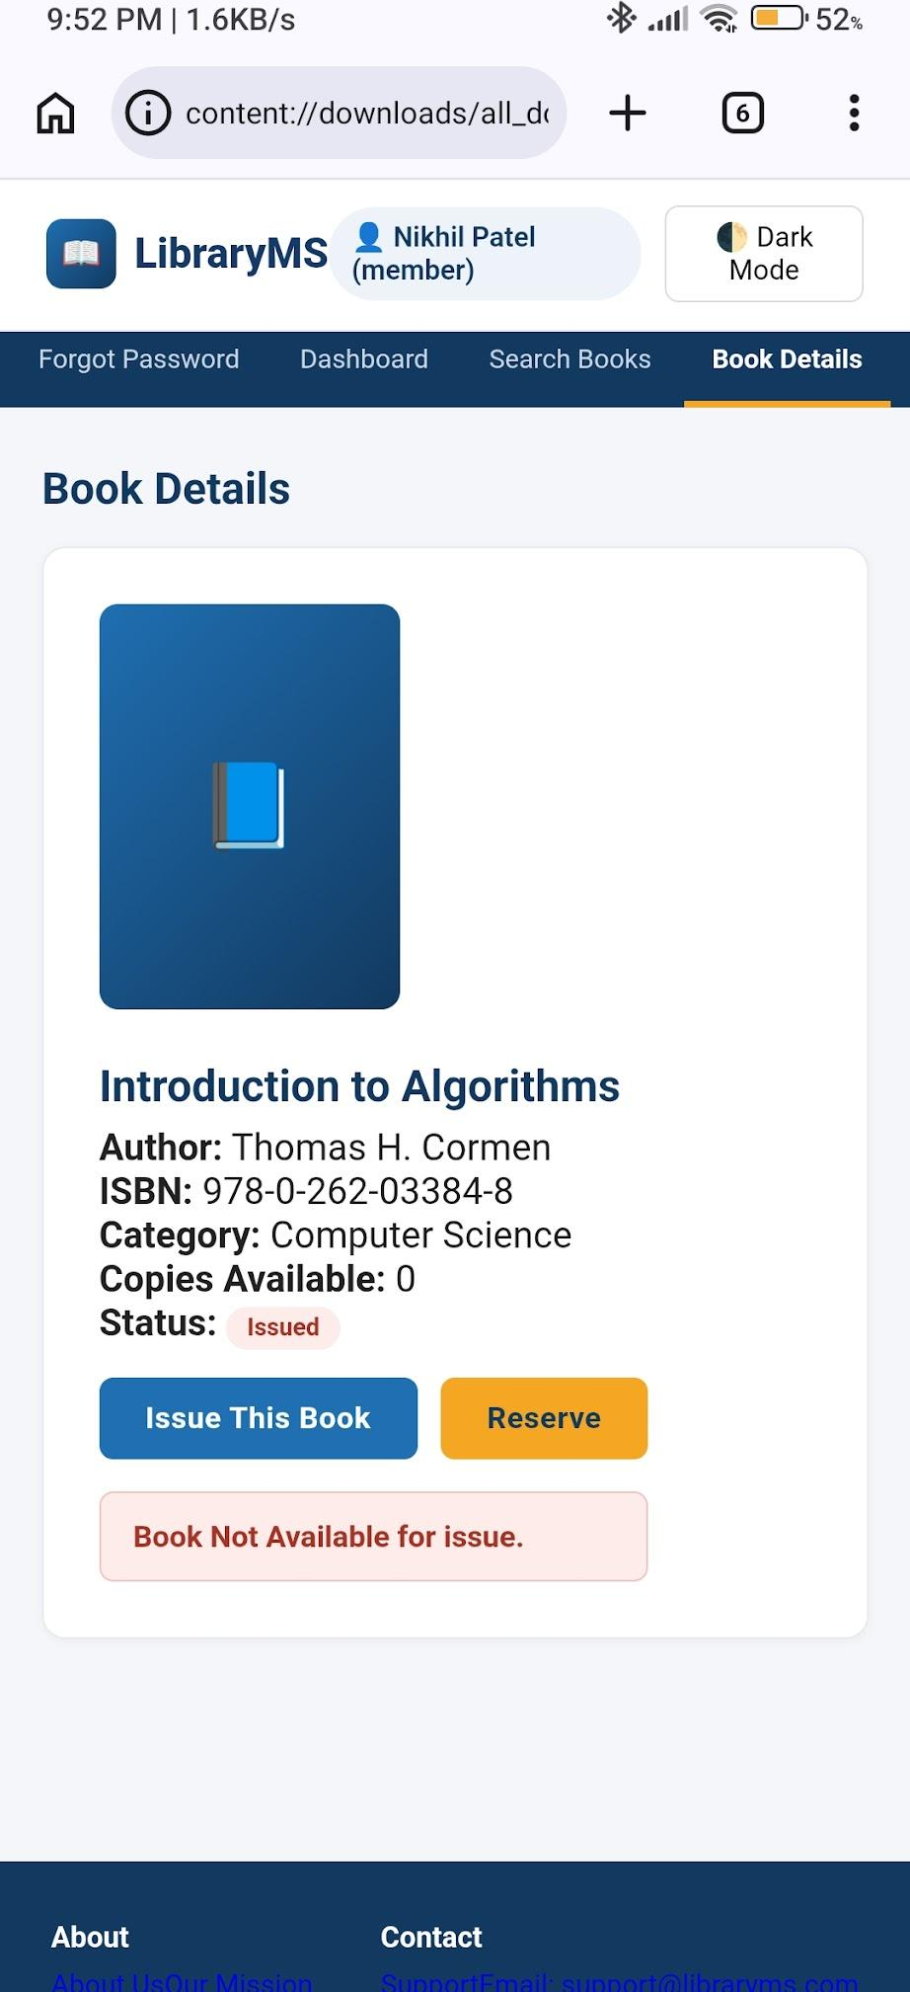
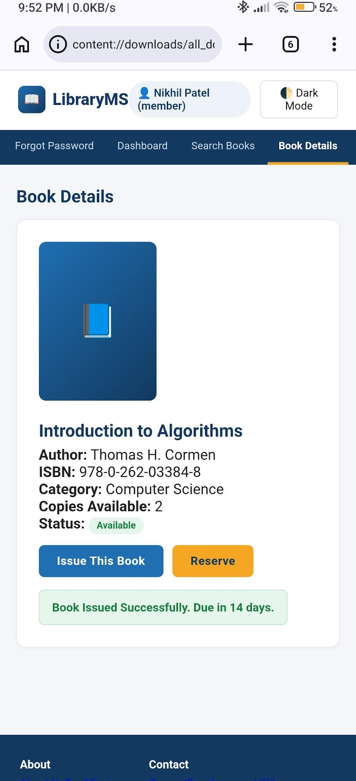
Scenario ID: 5c
Scenario: Return an issued book
Test Steps:
- Navigate to Return Book page
- Enter Book ID: 'B103'
- Click 'Return Book'
- Verify success message: 'Book Returned Successfully'
- Verify book status changes to 'Available' in catalog
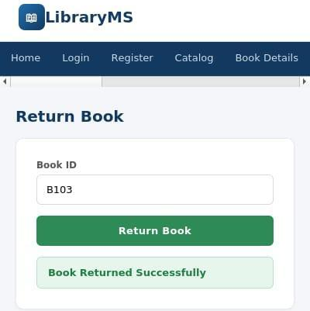

Reservations
Scenario ID: 6a
Scenario: Reserve a book for a member
Test Steps:
- Navigate to Reserve a Book page
- Enter Book ID: 'B103'
- Enter Member ID: 'S002'
- Click 'Reserve Book'
- Verify success message: 'Book Reserved Successfully'
- Verify reservation appears in Reservation History table
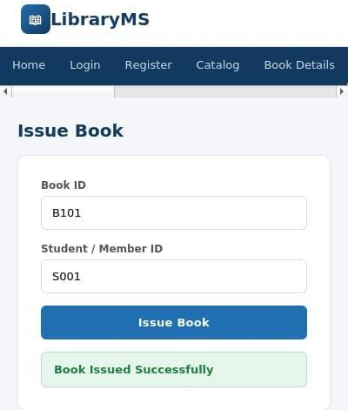
Scenario ID: 6b
Scenario: Reserve with invalid book ID
Test Steps:
- Navigate to Reserve a Book page
- Enter invalid Book ID: 737383388
- Verify error message: 'Book ID not found'
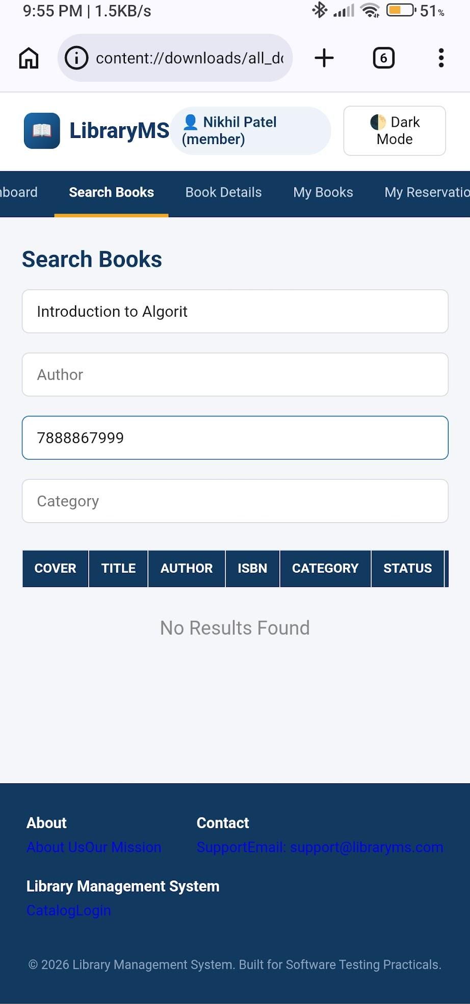
Scenario ID: 6c
Scenario: View reservation history
Test Steps:
- Navigate to Reserve a Book page
- Scroll to 'Reservation History' section
- Verify table shows Reservation ID, Book, Member, and Date columns
- Verify existing reservations are listed correctly
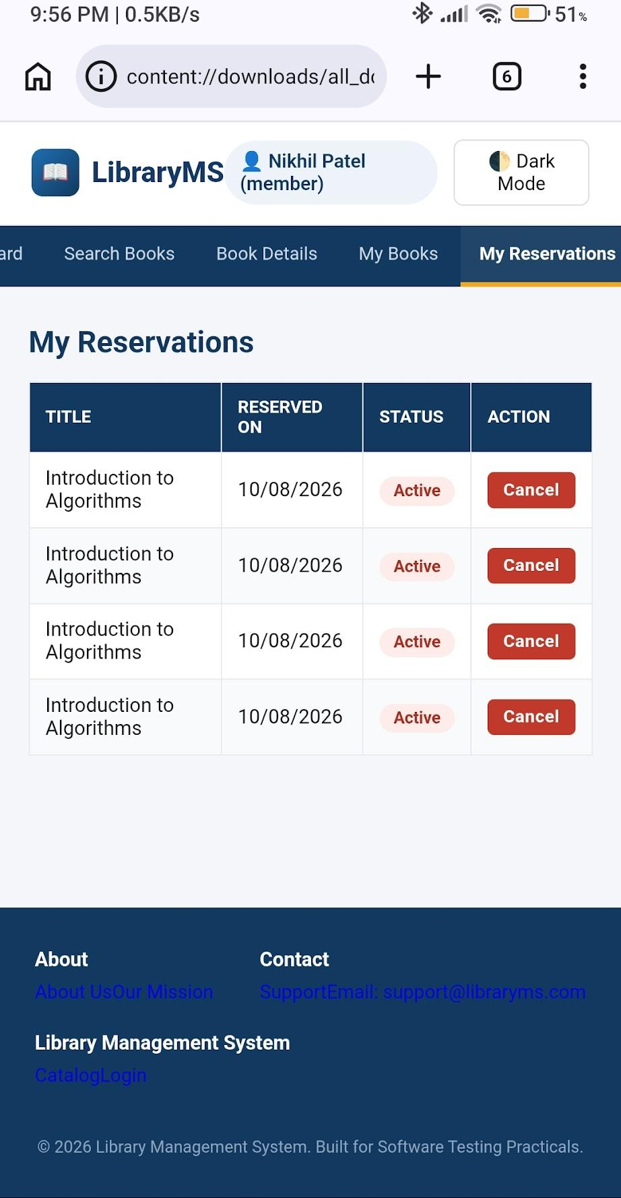

Member Dashboard
Scenario ID: 7a
Scenario: Member dashboard loads correctly
Test Steps:
- Log in as Member (S001)
- Navigate to Member Dashboard
- Verify all sections load: Statistics cards, Issued Books table, Profile Details
- Check statistics: Issued Books (3), Returned Books (5), Reservations (1), Fine Due (₹30)
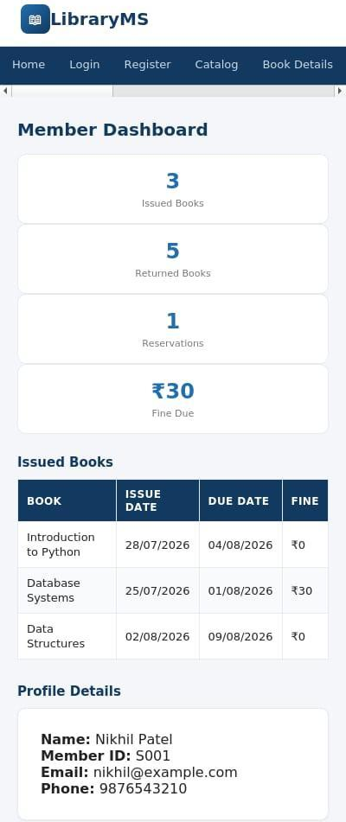
Scenario ID: 7b
Scenario: View member profile details
Test Steps:
- Navigate to Member Dashboard
- Scroll to 'Profile Details' section
- Verify Name: Nikhil Patel, Member ID: S001, Email: nikhil@example.com, Phone: 9876543210
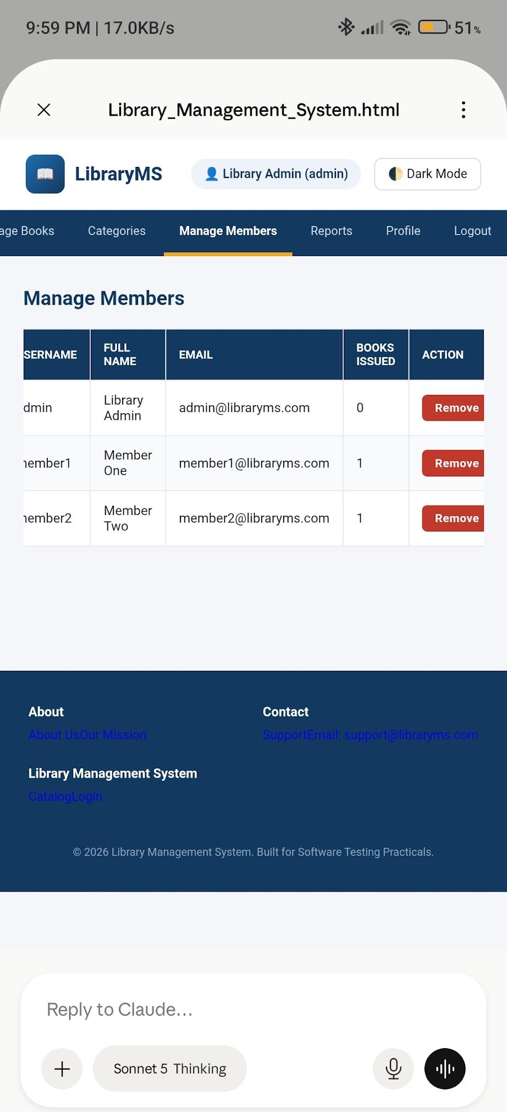

Admin Dashboard
Scenario ID: 8a
Scenario: Admin dashboard loads with all sections
Test Steps:
- Log in as Admin
- Navigate to Admin Dashboard
- Verify all sections load: Statistics cards, Add/Edit Book form, Manage Members table, Reports section, Footer
- Check navigation bar shows all admin links: Issue Book, Return Book, Reservation, Member Dashboard
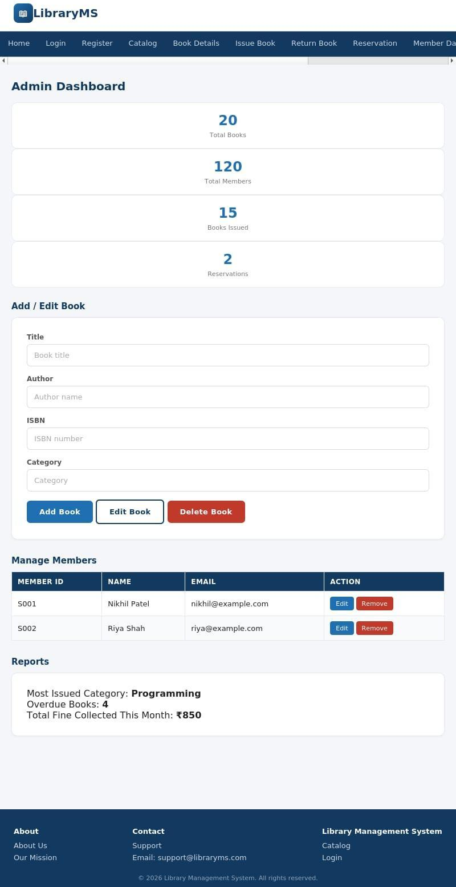

Dark Mode Colour Contrast
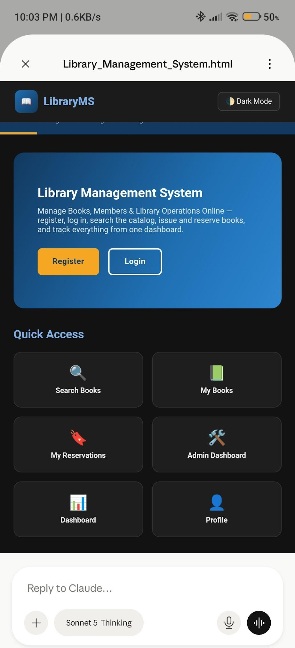

Logout
Scenario ID: 9a
Scenario: Logout from navigation menu
Test Steps:
- Log in to LibraryMS
- Click on 'Logout' from the navigation menu
- Verify logout confirmation page with 'Ready to Logout?' message
- Click 'Confirm Logout'
- Verify success message: 'You have been logged out successfully.'
- Verify user is redirected to login/home page
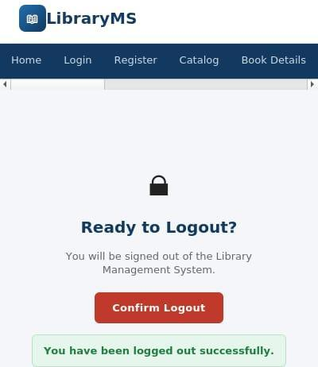

Summary of Test Results
Total Test Cases | 46
Passed | 40
Failed | 6
Pass % | 86.96%

Bug Reports

Bug 1
Bug ID | BUG-001
Title | Book status in catalog does not auto-update after issue/return
Module | Book Management / Issue & Return
Severity | High
Steps to Reproduce | 1. Navigate to Catalog page and note status of book B101 (Available).  2. Go to Issue Book page and issue B101 to member S001.  3. Return to Catalog page without refreshing.  4. Observe that B101 still shows 'Available' instead of 'Issued'.
Expected Result | Book status should automatically update to 'Issued' in the catalog without requiring a manual page refresh.
Actual Result | Book status remains 'Available' until the user manually refreshes the page. Data inconsistency between issue action and catalog display.

Bug 2
Bug ID | BUG-002
Title | Search filters do not reset when input fields are cleared
Module | Book Management / Catalog
Severity | Medium
Steps to Reproduce | 1. Navigate to Catalog page.  2. Enter 'Python' in Search by Title field.  3. Catalog filters to show matching results.  4. Clear the Search by Title field (delete all text).  5. Observe that catalog does not restore full book list.
Expected Result | Clearing all search input fields should automatically reset the catalog to display all books.
Actual Result | Catalog remains filtered even after clearing input. User must manually trigger a reset or refresh the page to see all books.

Bug 3
Bug ID | BUG-003
Title | System allows duplicate reservations for the same book by the same member
Module | Reservation
Severity | High
Steps to Reproduce | 1. Navigate to Reserve a Book page.  2. Enter Book ID: 'B103' and Member ID: 'S002'.  3. Click 'Reserve Book' - reservation succeeds.  4. Without any changes, click 'Reserve Book' again.  5. Observe that a second reservation is created for the same book-member pair.
Expected Result | System should reject duplicate reservations and display: 'This book is already reserved by this member.'
Actual Result | Multiple duplicate reservations are created. Reservation History table shows duplicate entries for the same book and member.

