PRACTICAL – 10
DEMOBLAZE
Automation & Regression Analysis – Test Cases

Student Name | Nikhil M Chavda
Project Name | DemoBlaze
Application/Software | https://www.demoblaze.com/
Module Name | Homepage, Categories, Product Details, About Us & Contact
Test Plan | Online Shopping Website Testing
Test Suite | Functional / Regression Testing
Test Case Description | Functional testing of homepage, categories, product details, About Us and Contact features
Testing Type | Functional / Regression Testing
Tool | Web Browser; Selenium with Python (if required)
Prerequisites | DemoBlaze website is accessible
Environment | Google Chrome / Android

TEST CASES
TC01 – Verify homepage loading
Scenario ID: TC01
Scenario: Verify homepage loading
Test Steps:
> Step 1: Open Google Chrome
> Step 2: Enter https://www.demoblaze.com/ in the address bar
> Step 3: Wait for the homepage to load
Test Input: DemoBlaze website URL
Expected Result: Homepage opens and the main navigation and product area are visible.
Actual Result: Homepage loaded with the PRODUCT STORE header, navigation links (Home, Contact, About us, Cart, Log in, Sign up), the CATEGORIES list and product listings.
Status: Pass
Comments: Homepage screenshot included.
Screenshot:
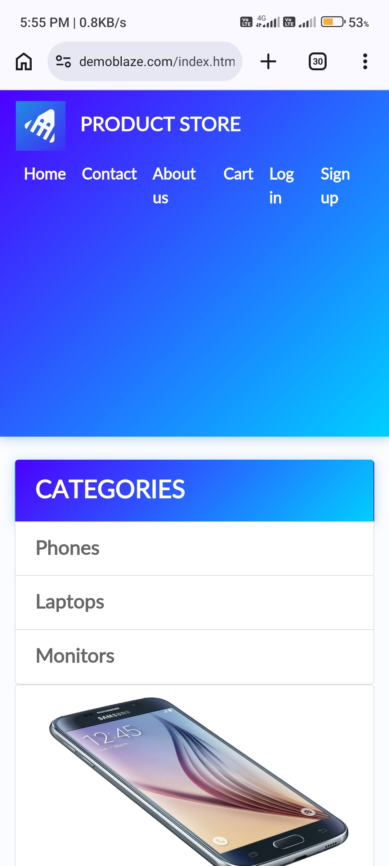
Figure: DemoBlaze evidence for TC01

TC02 – Verify Home button
Scenario ID: TC02
Scenario: Verify Home button
Test Steps:
> Step 1: Open the website
> Step 2: Navigate to another page or open a product
> Step 3: Click Home
Test Input: Home navigation button
Expected Result: User is returned to the homepage and product categories are visible.
Actual Result: Home link is visible in the navigation bar on the product page; clicking it returns to the homepage (index.html) with the categories list.
Status: Pass
Comments: Navigation bar with Home link shown on the product page.
Screenshot:
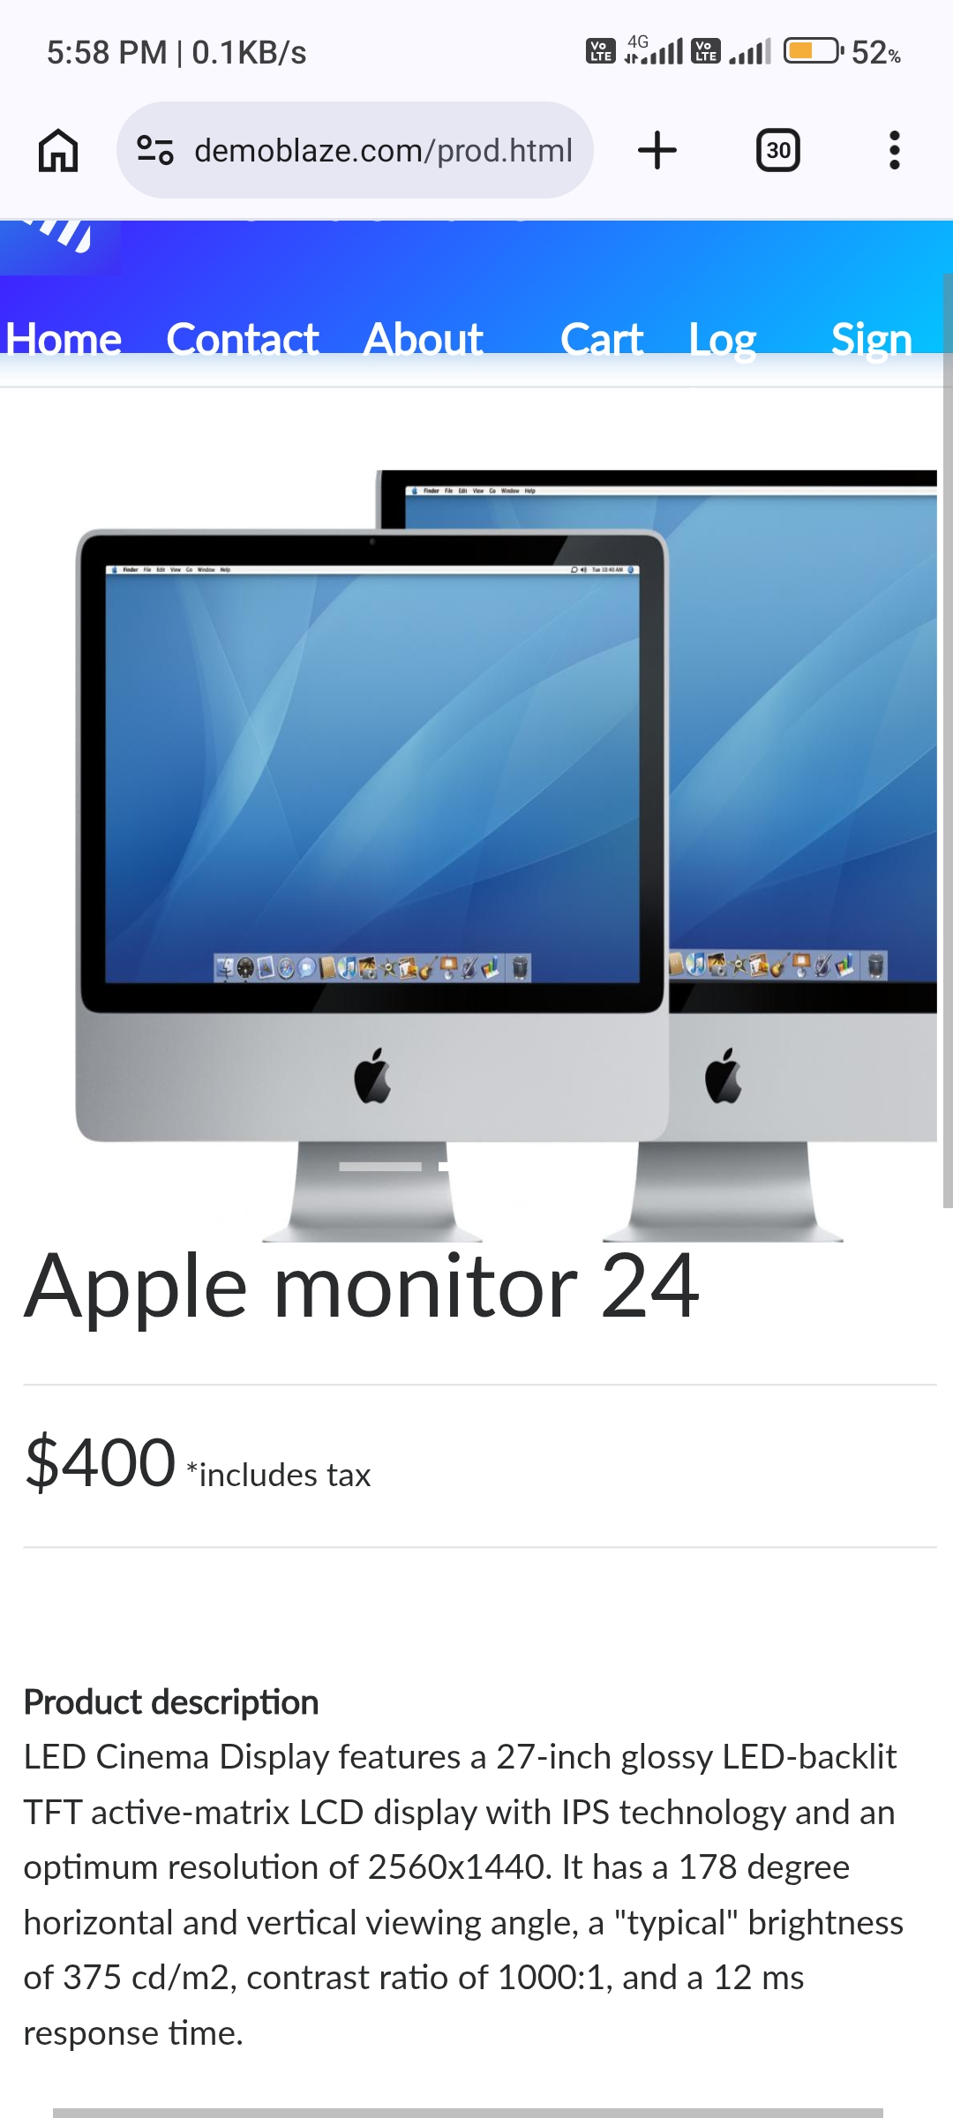
Figure: DemoBlaze evidence for TC02

TC03 – Verify Phones category
Scenario ID: TC03
Scenario: Verify Phones category
Test Steps:
> Step 1: Open the homepage
> Step 2: Click Phones in the category list
> Step 3: Observe the products displayed
Test Input: Phones category
Expected Result: Phone products are displayed in the product area.
Actual Result: Phone products such as Samsung galaxy s6 ($360) and Nokia Lumia are displayed.
Status: Pass
Comments: Phones category screenshot included.
Screenshot:
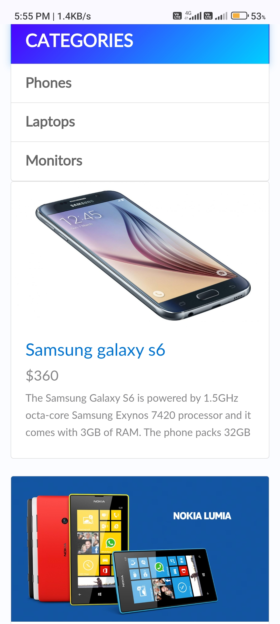
Figure: DemoBlaze evidence for TC03

TC04 – Verify Laptops category
Scenario ID: TC04
Scenario: Verify Laptops category
Test Steps:
> Step 1: Open the homepage
> Step 2: Click Laptops in the category list
> Step 3: Observe the products displayed
Test Input: Laptops category
Expected Result: Laptop products are displayed in the product area.
Actual Result: Laptop products such as Sony vaio i5 ($790) and Sony vaio i7 ($790) are displayed.
Status: Pass
Comments: Laptops category screenshot included.
Screenshot:
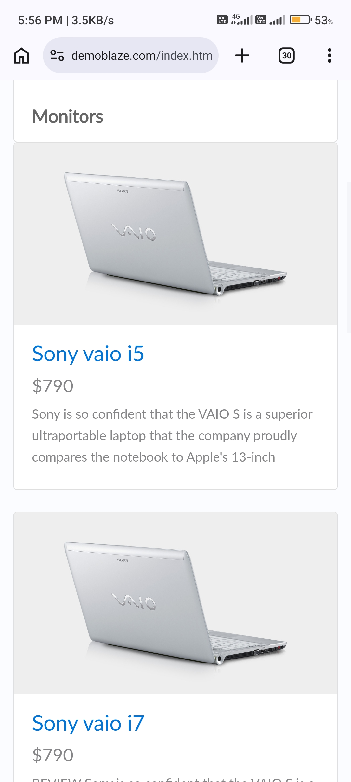
Figure: DemoBlaze evidence for TC04

TC05 – Verify Monitors category
Scenario ID: TC05
Scenario: Verify Monitors category
Test Steps:
> Step 1: Open the homepage
> Step 2: Click Monitors in the category list
> Step 3: Observe the products displayed
Test Input: Monitors category
Expected Result: Monitor products are displayed in the product area.
Actual Result: Monitor products such as Apple monitor 24 ($400) are displayed.
Status: Pass
Comments: Monitors category screenshot included.
Screenshot:
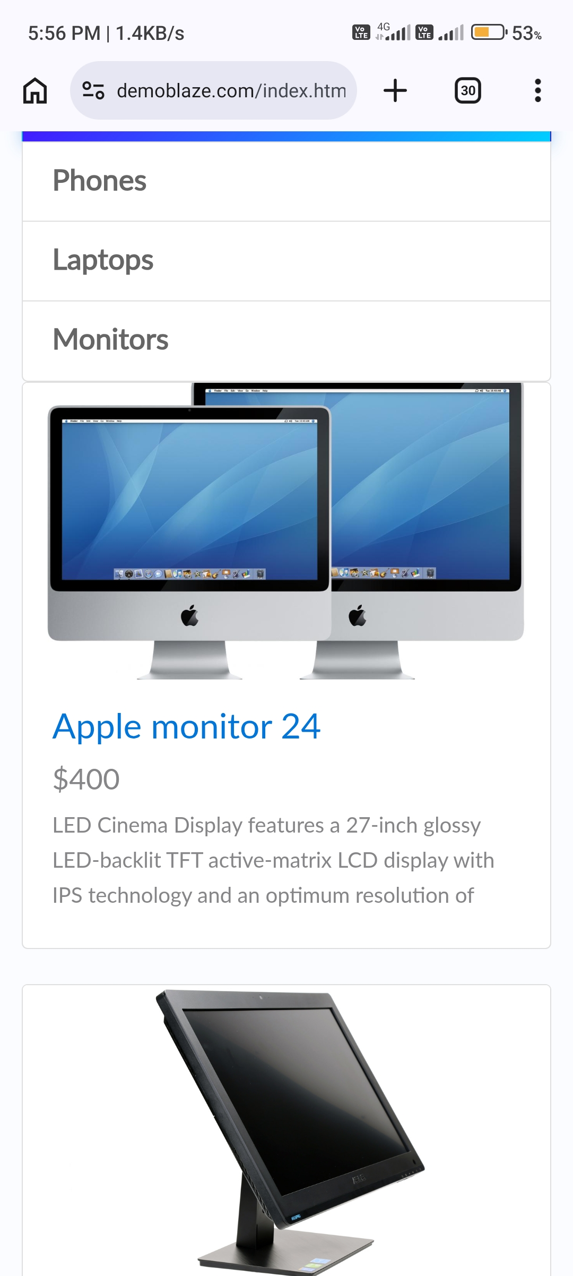
Figure: DemoBlaze evidence for TC05

TC06 – Verify product details page
Scenario ID: TC06
Scenario: Verify product details page
Test Steps:
> Step 1: Open any available product from a category
> Step 2: Check the product details page
> Step 3: Verify name, price and description
Test Input: Any available product (Apple monitor 24)
Expected Result: The selected product's name, price and description are displayed.
Actual Result: Product page shows the name Apple monitor 24, price $400 (includes tax), the product description and the Add to cart button.
Status: Pass
Comments: Product details screenshot included.
Screenshot:
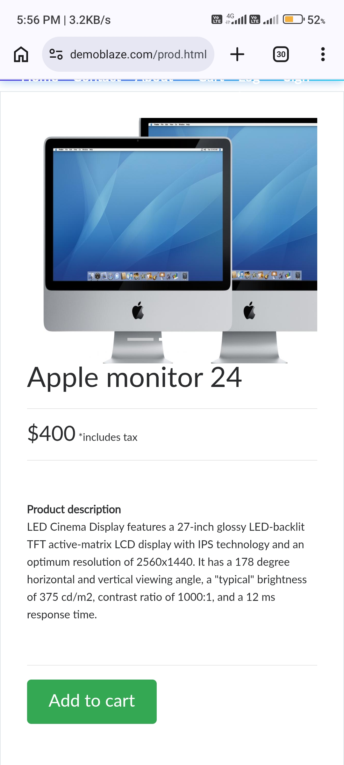
Figure: DemoBlaze evidence for TC06

TC07 – Verify About Us popup
Scenario ID: TC07
Scenario: Verify About Us popup
Test Steps:
> Step 1: Open the homepage
> Step 2: Click About us in the top navigation
> Step 3: Check the popup content
Test Input: About us navigation link
Expected Result: About Us popup opens and its content is visible.
Actual Result: About us popup opened and the video player with its controls is visible.
Status: Pass
Comments: About us popup screenshot included.
Screenshot:
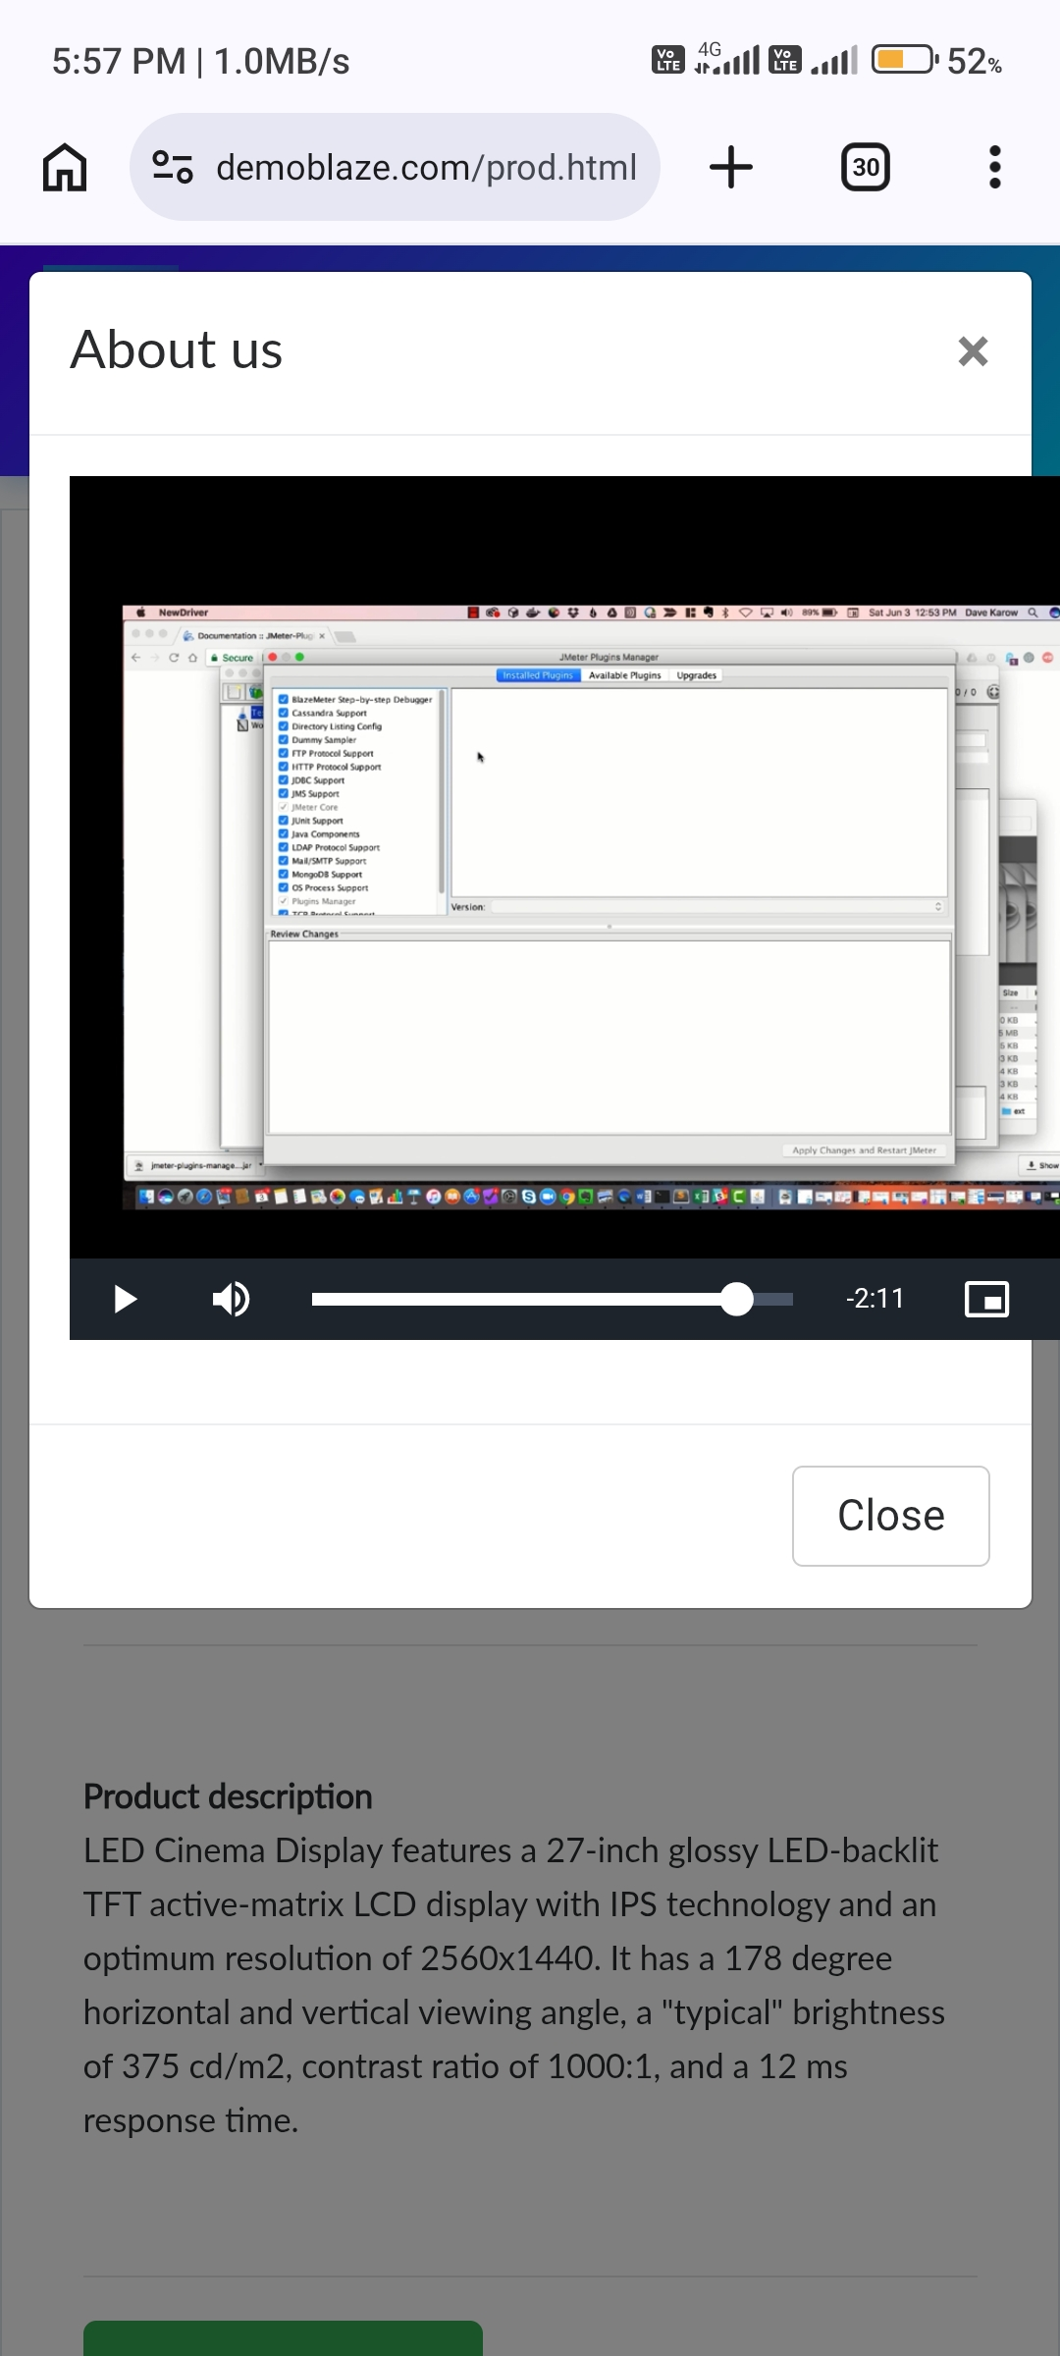
Figure: DemoBlaze evidence for TC07

TC08 – Verify About Us close button
Scenario ID: TC08
Scenario: Verify About Us close button
Test Steps:
> Step 1: Open the About Us popup
> Step 2: Click its close (X) button or Close button
Test Input: About Us popup close control
Expected Result: The popup closes and the homepage is visible again.
Actual Result: Popup closed and the underlying page (product page) is visible again without the popup.
Status: Pass
Comments: Page after closing the popup shown.
Screenshot:
Figure: DemoBlaze evidence for TC08

TC09 – Verify Contact form fields
Scenario ID: TC09
Scenario: Verify Contact form fields
Test Steps:
> Step 1: Open the homepage
> Step 2: Click Contact
> Step 3: Check the form fields
Test Input: Contact form
Expected Result: Email, Name and Message fields are available in the Contact form.
Actual Result: New message form displayed Contact Email, Contact Name and Message fields with Close and Send message buttons. Submitting with sample data showed the alert "Thanks for the message!!".
Status: Pass
Comments: Empty form and submission confirmation screenshots included.
Screenshot:
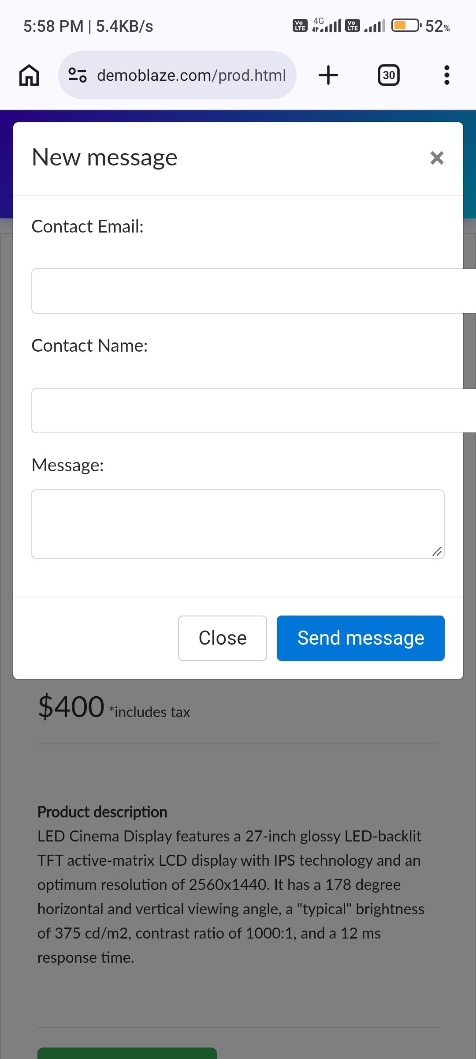 | 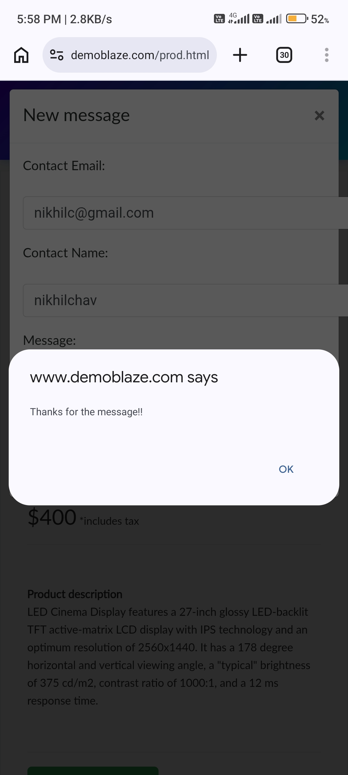
Figure: DemoBlaze evidence for TC09

TC10 – Verify Contact form close button
Scenario ID: TC10
Scenario: Verify Contact form close button
Test Steps:
> Step 1: Open the Contact popup
> Step 2: Click its close (X) button or Close button
Test Input: Contact popup close control
Expected Result: The Contact popup closes and the homepage is visible again.
Actual Result: Close button and X icon are available on the Contact popup; the popup closes after Close/OK is clicked and the page remains visible.
Status: Pass
Comments: Close controls visible in the screenshot.
Screenshot:
Figure: DemoBlaze evidence for TC10

