PRACTICAL – 9
DEMO WEB SHOP
Black-Box Testing – Test Scenarios

Student Name | Nikhil Chavda
Project Name | Demo Web Shop
Application/Software | https://demowebshop.tricentis.com/
Module Name | Product Search, Categories & Shopping Cart
Test Plan | Online Shopping Website Testing
Test Suite | Product and Cart Testing
Test Case Description | Functional testing of search, category, product details and cart features
Prerequisites | Demo Web Shop website is accessible
Environment | Google Chrome / Windows

TEST SCENARIOS
TC001 – Search for an available product
Scenario ID: TC001
Scenario: Search for an available product
Test Steps:
> Step 1: Open the Demo Web Shop home page
> Step 2: Enter “computer” in the search box
> Step 3: Click Search
Test Input: Valid product keyword: computer
Expected Result: Relevant matching products are displayed
Actual Result: Search field and matching results are visible in the supplied screenshot
Status: Evidence available
Comments: Search results screenshot included.
Screenshot:
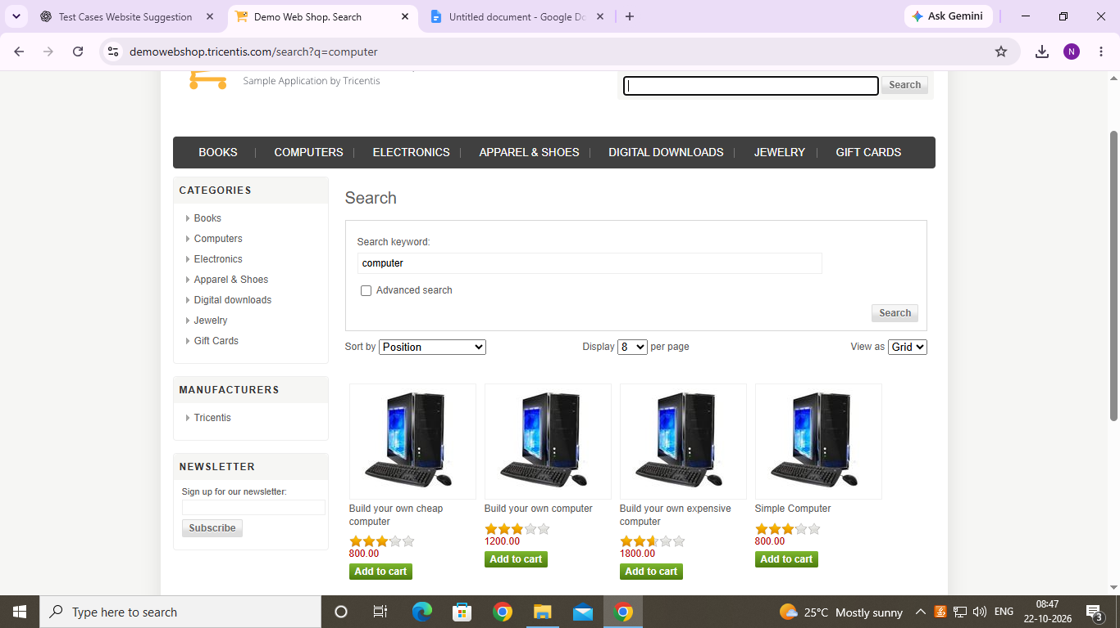
Figure: Demo Web Shop evidence for TC001

TC002 – Search for an unavailable product
Scenario ID: TC002
Scenario: Search for an unavailable product
Test Steps:
> Step 1: Open the home page
> Step 2: Enter a product name that is not available
> Step 3: Click Search
Test Input: Unavailable product keyword
Expected Result: A no-results message is displayed
Actual Result: No-results page is visible in the supplied screenshot
Status: Evidence available
Comments: No-results screenshot included.
Screenshot:
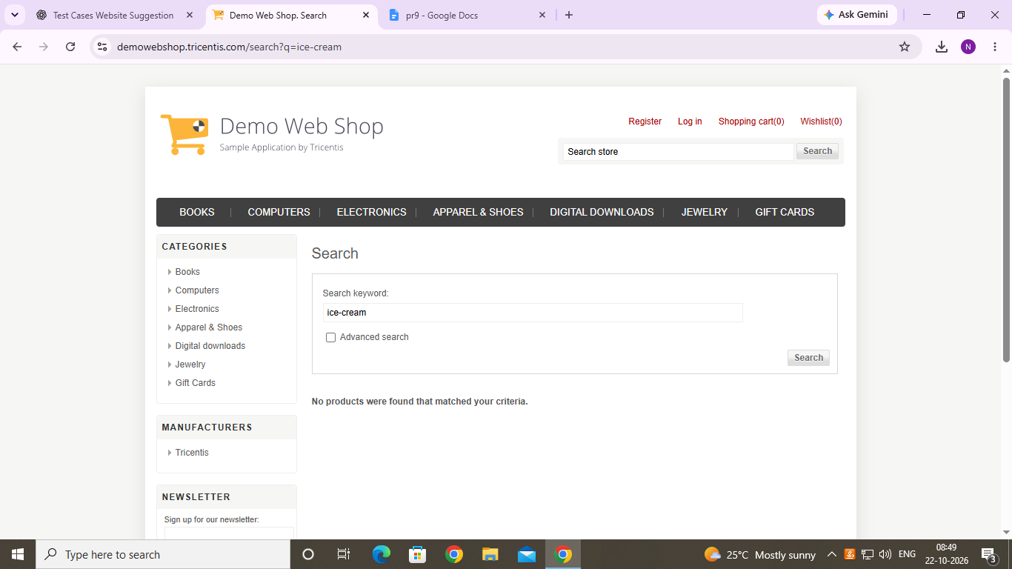
Figure: Demo Web Shop evidence for TC002

TC003 – Browse a product category
Scenario ID: TC003
Scenario: Browse a product category
Test Steps:
> Step 1: Open the home page
> Step 2: Select the Books category
Test Input: Books category
Expected Result: Books category page opens and lists relevant items
Actual Result: Books category page is visible in the supplied screenshot
Status: Evidence available
Comments: Category screenshot included.
Screenshot:
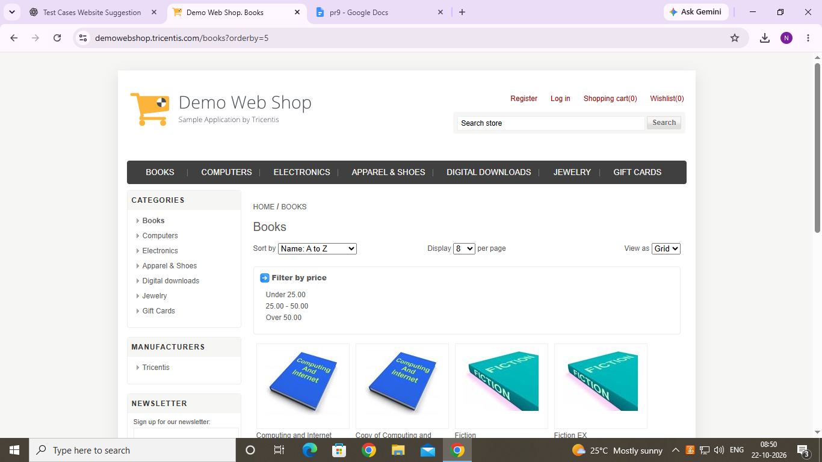
Figure: Demo Web Shop evidence for TC003

TC004 – Open product details
Scenario ID: TC004
Scenario: Open product details
Test Steps:
> Step 1: Search for a product or open a category
> Step 2: Select a product title
Test Input: Available product
Expected Result: Product details page opens
Actual Result: Product details and controls are visible in the supplied screenshot
Status: Evidence available
Comments: Product details screenshot included.
Screenshot:
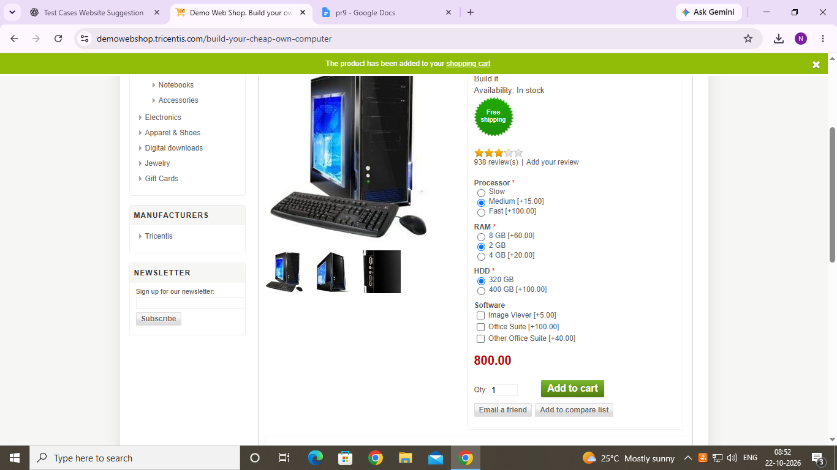
Figure: Demo Web Shop evidence for TC004

TC005 – Verify product price
Scenario ID: TC005
Scenario: Verify product price
Test Steps:
> Step 1: Open a product details page
> Step 2: Check the displayed price
Test Input: Displayed product price
Expected Result: Product price is clearly displayed
Actual Result: A price is visible on the supplied product screenshot
Status: Evidence available
Comments: Price screenshot included.
Screenshot:
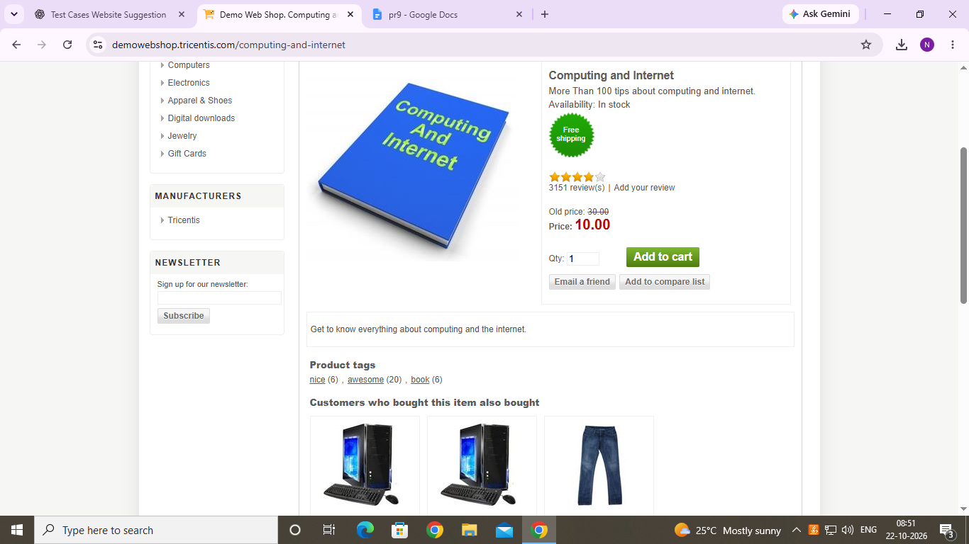
Figure: Demo Web Shop evidence for TC005

TC006 – Verify quantity field
Scenario ID: TC006
Scenario: Verify quantity field
Test Steps:
> Step 1: Open a product details page
> Step 2: Locate the quantity field
Test Input: Quantity value: 1
Expected Result: Quantity field is displayed and can be edited
Actual Result: Quantity field is visible; changing it must be executed to confirm behavior
Status: To Execute
Comments: Screenshot shows the quantity control only.
Screenshot:
Figure: Demo Web Shop evidence for TC006

TC007 – Add product to cart
Scenario ID: TC007
Scenario: Add product to cart
Test Steps:
> Step 1: Open a product details page
> Step 2: Click Add to cart
Test Input: Selected product
Expected Result: Product is added to the shopping cart and confirmation is shown
Actual Result: Please execute this action and record the actual confirmation
Status: To Execute
Comments: Existing screenshot does not by itself prove a successful add action.
Screenshot:
Figure: Demo Web Shop evidence for TC007

TC008 – View shopping cart
Scenario ID: TC008
Scenario: View shopping cart
Test Steps:
> Step 1: Open the shopping cart page
> Step 2: Check the listed product
Test Input: Cart with a product
Expected Result: Cart displays the selected product and its details
Actual Result: A cart page containing a product is visible in the supplied screenshot
Status: Evidence available
Comments: Cart screenshot included.
Screenshot:
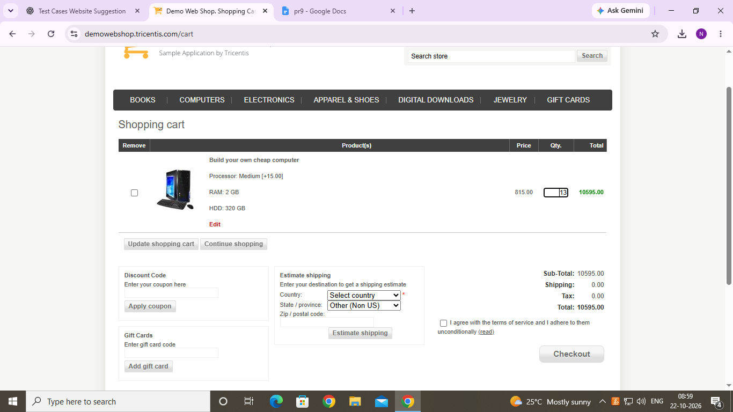
Figure: Demo Web Shop evidence for TC008

TC009 – Update cart quantity
Scenario ID: TC009
Scenario: Update cart quantity
Test Steps:
> Step 1: Open the shopping cart
> Step 2: Change the quantity and update the cart
Test Input: New quantity: 2
Expected Result: Cart updates the quantity and recalculates totals
Actual Result: Must be executed in the browser to verify the updated quantity and total
Status: To Execute
Comments: Screenshot of the updated cart is required.
Screenshot:
Figure: Demo Web Shop evidence for TC009

TC010 – Remove product from cart
Scenario ID: TC010
Scenario: Remove product from cart
Test Steps:
> Step 1: Open the shopping cart
> Step 2: Select Remove for a product
> Step 3: Update the cart if prompted
Test Input: Product selected for removal
Expected Result: Selected product is removed from the cart
Actual Result: Must be executed in the browser to verify removal
Status: To Execute
Comments: Screenshot after removal is required.
Screenshot:
Figure: Demo Web Shop evidence for TC010

